STYRENE PARK OFFSITE

Document Title:
Packing, Marking & Shipping Procedure

R0 | 14-05-2025 | IFI | F.SH | M.O | A.M
Rev. | Issued Date | DESCRIPTION | PREPARED | CHECKED | APPROVED

REVISION RECORD SHEET
Page  Page | Revisions |  |  |  |  |  |  |  | Page | Revisions
Page  Page | R0 | R1 | R2 | R3 | R4 | R5 | R6 |  | Page | R0 | R1 | R2 | R3 | R4 | R5 | R6
1 | X |  |  |  |  |  |  |  | 41
2 | X |  |  |  |  |  |  |  | 42
3 | X |  |  |  |  |  |  |  | 43
4 | X |  |  |  |  |  |  |  | 44
5 | X |  |  |  |  |  |  |  | 45
6 | X |  |  |  |  |  |  |  | 46
7 | X |  |  |  |  |  |  |  | 47
8 | X |  |  |  |  |  |  |  | 48
9 | X |  |  |  |  |  |  |  | 49
10 | X |  |  |  |  |  |  |  | 50
11 | X |  |  |  |  |  |  |  | 51
12 | X |  |  |  |  |  |  |  | 52
13 | X |  |  |  |  |  |  |  | 53
14 | X |  |  |  |  |  |  |  | 54
15 | X |  |  |  |  |  |  |  | 55
16 | X |  |  |  |  |  |  |  | 56
17 | X |  |  |  |  |  |  |  | 57
18 | X |  |  |  |  |  |  |  | 58
19 | X |  |  |  |  |  |  |  | 59
20 | X |  |  |  |  |  |  |  | 60
21 | X |  |  |  |  |  |  |  | 61
22 | X |  |  |  |  |  |  |  | 62
23 | X |  |  |  |  |  |  |  | 63
24 | X |  |  |  |  |  |  |  | 64
25 | X |  |  |  |  |  |  |  | 65
26 | X |  |  |  |  |  |  |  | 66
27 | X |  |  |  |  |  |  |  | 67
28 | X |  |  |  |  |  |  |  | 68
29 | X |  |  |  |  |  |  |  | 69
30 | X |  |  |  |  |  |  |  | 70
31 | X |  |  |  |  |  |  |  | 71
32 |  |  |  |  |  |  |  |  | 72
33 |  |  |  |  |  |  |  |  | 73
34 |  |  |  |  |  |  |  |  | 74
35 |  |  |  |  |  |  |  |  | 75
36 |  |  |  |  |  |  |  |  | 76
37 |  |  |  |  |  |  |  |  | 77
38 |  |  |  |  |  |  |  |  | 78
39 |  |  |  |  |  |  |  |  | 79
40 |  |  |  |  |  |  |  |  | 80

Packing, Marking & Shipping Procedure for Air Cooler

- PURPOSE
- SCOPE
- REFERENCES

- RESPONSIBILITY

- GENERAL REQUIREMENTS FOR PACKING

- PACKING PROCEDURE FOR TUBE BUNDLES

- PACKING PROCEDURE FOR STRUCTURAL PARTS

- Small Parts, Tools and spare Parts

- Format
1. PURPOSE
This procedure covers the requirements and instructions to be followed by the DAMAFIN for packing and marking of Air-cooled heat exchangers that will be procured in “Toase-ehe Park Sanati Gohar Ofogh Petrochemical Co. CONCEPTUAL, BASIC and DETAIL DESIGN ENGINEERING OF STYRENE PARK OFFSITE PROJECT”
2. SCOPE
This procedure is applicable for packing and shipping of tube bundles, machinery and steel structure parts of All Items.
3. REFERENCES
-DAMAFIN SPECIFICATION
-API 661
4. RESPONSIBILITY
DAMAFIN is solely responsible for packing and marking of goods.
5. GENERAL REQUIREMENTS FOR PACKING
The packing of the equipment and materials shall be carried out in order to comply with transport conditions, so it shall imply on following items:
5.1. The goods shall be dried, cleaned internally and externally, removed from all welded spatter ,scale, rust, cuttings, fittings, etc., as well as any all foreign material.
5.2. Protection against environmental corrosion caused by extremes of humidity, condensation, rain, dust, sand, salted air and sea spray shall be provided.
5.3. Packing means to efficiently protect the materials during the total transport operation:
5.4. High quality wooden cases and/or crates shall be used.

6. PACKING PROCEDURE FOR TUBE BUNDLES
6.1. Drying of Tube bundles
- Horizontal bundle to be lifted by 1 or 2 Cranes, each of them to hold one header.
- Unit to be alternatively tilted to one side and to the other (30 degrees).
- Then bundle to be laid down horizontally.
- Then bundle to be dried by hot air circulation for at least 3 hours.
6.2. All flange facing shall be covered and couplings plugged to prevent damage. Flange cover shall be 6mm steel plates bolted to the flange with a minimum of 4 bolts.
6.3. Machined surfaces, flange faces and threads of bolts shall be coated with heavy rust preventive grease to prevent corrosion during shipment and storage.
6.4. Flanges and connections shall be closed with blind flanges and plugs. Permanent blind flanges or covers included in the vendor’s scope shall be bolted with service stud bolts and nuts.
6.5. External surfaces of header box and surface of plugs shall be painted (thin layer) with the paint that used for last layer of painting header boxes.
6.6. External surfaces of bundles frame shall be cleaned and four damafin marks “DTT” shall be painted at the side wall near the header boxes with blue and red colour.
6.7. Inside protection of Tube bundles
After carryout drying completely, all nozzles shall be blind and Nitrogen purging shall be done with at least 1.5 bar pressure. One pressure gauge and valve shall be installed on tube bundle. The periodically inspection shall be done every 4 months.
6.8. Installing Stand for carrying tube bundles and set them on truck
6.8.1: Tube bundles with the width below 2.4m
-For carrying this type of tube bundles we use painted IPE 180 with the length equal to width of tube bundle plus 100mm.
Between IPE 180 and bundle, structures parts, a 10 mm Teflon sheet or rubber shall be placed.
-This stands will be fixed at the start and end of tube bundle and another stands, with space about 4m from them.
-Stands will be welded to besides edge of bundle frames.
6.8.2: Tube bundles with the width over than 2.4m
-For carrying this type of tube bundles we use dual of painted IPE 180, with the length equal to width of tube bundle plus 100mm. (At the first, 2 IPEs weld together from both back and front surfaces at 3 points.)
-This stands will be fixed at the start and end of tube bundle and another stands, with space about 4m from them.
-Stands will be welded to besides edges of bundle frames.
- Wooden plate is placed on the finned tube of tube bundle
- Motor, fan, vibration switch, belt and pulley... are packed in a wooden box.

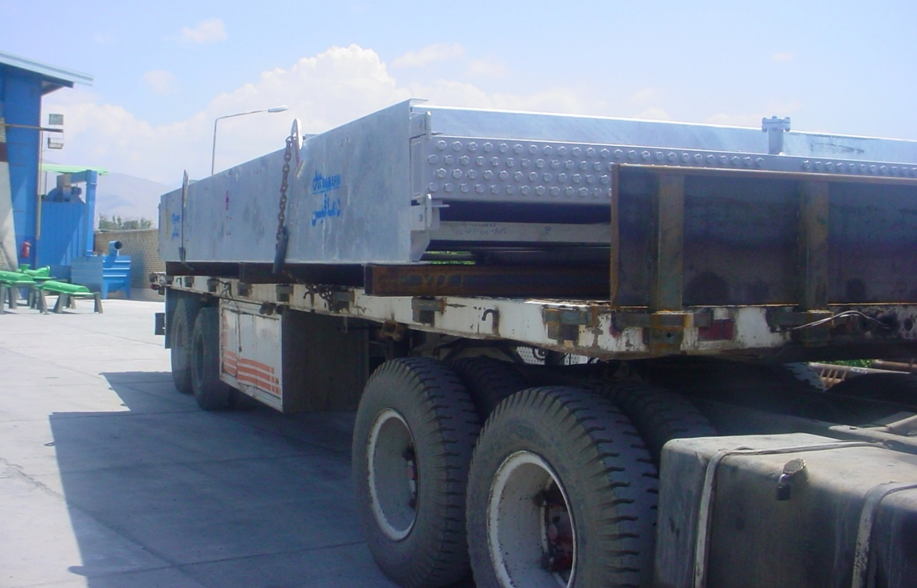
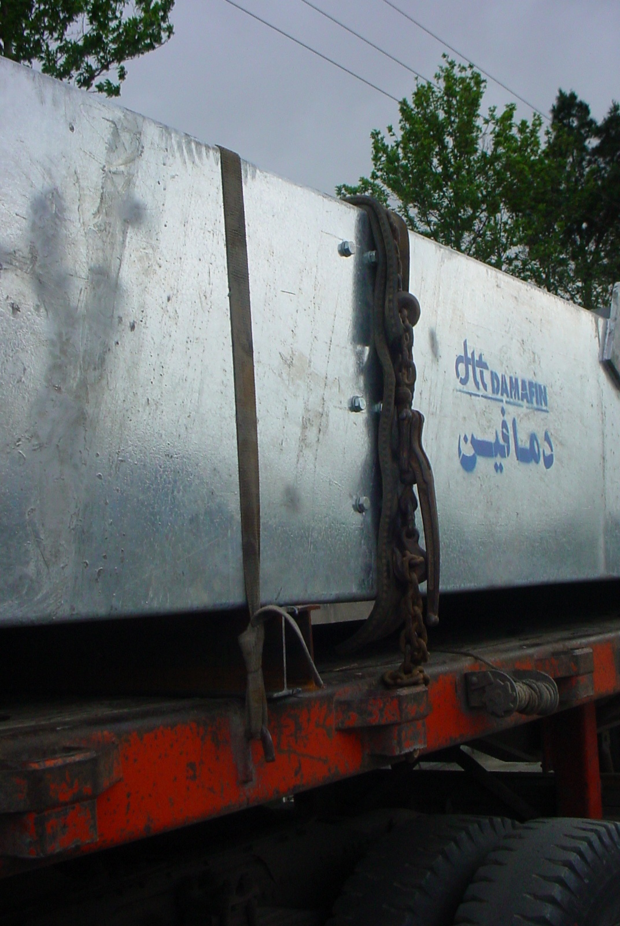

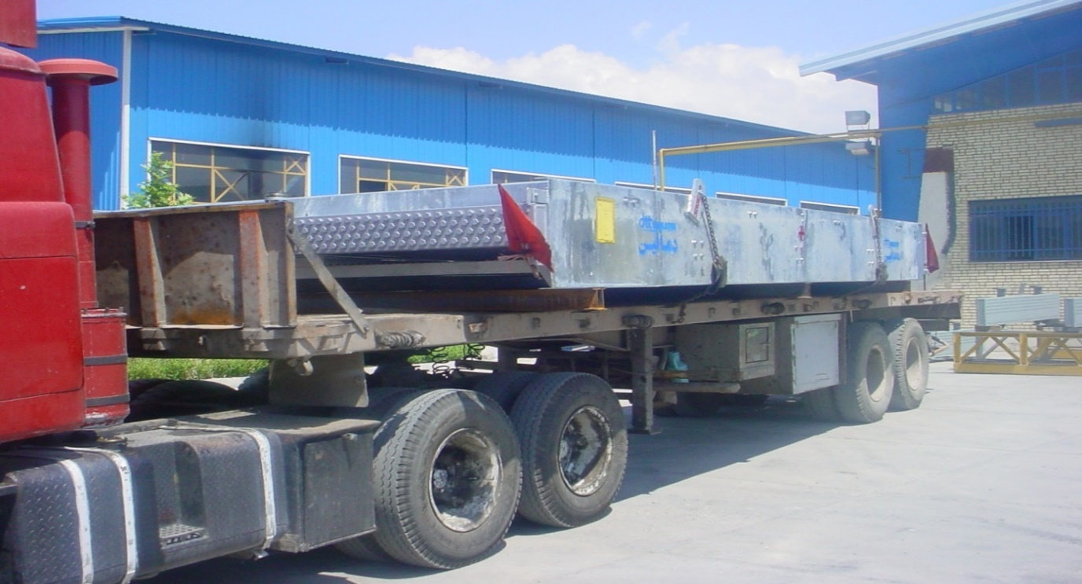

7. PACKING PROCEDURE FOR STRUCTURAL PARTS
All small structural parts together with belt and spanner and then fix in the pallets. and large parts like columns or fan ring parts will be fix in pallets separately. (As shown in below pictures).
- Columns, walkways, ladders are packed with proper observance of the color protection quality and depending on the dimensions of the equipment.

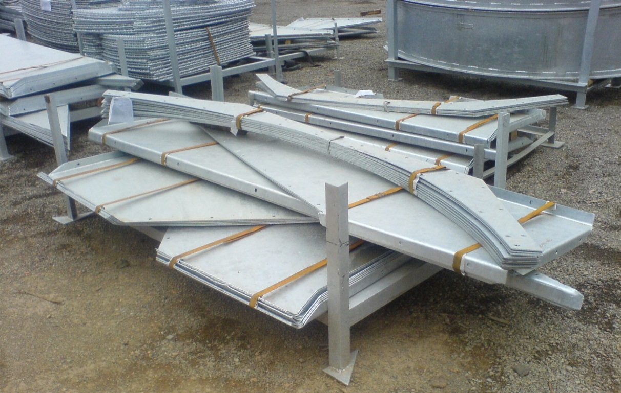

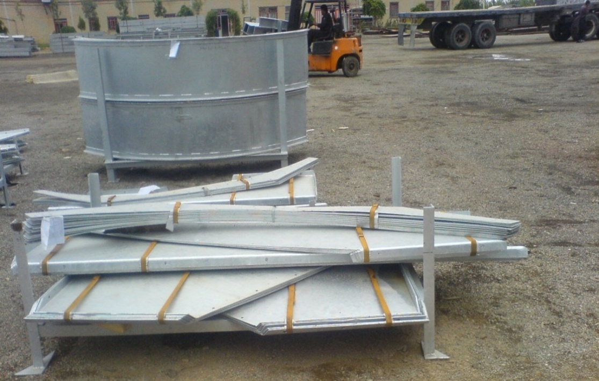

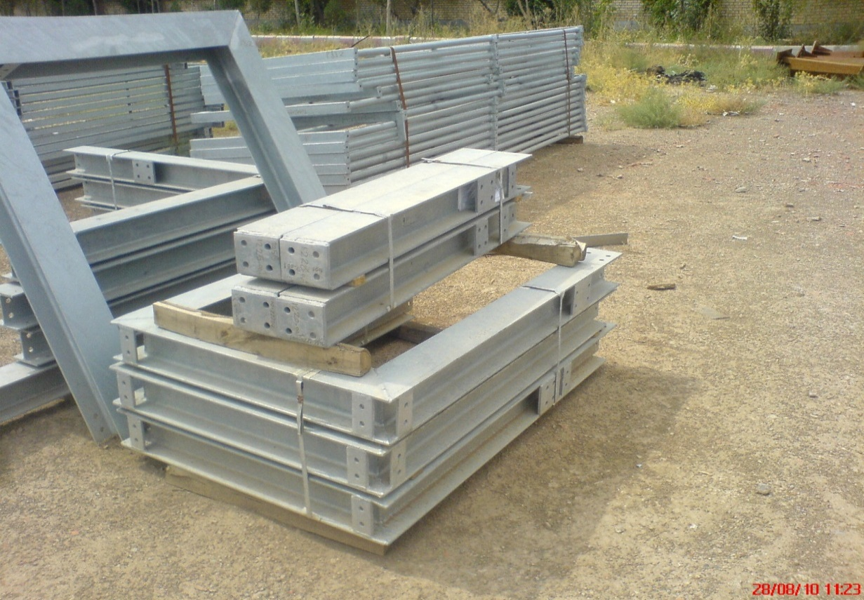

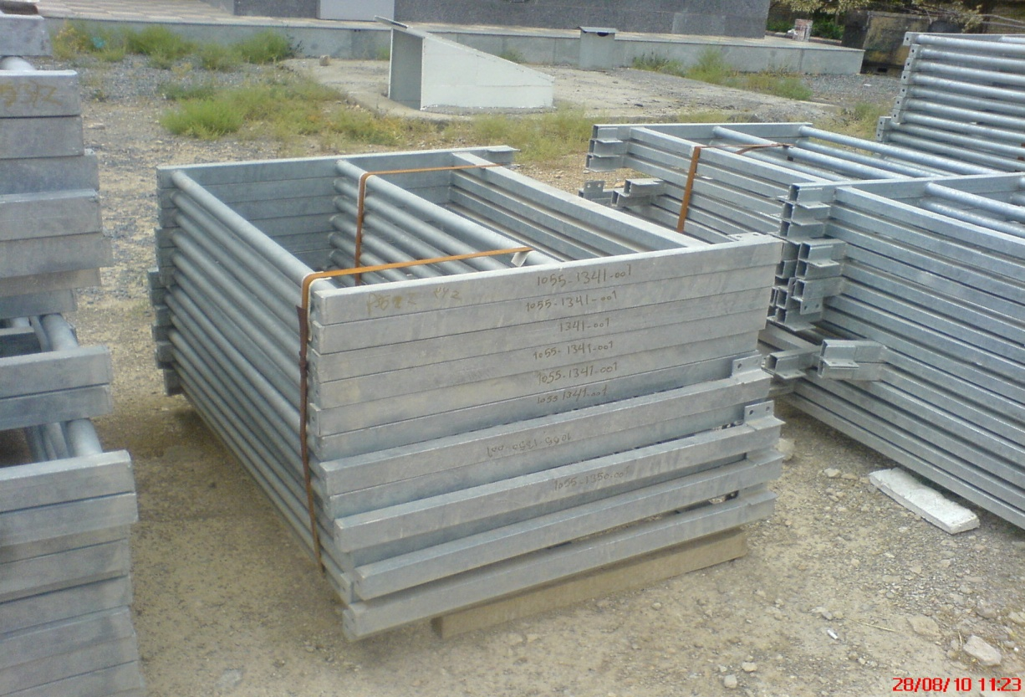

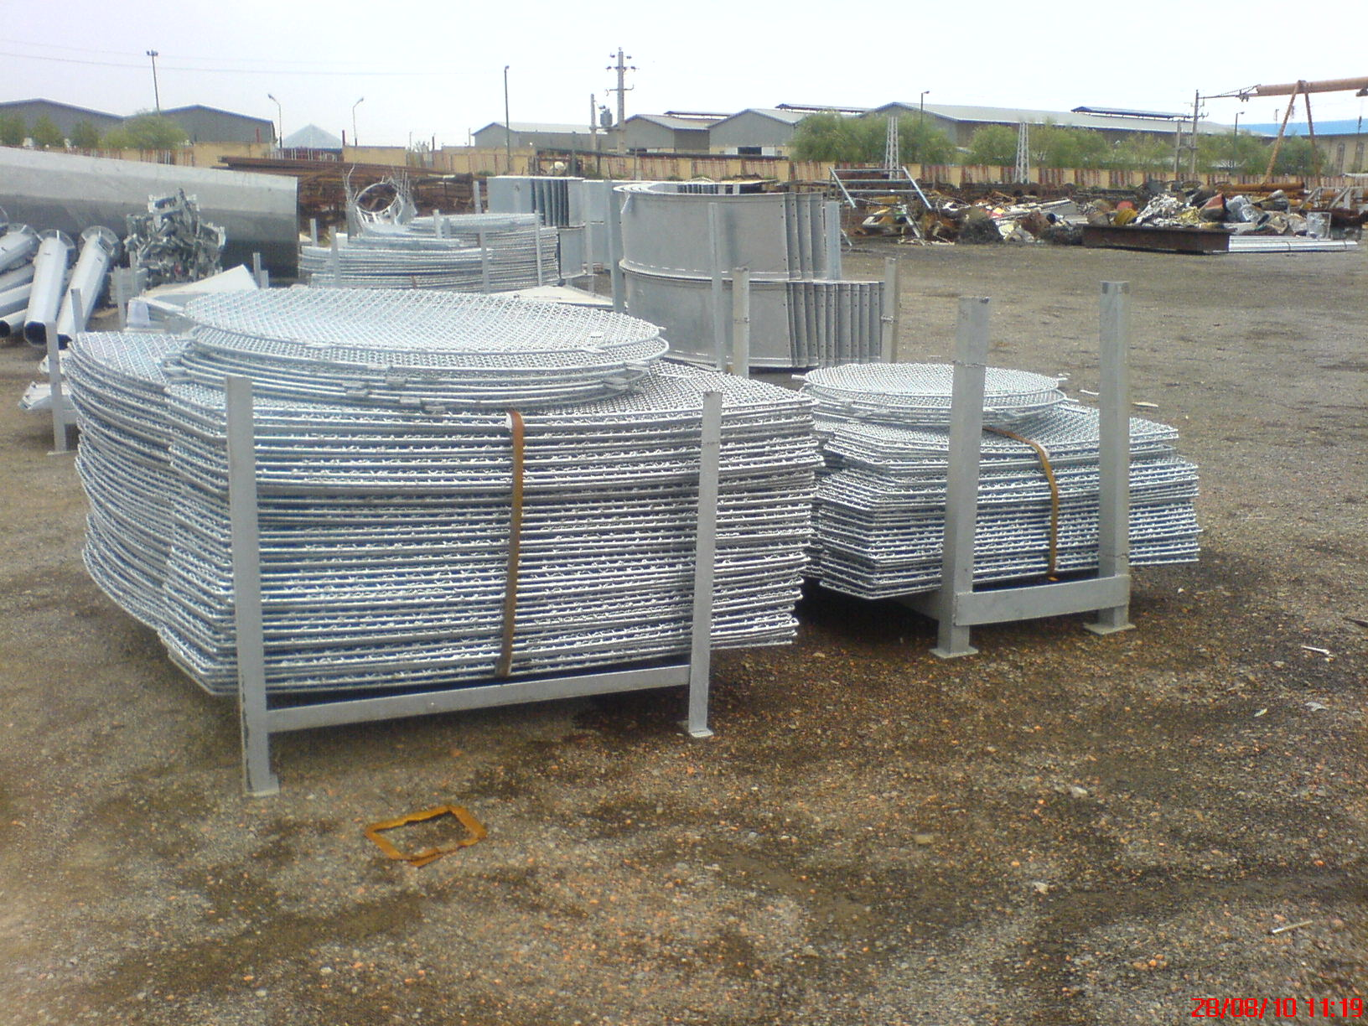

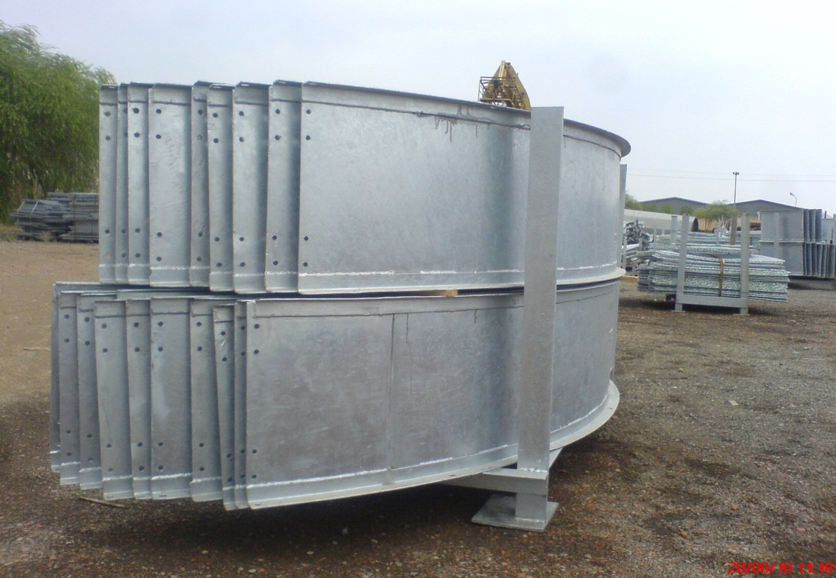

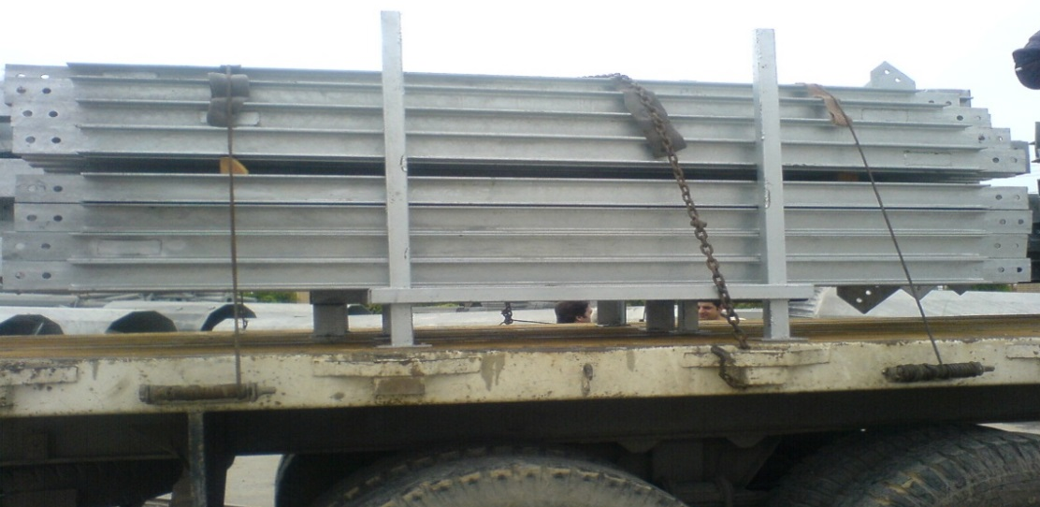

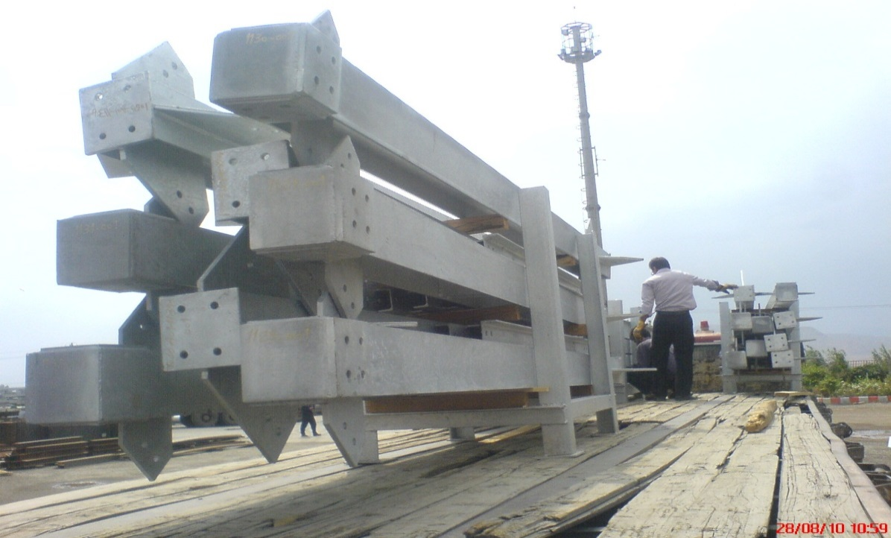

8. Small Parts, Tools and spare Parts
Small loose parts shall be tagged and packed in a separate, sturdy wooden box; any such box shall be shipped with main equipment being securely attached to the main skid or within the main box.

Packing, Marking & Shipping Procedure for Compressor Skid

- Purpose

- General

- Nude Packed

- Boxes

- Packaging Materials

- Packing Methods and Prohibited Materials

- Protection Methods

- Marking Instructions

- Sealing Of Packages

- Purpose
This specification defines the minimum requirements and procedures for protecting equipment and materials during export shipment. It is intended to serve as a minimum requirement guide and will depend on use of Vendor’s judgment to determine if physical characteristics of items being packed will require more than these minimum standards to ensure safe arrival at their destination. When portions of these instructions are not applicable, the best commercial export packing methods to attain comparable protection shall be used. In all cases, materials will be prepared for shipment to withstand multiple handling, outside storage, exposure to rain, dust and salt spray.
- General
  - Scope
This instruction providing the packing and marking information is applicable to the Gohar Ofogh Industrial park- made by DELTA GMBH. The equipment shall be nude packed and spare parts shall be packed by wooden box.
- Nude Packed
  - Firstly, all instruments, Junction Boxes and Local Control Panels will be bubble wraped the equipment by plastic film and firm the film by adhesive tape to protect the Instruments and Boxes from steam.
  - It is designed with sufficient flexibile and indispensible major and super parts, pulled tightly by steel wire rope from above to avoid it rolling along moving.
  - Skids will be shipped as Nude pack and on their own supports in Container.

- Boxes
The construction and reinforcing of a wooden box depends upon the size of the box and the weight of its contents. Following are minimum requirements for various boxes.
(a)To 140 kg
Box shall be made of a minimum of 1.5 cm nominal lumber or 0.7 cm plywood sheathing, 4x 8cm nominal skids, and 2x 8cm frames with completely cleated ends. All boxes over
22.6 kg to be skidded.
(b)140 to 450 kg
Box shall be made of a minimum1.8 cm nominal lumber, or 0.9 cm plywood sheathing with 4 cm nominal decking and 4 x 8 cm nominal skids. Box to have cleated ends, with 4 x 8 cm or 2x 8 cm battens. Plywood boxes shall be constructed with uprights set on 60.9 cm centers. All seams should be backed with an upright or brace.
- 450 to 4500 kg
Box shall be constructed with a 8 x 8 cm nominal skid base, 4 cm nominal floor, 2cm nominal lumber or 1 cm plywood sheathing, with cleated ends. Top and sides to be diagonally braced, with corner posts, bracing and stiffening members of 4 x 8 cm nominal lumber. Load bearing members shall be placed as needed. Top and upper edge members of large or heavy boxes shall be reinforced with 8 x 8 cm or 10x 10 cm spreaders to prevent crushing of boxes when lifting-slings are used.
above 4500 kg
Case to be built with 14x14cm nominal long. beams, transverse runners also size on 14x14cm nominal. Plywood of 1cm thickness to cover over the long. beams to form deck side of the case base,and set dunnage timbers sized 14x14cm nominal on deck at load bearing positions to sustain the cargoload.
Side Walls constructin sort to solid timber 38x89mm frame structure with 1cm plywood cladding. Top stretcher timber sized 90x90mm to be placed ontop to prevent the inwards crushing when lifting sling are used.
Plywood of 1cm thickness covers downtop alongside the top stretcher timbers with battens between to form the lid construction. Spare parts and interconnecting pipe spools will be shipped in wooden box.
- Packaging Materials

  - Lumber shall be new, sound and well-seasoned, knots are permitted provided they are sound and tight and do not exceed one-third of the board width. Knots shall be located as not to cause railing interference which would result in structural weakness. Lumber shall be certified completely free from bark, insect infestation and decay.

- Packing Methods and Prohibited Materials
  - When consolidating materials in a box or crate, items shall be packed or nested to reduce volume as much as possible. All items shall be braced and/or cushioned as necessary within the container to prevent damage from shock, vibration and rough handling. Finished and painted surfaces will be protected from abrasion.
  - Small items and spare parts not secured to main item shall be separately boxed with box properly identified as to its main item.
  - It is necessary that all shipping containers be tightly packed. Where void appear, they will be filled with cushioning material or securely blocked off to prevent any movement of contents. Wood wool may be freely used for packing but restricted materials include:
    - Used sacks and sacking - including jute and Hessian.
    - Hay and straw - including straw envelopes.
    - Rice Husks.
    - Agricultural waste products.
    - Any packing materials which may have come into contact with animals or soil.
    - Grass and similar matting.
    - Articles of peat.
    - Used wool packs and wool packers.

- Protection Methods
  - Flange openings shall be coated with a layer of anti-corrosive material then closed off with wooden, metallic or plastic, fastened in place with tape or non-rusting devices.
  - Caution shall be exercised in applying preservatives so that items fabricated of leather, mica, rubber, and similar material, are not coated with the preservative compound because of the damaging effect on such items.
  - Shipping containers shall be constructed and sealed in a manner that shall provide maximum protection from pilferage and theft. After rust-treating and sealing, equipment shall be boxed and crated as specified in Section 4 of this specification.
  - No equipment & materials should be dispatched by vendor unless vendor acquires inspection release note (IRN) through purchaser's which shall be issued by owner’s assigned inspection agency (TPI).

- MARKING

  - Marking shall comply with the requirements of the customer.

  - All packages will have shipping mark. The size of letters will be normally one inches high. Markings of small shipping boxes and units will be in proportion to their size.
- Color : Black – Position : both side, - Size : 15cm x 15cm or over

  - The appropriate instruction for handling, transport and storage will be stenciled on outside of the package.

- Sealing Of Packages

  - Upon completion of packaging in accordance with the relevant instructions, required sealing compatible with the type of package shall be applied by VENDOR. For materials packed in wooden cases, boxes, crates, pallets, and similar types of packages, sealing shall be done by using straps or special wires.

Packing, Marking & Shipping Procedure for Chiller

