STYRENE PARK OFFSITE

Document Title:
Test Procedure For Air Condenser and Chiller
R0 | 20-08-2024 | IFA | A. PARSAFAR | A. SHADMAND | M.HEIDARZADEH
Rev. | Issued Date | DESCRIPTION | PREPARED | CHECKED | APPROVED

REVISION RECORD SHEET
Page | Revisions |  |  |  |  |  |  |  | Page | Revisions
Page | R0 | R1 | R2 | R3 | R4 | R5 | R6 |  | Page | R0 | R1 | R2 | R3 | R4 | R5 | R6
1 | X |  |  |  |  |  |  |  | 41 | X
2 | X |  |  |  |  |  |  |  | 42 | X
3 | X |  |  |  |  |  |  |  | 43 | X
4 | X |  |  |  |  |  |  |  | 44 | X
5 | X |  |  |  |  |  |  |  | 45 | X
6 | X |  |  |  |  |  |  |  | 46 | X
7 | X |  |  |  |  |  |  |  | 47 | X
8 | X |  |  |  |  |  |  |  | 48 | X
9 | X |  |  |  |  |  |  |  | 49 | X
10 | X |  |  |  |  |  |  |  | 50 | X
11 | X |  |  |  |  |  |  |  | 51 | X
12 | X |  |  |  |  |  |  |  | 52 | X
13 | X |  |  |  |  |  |  |  | 53 | X
14 | X |  |  |  |  |  |  |  | 54 | X
15 | X |  |  |  |  |  |  |  | 55 | X
16 | X |  |  |  |  |  |  |  | 56 | X
17 | X |  |  |  |  |  |  |  | 57 | X
18 | X |  |  |  |  |  |  |  | 58 | X
19 | X |  |  |  |  |  |  |  | 59 | X
20 | X |  |  |  |  |  |  |  | 60 | X
21 | X |  |  |  |  |  |  |  | 61 | X
22 | X |  |  |  |  |  |  |  | 62 | X
23 | X |  |  |  |  |  |  |  | 63 | X
24 | X |  |  |  |  |  |  |  | 64 | X
25 | X |  |  |  |  |  |  |  | 65 | X
26 | X |  |  |  |  |  |  |  | 66 | X
27 | X |  |  |  |  |  |  |  | 67 | X
28 | X |  |  |  |  |  |  |  | 68 | X
29 | X |  |  |  |  |  |  |  | 69 | X
30 | X |  |  |  |  |  |  |  | 70 | X
31 | X |  |  |  |  |  |  |  | 71 | X
32 | X |  |  |  |  |  |  |  | 72 | X
33 | X |  |  |  |  |  |  |  | 73 | X
34 | X |  |  |  |  |  |  |  | 74 | X
35 | X |  |  |  |  |  |  |  | 75 | X
36 | X |  |  |  |  |  |  |  | 76 | X
37 | X |  |  |  |  |  |  |  | 77 | X
38 | X |  |  |  |  |  |  |  | 78 | X
39 | X |  |  |  |  |  |  |  | 79 | X
40 | X |  |  |  |  |  |  |  | 80-110 | X

NDT Procedure & Weld/NDT Map for Air cooler

- PURPOSE
- SCOPE
- REFERENCES
- DEFINITION
- SURFACE PREPARATION
- DRYING AFTER PREPARATION
- TECHNIQUES
- CALIBRATION
- EXAMINATION
- INTERPRETATION
- ACCEPTANCE CRITERIA
- POST-EXAMINATION CLEANING
- DOCUMENTATION
- CERTIFICATION
- PERSONNEL QUALIFICATION
- Repair and re-examination of defective weld
RADIOGRAPHIC TEST
- PURPOSE
- SCOPE
- REFERENCE
- DEFINITION
- GENERAL REQUIREMENTS
- SURFACE PREPARATION
- EQUIPMENT USED
- RADIOGRAPHIC DENSITY
- IDENTIFICATION OF RADIOGRAPHS
- GEOMETRICAL UNSHARPNESS
- FILM PROCESSING
- RADIOGRAPHIC TECHNIQUE
- INTERPRETATION OF RADIOGRAPHS
- EVALUATION OF INDICATIONS
- ACCEPTANCE CRITERIA
- DEFECT REMOVAL
- REPORTS
- FILM STORAGE

ULTRASONIC TEST
- PURPOSE
- SCOPE
- REFERENCES
- DEFINITION
- PERSONNEL QUALIFICATION
- GENERAL REQUIREMENTS
- EQUIPMENT USED
- WELD EXAMINATION
- Surface preparation
- Examination
- Evaluation
- ACCEPTANCE CRITERIA
- EXAMNATION REPORT (APPENDIX 1)

- PURPOSE
This procedure defines the methods of performance, the examination conditions and the precautions to be taken when liquid penetrant examination is carried out of Air-cooled heat exchangers of “
Toase ehe Park Sanati Gohar Ofogh Petrochemical Co.
CONCEPTUAL, BASIC and DETAIL DESIGN ENGINEERING OF STYRENE PARK OFFSITE "

2.0. SCOPE
This procedure is applicable for carry out testing on welded joints of header boxes of air-cooled heat exchanger and Materials, shapes, or sizes to be examined and the extent of examination are according to NDT. CHECK LIST & NDT MAP of project.
In principle, a liquid penetrant is applied to the surface to be examined and allowed to enter discontinuities. All excess penetrant is then removed, the part is dried, and a developer is applied. The developer function both as a blotter to absorb penetrant that has been trapped in discontinuities, and as a contrasting background to enhance the visibility of penetrant indications. The dyes in penetrants are either color contrast (visible under white light) or fluorescent (visible under ultraviolet light).

3.0. REFERENCES
3.1. ASME Sec.V- edition 2010
3.2. NDT. CHECK LIST & NDT MAP: EI027-DMF-VD-QC-PRO-023
3.3. ASME section VIII div.1 edition 2010 addendum 2011 shall be added
3.4 ASME B31.3
3.5 ASTM E165

4.0. DEFINITION
4.1. Relevant Indications:
Indications with major dimensions greater than 1/16 (1.5 mm)
4.2. Linear Indications:
An indication having a length greater than three times the width.
4.3. Rounded Indications
An indication of circular or elliptical shape with the length equal or less than three times the width.
5.0. SURFACE PREPARATION
5.1. In general, satisfactory results may be obtained when the surface of the part is in the as welded, as-rolled, as-cast, or as-forged condition. Surface preparation by grinding, machining,

Or other methods may be necessary where surface irregularities could mask indications.

5.2. Prior to each liquid penetrant examination, the surface to be examined and all adjacent areas within at least 1 in(25mm) shall be dry and free of all dirt, grease, lint, scale, welding flux, weld spatter, paint, oil, and other extraneous matter with using Hand tool cleaner like Brush.

Oil, paint, grease shall be cleaned with a solvent.

6.0. DRYING AFTER PREPARATION

After cleaning, drying of the surfaces to be examined shall be accomplished by normal evaporation or with forced hot or cold air. A minimum period of time shall be established to ensure that the cleaning solution has evaporated prior to application of the penetrant.
The surface of the part to be processed shall not be below 40°F (5°C) nor above 125°F(52°C). The air pressure shall not exceed 30psi (206KPa).

7.0. TECHNIQUES

7.1. Technique for Standard Temperature

As a standard technique, temperature of the penetrant and the surface of the part to be processed shall not be below 50ºF (10ºC) nor above 125ºF (52ºC) throughout the examination period. Local heating or cooling is permitted provided the part temperature remains in the range of 50ºF to 125ºF (10ºC to 52ºC) during the examination.

7.2. Techniques for Nonstandard Temperatures

When it is not practical to conduct a liquid penetrant examination within the temperature range of 40°F to 125°F (5°C to 52°C), the examination procedure at the proposed lower or higher temperature range requires qualification of the penetrant materials and processing in accordance with Mandatory Appendix III of this Article.

7.2. Technique Restriction

Fluorescent penetrant examination shall not follow a color contrast penetrant examination. Intermixing of penetrant materials from different families or different manufacturers is not permitted. A retest with water washable penetrants may cause loss of marginal indications due to contamination.
Either a color contrast (visible) penetrant or a fluorescent shall be used with water washable technique.

8.0. CALIBRATION
Light meters, both visible and fluorescence (black) light meters shall be calibrated at least once a year or whenever the meter has been repaired. If meters have not been in use for one year or more, calibration shall be done before being used.
9.0. EXAMINATION
9.1. Penetrant Application
The penetrant should be applied by spraying.
9.2. Penetration (Dwell) Time
Penetration (dwell) time is critical. The minimum penetration time shall be as required in following table (1) or as qualified by demonstration for specific applications.
9.3. Excess Penetrant Removal
After the specified penetration (dwell) time has elapsed, any penetrant remaining on the surface shall be removed, taking care to minimize removal of penetrant from discontinuities.
Excess penetrant shall be removed with a water spray. The water pressure shall not exceed 50 psi (350KPa) (According to ASME Sec V T-673.1), and the water temperature shall not exceed 110ºF(43ºc).
9.4. Fluorescent Penetrants.

With fluorescent penetrants, the process is essentially the same as in T-676.3, with the exception that the examination is performed using an ultraviolet light, called black light. The examination shall be performed as follows:

(a) It shall be performed in a darkened area.

(b) Examiners shall be in a darkened area for at least 5 min prior to performing examinations to enable their eyes to adapt to dark viewing. Glasses or lenses worn by examiners shall not be photosensitive.

(c) Black lights shall achieve a minimum of 1000W/cm2 on the surface of the part being examined throughout the examination.

(d) Reflectors and filters should be checked and, if necessary, cleaned prior to use. Cracked or broken filters shall be replaced immediately.

(e) The black light intensity shall be measured with a black light meter prior to use, whenever the light’s power source is interrupted or changed, and at the completion of the examination or series of examinations.

9.5. Drying After Excess Penetrant Removal

For the water washable technique, the surface may be dried by blotting with clean materials or by using circulating air, provided the temperature of the surface is not raised above 125ºF(52ºC).
Material | Form | Type of Discontinuity | Minimum Dwell Times (minutes)  * Note1
Material | Form | Type of Discontinuity | Penetrant | Developer
Steel | Welds | Cold shuts, Porosity, Lack of fusion, Cracks (all forms) | 5 | 10

Table (1) Ref.: TABLE T-672- ASME SEC.V ARTIVLE 6

*Note1: For temperature range from 50ºF to 125ºF (10ºC to 52ºC)

9.6.1. For temperatures from 5ºC to 10ºC, minimum penetrant dwell time shall be 2 times the value listed.

9.7 Developing

9.7.1. The developer shall be applied as soon as possible after penetrant removal; the time interval shall not exceed that established in the procedure. Insufficient coating thickness may not draw the penetrant out of discontinuities conversely, excessive thickness may mask indications.

With color contrast penetrants, only a wet developer shall be used. With fluorescent penetrants, a wet or dry developer may be used.

9.7.2. Developing time for final interpretation begins immediately after the application of a dry developer or as soon as a wet developer coating is dry. The minimum developing time shall be as required by Table.1 and minimum 10 minutes.

9.7.3. Developer Application

The developer should be applied by spraying.

9.8. Minimum time periods between steps and drying aids is 10 minutes.

Maximum time periods between steps and drying aids is 30 minutes.
10.0. INTERPRETATION

Final interpretation shall be made within 10 to 60 min. after the requirement of procedure are satisfied. Using a 1000 lux light All relevant indications shall be recorded and evaluated as per ASME sec. VIII Div. 1.

11.0. ACCEPTANCE CRITERIA

Liquid penetrant techniques shall be judged unacceptable when the examination exhibits any indication in excess of the limits specified below :( According to ASME Sec. VIII Div.1 Appendix8):

(I)-Any type of crack

(II)- Relevant linear indication

(III)-Relevant rounded indications greater than 3/16 in. (5mm)

(IV)-Four or more relevant rounded indications in a line separated by 1/16 in (1.5 mm) or less (edge to edge).
12.0. POST-EXAMINATION CLEANING

When post-examination cleaning is required by the procedure, it should be conducted as soon as practical after evaluation.

After evaluation the remaining material to be removed by Proper solvent or water and clean cloth.
13.0. DOCUMENTATION
13.1. Recording of Indication
(a) Non reject able Indication
Non rejectable indications shall be recorded as specified by the referencing Code Section.
(b) Reject able Indications
Reject able indications shall be recorded. As a minimum, the type of indications (linear or rounded), location and extent (length or diameter or aligned) shall be recorded.

13.2. Examination Report
For each examination, the following information shall be recorded (As a minimum, the examination report shall include required information, described in article 6. ASME section V)

Procedure identification and revision

Liquid penetrant type (visible or fluorescence)

Type (number or letter designation) of each penetrant, penetrant remover, and developer used.

Examination personnel identify and, qualification level

Map or record of indications Per T-691 ASME SEC.V

Material and thickness

Lighting equipment

Date and time examination were performed.

The report shall be signed and dated by the qualified and certified level II/III.

Examination report shall be prepared and furnished to the client.
14. CERTIFICATION

After examination a liquid penetrant examination report shall be filled out, in accordance with requirements of part T.693 of ASME Code sec. V
15. PERSONNEL QUALIFICATION

Operators shall be qualified and certified in accordance with SNT-TC-1A.

All NDE shall be done by personnel certified to SNT-TC-1A level II /III.

15.1. Performance Demonstration

When be required is according to ASME SEC.V Article 14. T-1423
16. Repair and re-examination of defective weld

Any weld defects shall be fully chipped out, and the repair cavity shall be inspected by the liquid penetrant method. The repair welding shall be re-examined after the required heat treatment.

17.0. PURPOSE
This procedure describes the procedure for radiographic examination of welds of Air-cooled heat exchangers that will be procured in “Toase-ehe Park Sanati Gohar Ofogh Petrochemical Co. CONCEPTUAL, BASIC and DETAIL DESIGN ENGINEERING OF STYRENE PARK OFFSITE"

18.0. SCOPE
This procedure is applicable for carry out testing on flange to pipe or obround butt welds of header boxes of air cooled heat exchanger and materials, shapes, or sizes to be examined and the extent of examination are according to NDT. CHECK LIST & NDT MAP of project .
19.0. REFERENCES
19.1. API-661-Edition 2006
19.2.ASME sec V-Edition 2010
19.3.ASNT-TC-1A-Edition 2006
19.4. ASME Section VIII Div.1 edition 2010 addendum 2011 shall be added.

20.0. DEFINITION
20.1. I.Q.I: Image Quality Indicator
21.0. GENERAL REQUIREMENTS
21.1. Particular instruction
The particular instruction shall refer to the general examination specification
- The areas of the part to be examined,
- Materials and thickness ranges to be radiographed,
- Isotope used
- Film brand or type to be used,
- Screens to be used,
- Acceptance criteria.
21.2. Operator qualification
Operators shall be qualified and certified in accordance with
SNT-TC-1A-Edition 2006 last applicable edition.
All NDE shall be done by or under the supervision of personnel certified to
SNT- TC-1A-Edition 2006 level II/III.
22.0. SURFACE PREPARATION
22.1. Materials
Surfaces shall satisfy the requirements of the applicable material specifications, with
additional conditions if necessary. In that case, surface irregularities shall be removed by any
appropriate means so as not to mask indications or interfere with them.

22.2. Welds
The welds ripples or weld surface irregularities on both the inside (where accessible) and
outside shall be removed by any suitable process to such a degree that the resulting
radiographic image due to any irregularities cannot mask or be confused with the image of
any discontinuity.
The finished surface of all butt-welded joints must be smoothly blended into the base material
within the limits specified in the referencing code section (ASME SEC.VIII-Edition 2012-U-35).
Permitted reinforcement on each face as following:
23.0. EQUIPMENT USED
23.1. Film selection
Radiographs shall be made using industrial radiographic film ASTM type (Very fine grain
film must be use (KODAK MX125) with 10Cm width).
23.2. Intensifying screens
Intensifying lead screens may be used except when otherwise specified. Good screen-film
contact is essential to get a good result. Thickness of front & back screen: 0.1 mm
23.3. Back scatter protection
A back lead layer has to be used in order to:
-reduce the scattering of the radiations,
-avoid secondary back-scattered radiations
This back lead layer shall be placed on the back of each film holder / cassette.
A lead symbol "B" with dimensions of 13 mm (1/2 inch) in height, and 1, 6 mm (1/16 inch) in
thickness has to be attached on the back of the film holder.
If a light image of the "B" appears on a darker background of the radiograph, protection from
backscatter is insufficient and the radiograph shall be considered unacceptable.
A dark image of the "B" on a lighter background is not cause for rejection.
Intensifying and back lead screens shall be perfectly clean, free from scratches, crimps,
blemishes or folds.
23.4. Irradiation equipment
23.4.1. Radioactive sources
Generally, the minimum thickness for which radioactive sources may be used is as less thickness may be radiographed with these sources if it is demonstrated that the required sensitivity can be obtained.
The maximum thickness for the use of radioactive sources is primarily dictated by exposure time. Therefore upper limits are not shown.
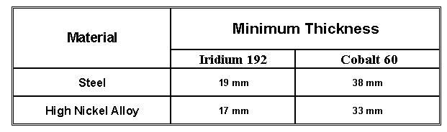
23.4.2. Special conditions
When an examination is performed, which strays from the conditions fixed above, or when other sources are used, a procedure for the particular examination must be issued.
In any case, the radiographic sensitivity depends essentially on:
-Film selection,
-Intensifying screen selection,
-Geometrical un sharpness,
-Film density.

23.5. Image quality indicators (Penetrometers)
23.5.1. Sensitivity of the radiographic technique (T 283)
The sensitivity of the radiographic technique shall be sufficient to display the penetrometer image and the specified wire of the penetrometer which are essential indications of the image quality of the radiograph. It shall also allow displaying the numbers and letters used to identify the films.
All radiographs shall show appropriate image quality indicators (penetrometers), in compliance with ASME codes. However the sensitivity shall not be lower than 2% of the thickness.
23.5.2. Selection of the penetrometers
23.5.2.1. Material
The penetrometers shall be made in a material with similar absorption coefficient to that of the material to be radiographed.
23.5.2.2. General dimensions of the penetrometers
The penetrometers shall be of the hole or wire type and its dimensions and geometry are given by the figures in 7.5.2.3.
Variations of length and /or width are accepted.
Other penetrometers may be used but require a special qualification and an agreement by contract.
23.5.2.3. Identification of the penetrometers(s)
The penetrometer shall be identified by lead numbers located in an appropriate area.

PENETRAMETERS WITH WIRE
Design for wire type IQI (SETA&B)-Alternate 1(Fig. 3 SE 747 Art. 22 ASME Sec. V)
Design for wire type IQI (SETA&B)-Alternate 2(Fig. 4 SE 747 Art. 22 ASME Sec. V)

7.5.2.4. PENETRAMETER DESIGNATION AND WIRE DIAMETERS
The following table shows the diameter of the wires of the different types of penetrometers.
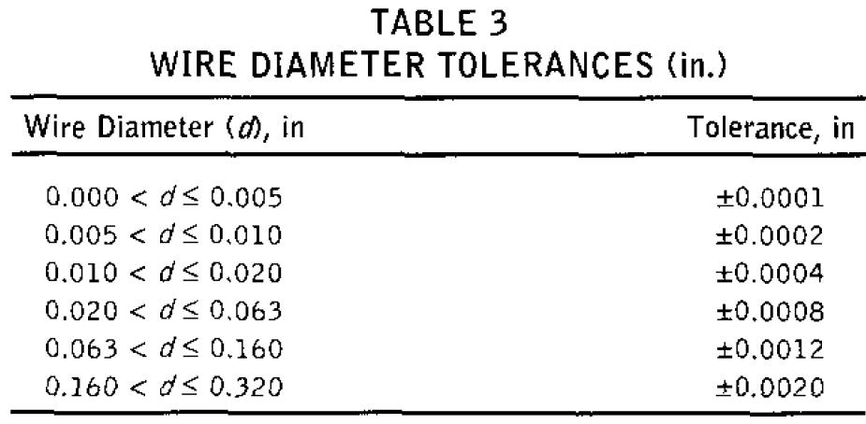
23.5.2.5. Selection of the penetrometer versus the thickness to be radio graphed
The tables on the next page give the selection elements of the penetrometer and the diameter of the characteristic hole or wire versus the thickness to be radio graphed.

23.5.2.5.1. Welds with reinforcements:
The thickness on which the penetrometer is based is the nominal single wall thickness plus the estimated weld reinforcement not to exceed the maximum permitted (according to section 7.2). Backing rings or strips shall not be considered as part of the thickness in penetrometer selection. The actual measurement of the weld reinforcement is not required.
23.5.2.5.2. Welds without reinforcements:
The thickness on which the penetrometer is based is the nominal single wall thickness. Backing rings or strips shall not be considered as part of the weld thickness in penetrometer selection.
23.5.2.6. Placement of penetrometers (T 277.1)
The penetrometer(s) shall be placed on the weld so that the length of the wires is perpendicular to the length of the weld. The identification numbers and lead letter "F", when used, shall not be in the area of interest, except for the conditions described in the above mentioned two cases.
For the material other than welds, the penetrometer and its identification, as well as the letter "F" when used, shall be placed in the area of interest.
If for reasons if inaccessibility, it is impossible to place the penetrometer on the source side, it shall be placed on the film side on the part and a lead letter "F", at least as high as the identification number to the penetrometer, shall be placed adjacent to or on the penetrometer.

Selection of the penetrometer
When the shape of the part or its dimensions do not allow to place the penetrometer(s) on the part, the penetrometer(s) may be placed on a separate block provided that the block:
-Is made of a material, radio graphically similar to the part,
-Has the same thickness as the part being radiographed,
-Is located as close as possible to the material being radiographed
The block dimensions shall exceed the penetrometer dimensions such that the outline of at least three sides of the penetrometer image shall be visible on the radiograph.
23.5.2.7. Number of penetrometers
a) For components where one or more film holders are used for an exposure, at least one penetrometer image shall appear on each radiograph. If the density of the radiograph anywhere through the area of interest varies by more than minus 15% or plus 30% from the density through the body of the penetrometer, within the minimum/maximum allowable density ranges specified in subparagraph 9.2, then an additional penetrometer shall be used for each exceptional area or areas and the radiograph retaken. When calculating the allowable variation in density, the calculation may be rounded to the nearest 0.1.
b) If the requirements of 7.5.2.7.a) and 8.2. are met by using more than one penetrometers, one shall be representative of the lightest area of interest and the other the darkest area of interest ; in that case, the intervening densities on the radiograph shall be considered as acceptable.
24.0. RADIOGRAPHIC DENSITY
24.1. Equipment used (T 262)
The density of the radiographic film shall be verified by means of
-Either a densitometer,
-Or a step wedge comparison film
The densitometer (or the step wedge comparison film) shall be verified by means of a calibrated step wedge film traceable to a national standard. The densitometer will be calibrated according to PI 022.
24.2. Limitation of the radiographic density (T 282.1)
The transmitted film density through the radiographic image of the body of the appropriate penetrometer and the area of interest shall be:
-For single film technique = 2.0. Minimum for radiographs made with Gamma-ray sources,
-For composite viewing of multiple film exposures, each film of the composite set shall have a minimum density of 1.3.
The maximum density shall be 4 for either single or composite viewing.
A tolerance of 0.05 in density is allowed for variations between densitometer readings.

25.0. IDENTIFICATION OF RADIOGRAPHS
25.1. System of film identification (T 224)
A system shall be used to produce permanent identification on the radiograph traceable to the order number, the part, the weld or the weld seam or part numbers as appropriate.
In addition, the date of the radiograph shall be plainly and permanently included on the radiograph. This identification system does not necessarily required that the information appear as radiographic images.
In any case, this information shall not obscure the area of interest.
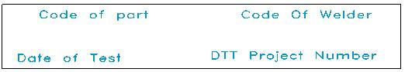
  - Film location markers (T 275)
Location markers, which are to appear as radiographic images on the film, shall be placed on the part to be radiographed and not on the film holder / cassette.
Their locations shall be marked on the surface of the part being radiographed or on a map, in a manner permitting the area of interest on a radiograph to be accurately traceable to its location on the part for the required retention period of the radiograph, and provide evidence on the radiograph that the required coverage of the region being examined has been obtained.
26.0. GEOMETRICAL UNSHARPNESS (T 274)
26.1. Definition of geometrical unsharpness
The geometrical unsharpness is given by the equation:
with : 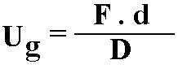
- Ug (mm) is the geometrical unsharpness,
- -F (mm) is the maximum projected dimension of the radiating source or focal spot in the plane perpendicular to the distance D from the weld or the part being radiographed,
- -D (mm) is the distance from source of radiation to weld or other object being radiographed,
-d (mm) is the distance from source side of weld or object being radiographed to the film.

26.2. Limitations of the geometrical unsharuness (T 285)
In the case of Section VIII the limitations below are only to be taken as a guide, the quality of the radiograph being judged according to the possibility of discerning the characteristic wire of penetrometer.
Material thickness (mm) | Ug maximum (mm)
Under 50 | 0.510
50 through 75 | 0.760
Over 75 through 100 | 1.020
Greater than 100 | 1.780
Note: Material thickness is the thickness on which the penetrometer is based.
27.0. FILM PROCESSING
The conditions of manual processing procedure are as follows:
a) Developer: temperature 20°C (68ºF), time = 5 or 8 min (according to the type of film);
b) Rinsing: stop bath = aqueous solution with 2% acetic acid, temperature 20°C (68ºF), time = 1 min;
c) Fixing: temperature 20°C (68ºF), time = 8 min
d) Washing: filtered water, room temperature, time = 10 min
e) Glazing: wetting agent, room temperature, time = 2 or 3 min immersions
f) Drying: Ambient temperature

28.0. RADIOGRAPHIC TECHNIQUE
A single-wall exposure technique shall be used for radiography whenever practical. When it is not practical to use a single-wall technique, a double-wall technique shall be used.
28.1. Single-wall technique
In the single-wall technique, the radiation passes through only one wall of the weld (material), which is viewed for acceptance on the radiograph. An adequate number of exposures shall be made to demonstrate that the required coverage.
SINGLE-WALL RADIOGRAPHIC TECHNIQUES (According to Fig.A-210-1 ASME SEC.V-Ed.2010)

28.2. Double -wall technique
12.2.1. For circumferential welds 4 in. (100 mm) outside diameter (3.5 in. nominal pipe size) or less, use a technique in which the radiation passes through both walls and both walls are viewed for acceptance on the same image. Unless otherwise specified, either elliptical or superimposed projections may be used. A sufficient number of views should be taken to examine the entire weld. Where design or access restricts a practical technique from examining the entire weld, agreement between contracting parties must specify necessary weld coverage.
12.2.2. For circumferential welds greater than 4 in.(100 mm) outside diameter (3.5 in. nominal pipe size), use a technique in which only single-wall viewing is performed.
A sufficient number of views should be taken to examine the entire weld. Where design or access restricts a practical technique from examining the entire weld, agreement between contracting parties must specify necessary weld coverage.
DOUBLE-WALL RADIOGRAPHIC TECHNIQUES (According to Fig.A-210-1 ASME SEC.V-Ed.2010)
29.0. INTERPRETATION OF RADIOGRAPHS
29.1. Prior to being presented to the Inspector for acceptance, the radiographs shall be examined and interpreted by the Manufacturer as complying with the referencing Code Section. The Manufacturer shall record the interpretation of each radiograph and disposition of the material examined on a radiographic interpretation review form accompanying the radiographs
29.2. Viewing facilities shall provide background lighting of an intensity that will not cause troublesome reflections, shadows, or glare on the radiograph. Equipment used to view radiographs for interpretation shall provide a variable light source sufficient for the essential penetrometer hole or designate wire to be visible for the specified density range. The viewing conditions shall be such that light from around the outer edge of the radiograph or coming through low-density portions of the radiograph does not interfere with interpretation.
29.3. The nightscope used shall allow the interpretation of films with 4.0 density.
29.4. The films shall be free from any processing defects, scratches or any other blemishes that could interfere with the interpretation.
13.5. Films shall be interpreted dry.

30.0. EVALUATION OF INDICATIONS
The evaluation of indications shall be made in terms of the acceptance criteria given in the applicable ASME Code Section and the particular specifications.
30.1. Questionable indications
Any questionable indication shall be considered as a defect, unless a re-examination using the same examination method or any other suitable non-destructive examination method can demonstrate that such a questionable indication is not a defect.
31.0. ACCEPTANCE CRITERIA
31.1. Terminology
a) Linear Indication:
Cracks, incomplete fusion, inadequate penetration, and slag are represented on the radiograph as linear indication in which the length is more than three times the width.

B) Rounded Indication:
Porosity and inclusions such as slag or tungsten are represented on the radiograph as rounded indication with a length three times the width or less.
These indications may be circular, elliptical, or irregular in shape; may have tails; and may vary in density.
C) Aligned Indications:
A sequence of four or more rounded indications shall be considered to be aligned when they touch a line parallel to the length of the weld drawn through the centre of the two outer rounded indications.

D) Thickness
The thickness of the weld excluding any allowable reinforcement. For a butt weld joining two members having different thicknesses at the weld, t is the thinner of these two thicknesses.
31.2. Acceptance Criteria:
The following discontinuities are considered unacceptable (According to ASME Sec.VIII- Div.1-UW-51-Ed.2010).
(I)Linear Indications:
I.1) any type of crack or zone of incomplete fusion or penetration.
I.2) any elongated slag inclusion which has a length greater than:
a. 6 mm for t up to 19mm
b. ⅓ t for t over 19mm to 57mm
c. 19 mm for t over 57mm
I.3) any group of aligned inclusions that have an aggregate length greater than t in a length 12 t , except when the distance between the successive imperfections exceeds 6L where L is the length of the longest imperfection in the group.
(II) Rounded Indications (According to ASME SEC.VIII Div.1-APP.4-ED.2010)
II.a) Relevant indications
Only those rounded indications which exceed the following dimensions shall be considered relevant.
II.a.1) 1/10 t for t less than 3mm
II.a.2) 0.4mm for t from 3mm to 6 mm, incl.
II.a.3) 0.8mm for t greater than 3mm to 50mm, incl.
II.a.4) 1.6mm for t greater than 50mm
II.b) Maximum size of rounded indication
The maximum permissible size of any indication shall be 1/4 t, or 4mm, whichever is smaller; except that an isolated indication separated from an adjacent indication by 25mm or more may be 1/3 t or 6mm, whichever is less. For t greater than 50mm the maximum permissible size of an isolated indication shall be increased to 10mm.
II.c) Aligned rounded indications
Aligned rounded indications are acceptable when the summation of the diameters of the indications is less than t in e length of 12t. (See fig 15.1.1). The length of groups of aligned rounded indications
and the spacing between the groups shall meet the requirements of Fig.51.2
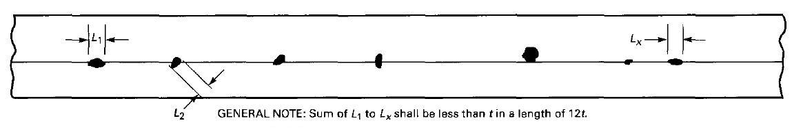
Fig.15.1.1. Aligned rounded indications

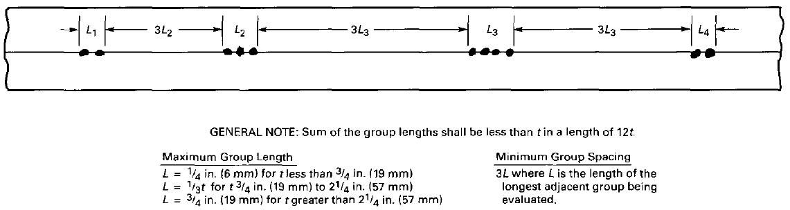
Fig.15.1.2. Groups of aligned rounded indications

II.d) Spacing
The distance between adjacent rounded indications is not a factor in determining acceptance or rejection, except as required for isolated indications or groups of aligned indications.
II.e) Rounded Indication Charts:
The rounded indications characterized as imperfections shall not exceed that shown in the charts.
The charts in Figs.15.1.3 through 15.1.8 illustrate various types of assorted, randomly dispersed and clustered rounded indications for different weld thicknesses greater than 1/8 in (3mm). These charts represent the maximum acceptable concentration limits for rounded indications. The charts for each thickness range represent full-scale 6 in.(150mm) radiographs, and shall not be enlarged or reduced. The distributions shown are not necessarily the patterns that may appear on the radiograph, but are typical of the concentration and size of indications permitted.
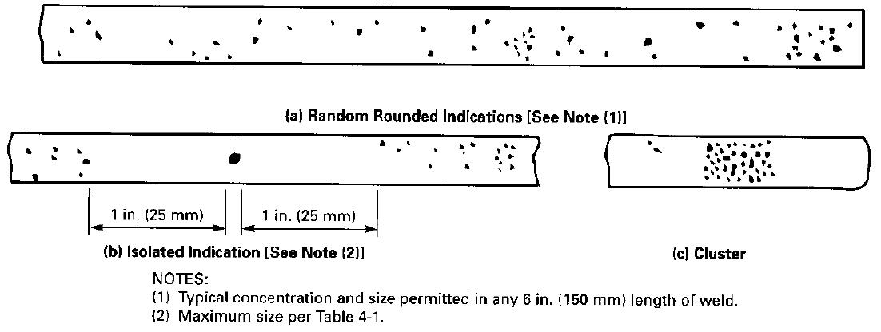
Fig.15.1.3. Charts for t equal to 1/8 in. to 1/4 in (3 to 6 mm) inclusive
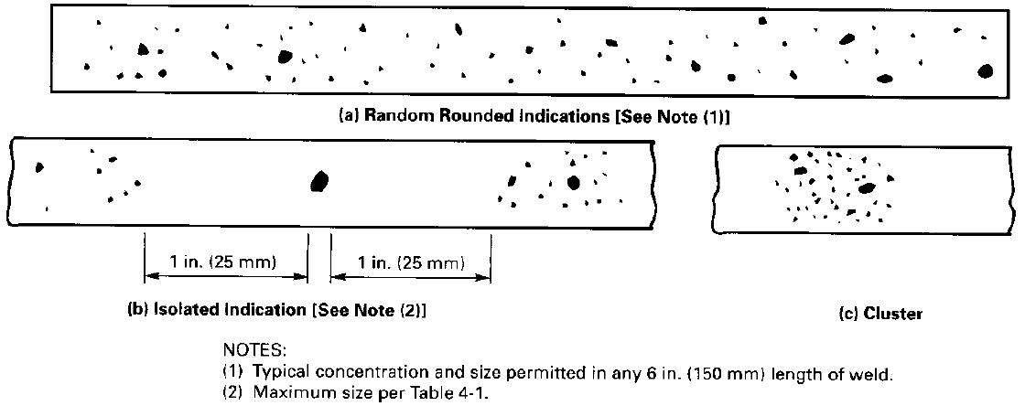
Fig. 15. 1. 4 . Charts for t equal to over 1/4 in. to 3/8 in. (6 to 10 mm) inclusive
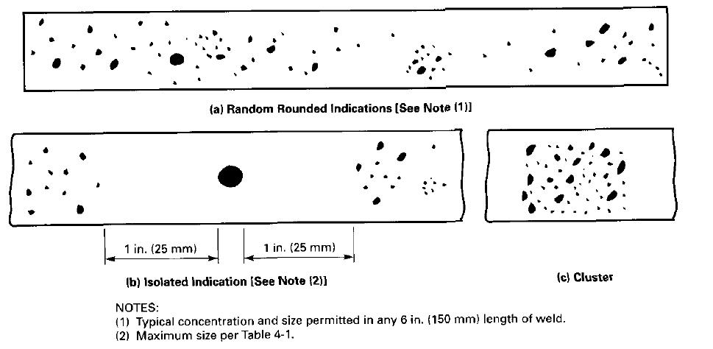
Fig. 15. 1. 5 Charts for t equal to over 3/8 in. to 3/4 in. (10 to 19 mm) inclusive

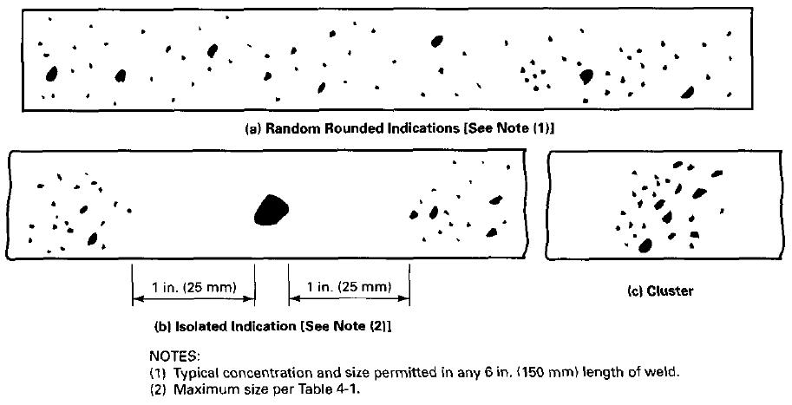
Fig. 15. 1. 6. Charts for t equal to over 3/4 in. to 2 in. (19 to 50 mm) inclusive
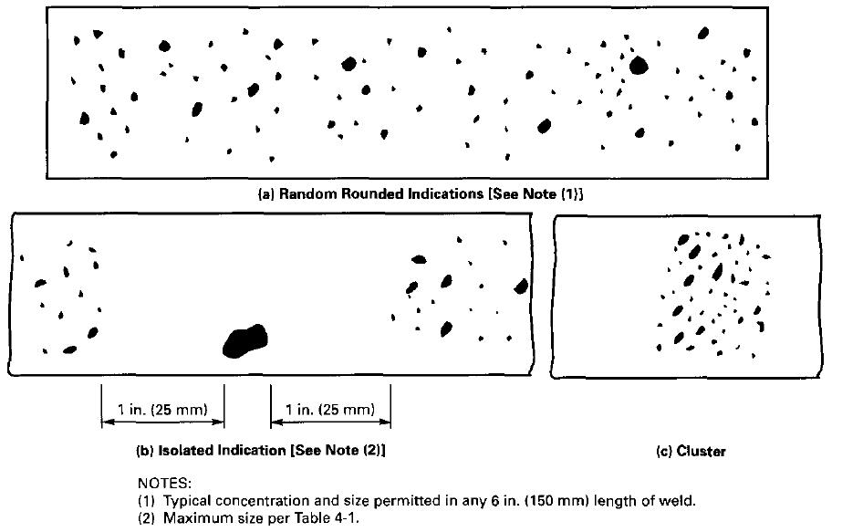
Fig. 15. 1. 7. Charts for t equal to over 2 in. to 4 in. (50 to 100 mm) inclusive
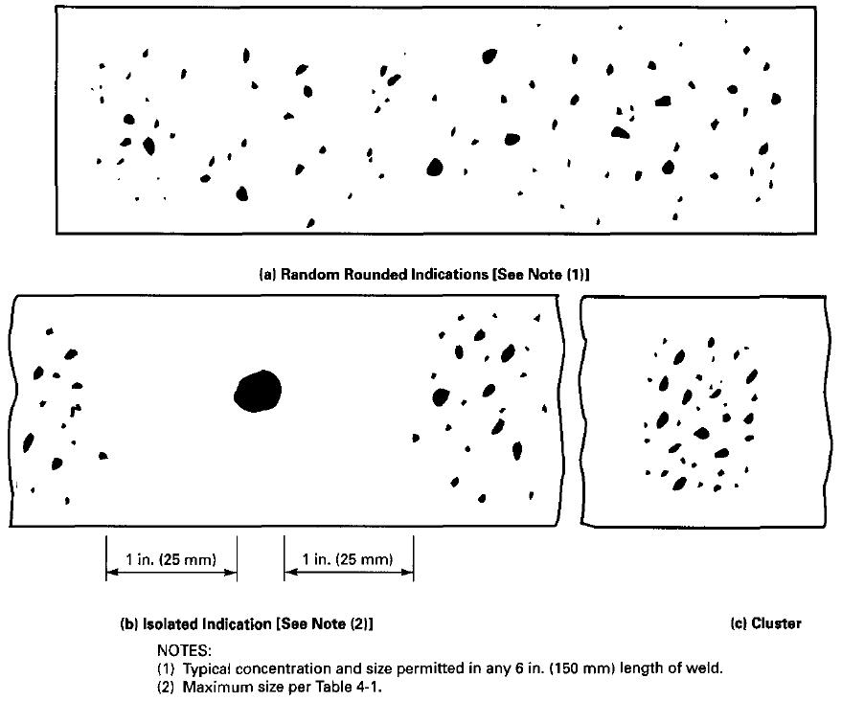
Fig. 15. 1. 8. Charts for t over 4 in. to 4 in. (100 mm) inclusive

II.f) Weld Thickness t less than 1/8 in(3mm)
For t less than 1/8 in.(3mm) the maximum number of rounded indications shall not exceed 12 in 6 in.(150mm) length of weld. A proportionally fewer number of indications shall be permitted in welds less than 6 in. (150mm) in length.

II.g) Clustered indications
The illustrations for clustered indications show up to four times as many indications in a local area, as that shown in the illustrations for random indications. The length of an acceptable cluster shall not exceed the lesser of 1 in. (25m) or 2t. Where more than one cluster is present, the sum of the lengths of the clusters shall not exceed 1in.( 25mm) in a 6 in.(150mm) length weld.

32. DEFECT REMOVAL
16.1. All discontinuities in excess to acceptance standard shall be removed suitable means and repaired according to approved procedure.
16.2. The repaired area shall be radio graphed after repair accordance with this specification; the repeated film shall be identified with lead letter ”R”.
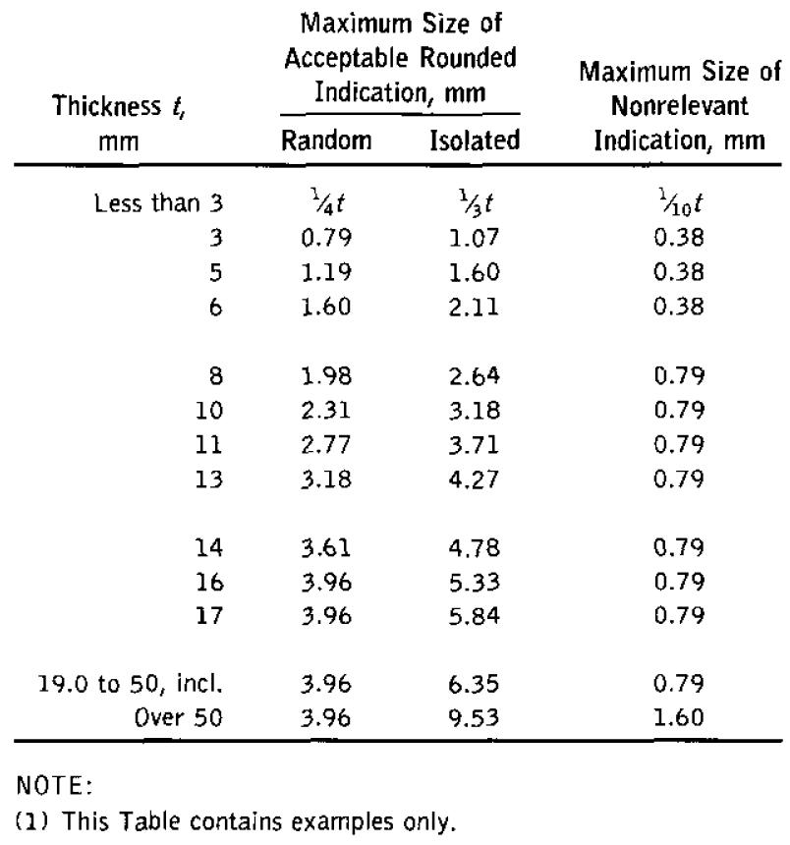
Table 16.1: Maximum Size Of Acceptable Rounded Indication (mm)

33. REPORTS
Any radiographic examination shall be documented in a report made using the form shown in the Appendix 1.
This report shall include the following minimum information:
-Identification, job number,
-Isotope
-Material type and thickness range,
-Minimum source to film distances,
-Film brand and designation,
-Number of films per cassette,
-Single -or double-wall exposure,
-Single -or double-wall viewing.
The report shall be prepared and dated by the qualified and certified Level II who examined the evaluation and disposition of the radiographs and approved by the qualified and certified Level II or Level III who performed the final acceptance of the radiographs.
A report shall be prepared and furnished to the client. Report of Radiographic Examination will be used.
34-FILM STORAGE:
Exposed films shall be stored in accordance with ASME SEC V article2 Appendix3

35.0. PURPOSE
This procedure defines the methods of performance, the examination conditions and the precautions to be taken when an ultrasonic examination is carried out of Air cooled heat exchangers that will be procured in “Toase-ehe Park Sanati Gohar Ofogh Petrochemical Co. CONCEPTUAL, BASIC and DETAIL DESIGN ENGINEERING OF STYRENE PARK OFFSITE "
36.0. SCOPE AND APPLICABLE PARTS FOR TEST
This procedure is applicable for carry out testing on welded joints of header boxes of air cooled heat exchanger and materials, shapes, or sizes to be examined and the extent of examination are according to NDT. CHECK LIST & NDT MAP of project (EI027-DMF-VD-QC-PRO-023).
37.0. REFERENCES
37.1. ASME section VIII div.1 edition 2010 addendum 2011
37.2. ASME SEC.V-Last Edition
37.3 ANSI/ASME B31.3
38.0. DEFINITION
38.1. S.D.H Block: Side Drilled Hole block
38.2. D.A.C: Distance -Amplitude Correction
39.0. PERSONNEL QUALIFICATION
Operators shall be qualified and certified in accordance with SNT-TC-1A
All NDE shall be done by or under the supervision of personnel certified to SNT-TC-1A level II /III.
40.0. GENERAL REQUIREMENTS
40.1. Particular specifications
Each particular specification shall include at least the following information:
-Type of the material and/or of the weld to be examined including dimensions, thickness and shape of the product,
-Surface(s) from which the ultrasonic examination is to be carried out,
-surface finish,
-Couplant to be used
-examination technique: straight beam, angle beam, contact and/or immersion,
-calibration description calibration blocks and calibration technique,
-directions and extent of scanning,
-information mentioned on examination report and recording method (manual or mechanized)
-Automatic alarm or recording equipment or both,
- Scanning mechanism; rotation, revolving, etc.
-Post-examination cleaning.
40.2. General examination requirements
40. 2.1. To assure a complete coverage of the whole area to be examined, each pass of the search unit shall overlap a minimum of 10% of the search unit width.
40.2.2. The rate of the search unit movement shall not exceed 150 mm / s.
41.0. EQUIPMENT USED
41.1. Frequency
Unless otherwise required in the particular examination specifications, the examination shall be conducted with pulse echo ultrasonic equipment capable of generating frequencies over the range of 1 to 5 MHz
41.2. Screen Height Linearity
The ultrasonic instrument shall provide linear vertical presentation within ±5 % of the full screen height for 20 % to 80 % of the calibrated screen height. The evaluation of the screen height linearity shall be performed before each period of extended use or at least every three months.
41.3. Amplitude Control Linearity
The ultrasonic instrument shall use an amplitude control accurate over its useful range to ± 20 % of the nominal amplitude ratio. The evaluation of the amplitude control linearity shall be performed before each period of extended use or at least every three months. (Accordance to ASME Sec.V Art.4)

41.4. Equipment calibration
The adequate calibration shall be carried out before and after each examination .when there is a change in operator and when bad functioning is suspected.
When bad functioning is established during calibration, all examinations carried out after the last valid calibration shall be reconducted.
41.5. Search Units
Search Units may contain either single or dual transducer elements.
42.0. WELD EXAMINATION
42.1. Calibration
a) V1 & V2 Standard Test block.
b) ASME Reference block (Side drilled hole φ=1.5)
c) The Material of Calibration shall be same P-No with base material
42.1.1. Calibration block for circular weld examination
For examination in materials where the examination surface diameter is greater than 500 mm (20in), a flat calibration block shall be used.
Otherwise the calibration block to be used shall be such as to calibrate examination on surfaces in the range of curvature from 0.9 to 1.5 times the calibration block diameter.
42.2. Technique
42.2.1. Angle beam calibration
The calibration shall include the following measurements:
a) Sweep range calibration on block V1
b) Distance- amplitude correction,
c) Position calibration (given directly by numeric equipment),
d) Echo amplitude measurement
The examination sensitivity shall be established at 80% of full screen height using the side drilled hole predicting the largest response. The distance amplitude correction (DAC) curve shall be constructed by utilizing the responses from the side drilled whole reflectors in the calibration block.
42.2.2. Straight beam calibration
The calibration shall include the following measurements:
- sweep range calibration on block V1
- Distance – amplitude correction
- echo amplitude measurement
Base metal:
The examination sensitivity shall be established at 75% of full screen height using the second back wall echo of the thickness examined.
Weld:
The examination sensitivity shall be established at 80% of full screen height using the side drilled hole predicting the largest response.
42.2.3. Non-Piping Calibration Block
42.2.3.1. Basic Calibration Block
The basic calibration block configuration and reflectors shall be as shown in next page .The block size and reflector locations shall be to perform calibrations for the beam angles used.
42.2.3.2. Block Thickness
When two or more base material are involved, the calibration block thickness shall be determined by the average thickness of the weld. Alternatively, a calibration block having the greater base material thickness may be used provided the reference reflector size is based upon the average or smaller weld thickness.
42.2.3.3. Block Range of Use
When the block thickness ±1 in (25mm) spans two weld thickness ranges as shown in Fig. 1, the blocks̉ use shall be acceptable in those portions of each thickness. As an example, a calibration block with a thickness of 1½in. (38mm) could be used for weld thicknesses of 0.5 in (13mm) to 2.5in (64mm)
42.2.3.4. TECHNIQUES FOR STRAIGHT BEAM CALIBRATIONS (Distance–Amplitude Correction
The following is used for calibration (see Fig.2)
(a) Position the search unit for the maximum indication from the SDH, which gives the highest indication.
(b) Adjust the sensitivity (gain) control to provide an 80% (±5%) of FSH indication. This is the primary reference
Level. Mark the peak of this indication on the screen.
(c) Position the search unit for maximum indication from another SDH.
(d) Mark the peak of the indication on the screen.
(e) Position the search unit for maximum indication from the third SDH and mark the peak on the screen.
(f) Connect the screen marks for the SDHs and extend through the thickness to provide the distance–amplitude curve.
Figure 1. Non-Piping Calibration Block

Figure 2. Distance–Amplitude Correction
42.2.4. Calibration for Piping
42.2.4.1. Calibration Block(s).
Calibrations shall be performed utilizing the calibration block shown in Fig. T-434.3.
42.2.4.2. Angle Beam Calibration.
The angle beam shall be directed toward the calibration reflector that yields the maximum response. The gain control shall be set so that this response is 80% ±5% of full screen height. This shall be the primary reference level. The search unit shall then be manipulated, without changing instrument settings, to obtain the maximum responses from the calibration reflectors at the distance increments necessary to generate a three-point distance-amplitude correction (DAC) curve.
Separate calibrations shall be established for both the axial and circumferential notches. These calibrations shall establish both the distance range calibration and the distance amplitude correction.
Straight Beam Calibration. When required, straight beam calibrations shall be performed to the requirements of Nonmandatory Appendix C using the side-drilled whole alternate calibration reflectors of T-434.1.1. This calibration shall establish both the distance range calibration and the distance amplitude correction.
System Calibration for Non-Distance Amplitude Techniques. Calibration includes all those actions required to assure that the sensitivity and accuracy of the signal amplitude and time outputs of the examination system (whether displayed, recorded, or automatically processed)
are repeated from examination to examination. Calibration may be by use of basic calibration blocks with artificial or discontinuity reflectors. Methods are provided in Nonmandatory Appendices B and C. Other methods of calibration may include sensitivity adjustment based on the examination material, etc.
42.3. Calibration control
Calibration control shall be carried out each time the calibration block is to be used. This control shall concern the sweeping speed and the distance amplitude curve.
A calibration control of at least one reflector of the calibration block shall be carried out at the end of each examination of series of similar tests, or every four hours or when there is a change in operator.
42.3.1. Sweep range correction
If a point of the DAC curve has moved on the sweep line more than 10 % of the sweep reading or 5 % of full sweep-whichever is greater correct the sweep range calibration and note the correction on the examination record.
If reflectors are recorded on the data sheets, a new calibration shall be recorded. All recorded indications since the last valid calibration or calibration check shall be reexamined with the corrected calibration and their values shall be changed on the date sheets.
42.3.2. DAC correction
If a point of the Distance -Amplitude Correction (DAC) curve has decreased 20 % or 2dB of its amplitude, all date sheets since the last valid calibration or calibration check shall be marked void. A new calibration shall be made and recorded and the area covered by the voided data shall be re-examined.
If any point of the DAC curve has increased more than 20 % or 2 dB of its amplitude, all recorded indications since the last valid calibration or calibration check shall be re-examined with the corrected calibration and their values shall be changed on the data sheets.
43. Surface preparation
43.1. Base Metal
The contact surfaces shall be free from weld spatter or any roughness which would interfere with the free movement of the search unit or impair the transmission of the ultrasonic waves in the part.
44.0. Examination
44. 1. Straight beam scanning
For weld examination using angle beam search unit, the volume of the adjacent base metal to be crossed by the ultrasonic waves shall be scanned with a straight beam search unit so as to detect reflectors that might affect the interpretation of angle beam results.
This precaution is not to be considered as an acceptance-rejection examination. Locations and areas of such reflectors shall be recorded.
The weld and base metal scanning shall be performed at a gain setting two times (at least) the primary reference level Evaluation shall be performed with respect to the primary reference level. Evaluation shall be performed with respect to the primary reference level.
44. 2 .Angle beam scanning for detecting reflectors oriented parallel to the weld
The angle beam shall be directed at approximate right angles to the weld axis from two directions where possible.
The search unit shall be manipulated laterally and longitudinally so that the ultrasonic waves pass through the weld and the adjacent base metal.
The scanning shall be performed at a gain setting two times (at least) the primary reference level. Evaluation shall be performed with respect to the primary reference level.
44.3. Angle beam scanning for detecting reflectors transverse to the weld
The angle beam shall be essentially directed parallel to the weld axis. The search unit shall be manipulated so that the ultrasonic waves pass through the whole weld and the base metal adjacent to it.
The scanning shall be performed at a gain setting two times the primary reference level. Evaluation shall be performed with respect to the primary reference level. The search unit shall be rotated in two directions 180 º and the examination repeated.
44.4. Ultrasonic System
Calibrations shall include the complete ultrasonic system and shall be performed prior to using
The system in the thickness range under examination.
44.5. Calibration Surface
Calibrations shall be performed from the surface (clad or unclad; convex or concave) corresponding to the surface of the component from which the examination will be performed.
44.6. Couplant
The same couplant to be used during the examination shall be used for calibration.
44.7. Contact Wedges
The same contact wedges to be used during the examination shall be used for calibration.
44.8. Instrument Controls
Any control which affects instrument linearity (e.g., filters, reject, or clipping) shall be in the same position for calibration, calibration checks, instrument linearity checks, and examination.
44.9. Temperature
For contact examination, the temperature difference between the calibration block and examination surfaces shall be within 25 %.
45.0. Evaluation
All indications producing a response greater than 20% of the reference level shall be investigated so as to evaluate the shape, identify and location of the reflectors in accordance with the acceptance criteria defined in Chapter 13.
46.0. ACCEPTANCE CRITERIA
a) The discontinuities are unacceptable if their amplitude exceeds the reference level and their length the following dimensions (Accordance to ASME SEC VIII Appendix 12):
- 6 mm for t ≤ 19 mm
- 1/3 t for 19 < t ≤ 57 mm
- 19 mm for t > 57mm
* t = thickness to be examined
b) When discontinuities are interpreted to be cracks, lack of fusion or incomplete penetration, they are considered as unacceptable whatever their amplitude.
Repairs shall be re-examined according to this procedure.

47.0. EXAMNATION REPORT
The Examination Report (see Appendix 1) shall be generated, filed during five (5) years at least and shall contain the following information:
-all references, procedures and equipment used for examination so that the examination may be reconducted later on in the same conditions;
-reference of the conditions of equipment calibration;
-a sketch or drawing indicating the examined weld and the item / piece number;
-a record of repaired surfaces and results of the new examination; the report shall specify the location, the amplitude, the dimensions and the depth of the discontinuities below the surface and the classification.

Hydrostatic Test Procedure for Chiller

1. SCOPE ………..…
2. Reference Code and Standards
3. Description
3.1. Test Equipment
3.2. Test Fluid
3.3. Safety Instruction
3.4. Safety Zones
3.5. Preparation for Pressure Test
3.6. Consider the following Notes
3.7. Testing Process
4. Acceptance Criteria
5. Pneumatic Test
6. Documentation
7. REPORT………………………………………….………………………………………….........

- Scope
This procedure describes the way Farnikan Co. carries out Hydrostatic test of Heat Exchanger in according to applicable code and specifications. The Hydrostatic Test is carried out to verify tightness and stability of equipment against internal pressure.

2. Reference Code and Standards
Test shall be performed in accordance to ASME VIII Div.1

3. Description

3.1. Test Equipment
The test equipment comprises a manually operated test pump, a water tank & two pressure gauges. For the respective measuring range and suitable connection material (flanges, blind flanges, Vent and drain connections, covers, bolts, gaskets) to comply with test Requirements shall be supplied.
The calibration / test certificate form for relevant pressure gauges shall be attached to test report & the calibration expiry date must be valid.

3.2. Test Fluid
Test Fluid shall be fresh and clean and freshwater for the hydrostatic test. When carbon and low alloy steel materials are exposed to potable water, chloride content in the water shall be less than 50 ppm. In the case of stainless steel equipment or parts, the water shall have a maximum chloride content of 30 ppm @ PH 8. Hydrostatic test shall be done by water and at the temperature of at least 16°C above MDMT but not more than 48°C.

3.3. Safety Instruction
All flange connections shall be closed and relevant bolts to be tight before pressurizing. Repairs and rework are not allowed on pressurized equipment. If repairs are required, the test must be stopped & started again after repair work is completed.

3.4. Safety Zones
In case of test pressure less than 100 barg and test temperature greater than 48°C, staying in direct vicinity (2m zone) has to be avoided and for test pressure greater than 100 bar and less or equal to 350 bar, and test temperature greater than 48°C, the pressure test shall be carried out at a remote part of workshop, or the near vicinity (5 m zone) has to be barricaded by plastic strips and marked by information plates as danger zone and prohibited area.

3.5. Preparation for Pressure Test
Prior to starting the pressure test, the inner and outer and welded joint surface has to be cleaned from dust, rolling residues, dirt, oils, paint and other foreign material.
The pressure gauges must be installed that way the operating personnel can inspect it during pressurizing.
Each equipment shall be equipped with min. 2 Numerical calibrated gauges with their valid calibration test certificate is available. (i.e. one pair on the highest point and another pair on the lowest point.)

3.6. Consider the following Notes
-Dial indicating pressure gages used in testing shall be graduated over a range of about the intended maximum test pressure, but in no case shall the range be less than 1 ½ nor more than 4 times that pressure.
-The test pressure shall be read at the top of the equipment, erected as for operation.
-Vertical equipment shall be hydrostatically tested at horizontal position.
-Equipment has to be properly vented at the highest point.
-The gasket shall be of the same type and material as the service gasket for not removable connection.
- Service bolting shall be used for pressure testing. Bolt and nuts shall be thoroughly inspected after testing and replaced whenever damaged. This inspection shall be witnessed by the inspection agency.

3.7. Testing Process
A fully detailed testing procedure shall be submitted to the Purchaser for approval prior to fabrication. The equipment shall be tested in the presence of the Inspection Agency, before being painted. Prior to testing, the equipment shall be thoroughly cleaned and free from dirt, debris, loose scale and slag, pieces of metal, weld spatter, oil and grease, etc.
- Tightness of welded attachments with telltale hole shall preliminarily be air and soapsuds tested.
- Service bolting shall be used for pressure testing; bolts and nuts shall be thoroughly inspected after testing and replaced whenever damaged. This inspection shall be witnessed by the Inspection Agency.
- Gaskets shall be the same as for the service type, dry or coated with graphite. Use of compounds,
glue, lead, is not permitted. Rings gaskets shall be replaced after testing if damaged. All other gaskets shall be replaced with new ones after testing.
• All air shall be vented from the equipment before the pressure is applied.
• Test pressure shall be held at least one hour during visual examination of the equipment by the Inspection Agency.
All items should be tested according to Pressure Test Curve (Fig.1) and related pressure data(Table.1).
-The equipment shall be stand on suitable condition pressurized slowly and gradually to the half of the design pressure according to pressure schedule table. The holding time for a visual check at this stage is minimum 15min.
- The pressure shall be increased to design pressure and inspection shall be accomplished. The holding time for this stage is minimum 15 min.
- The pressure shall be increased to test pressure and a complete visual check for all connections (such as flanges, blind flanges, vent and drain connections, covers, bolts, gaskets) and weld joints shall be done for determining leakages or deformation. Hydrostatic test pressure shall normally be maintained for 1 hour. Then test pressure shall be decreased slowly and gradually to the 2/3 test pressure and inspection shall be accomplished. The holding time for this stage is minimum 15 min.
- After hydro testing the vent valve shall be gradually opened. After ensuring this valve is fully opened, the drain valve shall be slowly opened. At this stage care must be taken to avoid any vacuum in Equipment due to waters draining.
- For protection and preservation of corrosion after hydro testing, equipment must be fully drained.
- Both heat exchangers have been pressure tested .
4.Acceptance Criteria
-During the holding time, the test pressure shall not fall below the required value.
-A deformation of the pressure retaining parts into the plastic region (permanent deformation) is not allowed.
-If leakages are found at the weld joints, repairs shall be performed according to code and spec. All repair works shall be subject to approval by TPI and inspection shall be repaired and re-hydrostatic tested.

5. Pneumatic Test
Pneumatic test for reinforcing pads shall be done in following conditions:
- Dial indicating pressure gages used in testing shall be graduated 5 Bar.
- The calibration / test certificate form for relevant pressure gauges shall be attached to test report.
- Test pressure: 2 barg
- Test media: Compressed air
- Holding Time: 5 Min
- All reinforcing pads for nozzles (welds of each pad or segment) shall be air tested at 2barg. Afterwards, the pressure must be reduced to 0.5 barg and all welds must be tested for leaks with soap solution. Vent holes will be left open after testing. After hydro-test, the holes must be filled with stiff grease and plugged.

6. Documentation

After satisfactory performance of pressure test, the hydrostatic test report shall be approved and signed by relevant inspectors (according to inspection test plan).

Table 1. Pressure Schedule
Table 1. Pressure Schedule
ITEM NO. | DESIGN PRESSURE (barg) |  | TEST PRESSURE (barg)
ITEM NO. | Shell Side | Tube Side | Shell Side | Tube Side
EVAPORATOR | 22 | 6.8 | 28.6 | 8.84

Fig. 1: Hydrostatic Test Curve
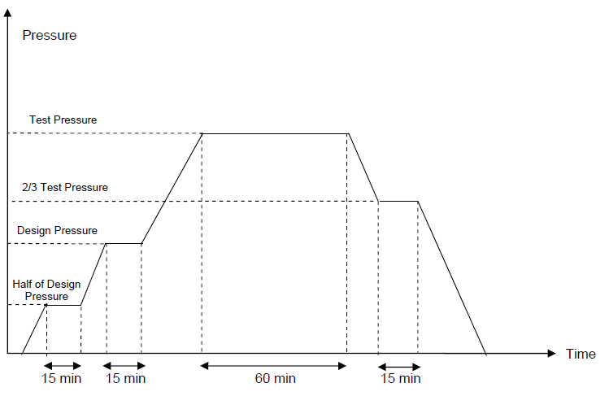

NOTE: Increasing/decreasing Pressure rating should not be greater than 5 bar/min.

