
Industry & Facilities Division Procurement Services Inspection Report
Page 1 of 6
INSPECTION REPORT N° 12355-01
Initial Interim Final Resident Remote
Inspection requested by: Delta GmbH
BV Job Nr: 20412767

Project: Refrigeration Compressor 2 Sets 160S Model | IPO Ref (If applicable): 20392985-1002  (BV internal P/o)
BV Client: Delta GmbH | P/o nr:  (client to BV)
Manufacturer/Vendor: MAYEKAWA Europe | P/o nr: DELTA-PE-2023-PO-200-1  (client to Manufacturer)
Sub-Vendor (If applicable): -
Inspection Location (Address): Mayekawa Europe BV, Belgium | Previous Inspection (If applicable): NONE
Inspection Location (GPS coordinates): | Next Inspection (If applicable): NONE  (Date)
Inspection performed on: Oct. 02, 2024  ( Date(s) ) | Total No. of Inspection Days: 1

MATERIAL / SUBJECT OF INSPECTION  Refer to attachment section J instead  (Indicate if separate material list is provided in attachment) | ITEM / TAG Nr | QTY  As per P/O | QTY  Offered for inspection
Screw Compressor Visual Inspection | RU-0001 A/B | 2 | 2

A – INSPECTION RESULT
Satisfactory  (Without comments) | Satisfactory with comments  (Any of trailing Punch or Non Conformity items is still open) | Not Satisfactory (NCR raised during the inspection)
Inspection Summary: (for details refer to section E)

I visited MAYEKAWA on Oct. 02, 2024 to witness Compressor Visual Inspection Model 160S two sets for Screw compressor.
The result was Satisfactory without comment.

Open Non Conformities: | Yes, details in section G | No
Open Punch List Items: | Yes, details in section H | No
Release Note Issued: | Yes, number(s): (Release Note number) | No

BV Inspector: Atsuo IMAI  (Name and Signature) | BV Coordinator: Chika KIOI  (Name and Signature)
BV Office: Yokohama Japan | Inspection Report Date: Nov. 03, 2023
Distribution: CLIENT BV  OTHER : | Attachments Report:  Yes, details in section J No

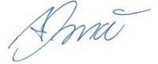
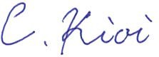
INSP PROC 002-En Rev.3.3 – June 2021

This inspection report is relevant to inspection services performed by Bureau Veritas for and on behalf of the Client

B - REFERENCE DOCUMENTATION:
Refer to attachment section J instead
(Indicate if separate document list is provided in attachment)
Title | Reference n° | Rev. | Approval status | Approved by | Date
INSPECTION AND TEST PLAN FOR COMPRESSOR | 2513293 | 0 | Approved | Delta GmbH | -
Screw Compressor Standard Inspection Procedures  Performance Test, Mechanical Running Test, Noise and Vibration Test | SCSD-010-13 | 13 | Approved | Delta GmbH | 2023/01/17

C – ATTENDEES
Name | Position | Representing
Mr. TETSUO KAZASA | General Manager | MAYEKAWA
Mr. Toshiyuki Sakaguchi | QA Gr. | MAYEKAWA
Ms. Tomoko Kanazawa | QA Gr. | MAYEKAWA
Mr. Frank IMAI | On Behalf of Delta GmbH (BV Inspector) | BV Belgium

D - MEASURING & TESTING EQUIPMENT USED
Refer to attachment section J instead
(Indicate if separate equipment list is provided in attachment)
Equipment Type | Equipment Identity n° | Last Calibration Date | Expiry Date
-

E - INSPECTION DETAILS
E – General
The following Test was carried out accordance with “Reference documents” above-mentioned. The result was Satisfactory without comment.
E1 – Details of Witness (W) & Hold (H) Inspection Points
- Witness of Compressor Skids 160S used for Propane Refrigeration Package Air Cooled Unit with Compressor Serial Numbers 1656466 and 1656467. The Inspection was including Compressor Block, Oil Pump, and other parts assembled on Compressor skid and inspection included of Visual and Scope Check of both skids on behalf of DELTA GmbH.

E2 – Details of Monitoring and Surveillance Patrols
Tick if conducted during the visit
NONE
E3 – Details of Certificates Review
Tick if conducted during the visit
NONE

F – HEALTH, SAFETY & ENVIRONMENT COMMENTS

(Comment on Observations and Actions Taken During the Inspection)
No health and safety concerns or violations were observed before or during conducting the inspection activity.

G- NON CONFORMITIES
Refer to attachment section J instead
(Indicate if separate punch list is provided in attachment)
Item | Description | Status | Raised on | Report # | Closed on | Report # | Comments
 | NONE

H – PUNCH LIST
Refer to attachment section J instead
(Indicate if separate punch list is provided in attachment)
Item | Description | Status | Raised on | Report # | Closed on | Report # | Comments
 | NONE

I - DIGITAL PICTURES
 | 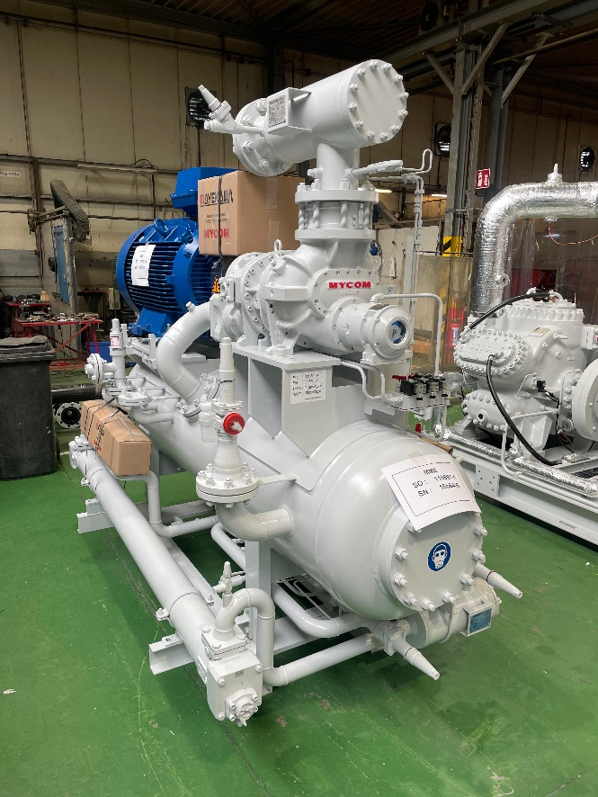 | 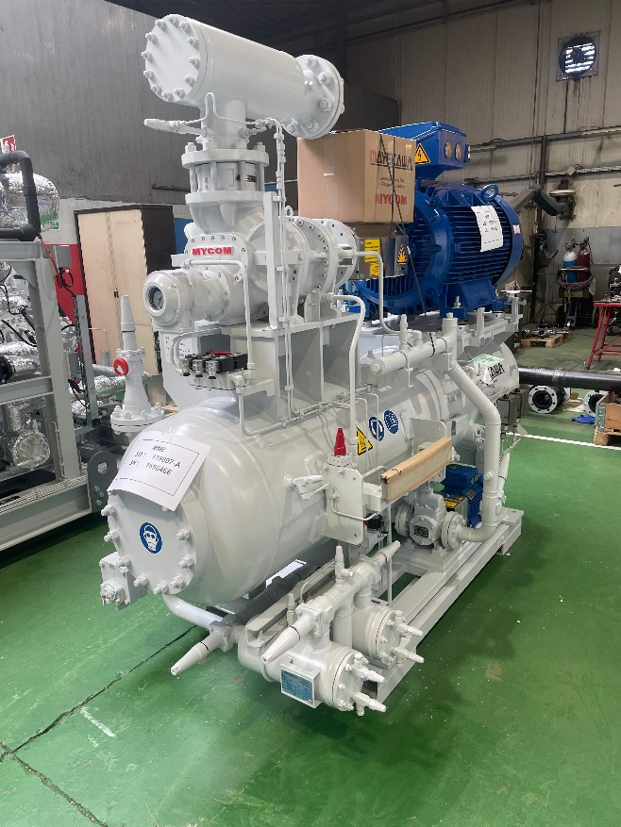
 | Description: Compressor Skid A  (Model No. P160S / Sr. No. 1656466) | Description: Compressor Skid A  (Model No. P160S / Sr. No. 1656466)
 | 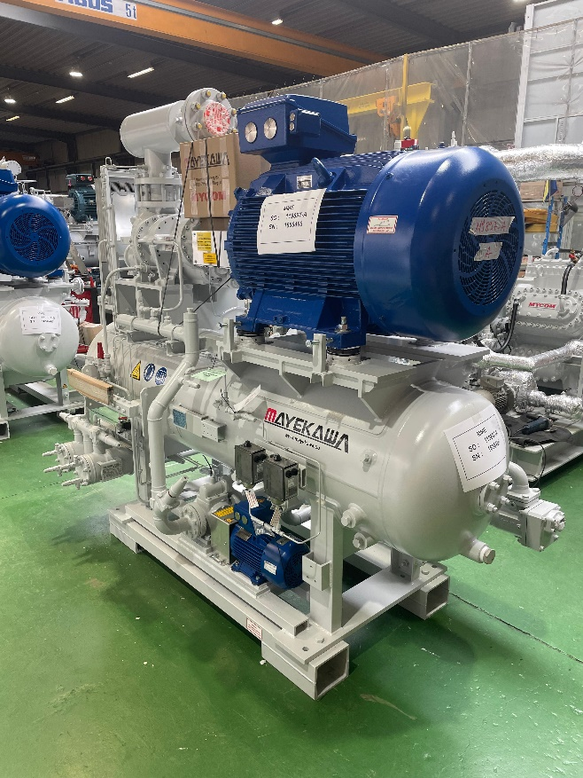 | 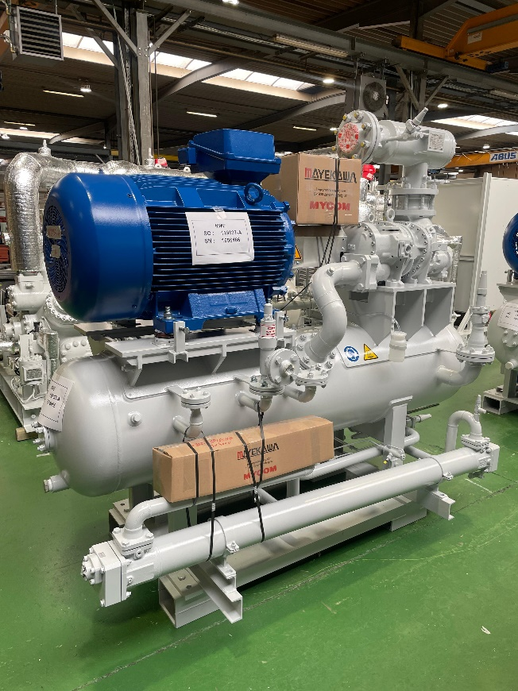
 | Description: Compressor Skid A  (Model No. P160S / Sr. No. 1656466) | Description: Compressor Skid A  (Model No. P160S / Sr. No. 1656466)

 | I - DIGITAL PICTURES
 |  | 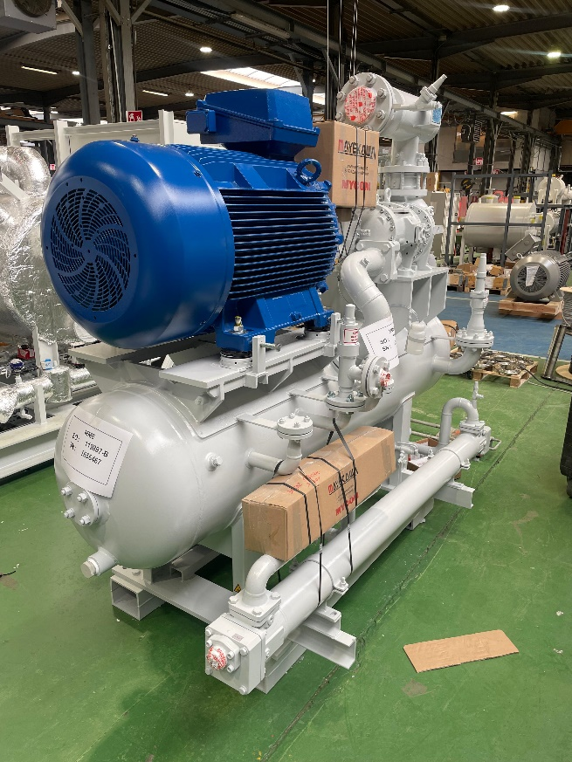 |  |  |  | 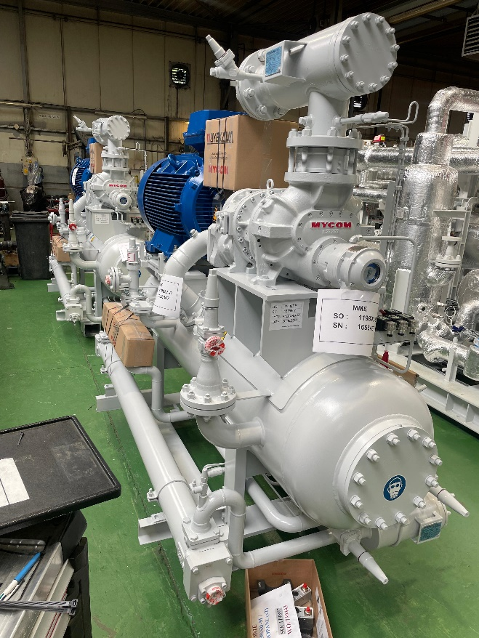
 |  | Description: Compressor Skid B  (Model No. P160S / Sr. No. 1656467) |  |  |  | Description: Compressor Skid B  (Model No. P160S / Sr. No. 1656467)
 |  | 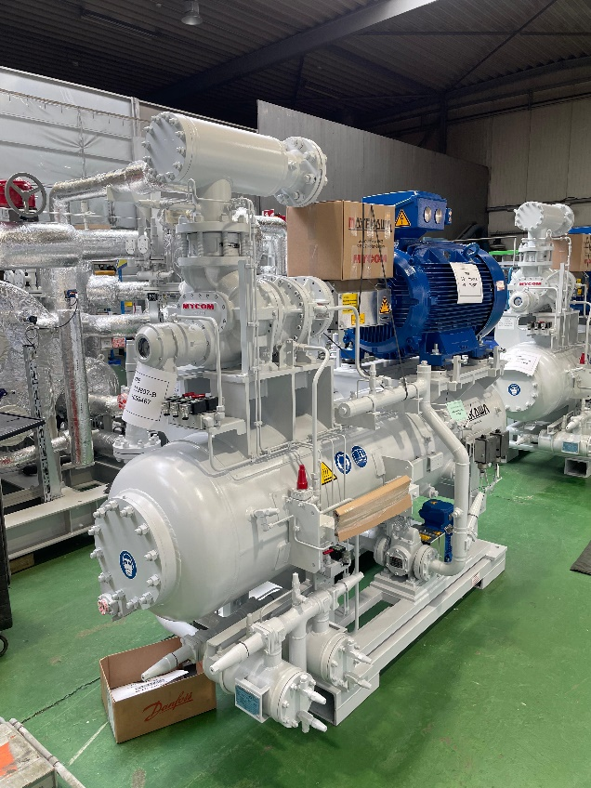 |  |  |  | 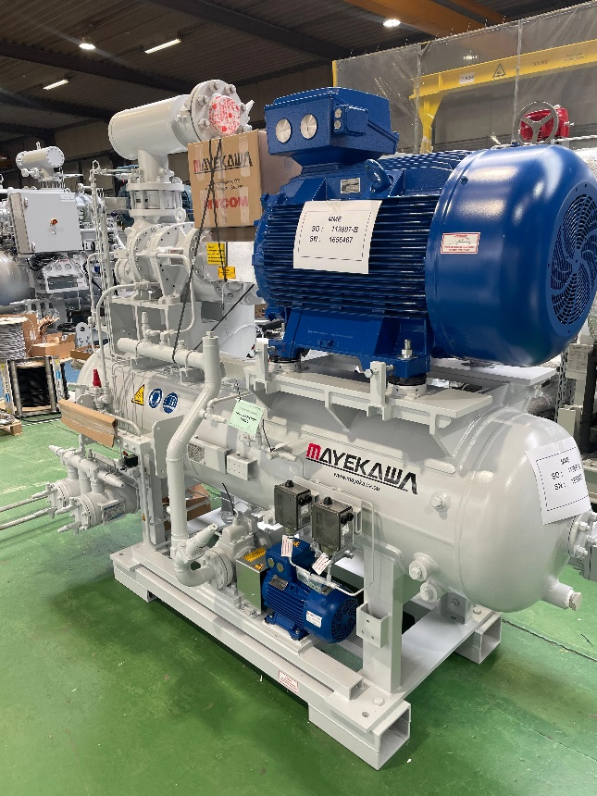
 |  | Description: Compressor Skid B  (Model No. P160S / Sr. No. 1656467) |  |  |  | Description: Compressor Skid B  (Model No. P160S / Sr. No. 1656467)
 | J – ATTACHMENTS
 | Item |  | Attachment Name | Total Pages | Description
 |  |  | Inspection & Test Record | 44 | (Mechanical running test and Performance inspection)
END OF REPORT

