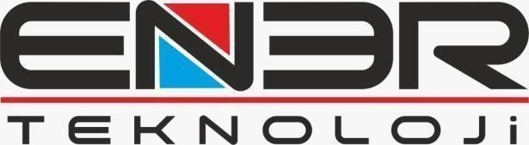

Date: 05 Feb 2024

ATTN TO: Mr. Salari

Petroelectric Energy Development Managing Director

Subject: Introduction of Authorized Person

Dear sir,
With reference to Contract NO. OFFSITE 60 We hereby, introduce Mr. Amin Malekinia as authorized person and signature for this project.

Best regards,
Perisa Mahdizadeh
Manging Director

Address : 19 Mayis Mah.Turaboğlu Sk. Hamdiye Yazgin is Merkezi 4/2 Kadiköy -Istanbul Tel : +905350296388 Email : info@ener-teknoloji.com

