PURCHASE ORDER

SELLER | : |  | PURCHASE ORDER No.:  DELTA-WIKA-2024-PO-200-A1  ISSUE DATE: 14-Oct-2024
  WIKA Alexander Wiegand SE & Co. KG
Add. | : | Alexander- Wiegand-straße 30  63911 Klingenberg- Germany
Tel. | : | +49 9372 132-0

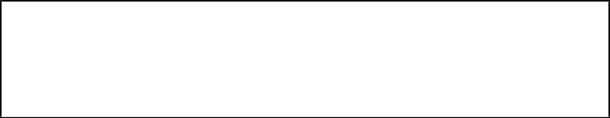
P.O. number must be shown on all shipping packages, shipping documents, invoices and correspondence in connection with this PURCHASE ORDER.

This PURCHASE ORDER is subject to the descriptions, terms, conditions and instructions stipulated hereunder and attachments hereto, if any.

SUBJECT: Level Transmitters and Level Switches as per Quotation Q110071983-3 dated 11.10.2024 and relevant emails including all Technical details, clarification and comments discussed and agreed between parties.

This PURCHASE ORDER, together with all its attachments shall be referred to as “CONTRACT
No. DELTA-WIKA-2024-PO-200-A1.
In the event of any inconsistency between the matters contained in the CONTRACT, the portions shall govern in the order of following precedence. The first named being paramount.

- PURCHASE ORDER
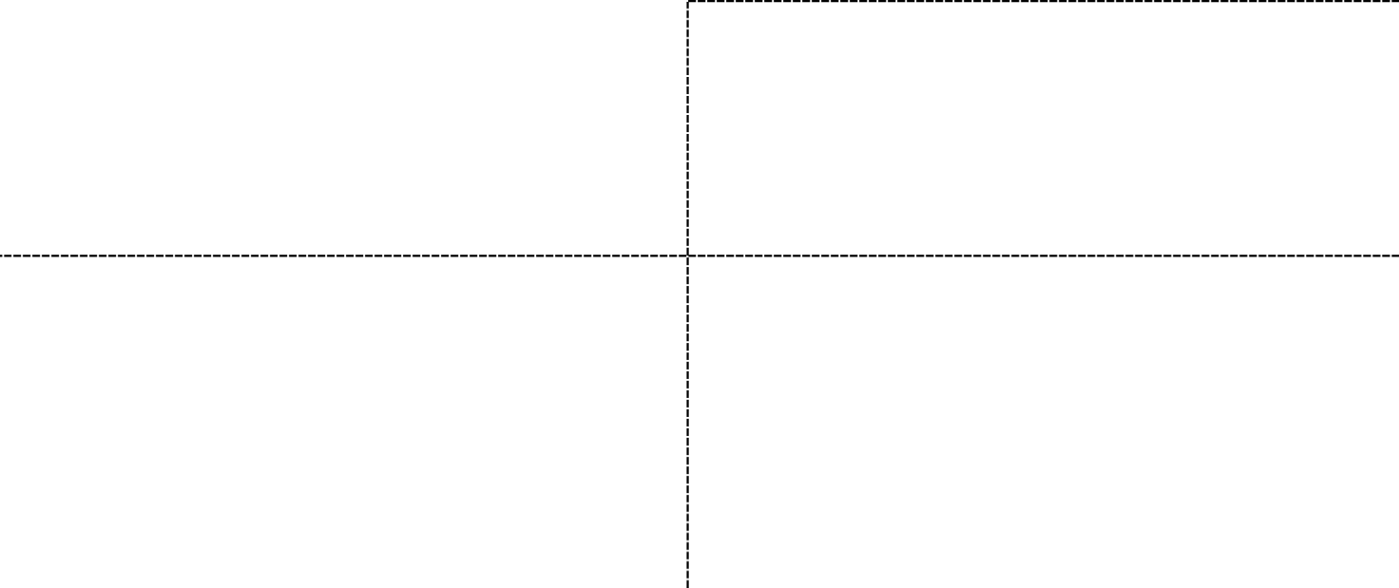
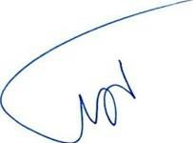
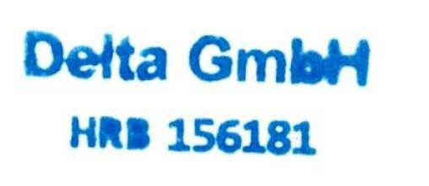
- Attachments PURCHASE ORDER
Page 1 of 4

SELLER’S ACCEPTANCE:  WIKA Alexander Wiegand SE & Co. KG | BUYER: DELTA GMBH
Alexander- Wiegand-straße 30  63911 Klingenberg- Germany | Lübecker Straße 1, 22087 Hamburg, Deutschland
Name(s) / Title(s): | Name / Title: Managing Director
Seal & Sign: Date: | Seal & Sign: Date:

Reference Correspondence

  - SELLER’s Commercial Quotation:
    - Quotation Q110071983-3 dated 11.10.2024 for Instruments

  - SELLER’s Clarifications Letter(s):
    - No.: Latest Communications by Email.

Attachments

  - SELLER’s Quotation Q110071983-3 dated 11.10.2024.
  - Buyers Datasheet

Price

  - Total FCA/Klingenberg (according to Incoterms 2020) price of Equipment subject to this PURCHASE ORDER, including Documentation, Seaworthy packing, marking, loading and all other related costs based on FCA/ Klingenberg delivery term amounts to be 14,310.38 Euro based on relevant unit price(s) mentioned under SELLER COMMERCIAL QUOTATION of this PURCHASE ORDER.
.
  - The unit price(s) shall be fixed and firm for the duration of CONTRACT and shall not be subject to escalation.

Payment

  - 100% of PURCHASE ORDER price shall be paid 30 days after delivery and submission of following documents

    - One Original Total Signed Payment Invoice.
    - Commercial Invoice, Packing List, and COO
    - Test Reports and Material Certificates

    - Submission of Technical documents and Certificates according SELLER Offer.

Test and Inspection

  - According to agreements in SELLER Quotation.

Packing and Marking

  - Packing and Marking shall be made for Sea Shipment in accordance with Sea Worthy Packing requirement.

  - Final Packing List written in English in One original copy to be submitted to BUYER officially not later than 10 calendar days prior to dispatch of cargo.

Delivery
  - All Equipment shall be delivered within 12-14 weeks (FCA Klingenberg)
from Effective Date of PURCHASE ORDER.
  - Partial delivery is Allowed.

Guarantee Period

The Guarantee Period for the subject Equipment shall be 12 months from installation or 24 months from date of shipment, whichever occurs first.

Liquidated Damage

SELLER undertakes to deliver the subject Equipment within the period stipulated under Clause
  - of this PURCHASE ORDER. In the event of any delay beyond the delivery period for reasons attributed to the SELLER, SELLER shall pay the following amounts to BUYER as liquidated damage:

  - The liquidated damage for every full week delay is 0.5% of the PURCHASE ORDER PRICE.

  - Maximum liquidated damage is 5% of the PURCHASE ORDER price. In Case of delay by parts Manufacturer, this delay will be considered as and acceptable, delay and not subject to this article.

  - BUYER has the right to deduct the applicable liquidated damages from any SELLER’s entitlements.

Effective Date of the PURCHASE ORDER

Upon countersigning of this PURCHASE ORDER and fulfillment of the following conditions, this PURCHASE ORDER shall become effective:

  - Upon Countersign of the Purchase Order and advance payment receipt by the SELLER, whichever is latest.

- Arbitration:
Any dispute arising out of or in connection with the Contract, which cannot be settled amicably by the parties in accordance with the provisions of the Contract, shall be finally settled under the Rules of Arbitration of the International Chamber of Commerce (ICC). The arbitration shall be conducted in English at a location agreed upon between the parties, and the arbitral award shall be final and binding on both parties without any right of appeal for any party.
The arbitral award shall also determine the expenses of the arbitration and the party, which shall bear them or the proportion of such expenses to be borne by each party.
Arbitration shall not prevent Seller from continuation of the works.

- Governing Law:

This Contract shall be governed by and interpreted in accordance with the Laws of GERMANY.

