STYRENE PARK OFFSITE

Document Title:
Tube Expanding Procedure
R1 | 10-Dec.-2024 | IFA | A.Parsafar | A.Shadmand | M.Heidarzadeh
R0 | 06-Oct.-2024 | IFA | A.Parsafar | A.Shadmand | M.Heidarzadeh
Rev. | Issued Date | DESCRIPTION | PREPARED | CHECKED | APPROVED

REVISION RECORD SHEET
Page | Revisions |  |  |  |  |  |  |  | Page | Revisions
Page | R0 | R1 | R2 | R3 | R4 | R5 | R6 |  | Page | R0 | R1 | R2 | R3 | R4 | R5 | R6
1 | X | X |  |  |  |  |  |  | 41
2 | X | X |  |  |  |  |  |  | 42
3 | X | X |  |  |  |  |  |  | 43
4 | X |  |  |  |  |  |  |  | 44
5 | X |  |  |  |  |  |  |  | 45
6 | X |  |  |  |  |  |  |  | 46
7 | X | X |  |  |  |  |  |  | 47
8 | X | X |  |  |  |  |  |  | 48
9 | X | X |  |  |  |  |  |  | 49
10 |  | X |  |  |  |  |  |  | 50
11 |  | X |  |  |  |  |  |  | 51
12 |  |  |  |  |  |  |  |  | 52
13 |  |  |  |  |  |  |  |  | 53
14 |  |  |  |  |  |  |  |  | 54
15 |  |  |  |  |  |  |  |  | 55
16 |  |  |  |  |  |  |  |  | 56
17 |  |  |  |  |  |  |  |  | 57
18 |  |  |  |  |  |  |  |  | 58
19 |  |  |  |  |  |  |  |  | 59
20 |  |  |  |  |  |  |  |  | 60
21 |  |  |  |  |  |  |  |  | 61
22 |  |  |  |  |  |  |  |  | 62
23 |  |  |  |  |  |  |  |  | 63
24 |  |  |  |  |  |  |  |  | 64
25 |  |  |  |  |  |  |  |  | 65
26 |  |  |  |  |  |  |  |  | 66
27 |  |  |  |  |  |  |  |  | 67
28 |  |  |  |  |  |  |  |  | 68
29 |  |  |  |  |  |  |  |  | 69
30 |  |  |  |  |  |  |  |  | 70
31 |  |  |  |  |  |  |  |  | 71
32 |  |  |  |  |  |  |  |  | 72
33 |  |  |  |  |  |  |  |  | 73
34 |  |  |  |  |  |  |  |  | 74
35 |  |  |  |  |  |  |  |  | 75
36 |  |  |  |  |  |  |  |  | 76
37 |  |  |  |  |  |  |  |  | 77
38 |  |  |  |  |  |  |  |  | 78
39 |  |  |  |  |  |  |  |  | 79
40 |  |  |  |  |  |  |  |  | 80

Table of Contents

1.0 PURPOSE

2.0 SCOPE

3.0 REFERENCES

4.0 DEFINITION

5.0 EQUIPMENT SPECIFICATION

6.0 TUBE HOLE GROOVING

7.0 Expanded tube-to-tube sheet joints

8.0 CLEANING BEFORE EXPANSION

9.0 EXPANSION CRITERIA

10.0 CHECKING OF THE EXPANSION

11.0 WORK SEQUENCE

12.0 Appendix I: sample inspection report,
- PURPOSE

This procedure describes the practical application of the strength expanding operation for tube-to-tube sheet of Air-cooled heat exchangers Project: “Toase-ehe Park Sanat Gohar Ofogh Petrochemical Co.
CONCEPTUAL, BASIC and DETAIL DESIGN ENGINEERING OF STYRENE PARK OFFSITE”.

- SCOPE

This method is used for the expansion of tubes in a standard air-cooled exchanger when the yield strength of the tube sheet is superior to the yield stress of the tube. Therefore, the plastic deformation of the tube during the expansion process includes BWG 10 to BWG16, which are categorized according to the outer diameter and wall thickness-refer to Appendix Table1. This procedure shall provide essentially uniform expansion throughout the expanded portion of the tube without a sharp transition to the unexpanded portion.
- REFERENCES
API 661: Air-Cooled Heat Exchangers

- DEFINITION
B.W.G: Birmingham wire gauge
di = inner diameter of the tube after expansion
d0 = inner diameter of the tube before expansion
H= diameter of the tube sheet plate hole
D = outer diameter of the tube before expansion
%ER= expansion ratio%

EQUIPMENT SPECIFICATION

TROUVAY & ARUVIN LE HAVRE FRANCE TYPE: TCM3

6.0. TUBE HOLE GROOVING
All tube sheet holes for expanded joints in tube sheets less than 1inch (25mm) thick shall be machined with one groove approximately 1/8 inch (3 millimetres) wide by 1/64 inch (0.4millimeter) deep. A second groove shall be provided for tube sheets 1inch (25millimeters) or greater in thickness.
Grooves shall be located at least 1/8 inch (3mm.) plus corrosion allowance from the process face of the tube sheet and at least ¼ inch (6millimeters) from the airside face of the tube sheet.
Tube-hole grooves shall be square-edged, concentric and free of burrs.

7.0. Expanded tube-to-tube sheet joints
Tubes shall be expanded into the tube sheet for a length at least the smaller of the following:
a) 50 mm (2 in)
b) The tube sheet thickness less 3 mm (1/8 in).
In no case shall the expanded portion extend beyond the air-side face of the tube sheet.
The ends of tubes shall extend at least 1.5 mm (1.6 in) and not more than 10mm (3/8 in) beyond the tube sheet.

8.0. CLEANING BEFORE EXPANSION
The tube sheet bores must be cleaned before tubing and must be free from barbs at the level of the expansion grooves.
The inner bore of the tube must be smooth, free from barbs and swellings which would jeopardize the good expansion process.

9.0. EXPANSION CRITERIA:
To obtain the permissible expansion range in the inner diameter of the tube, we consider the internal expansion of the tube in the plastic range.

so that the tube sheet is still elastic and after removing the expansion force, it is closed by returning to the original state.
This condition is created when the expansion ratio ER % is defined as the following relationship:
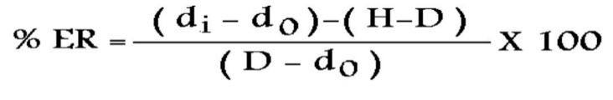

% ER Is situated in the following range: 3 % ≤ ER% ≤ 10 %
for tubes with gauge BWG 12 to 16

10.0. CHECKING OF THE EXPANSION
Due to the application of tube-to-tube sheet weld in the connection of tube and tube sheet: the expansion of tube sheet to tube is done in two stages:
The first step is a small expansion to help escape the welding fumes and fix the tube to the hole in the tube sheet, and there is no need to measure the corresponding amount.
The final expansion rate after full expansion is measured and reported according to Table 1.
The expansion operation inside the tube goes back to the first 10 samples.
As a result, the normal value of the expansion force is determined by adjusting the ampere device.
The obtained result is applied to all tubes. Finally, the inner diameter of the pipes after expansion is measured and recorded. This diameter should be within the range of parameter "di" in Table 1.

ITEM No.'s | BWG | Min. Wall THK. | OD | H(mm) | Range Of heavy exp% | d0 | Range of di
Air cooler | 16 | 1.651 | 25.4 | 25.7 | 3~10 | 22.098 | 22.49~22.79

Range of Expanding L (light), H (Heavy)
Range of di: The limits of "di" values are calculated according to the percentage
of permissible expansion from 3% to 10% using the ER% relationship.
The suitable mandrel model is selected according to the thickness of the tube wall and the outer diameter of the tube according to the BWG table.
The expansion on the tubes and the holes of the tube sheet is done according to the ampere and power settings of the device.
The final expansion efficiency is checked during the hydrostatic test, and in case of leakage from the expanded area, by re-expanding up to the maximum allowed range, the sealing of the area is ensured. The results obtained will be reported in the inspection report.
11.0 work sequence
According to the connection plan (picture 1) and work chart (picture 2), first the tube is welded to the tube sheet and then EXPAND is done.
According to NDT Map (EI027-DMF-VD-QC-PRO-023), NDT tests are not possible in this type of connection.
Leak test according to Hydrostatics Procedure. is done.

picture 1
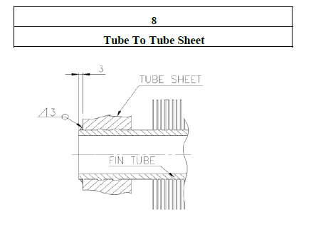
WPS & PQR for Pressure Part and Structure: EI027-DMF-VD-QC-WPS-022(Page 3)
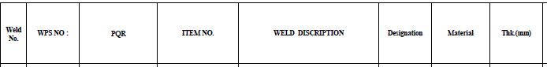
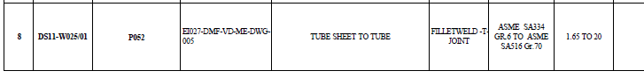

work chart

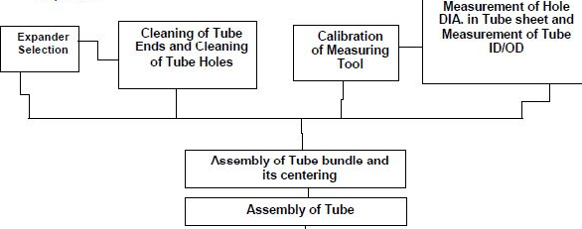
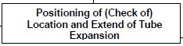
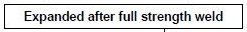
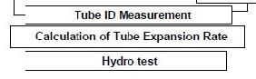

12.0 Appendix I: sample inspection report,

