STYRENE PARK OFFSITE

Document Title:
Shop Run Test Procedure
R0 | 07-Oct.-2024 | IFA | A.Parsafar | A.Shadmand | M.Heidarzadeh
Rev. | Issued Date | DESCRIPTION | PREPARED | CHECKED | APPROVED

REVISION RECORD SHEET
Page | Revisions |  |  |  |  |  |  |  | Page | Revisions
Page | R0 | R1 | R2 | R3 | R4 | R5 | R6 |  | Page | R0 | R1 | R2 | R3 | R4 | R5 | R6
1 | X |  |  |  |  |  |  |  | 41
2 | X |  |  |  |  |  |  |  | 42
3 | X |  |  |  |  |  |  |  | 43
4 | X |  |  |  |  |  |  |  | 44
5 | X |  |  |  |  |  |  |  | 45
6 | X |  |  |  |  |  |  |  | 46
7 | X |  |  |  |  |  |  |  | 47
8 | X |  |  |  |  |  |  |  | 48
9 |  |  |  |  |  |  |  |  | 49
10 |  |  |  |  |  |  |  |  | 50
11 |  |  |  |  |  |  |  |  | 51
12 |  |  |  |  |  |  |  |  | 52
13 |  |  |  |  |  |  |  |  | 53
14 |  |  |  |  |  |  |  |  | 54
15 |  |  |  |  |  |  |  |  | 55
16 |  |  |  |  |  |  |  |  | 56
17 |  |  |  |  |  |  |  |  | 57
18 |  |  |  |  |  |  |  |  | 58
19 |  |  |  |  |  |  |  |  | 59
20 |  |  |  |  |  |  |  |  | 60
21 |  |  |  |  |  |  |  |  | 61
22 |  |  |  |  |  |  |  |  | 62
23 |  |  |  |  |  |  |  |  | 63
24 |  |  |  |  |  |  |  |  | 64
25 |  |  |  |  |  |  |  |  | 65
26 |  |  |  |  |  |  |  |  | 66
27 |  |  |  |  |  |  |  |  | 67
28 |  |  |  |  |  |  |  |  | 68
29 |  |  |  |  |  |  |  |  | 69
30 |  |  |  |  |  |  |  |  | 70
31 |  |  |  |  |  |  |  |  | 71
32 |  |  |  |  |  |  |  |  | 72
33 |  |  |  |  |  |  |  |  | 73
34 |  |  |  |  |  |  |  |  | 74
35 |  |  |  |  |  |  |  |  | 75
36 |  |  |  |  |  |  |  |  | 76
37 |  |  |  |  |  |  |  |  | 77
38 |  |  |  |  |  |  |  |  | 78
39 |  |  |  |  |  |  |  |  | 79
40 |  |  |  |  |  |  |  |  | 80

TABLE OF CONTENTS

- PURPOSE
- SCOPE
- REFERENCES
- RESPONSIBILITY
- SEQUENCE OF WORK
- EQUIPMENT START UP
- CONTROL OF FAN SPEED
- CONTROL OF MOTOR SPEED
- NOISE LEVEL TEST
- VIBRATION MEASUREMENT PROCEDURE
- AIR FLOW TEST
12.0 SAMPLE OF RUN-IN TEST RECORD SHEET

1. PURPOSE
This procedure defines the methods of Shop Mechanical Run-In Test Procedure FOR Air Cooler and define measured data when RUN-IN TEST be necessary according to contract of project for Air cooled heat exchangers of which will be fabricated and assembled in DAMAFIN Co.

2. SCOPE
This procedure included the key elements of Control of the fan speed and vibration measuring.
Air Cooler
ROW | Item | QTY.
1 | Bundle | 2
2 | Bay | 1
3 | Electro Motor | 2

3. REFERENCES
3.1. API-661. SIXTH EDITION, FEBRUARY 2006
3.2. INSTALLATION, OPERATION & MAINTANENCE PROCEDURE: EI027-DMF-VD-ME-MNL-032
3.3. Data Sheets and Drawings
3.4. ASME Sec. VIII Div. 1
4. RESPONSIBILITY
This procedure is managed by the Quality Engineering Department of Damafin.

5. SEQUENCE OF WORK
5-1-Steel work assembly
- Columns
- Beams
- Walkway and grating
- Handrail
- Ladder
- Bracings
- Truss
- Plenum
- Fan ring
- Motor support UPNs
- Housing
- Bundle

5-2- Electrical Equipment
- Installation of vibration switch
- Motor

5-3-Mechanical equipment assembly
- Pulley
- Pulley guard
- Installation of fans & Belt (1 set / Tube bundle)
- Installation of auxiliary parts (which are supplied by DAMAFIN) for installing motors.
6- Equipment starts up:
- Check the exact alignment of mounting and shaft.
- Avoid resonance of the base with the turning frequency Turn the rotor by hand.
- Check the direction of rotation.
- Turn the rotor by hand. Check the direction of rotation.
- Turn the motors on and check before connect any part.
- Check the belt tension

7. CONTROL OF FAN SPEED
Control of the fan speed shall be done according to the specifications of the fan. (Using a digital R.P.M indicator) in 5 stage (every 2 minutes) for each fan.
8. CONTROL OF MOTOR SPEED
Control of the motor speed in 5 states for each electromotor.
9. Noise Level Test:
DAMAFIN guarantees the noise level will not exceed that specified.
Noise level shall be measured by A device at one meter distance from air cooler in three points; under, beside and above the bay which is shown below and in 5 stages (Figure 1).
All the information Will be written down in run-in test report (please refer to sample of run-in test record sheet).
Measured values shall be less than Max (85 dB).
10. Vibration Measurement Procedure:
Checking of the structure and mechanism vibrations in conformity with the applicable code or the fan supplier´s requirements. Using a vibrometer and filling up the run-in test report (please refer to sample of run-in test record sheet).
11.0. Air Flow Test
The speed of air that blow form fan and then over the tube bundle shall be measured and compared with related data in API data sheets.
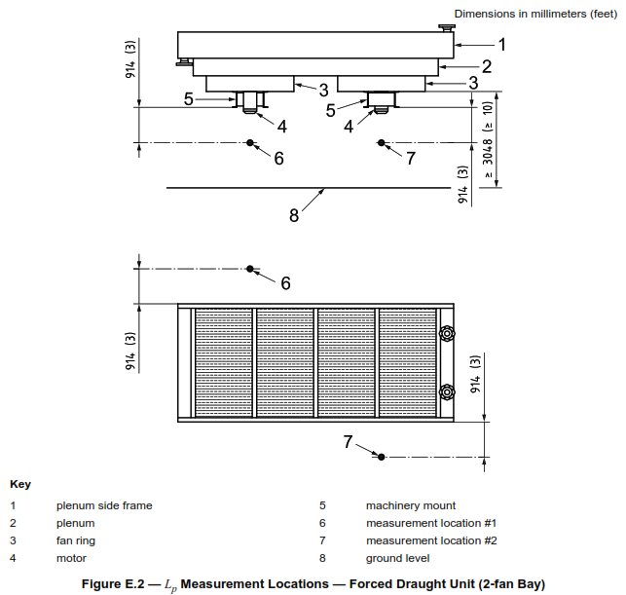

API 661 EDITION 17TH REAFFIRMED 2018, FIGURE E.2-Lp measurements location – forced draught unit

12.0. SAMPLE OF RUN-IN TEST RECORD SHEET

