STYRENE PARK OFFSITE

Document Title:
Installation, Operation & Maintenance (Manual)
R0 | 09-03-2025 | IFA | K.BASAMI | J.BEIGLOO | A.GHOLIZADEH
Rev. | Issued Date | DESCRIPTION | PREPARED | CHECKED | APPROVED

REVISION RECORD SHEET
Page | Revisions |  |  |  |  |  |  |  | Page | Revisions
Page | R0 | R1 | R2 | R3 | R4 | R5 | R6 |  | Page | R0 | R1 | R2 | R3 | R4 | R5 | R6
1 | X |  |  |  |  |  |  |  | 41 | X
2 | X |  |  |  |  |  |  |  | 42 | X
3 | X |  |  |  |  |  |  |  | 43 | X
4 | X |  |  |  |  |  |  |  | 44 | X
5 | X |  |  |  |  |  |  |  | 45 | X
6 | X |  |  |  |  |  |  |  | 46 | X
7 | X |  |  |  |  |  |  |  | 47 | X
8 | X |  |  |  |  |  |  |  | 48 | X
9 | X |  |  |  |  |  |  |  | 49 | X
10 | X |  |  |  |  |  |  |  | 50 | X
11 | X |  |  |  |  |  |  |  | 51 | X
12 | X |  |  |  |  |  |  |  | 52 | X
13 | X |  |  |  |  |  |  |  | 53 | X
14 | X |  |  |  |  |  |  |  | 54 | X
15 | X |  |  |  |  |  |  |  | 55 | X
16 | X |  |  |  |  |  |  |  | 56 | X
17 | X |  |  |  |  |  |  |  | 57 | X
18 | X |  |  |  |  |  |  |  | 58 | X
19 | X |  |  |  |  |  |  |  | 59 | X
20 | X |  |  |  |  |  |  |  | 60 | X
21 | X |  |  |  |  |  |  |  | 61 | X
22 | X |  |  |  |  |  |  |  | 62 | X
23 | X |  |  |  |  |  |  |  | 63 | X
24 | X |  |  |  |  |  |  |  | 64 | X
25 | X |  |  |  |  |  |  |  | 65 | X
26 | X |  |  |  |  |  |  |  | 66 | X
27 | X |  |  |  |  |  |  |  | 67 | X
28 | X |  |  |  |  |  |  |  | 68 | X
29 | X |  |  |  |  |  |  |  | 69 | X
30 | X |  |  |  |  |  |  |  | 70 | X
31 | X |  |  |  |  |  |  |  | 71 | X
32 | X |  |  |  |  |  |  |  | 72 | X
33 | X |  |  |  |  |  |  |  | 73 | X
34 | X |  |  |  |  |  |  |  | 74 | X
35 | X |  |  |  |  |  |  |  | 75 | X
36 | X |  |  |  |  |  |  |  | 76 | X
37 | X |  |  |  |  |  |  |  | 77 | X
38 | X |  |  |  |  |  |  |  | … | X
39 | X |  |  |  |  |  |  |  | 93 | X
40 | X |  |  |  |  |  |  |  | 94 | X

Table of Contents
SECTION | CONTENTS | PAGE
1 | Introduction | 4
2 | Thermal Datasheet | 5
3 | Installation & Erection: | 11
3-1 | Description | 12
3-2 | Assembly Procedure of a Forced Draft Air-Cooler | 13
3-3 | Anchoring Verification | 18
3-4 | Main Steel Structure & Walkway Assembly | 19
3-5 | Fan Hood | 22
3-6 | Installation of Forced Draft Fan Belt Arrangement | 25
3-7 | Belt Drive Installation | 29
3-8 | Tube Bundle Installation, Lifting and Transportation Procedure | 34
3-9 | Fan and Mechanism Guards | 38
3-10 | Equipotential Interconnection of Metallic Masses | 39
3-11 | Closure Sheets | 39
3-12 | Standard Tolerances | 40
4 | Maintenance & Operation: | 42
4-1 | Procedure for Introduction of the Process Fluid | 43
4-2 | Remedying Leakage Observed in Tube Bundle Test | 44
4-3 | The Air-Cooler Shuts Down Unexpectedly | 45
4-4 | Pre-Commissioning | 46
4-5 | Procedure for Fin Tube Maintenance | 48
4-6 | Protection of Tube Bundle Units | 50
4-7 | Machinery Component | 51
4-8 | Fan Shaft Bearing Lubrication | 53
4-9 | Lubrication of Fan Drive Electric Motors | 53
4-10 | Utility Consumption | 56
4-11 | Bolt and Plug Torque (Steel Structure, Header Box and Driving Parts) | 56
5 | APPENDICES (Datasheet of Components and Sub-Suppliers Manual): | 57
5-1 | Axial Fan Datasheet | 58
5-2 | Electric Motor Datasheet | 69
5-3 | Belt and Pulley Datasheet | 80
5-4 | Vibration Switch Datasheet | 86

1. INTRODUCTION
These instructions have been prepared to facilitate the erection, installation and maintenance of equipment supplied by DTT and offer customers best procurement conditions and delivery time of detail and spare parts requested.
The equipment assembly and erection operation procedures within this document shall be handled by qualified personnel with experience in the field of air-cooler erection in full compliance with API 661.
Erection and commissioning shall be carried out in strict conformity with the instructions of this manual. Any problems regarding the implementation of these instructions shall be filed and reported to DTT in writing (via email or fax) after sale service spec manual, which will answer as soon as possible.
DTT’s responsibility cannot be engaged when the clauses of this document are not met, furthermore should any issue arise, please contact DTT.
Damafin Thermal Technology Co. (DTT)
Zamyad Street, Iran-Khodro Blvd., 14th Km Karaj Road, Tehran, Iran
Tel: (98) 21 44922312-14
Fax: (98) 21 44922494
Email: sales@damafin.com

DETAIL/SPARE PARTS PROCUREMENT

SPARE PARTS AND SERVICE DEPARTMENT
For procurement of detail and spare parts, please contact DTT Sale Service Department. When ordering, please specify the following information:
DTT job No. (for example: 21105, 23153, 26102…).
DTT serial No. which is stamped on the tube bundle unit nameplate.
Item No. (for example: E601, 172 A01, etc.).
Description and reference No. of part.

MARKING SYSTEM
To facilitate the picking of parts, they are marked in the following pattern:
- 1st group: 3 Number Characters >> DTT's job number (DTT’s job number for this project is 1158)
- 2nd group: 1 Letter following a 2-Digit Number >> DTT's item number (DTT’s Item Code: A, B, C, … following DTT’s Bank Number:01, 02, 03, …)
- 3rd group: Numbering Code for Document (for common parts such as steel structure part number, see general part list)
- 4th group: 2 Number Characters >> Representing Document Series Number

Example: steel structure part of item: Drawing no.: 1158-A01-1100-00
Marking: Column: CL-1 or 1111-00
Note: some of identical parts for all items are not marked, such as
- Tie Rod
- Butt Straps
- Special Washer

2. THERMAL DATASHEET

3. INSTALLATION AND ERECTION

3.1 DESCRIPTIONS
The following documents should be consulted before undertaking erection:
- This Instruction Manual
- Outline Drawing
- Supporting Steel Structure Erection Diagram
- Fan Drive Machinery Diagram
- Service Walkway Assembly and Installation Diagram
- Parts and Hardware Lists

Erection Sequence:
1 - Anchoring Verification
- Verification of Pieces
- Pipe Rack Level

2 - Main Steel Structure
- Civil Engineering Level
- Assembling

3 - Fan Hoods
- Fan Plenum
- Fan Ring

4 - Fan & Drive
- Bearings
- Speed Reducer (Belt & Pulley)
- Fans
- Motors

5 - Bundles
- Lifting

6 - Louvers
- Assembly
- Adjustment

7 - Finishing
- Guard
- Ladder and Walkway
- Sealing Strips

3.2 ASSEMBLY PROCEDURE OF A FORCED DRAFT AIR-COOLER
Pre-Assembling on the Ground in Modular or Semi-Modular Way

Lifting of The Pre-Assembled Tube Bundle onto The Rack or Platform:
Stage 1 - Front View of a Forced Draft Air-Cooler Unit. (Figure 3-1)
A Column
B Bracing
C Beam
D Tube Bundle
E Louver
F Plenum
G Fan Ring
H Fan Guard
I Support Mechanism

Stage 2 - 3D View of Assembled Steel Structure (Figure 3-2)

Stage 3 - including:
1- Assembly Operation of the Fan Ring and Plenums on the Ground
2- Assembly Operation of the Plenums and Structures (Figure 3-4)

Stage 4 - Assembling the Mechanisms on the Ground on Temporary Irons to be supplied by Company in charge of Assembly Operation (Figure 3-5)

Stage 5 - Fastening of the Mechanisms under the Fan Ring and Plenums of the uneven Modules (Figure 3-6)
The mechanisms of the even units will be lifted onto the platforms to be installed there after the modules and units are lifted. The fans can be installed also on the uneven modules.

Stage 6 - Lifting of the Tube bundles and Louvers (Figure 3-7)

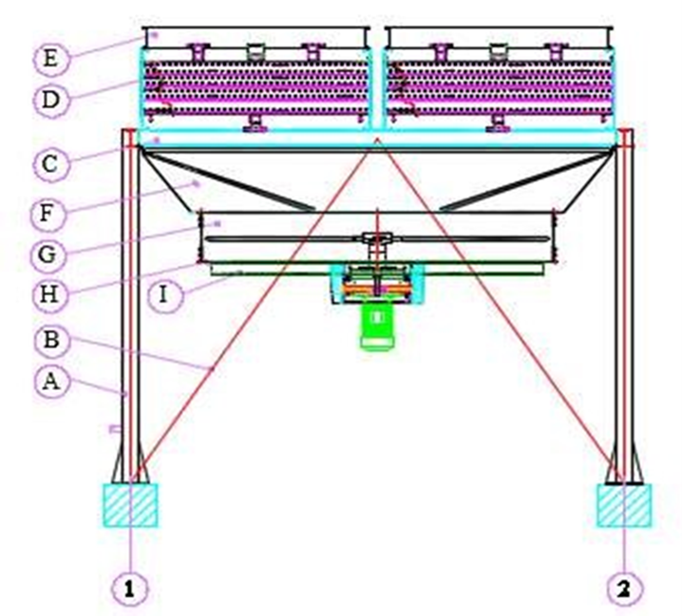
Figure 3-1

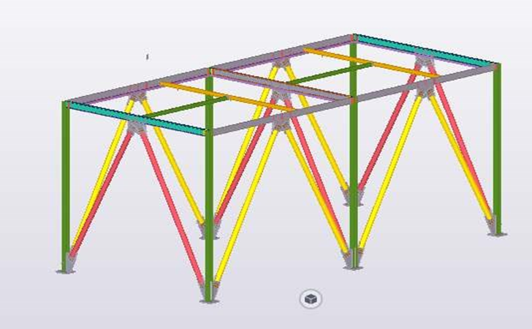
Figure 3-2
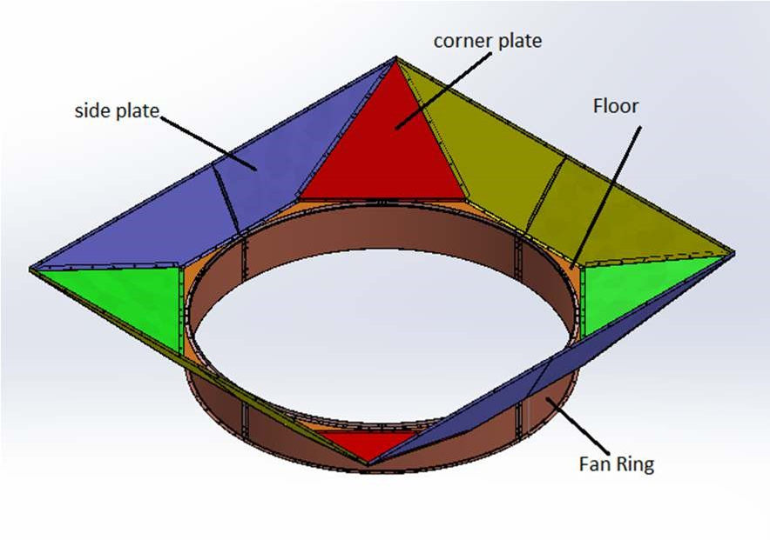
Figure 3-3

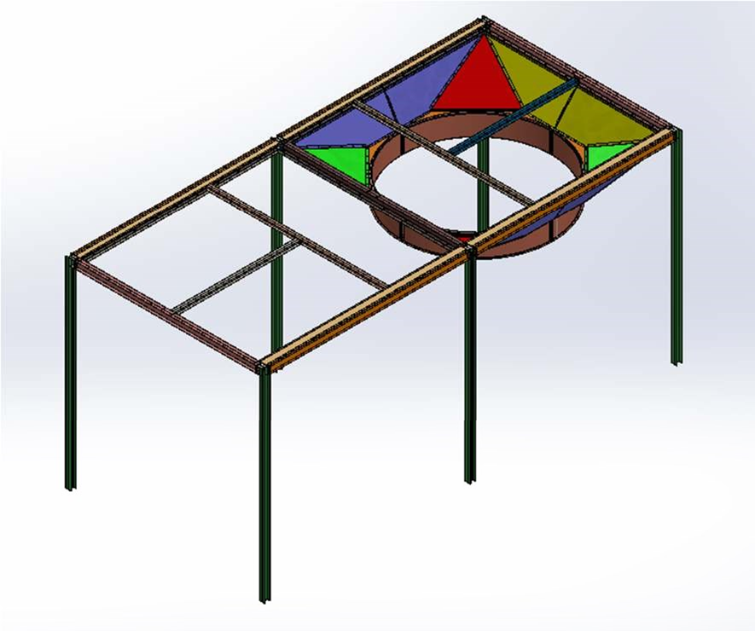
Figure 3-4
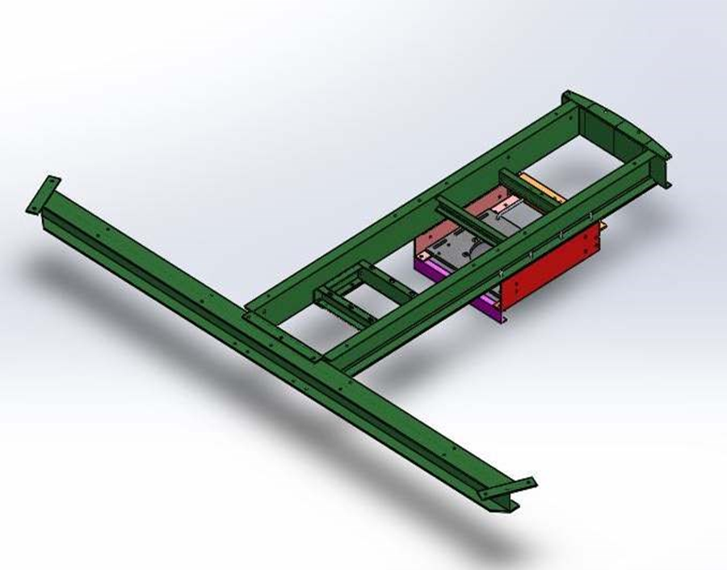
Figure 3-5

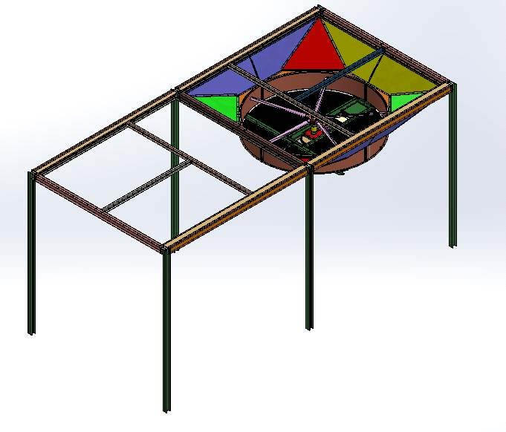
Figure 3-6
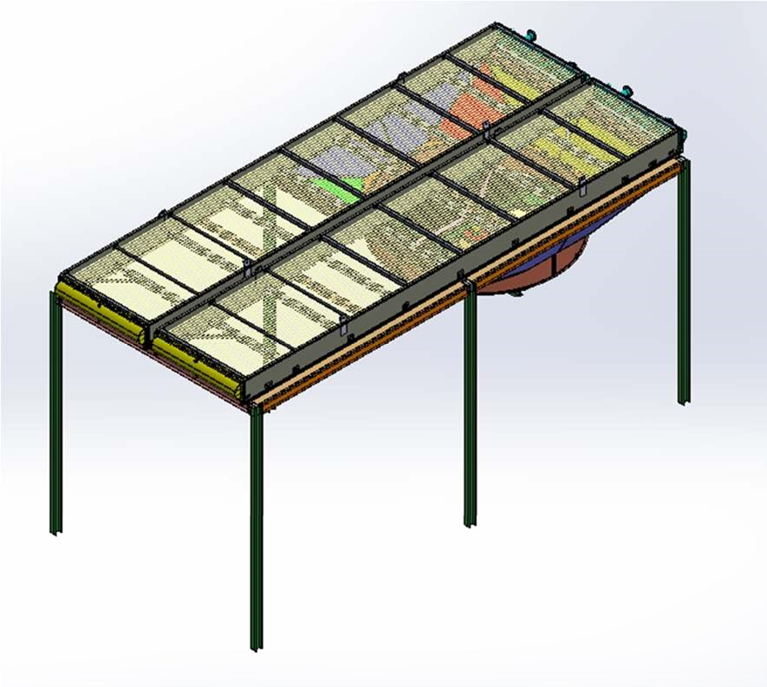
Figure 3-7

3-3 ANCHORING VERIFICATION
The foundations or supports (pipe rack) are to be supplied by the purchaser. They are to be in compliance with the dimensions shown on the DTT drawings as approved by the purchaser.

- Foundation Case
The top surface of foundation footings/slabs shall be leveled within maximum tolerance of +0mm/-30mm from the elevation as specified by DTT. Anchor bolts must be arranged according to the purchaser (see limit of supply on drawings).
- Substructure Case
The top surface of substructure which will be used as seating plan for items of equipment, as well as the holes drilled in it for bolts, must exactly comply with the dimensions shown on the DTT drawings approved by the purchaser.
The bolts to secure DTT items of equipment to the substructure top members are supplied by either DTT or the purchaser (see limit of supply on drawing).

IMPORTANT NOTE!
The erector must prior to undertaking erection work ensure that the substructure top surface is true leveled and flat, and they shall provide any shims required to obtain a true level seating plan.

3-4 MAIN STEEL STRUCTURE AND WALKWAY ASSEMBLY
The pieces of steel structure will be uncrated, picked out and verified with marks and quantities in regards to part lists.
The columns should be erected, if necessary, with shims under base plates so as to have their top flanges exactly at the elevation shown on DTT erection diagram. The cross beams, if any, as well as front and rear bracing members should be fitted then bolted. Finally, tighten the nuts of hook anchor bolts when bars have been previously embedded in concrete footings or place and grout the fishtail anchor bolts into concrete footing recesses.
For more information see “Steel Structure Drawing for Air Cooled Heat Exchanger (All Items)”.

WALKWAY ASSEMBLY
Consult DTT outline drawing, Platform installation diagram(s) and part list.
- Bolt walkway frame brackets to the main steel structure columns or, in some cases, to the tube bundle frame members.
- Bolt the walkway stringers onto walkway brackets or supports.
- Place and secure the flooring sections using hardware or screws supplied for that purpose.
NOTE! When flooring consists of dropped-tear or checked/serrated steel plates, they are sometimes shop welded onto walkway supporting structure.
- Install and secure ladders, after fitting the safety cages, if provided.

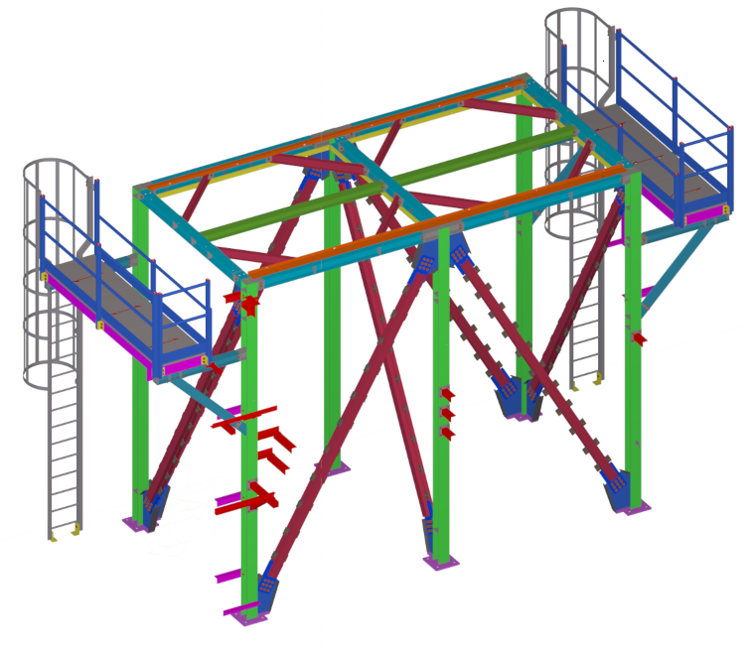
Figure 3-8 Steel Structure of Air Cooler
For Reference See “Steel Structure Drawing”
Document No.: EI027-DMF-VD-ST-DWG-013

3-5 FAN HOOD

3-5-1 Fan Ring Assembly
- On the floor, position the 4 quarter sections of fan ring.
- Connect the 4 quarter sections together, using the fixing plates with provided bolts and nuts. (See Fan Ring Drawing)
See Figure 3-9

3-5-2 Plenum Assembly on the Assembled Fan Ring
- Place the 4 quarter sections of floor plate (octagonal plates) on the corresponding side of the assembled fan ring.
- The octagonal plates junction shall be positioned at a 45-degree angle relative to the junction of fan ring sections.
- Install the angle brackets, superimposing them over the quarter floor. Link the angle brackets, quarter floor and ring with the hardware.
- Position the fan hood side sheets (trapezoid plates) to rest over the quarter floor plates. Link them to each other with the inside clamps. Maintain the side sheets at the ends using support parts (wooden blocks).
NOTE! The side sheets are symmetrical.
- Position the corner sheets (triangular plates) to rest over the quarter floor and link with the quarter floor and side sheets. (WARNING! The corner sheet butt plates are located outside the fan hood). The corner sheets are symmetrical.
The ring is locked after installation of the blades and adjustment of a correct clearance on the blade tip.
The butt plates enable the ring to be widened.
For storage purpose (according to the fan hood geometry) it is possible to stack 3-4 completely assembled plenums.
The screws are fitted with 2 washers, the nuts are located inside the plenum.
Fit the motors, the bearings, the fan pulleys and hub and accessories onto the machinery mount and assemble the unit according to the space requirement drawing(s).
See Figure 3-10 & 3-11

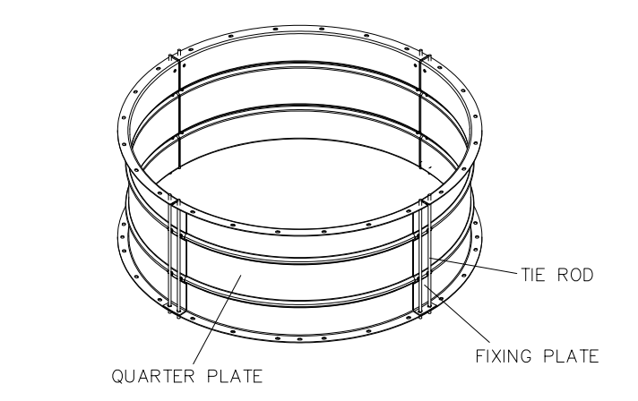
Figure 3-9 Assembled Fan Ring (All Items)

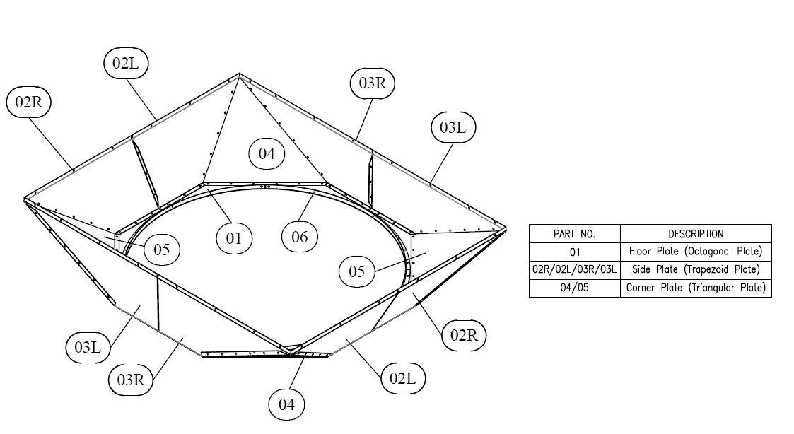
Figure 3-10 Double Section Side Plate Plenum (All Items)

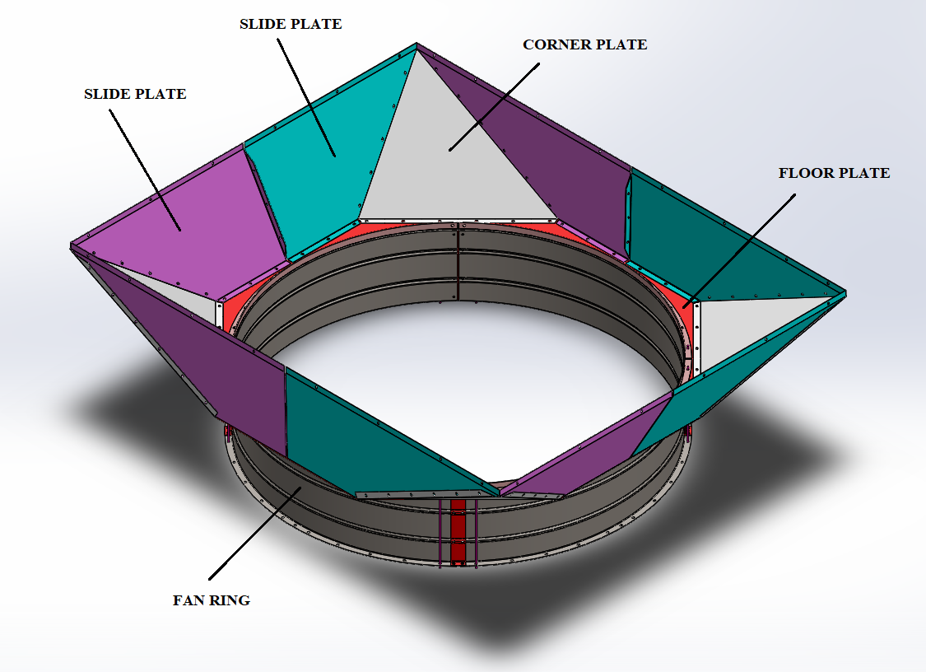
Figure 3-11 Assembled Fan Hood (Plenum + Fan Ring)

3-6 INSTALLATION OF FORCED DRAFT FAN BELT ARRANGMENT

3-6-1 INSTALLATION STEPS
- Mechanism support, fan ring and plenum are to be assembled on the floor before being lifted and installed on the structure under the bundle frame.
(See Figure 3-12)
- The mechanism support shall be horizontally level by means of tie beams.
(See Figure 3-13)
- After step B, the screws connecting different sections of plenum together and also the screws connecting plenum to fan ring shall be completely tightened.
- Install complete fan shaft assembly (Shaft+Bearing Blocks) on the mechanism support, but don’t tighten the bolts. (See Figure 3-14)
Note! The fan shaft comes pre-assembled to the site.
- Center the fan shaft with regard to the fan ring and make sure of its vertical alignment. After that, tighten the bolts connecting fan shaft to the mechanism support.
- Install the driven pulley on the fan shaft.
- Equip the motor with its motor support plate, the driver pulley and the motor support frame. (See Figure 3-15)
- Hoist the motor assembly (electric motor + motor plate + motor support frame) and bolt it to mechanism support.
- Slide the fan propeller hub to let it rest on shaft shoulder. Tighten hub securing bolts, then install the fan blades at angle setting required on project’s thermal or fan datasheets. (See Figure 3-16)
(Refer to fan manufacturer’s instructions attached in section 5.)
WARNING! Set the fan ring inside diameter to obtain 6-10 mm or 8-15 mm tip clearance for reinforced resin or aluminum blades respectively.
- Unscrew the grease nipples from the fan shaft bearings to screw them into the lubrication block fitted on the side of the motor supporting frame (See Figure 3-17). Then connect copper (or stainless steel) lubricating lines between the two shaft bearings and the block using the fittings provided for this purpose.
- Then install the belt of the fan drive systems.
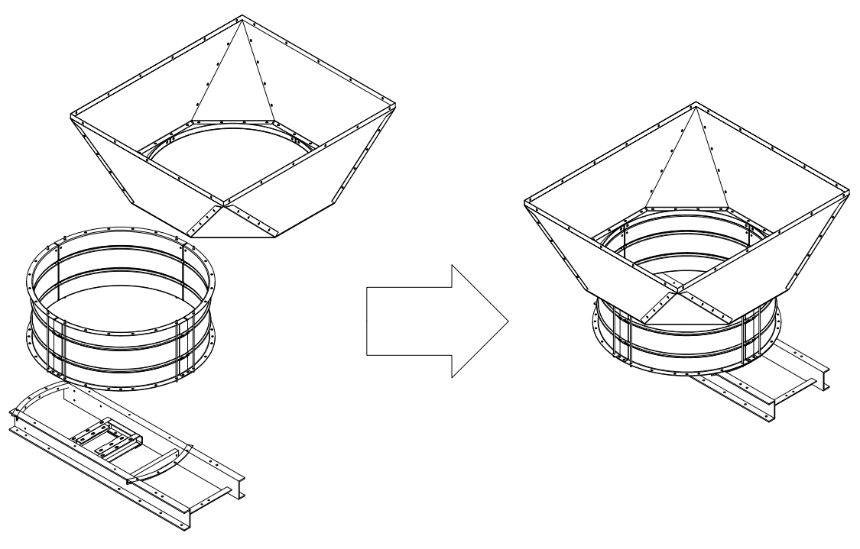
Figure 3-12 Assembly of Mechanism Support, Fan Ring & Plenum on the Floor
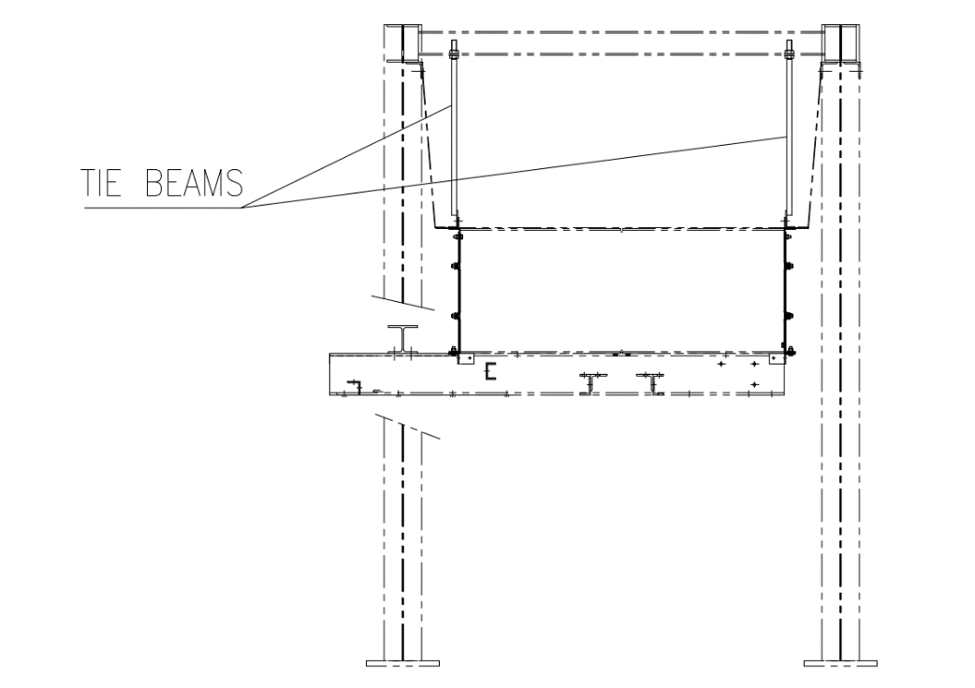
Figure 3-13 Connecting Support Mechanism + Fan Ring + Plenum
to Structure and Leveling by Tie Beams
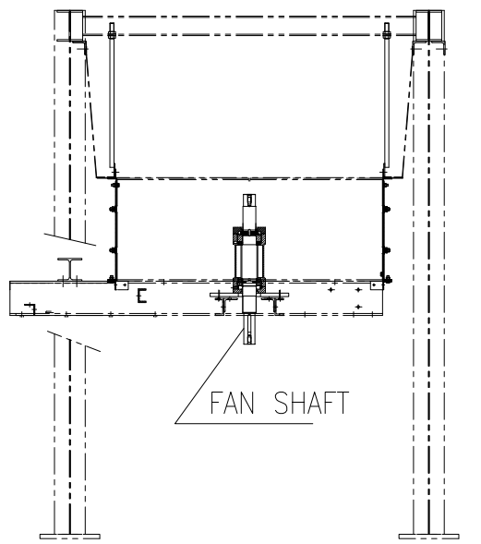
Figure 3-14 Installation of Fan Shaft on Mechanism Support

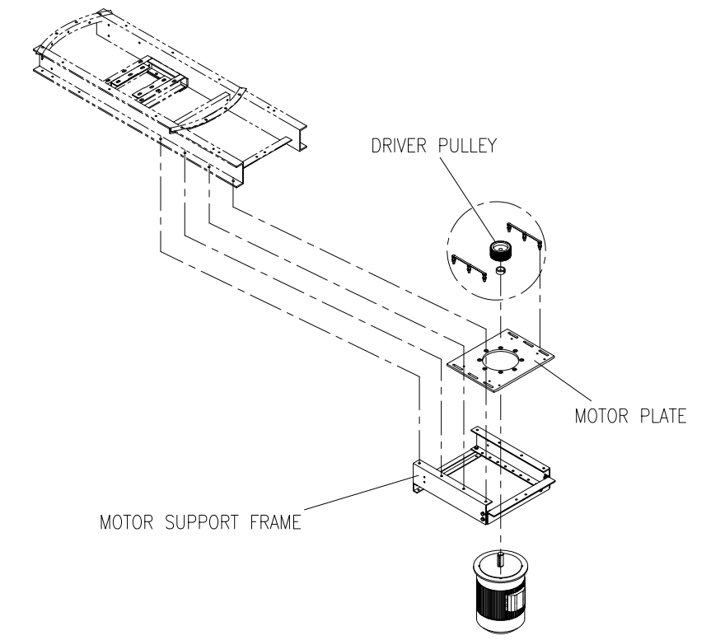
Figure 3-15 Motor Installation on Mechanism Support
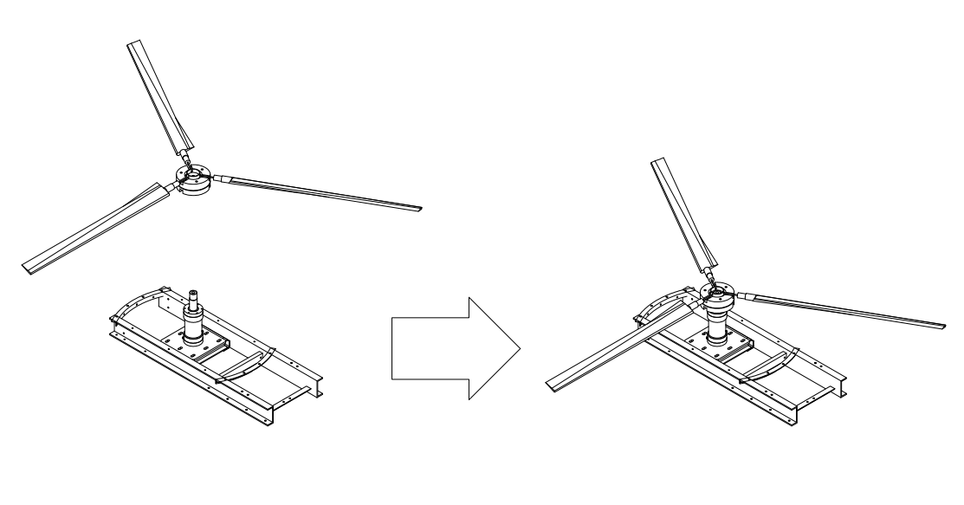
Figure 3-16 Fan Blade Assembly on Shaft Shoulder
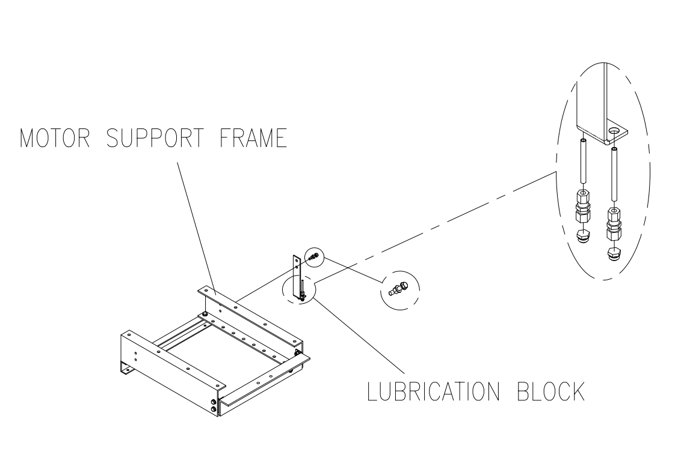
Figure 3-17 Lubrication Block Location

3-7 BELT DRIVE INSTALLATION
- Paying special attention to the Machinery Diagram, make sure that motor baseplate is properly resting on the supporting slide members.
- Align the driven pulley on the driving pulley. Both pulleys must be within one horizontal plane (see instruction on the following page).
- After locking the pulley mounting hub bolts, check alignment again and correct if needed.
- Loosen the motor securing bolt and slide the motor towards the fan shaft. Place the belts (see instructions on the following page) and tension them by means of the tensioning screws.
- Turn fan propellers by hand to ensure that they operate freely and there are no obstacles to their starting up. Switch on the motors for an instant to check that the direction of rotation and blade positions are compatible. The leading edge is the thicker edge, which must be downwards. For reverse rotation, the motor supply phases should be reversed.
- Check the motor power required, which must comply with the data (see the following page). Should power requirements not comply with specifications, adjust the blade angle accordingly.
- Finally, install the belt guards.

3-7-1 PULLEY ALIGNMENT DIAGRAM
Align the driven pulley on the driving pulley. Both pulleys must be within one horizontal plane. After locking the pulley mounting hub bolts, check alignment again and correct if needed. (See figure 3-18)
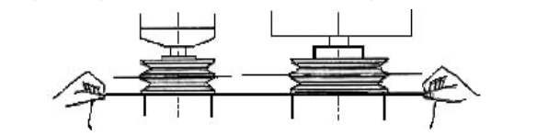
Figure 3-18 Pulley Alignment

3-7-2 INSTALLATION OF BELTS
Belts must be installed without induced forces. Some severe stresses would be placed upon belts if they are forced over the sheave flanges. It can seriously damage the cover fabric and the high quality, low stretch tension members.

3-7-3 BELT TENSIONING
The load C is to be applied at the right angle at the center of the belt span (See Figure 3-19). The drive must be tensioned until the calculated deflection F_{a} is obtained.
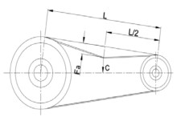
Figure 3-19 Belt Tensioning Load

For a first tension (new belts), take into account C for new belts. See Table 3-1 to check the values required to proceed with the following tensioning procedure:
Place gauge with load hook “A” in the center of the belt span with slider “B” overhanging to next the belt in set as illustrated. (See Figure 3-20)
Apply appropriate load (see Table 3-1) to belt section. At this load upper end of slider “B” should just come into contact with top of next belt in set for deflection F_{a}.
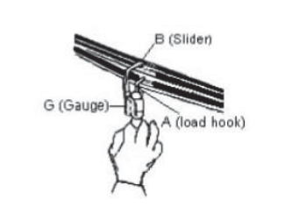
Figure 3-20 Belt Tensioning Procedure
Table 3-1
Item No. | BELT TYPE | TEST LOAD (N) | DEFLECTION (mm)
AIR COOLER | V-Belt  Profile: NARROW (SPA) | New: 69  Used: 60 | New: 11.6  Used: 11.6

3-7-4 CHECKING THE BELT DRIVES
- Check the free rotation of fan by turning the fan propeller manually.
- Check that whether belts are properly tensioned.
- Switch on the motors for an instant to check if the direction of rotation is consistent with the blade angle and to ensure that there is no excessive vibration and overheating. Also record power requirements (measure current, power, etc.) and check if they comply with specifications.
- After 5 to 10 hours in operation, take up the belt tension as required.

Procedure to Adjust Electric Fan Drive Motor Current Absorbed with Unit Being Shut-Down

NOTATION
$$P=Absorbed Fan Power \left(kW\right)-Refer to Fan Datasheet$$
$$U=Line Voltage$$
$$I=Absorbed Current, Measured at Site while Fan Working$$
$$I_{s}=Calculated Absorbed Current$$
$$I_{r}=Absorbed Current, Corrected for Different Fan Blade Pitch Angle$$
$$E_{m}=Motor Efficiency$$
$$E_{d}=Drive Efficiency$$
$$PF=Power Factor$$
$$K=Correction Factor for Fan Blade Pitch Angle$$
$$T_{c}=Deliver Air temperature$$
$$T_{a}=Fan Outlet Air Temperature, Measure at Site$$

CALCULATING ABSORBED CURRENT UNDER OPERATING CONDITION
- Item No.: Air Cooler(@ Min. Temperature)

- Fan Data
P (Fan Absorbed Power) = 4.5 kW
E_{d} (Drive Efficiency) = 95 % (V- Belt)
- Motor Data
E_{m} (Motor Efficiency) = 90.4 %
PF (Power factor) = 0.84

$$I_{s}=\frac{1000×P}{\sqrt{3}×U×PF×E_{d}×E_{m}}$$

$$I_{s}=\frac{1000×4.5}{\sqrt{3}×400×0.84×0.95×0.904}=9.2 A$$

CORRECTING CALCULATED ABSORBED CURRENT FOR FAN PITCH ANGLE

$$I_{r}=I_{s}×K$$

$$K=\frac{273+T_{c}}{273+T_{a}}$$

For a forced draft unit, T_{c} equals the inlet air temperature (the lesser of the two specified on fan datasheet). If “I” measured during operation is different from I_{r}, adjust fan blade pitch so as to achieve I_{r}.

WARNING!
The “I” measured during operation shall never be exceeding the rated current specified on motor nameplate. If this happens, please inform DTT.

3-8 TUBE-BUNDLE INSTALLATION
When lifting a very large unit, it is recommended to use a 4-leg sling arrangement of sufficient length and place cross-bars between the lifting lugs to prevent any warp to tube-bundle frame (refer to figure 3-21).
Very large tube bundles are supplied by DTT equipped with cross bars between the lifting lugs. When bundles are delivered uncrated two by two, only the upper tube-bundle is equipped with cross bars (those are to be removed for handling the second tube-bundle).
Finally, remove transport temporary clips from tube-bundle frame and protective material from fin-tube layers as well as the cross bars.

IMPORTANT NOTE!
To avoid any damage to fin-tubes, refer to recommendations on diagram.
When the items are equipped with heating bundle, it is necessary to fix them under tube-bundle units; using special hardware components itemized in DTT part lists before lifting them on steel structure.

VERIFICATION OF BUNDLE INSTALLATION
Check that bolts connecting the sliding header to the side frame are removed after installation to allowe the free expansion of the tubes during operation.
Check that the protection material had been removed and do not get in the way of air flow. If required check that the sealing sheets are set between the bundle of the same bay to avoid the bypass of cooling air.
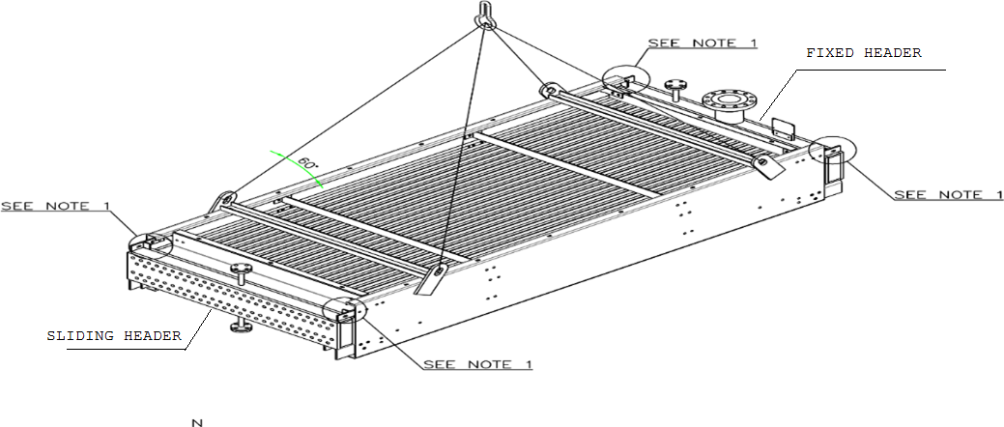
Figure 3-21
Note 1: Bolts which are used for fixing header to side frame should be locked during transportation. But make sure to remove these bolts on the sliding header side to allow free expansion of tubes during operation.

3-9 FAN & MECHANISM GAURDS
After complete installation of fan and belt drive system, assemble the guards for each item as shown on diagrams below.

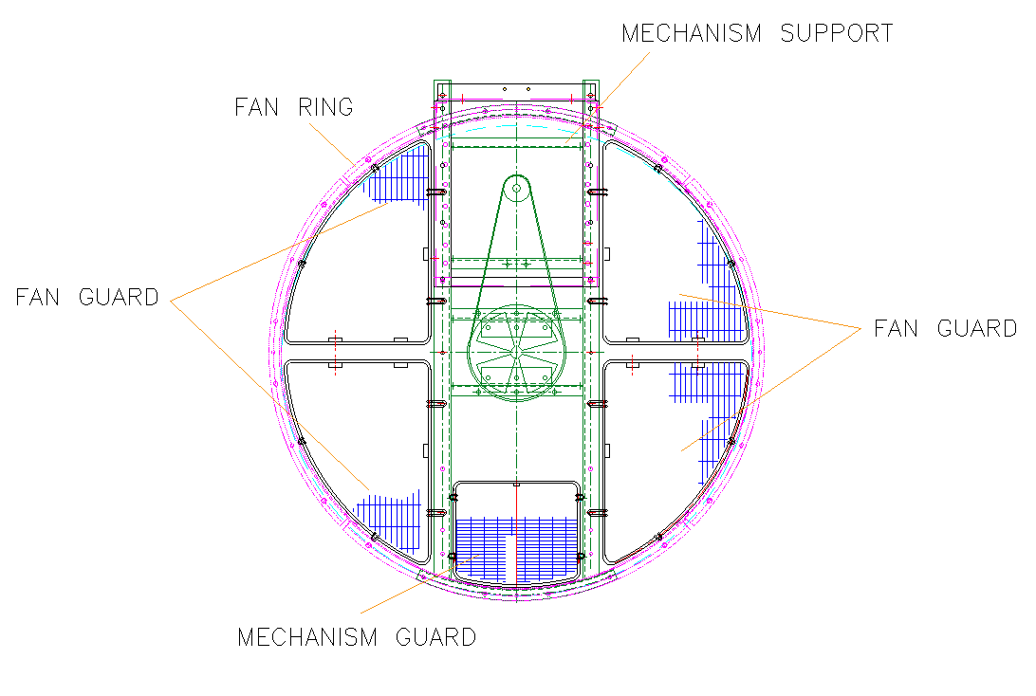
Figure 3-22
For Reference See “Fan Drive Assembly Drawing For Air Cooled Heat Exchangers ”
Document No.: EI027-DMF-VD-ME-DWG-008

3-10 EQUIPOTENTIAL INTERCONNECTION OF METALLIC MASSES
Subsequently to complete assembling of all parts and for safety reasons the equipotential interconnection of metallic masses must be ensured.
For this purpose, all headers and hoods, as well as the 2 columns in the middle of each row, are fitted with an earthing lug (see General Arrangement Drawing). The fitter will have to connect these earthing lugs through some 35 mm2 section stranded copper wire.
The connections of all further bolted metal parts shall be ensured through weld seams or spots protected by paint or varnish compatible with the basic protection coating (see General Arrangement Drawing).

3-11 CLOSURE SHEETS
When several bundles are fitted under a common fan hood it is necessary to equip those with sealing sheets to avoid the "By-pass" of the air.

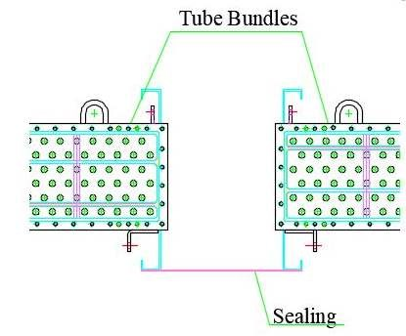
Figure 3-23
For Reference See “General Arrangement Drawing For Air Cooled Heat Exchangers (All Items)”

3-12 STANDARD TOLERANCES

3-12-1 Standard Tolerances for The Dimensions of Air-Cooler Tube Bundles
The standard tolerances for assembly dimensions of air-cooler tube-bundles are shown below. Tolerances apply to both forced-draft and induced-draft units.
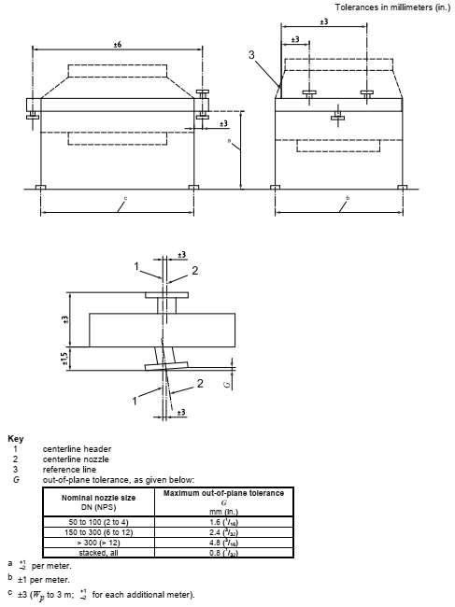

3-12-2 Standard Tolerances for Shaft and Pulley Alignment
Offset and Angular Tolerances are as per figure below:

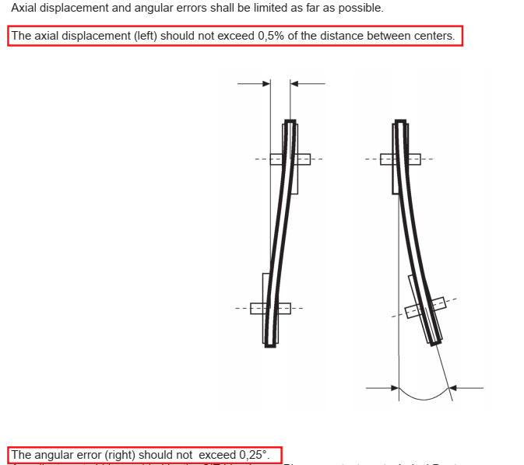

4. MAINTENANCE AND OPERATRION

4-1 PROCEDURE FOR INTRODUCTION OF THE PROCESS FLUID
- During starting up process it is advisable to limit the thermal shock to the tube-bundle and also to avoid a brutal cooling during periods of low ambient temperature and low heat load.

- It is advisable to take certain special precautions when starting up units intended to release heat from process fluids with the following properties:
High viscosity fluids; fluids whose pour point is above the ambient air temperature
In many cases where fluids with these properties are circulating in air-coolers, the units are equipped with one or more of the following systems, aimed at eliminating such problems in starting and during operation: Manually or automatically controlled louvers, steam-coils and auto-variable pitch fan propellers.
Start-up problems are much reduced with units thus equipped. Before introducing the process fluid, close the louvers, start to circulate steam through the coils and switch off the fans.
Progressively increase the fluid flow until the normal rate is reached. Then gradually open the louvers, shut off the steam inlet and start the AV fans. Watch carefully the temperature of the output fluid during all this period and, if there is a risk of excessive cooling, run the heating steam.
For the units without louvers nor steam-coil, the process fluid should be introduced rapidly in order to avoid excessive cooling of the initial charge of fluid in contact with the cold tubes. It is advisable, however, to avoid any fluid pressure surge.

- In order to release heat from a process fluid having a low viscosity and a very low pour point, the starting procedure will be somewhat simplified. First of all, start up the fans, then admit the process fluid, initially with a low rate of flow, but gradually increase it to the required value.

4-2 REMEDYING LEAKAGE OBSERVED IN TUBE-BUNDLE TEST
Check that assembly bolting is screwed and locked.
Every tube-bundle unit has been subjected to a hydrostatic pressure test in manufacturer's shop. Nevertheless, in order to check that it has not been damaged during transport or erection, it is advisable to subject the tube-bundle and the associated piping, circulating pumps, etc. to further hydraulic proof test, before starting up the plant.

The tube-bundle units will be delivered perfectly leakproof after being subjected to tightness test. However, should any leak be found (which may occur where tube-bundle units have been stored for a period of time) proceed as follows:
- LEAKAGE AT TUBE SHEET HOLE EXPANDED TUBE JOINT
- Remove cover plates of header.
- Roll in the tube a little further
- Replace the cover plates after changing the gaskets
- Re-pressurize to check the tightness. Repeat this procedure if seal is not perfect.

- LEAKAGE RESULTING FROM CRACK IN A FAULTY TUBE
In such case, both ends of the faulty tube must be blocked. Proceed as follows:
Remove the cover plates of header
Cut through the faulty tube at one end, a few millimeters from the tube sheet before the start of the finned section of the tube, using an inner tube cutter. - This is a must to prevent the tube acting as a tie-rod between the two box headers.
Using the special mandrel provided by the manufacturer, insert a taper plug into each end of the leaky tube.
Gently hammer in the taper plugs.
Replace the cover plates and new gaskets.

4-3 THE AIR-COOLER SHUTS DOWN UNEXPECTEDLY
In this occasion following steps shall be regarded:
- Motor power supply line shall be checked.
- If electrical power line has been disconnected by the vibration switch, check the vibration switch to ensure that it works in proper condition, otherwise, the other vibration possibilities in system shall be checked.
- Power transmission system included pulleys, belts and fans also inside surface of fan rings shall be checked. Moreover, the bolted connections of motor to motor-support as well as housing to housing-support shall be visually checked in order to distinguishing any vibration.
- Proper operation of pulleys, belts, motor bearings and housing bearings shall be checked while motor is running.
Note! Before starting the motor, following steps must be taken:
- Rotate the fan by hands in order to ensure that the fan blades have no clash with inside surface of fan ring.
- Start the fan for a moment (ON/OFF) to check if any abnormal vibrations exist.
- Any fault in components operation that mentioned above shall be maintained (please contact the producer if required).

4-4 PRE-COMMISSIONING
Document title: Shop run-in test procedure
Checking the tip gap between the end of the blade and the fan ring in accordance with API 661 requirements (Using a ruler).
Fan testing of the machinery by rotation test (Clockwise).
Control of the fan speed according to the specifications of the fan (Using an achy meter).
Record of the absorbed intensity and voltage measurement (using an ammeter).
Power of items plus ambient condition shall be recorded.
Checking of the structure and mechanism vibrations in conformity with the applicable code or the fan supplier´s requirements. Using a vibro-meter and filling up the vibration table (QF-23 as shown at next page).
Point of vibration measuring shall be min 3 points (are shown below), each point related to one direction. For each measuring item, RMS and peak to peak shall be recorded.
Structural members shall be designed to minimize vibration, the maximum amplitude of vibration over the design fan-speed range shall be 0.15mm (0.006 inch) from peak to peak, as measured on primary structural members and machinery mountings (acc. to 7.3.2.1 API 661).

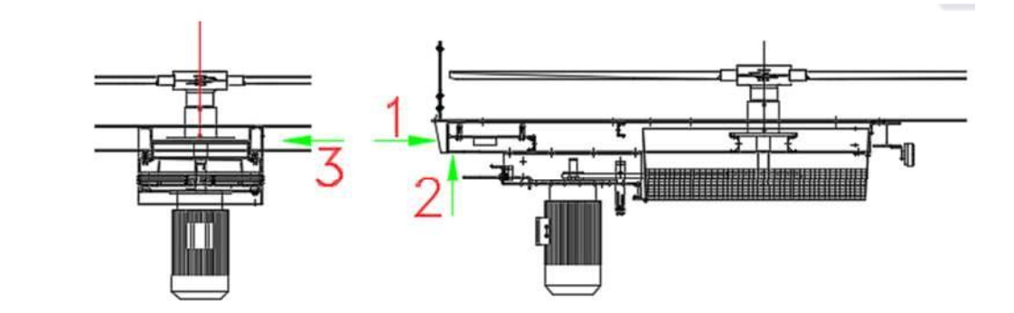

Figure 4-1 Test for Motor and Fan Vibration

 |  |  | VIBRATION RECORD RUN-IN TEST
Report No.:
Project Name/DTT Job No.: |  |  | CONCEPTUAL, BASIC and DETAIL DESIGN ENGINEERING OF STYRENE PARK OFFSITE / 1158
Reference Doc. Name/No.:
Item No.: |  |  | Air Cooler
Sketch:
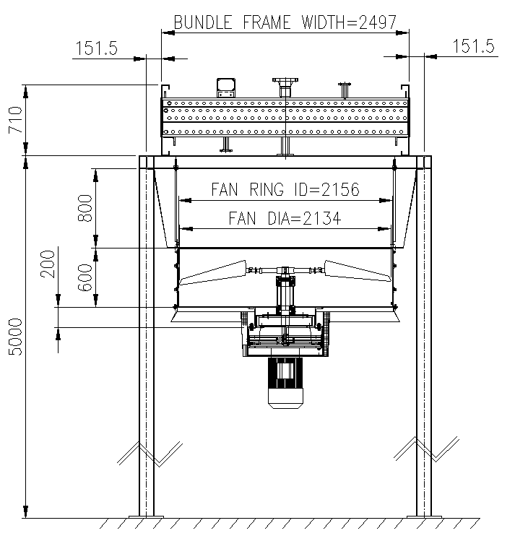
Measure Point |  | 1 |  | 2 |  | 3 | RPM
Displacement Speed (mm/s) |  |  |  |  |  |  | Motor
Displacement (µm) |  |  |  |  |  |  | Fan
DESCRIPTION:
Vendor | PMC |  |  |  | TPA |  |  | OWNER
Name: | Name: |  |  |  | Name: |  |  | Name:
Date: | Date: |  |  |  | Date: |  |  | Date:
Sign: | Sign: |  |  |  | Sign: |  |  | Sign:

4-5 PROCEDURE FOR FIN TUBES MAINTENANCE (Instructions for tube cleaning)

4-5-1 INTERIOR CLEANING OF FIN-TUBES
The methods used for the cleaning of the inside of air-cooler tubes are the same as for conventional shell-and-tube heat-exchangers;
1. Mechanical Cleaning
This method consists of drills or wire brushes fitted to long rods which are rotated by a compressed air motor. This method is normally completed with a water rinse or a blowing out. It is not an advised method for the removal of tarry deposits.
2. Chemical Cleaning
This method consists of circulating a hot chemical solution through the tubes. Such solutions contain inhibitors against tube wall corrosion.
It is recommended to contact a specialist and to supply him with a sample of the fouling deposit, in order to choose the most appropriate chemical solution. Each tube-bundle has to be fitted with inlet and outlet pipe fittings (1 1/2" to 3") to facilitate the passage of the solution. A circulating pump and a topping-up tank should also be available.
This method is becoming more popular in process plants because it reduces downtime and avoids disassembling the unit. It offers no advantage at all with blocked tubes.
3. High-Pressure Hushing Equipment
The use of these units (or "Hydro Jets") has become widespread in the U.S. and Europe during recent years. The tube cleaning can be accomplished by means of a portable HP pump. Generally speaking, such pumps have a capacity of 25 GPM with discharge pressures as high as 62 MPa. The sprinkler head is fitted at the end of a long tube, similar to that used for mechanical cleaning, and it is introduced into each tube individually. The best pressure is found by trial and error. Generally speaking, the softer the deposit, the lower water pressure needs to be. For example, an amine heat-exchanger can be cleaned with a water pressure of around 14 MPa. A scale deposit left by carbonated water requires a higher pressure ranging about 41 to 62 MPa. Here again, it should be emphasized that this is not suitable for blocked tubes. Those have to be mechanically cleaned.

4-5-2 OUTSIDE CLEANING OF FIN-TUBES (General)
The fouling of the extended heat-transfer or fin surfaces depends on the location of the unit, the kind of process, the ground conditions, foliage or other environmental factors, such as presence of other factories in the area.

The most common types of fouling are as follows:
A. Dirt or Dust
It accumulates over fins and between fins.
Sometimes, it collects as a fine powder and after being wetted, it forms a crusty deposit. Or alternatively, with oil, it can produce a mixture having the consistency of putty.

B. Lint, Popular Seeds, Down of Cotton Wool, etc.
C. Insects
D. Mixtures of Dust with Oil and Corrosive Substances

Generally speaking, only the two or three lower fin-tube rows will be found to be fouled. This indicates that the cleaning should be undertaken from the top downwards with the fan at standstill and shut-off valves closed. A preliminary examination should first be made to determine which type of cleaning would be best.
I. Air Nozzle
An air jet from a nozzle under a pressure of 0.22 MPa should normally remove dust powder and dry insects. One should ensure that the air jet is always within the plane of the fins to avoid bending them over. The nozzle usually consists of a 1-inch dia. pipe and 10-inch long, flattened at the end to from a tip about 1 1/4" across. The air is supplied via a hose, a control valve and a pressure gage.
II. Water Nozzle
A cold water-jet under a pressure of 0.22 MPa normally allows the removal of agglomerated dust and other impurities.
A fire hose with a 1" round-nosed jet should be satisfactory. As above, the jet should always he within the fin plane, to avoid bending them over.

III. Hot Water or Steam Jet
If the consistency of the fouling is such as to resist both the cold water and the air jet, an atomized spray of hot water or steam should be sufficient to clean the fins.
The steam nozzle can be made in the same manner as the air nozzle. How water can be obtained by means of a proportioning/mixing device fitted at the inlet of the steam nozzle.
IV. Chemical Cleaning
Normally, in 75% of cases, methods A, B and C will be sufficient to clean the fins. Nevertheless, there are times when the composition of the fouling is either chemical or organic. It is then necessary to consult a specialized chemical cleaning firm. With regard to chemical cleaning, great care must be taken. The cleaning fluid should be consistent with the fin material. The chemical cleaning specialist is familiar with these problems and is capable of supplying the proper cleaning solution.

4-6 PROTECTION OF TUBE-BUNDLE UNITS

4-6-1 EXTERNAL PROTECTION OF TUBE-BUNDLE UNITS
Where the unit is not equipped with control louvers, a canvas or plastic cover should be laid all over the top side of the tube-bundle to prevent the fins from becoming fouled by sand or dust deposits due to wind and/or natural air draft.
Where the unit is equipped with control louvers, the blades should be kept in closed position.

4-6-2 INTERNAL PROTECTION OF TUBE-BUNDLE UNIT
All of the inlet and outlet nozzle and connections should be shut off with blind flanges, one of which per tube-bundle on the side should be fitted with a valve, pressure gauge and blocking plug.
Then connect a nitrogen supply line to the blind flange with valve. Loosen the bolts at one of the inlet nozzle blind flanges to let air escape. Inject gas into tube-bundle so as to effective nitrogen flushing for about 10 minutes and thus to expel all of the air out of the unit.
Finally, re-tighten the inlet nozzle blind flange bolts and let nitrogen pressure build up to 300-500 Pascals so as to get tube-bundle pressurized.
Disconnect the nitrogen line and screw in the blocking plug to avoid any pressure drop in case of valve leak.

4-7 MACHINERY COMPONENTS
First, all drive motors should be taken down to be stored indoors. Then, every month, turn motor shafts by hand to distribute lubricant all over bearing parts.
DRIVE BELTS
General Storage Conditions
The physical properties of correctly stored belts will not change over a period of many years. In poor storage conditions and with incorrect handling, rubber products are, however, subject to changes in their physical properties. These changes can for example, be caused by effects of oxygen, ozone, extreme temperature, light, moisture and solvents.
The storage area should be dried, dust-free and reasonably well ventilated. Belts must not be stored close to chemicals, solvents, fuels, lubricants and acid.
Storage Temperature
The storage temperature should be between +59˚ F (+15˚ C) and +77˚ F (25˚ C). Normally, lower temperatures are not detrimental to Belts. However, since they become very stiff at low temperatures, they should be warmed to a temperature of approximately +68˚ F (20˚ C) before fitting to avoid ruptures and cracks.
Radiators and their supply lines should be guarded. The distance between a radiator and the stored Belts must be at least three feet.
Storage Lighting Conditions
Belts should be protected against light, especially direct sunlight and high ultra violet content (ozone formation) such as naked fluorescent tubes. Illumination utilizing conventional light bulbs is advisable.
Where possible, windows should be painted a red or orange protective paint. Under no circumstances should blue be used.
Ozone
In order to counteract the harmful effects of ozone, warehouses should not contain any ozone producing appliances, for example fluorescent lights, mercury vapor lights or high voltage electrical equipment. Combustion gases and vapors which may lead to the formation of ozone by photo chemical processes must be avoided or eliminated.

Moisture
Damp store rooms are unsuitable. Care must be taken to ensure that condensation does not occur. The most favorable relative air humidity is below 65%.
Storage Position
Because stresses can prompt both permanent deformation and the formation of cracks, care must be taken to ensure that Belts are stored without stress, i.e., without tension, pressure or any other form of deformation.
If Belts are stored horizontally and stacked upon each other, it is recommended that the stack height does not exceed 12 inches to avoid deformation. If to save space, belts are hung, the diameter of the cylinder on which the belts rest should be at least ten times the height of the belt section.
Cleaning
Contaminated belts can be cleaned using a 10:1 glycerin-spirit mixture. Benzene, benzol, and turpentine amongst others must not be used.
In addition, sharp edged objects, wire brushes, emery paper, etc. must not be used under any circumstances. Such action will seriously damage the belts.
PULLEY
Thoroughly clean all the pulley grooves, then coat spray anti-rust compound all over the groove sides.
FAN and DRIVE SHAFT
Clean all machined or exposed surfaces, then coat spray anti-rust compound all over.
BALL/ROLLER BEARING
Every month, turn the fan propelled and shafting by hand to distribute grease evenly all over the bearing parts. Then, every three months, inject grease to prevent any blocking of the lubrication lines possibly due to grease hardening.
Whenever the fan propeller and shafting have been turned, it is a must to secure them at standstill.

FAN UNIT
Fixed Blade Propeller: no particular care is required for bladesSelf-Adjustable Pitch Angle Blade Propeller: every month operate pneumatic control system to actuate blade control linkage so as to prevent hub internals from sticking.
FAN PITCH CONTROL SYSTEM
The pneumatic control system should be supplied with nitrogen and not with air, which even with a very low moisture content, can be detrimental to servo-actuators and controllers.
NOTE!
For protection of equipment, when not operated for long periods of time, the grease used must be a long-time non oxidizing preservation grease.

4-8 FAN SHAFT BEARINGS LUBRICATION
- 1st FILLING
Fan Shaft Upper Bearing
Fan Shaft Lower Bearing
Bearing Block Grease Capability: Around 0.5 kg
The lubrication lines must be filled with lubricant as well, which requires loosening line fittings at bearing housing. Then, using a grease gun, inject lubricant at the lubrication block nipples so that grease will flow out of the other end of line. Now loosen bearing housing fittings and inject again so that grease flows out at the bearings.
- PROCEDURE PRIOR TO STARTING-UP
Check that fan shaft bearings for grease packing are correct, and make up lubricant if required. Check that greasing for mechanical equipment is correct, and make up lubricant if required. See supplier's instructions.
- LUBRICATION OF FAN SHAFT BEARINGS
Lube each 20,000 hours with Athesia EP2 or equivalent. (See Table 4-1)

4-9 LUBRICATION OF FAN DRIVE ELECTRIC MOTORS
Motor bearings are packed with grease before leaving manufacturer's factory. When changing over to a new grade/brand of lubricant, it is necessary to take down the bearing, remove the old grease and clean thoroughly before repackaging with new grease.
WARNING!An excess of grease will be detrimental to bearing life.FITTING OF FAN SHAFT BEARING
Lubrication for Forced Draft Units

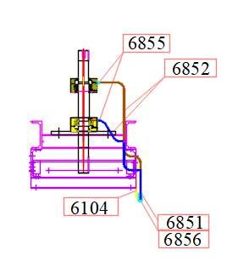
Figure 4-2 Fan Shaft Bearin Block

6851: Union Female Connector (1/8” NPT-8 mm (Tube))
6852: Tube (OD=8 mm, ID=6 mm)
6855: Union Male Connector (1/4” NPT-8 mm (TUBE))
6856: Grease Nipple (1/8” NPT)
6104: Lubrication Piping Support

LUBRICATION SCHEDULE (DS21-6701-01)
Table 4-1

 | Equipment | Bearing type | Lubrication  Method | Oil  Reservoir | Lubricant | Recommended Brand |  |  | Initial Charge  (1 Set) |  | Maintenance Frequency |  |  | Annual  Consumption  (for 4 Sets)
 |  |  |  |  |  | Shell | Total | Domestic  Brands | Quantity | Break-in Period | Inspection | Replace | Refill | Annual  Consumption  (for 4 Sets)
1 | FAN BEARING | BEARING: (set) | INJECTION | - | GREASE | See below table |  |  | 0.5 kg | 20000 h | - | - | 0.5 | 2 kg
Lubricant chart. (Standard)
SHELL ALVANIA G2 OR G3
TOTAL MULTIS 2 OR 3
ایرانول لیما EP2 یا EP3
بهران یاقوت EP2 یا EP3
نفت پارس، پارس لیتیوم (ماهان سابق) EP2 یا EP3

Note! All of these lubricant types are recommended based on related temperature range.

4-10 UTILITY CONSUMPTION
No. | Item No. | Power/Motor (kW) | QTY. | Total Consumption (kW)
1 | AIR COOLER | 7.5 | 4 | 30
 |  | TOTAL |  | 30

Table 4

4-11 BOLT AND PLUG TORQUE
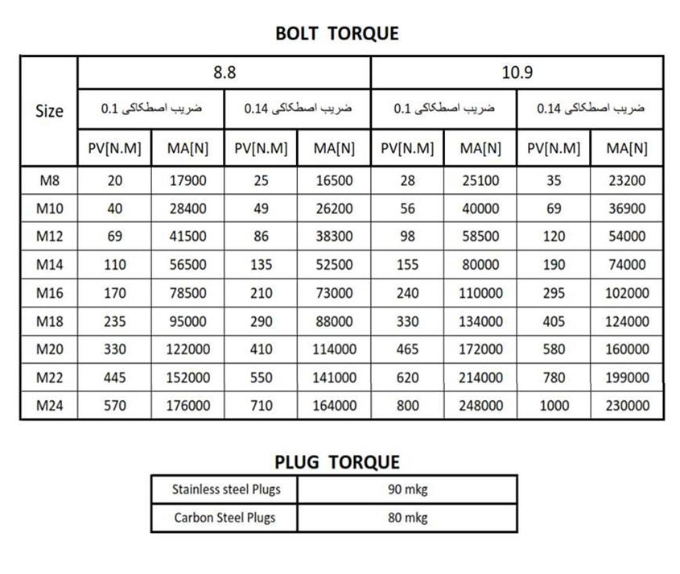

5. APPENDICES
(Datasheet of Components and Sub-Supliers Manual)

5.1 Axial Fan Datasheet

5.2 Electric Motor Datasheet

5.3 Belt and Pulley Datasheet

5.4 Vibration Switch Datasheet

