Mission Report – PetroElectric Project (PR-200), Dubai
Participants: Farshad Shoarian, Reza Ghodbouei
Report Prepared By: Farshad Shoarian
Date: May 20–24, 2025

Objectives and Tasks Completed:
- Drawing Review and Tubing Decision
All available drawings were reviewed and compared against the actual skid. Discrepancies were identified and final decisions regarding tubing were made.
- Verification of Delivered Items
A full inspection was carried out for all materials delivered to Nash. All components were found to be present except for the sight glass and strainer, which were missing. Will be followed up again on Monday.
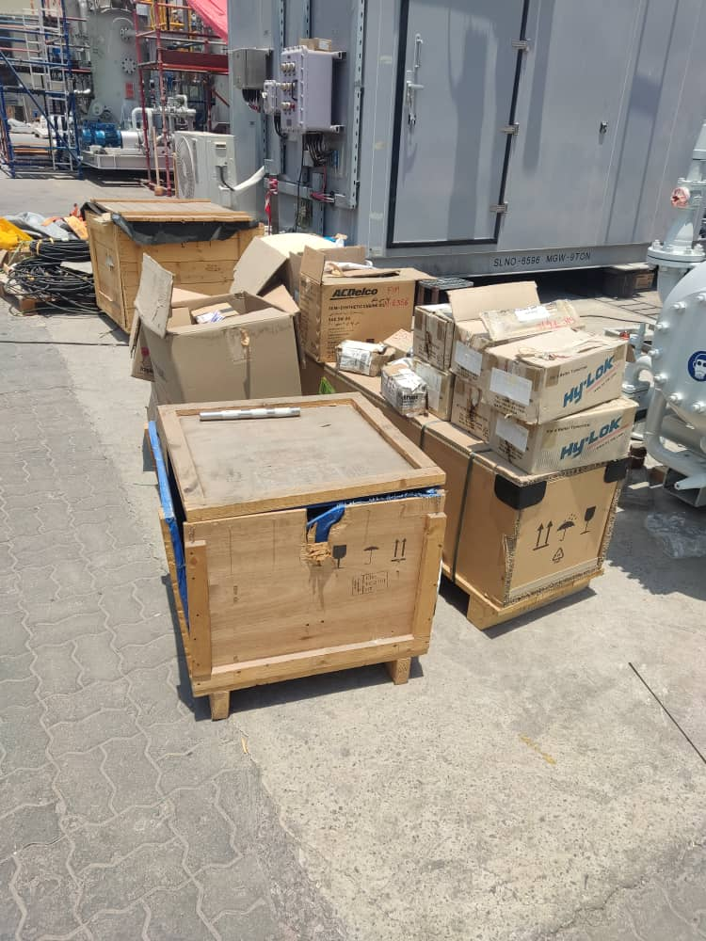
- All excess parts and tubes were removed from the skid.
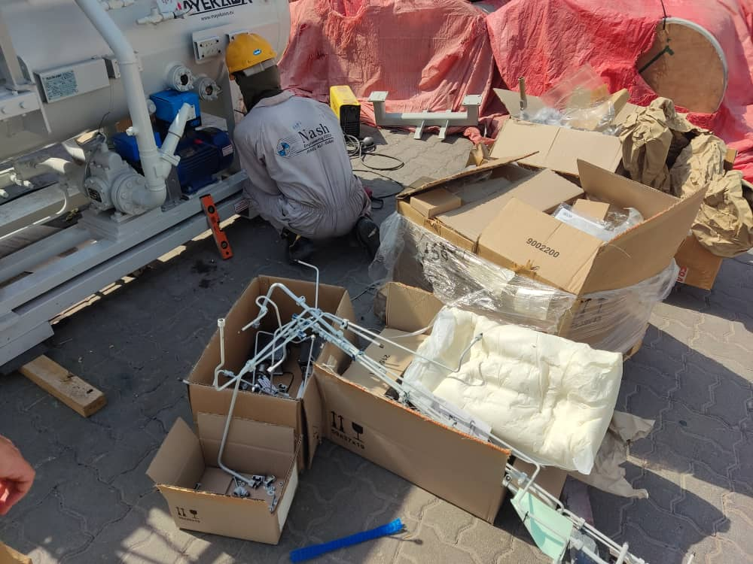

- Installation of Temperature Transmitters (TITs)
The TT connections were of BSPT type. Initial concerns were raised about whether WIKA had sent the correct items. Upon investigation, it was found that WIKA had likely supplied the correct type (although full certainty remains pending).
  - Note: BSPT connections typically allow 5 threads to engage, whereas NPT on BSPT results in about 4 engaged threads.
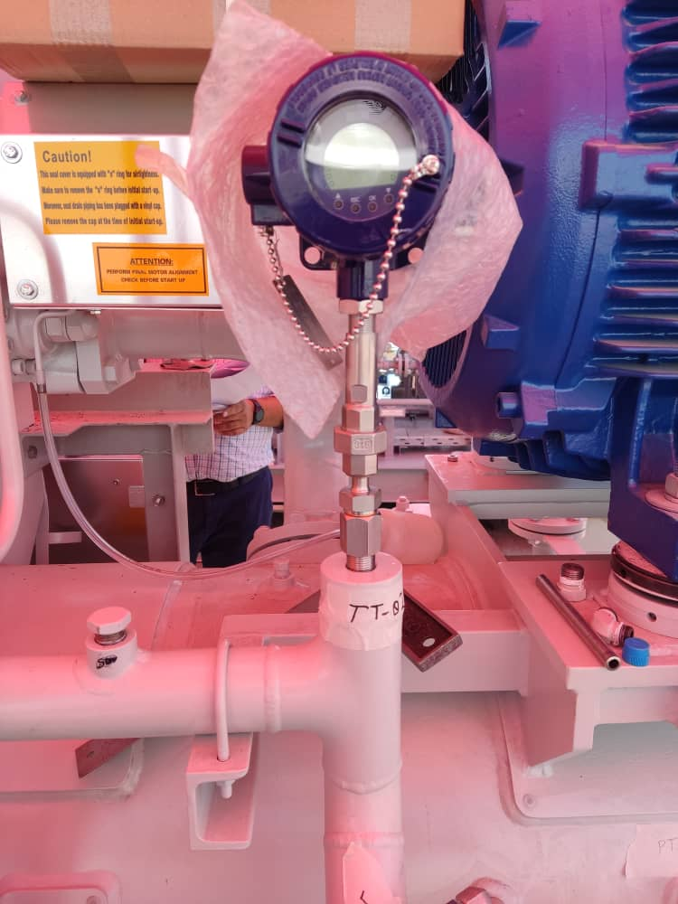
- Positioning and Installation of Pressure Indicating Transmitters (PITs)
PITs were properly located and installed as per layout requirements.
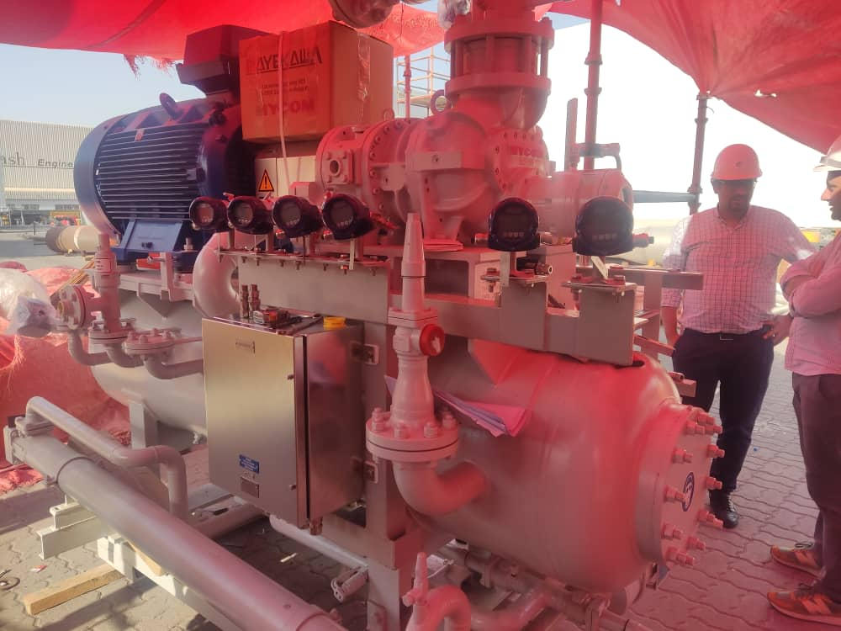
- Positioning and Installation of Shutoff Line Valves (SLVs)
All SLVs were positioned and installed successfully.
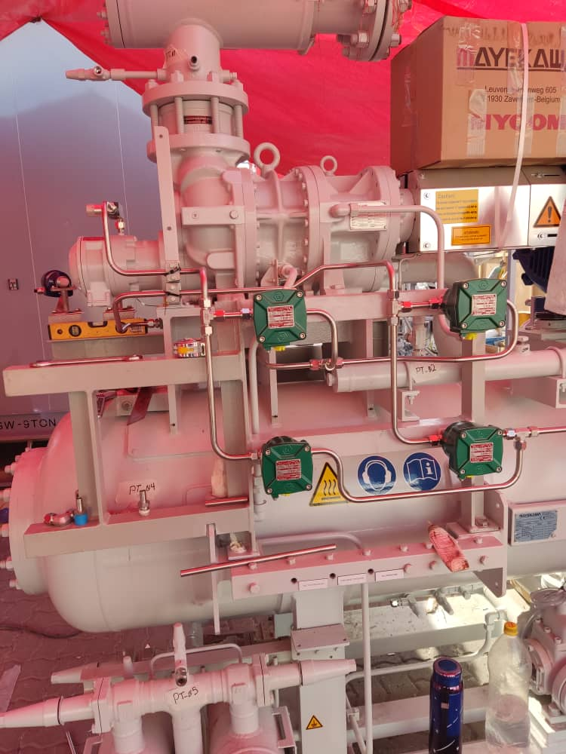
- Positioning of Level Switches
Level switches were positioned and installed successfully.
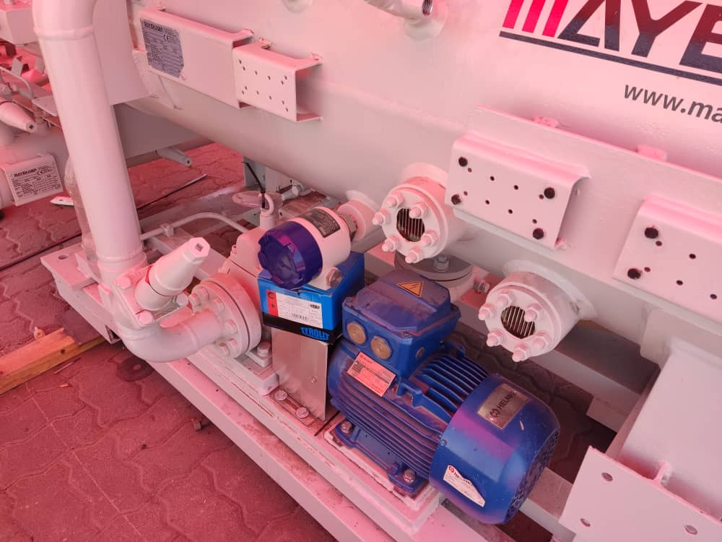
- Installation of Oil Heater
The oil heater was installed using BSPT connectors. Some interference was noted between the heater elements and the connector walls. The elements were inserted with slight force. However, the element holders became non-functional as the elements were fully inserted. This issue requires further evaluation.
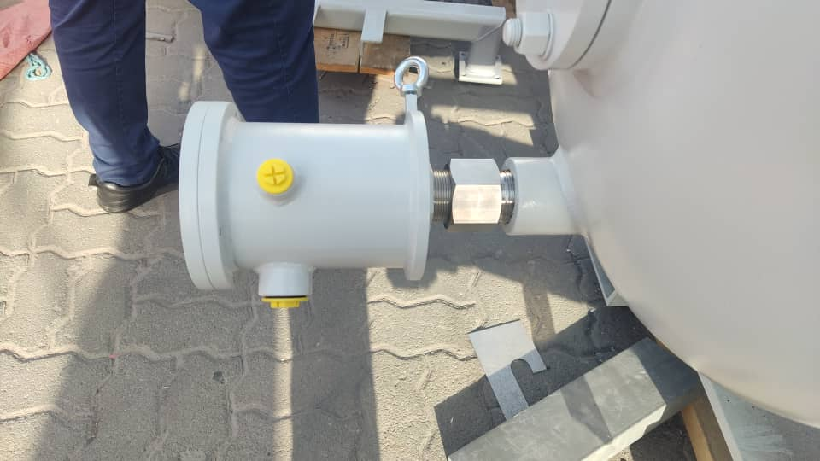
- Tubing Installation Procedure
The complete method for tubing installation was reviewed and explained in detail to the Nash team.
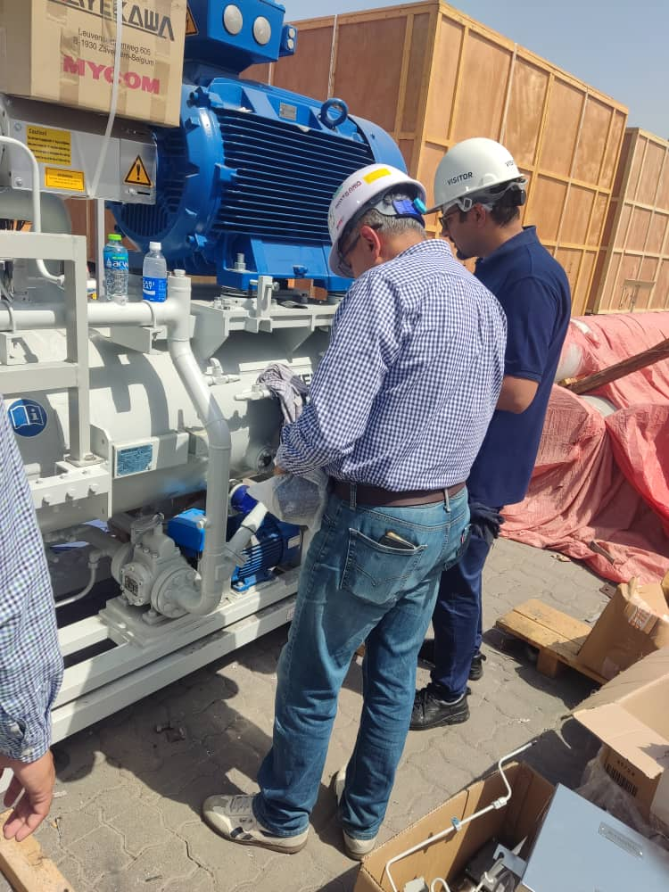
- Documentation
All catalogs and manuals were collected and packed into a single box for proper record keeping.
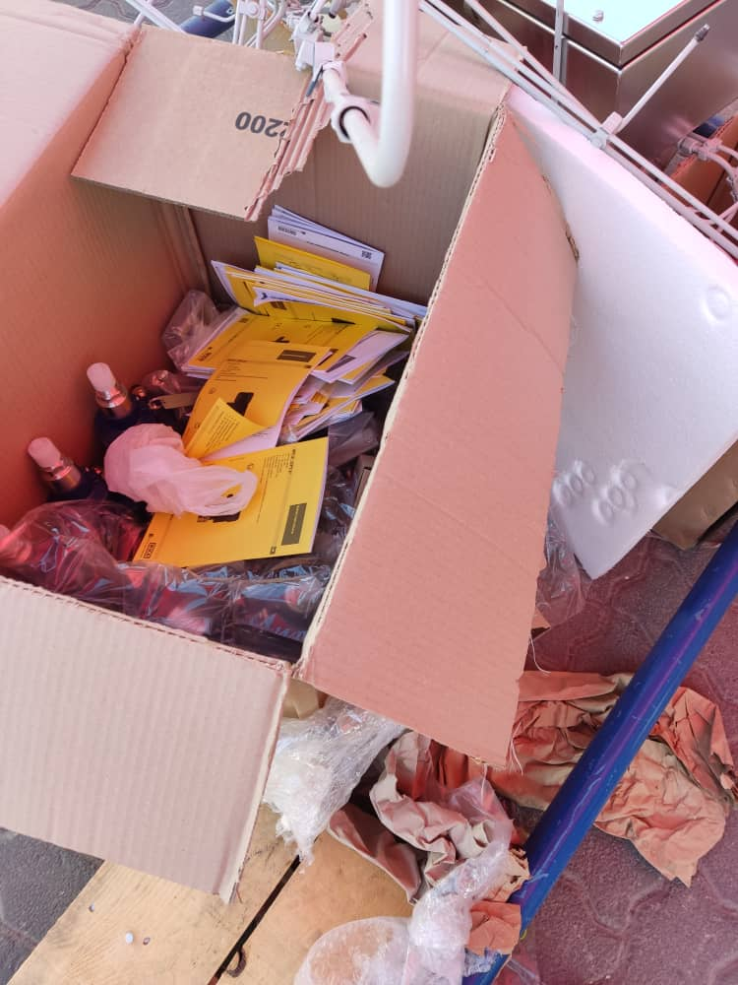
- Handling of Unused Materials
Discussions were held with Mr. Fahad regarding the transportation of unused materials from the skid like LITs, male stubs, etc. These items should be shipped with skids. An email regarding this should be sent to Nash.
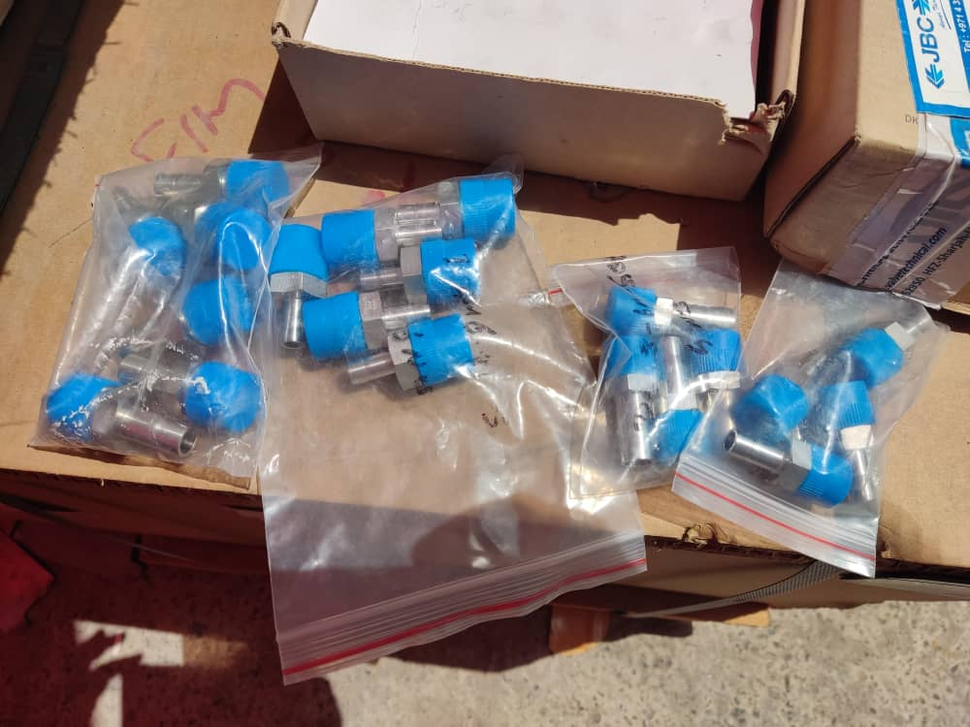
- LCP Support Design Issue
The LCP support design was incorrect and smaller than necessary. This issue has been resolved and communicated both on-site and via email by Mojtaba.
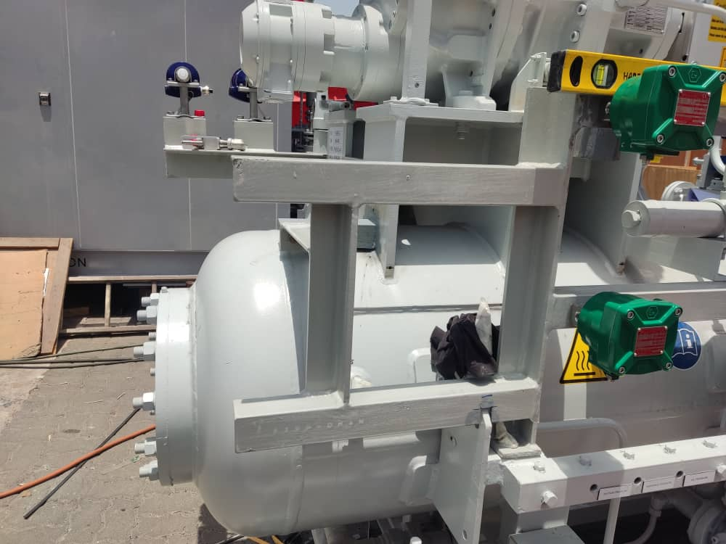

Recommendations and Observations:
- Pre-Mission Meeting
A project-wide meeting should be held before such missions to finalize all drawings, review the 3D model, and prepare a checklist of scope items.
On this mission, the first day was entirely spent reviewing drawings—a task that could have been done before departure.
- Not informed in some issues
For all procurement and shipping matters not directly managed by the project manager, it is strongly recommended that the project manager be included in all related correspondence (CC).

