PURCHASE ORDER

SELLER | : | Technical srl | PURCHASE ORDER No.:  DELTA-TECHNICAL-2024-PO-200  ISSUE DATE: 16-Sep-2024
Add. | : | Via Toscana, 9  20052 Vignate – Mi – Italy
Tel. | : | +39 02 95361240


P.O. number must be shown on all shipping packages, shipping documents, invoices and correspondence in connection with this PURCHASE ORDER.

This PURCHASE ORDER is subject to the descriptions, terms, conditions and instructions stipulated hereunder and attachments hereto, if any.

SUBJECT: 4 Pieces of Pressure Safety Valves as per Quotation 24-2385 R1 dated 09.09.2024 and relevant emails including all Technical details, clarification and comments discussed and agreed between parties.

This PURCHASE ORDER, together with all its attachments shall be referred to as “CONTRACT
No. DELTA-TECHNICAL-2024-PO-200.
In the event of any inconsistency between the matters contained in the CONTRACT, the portions shall govern in the order of following precedence. The first named being paramount.

- PURCHASE ORDER
- 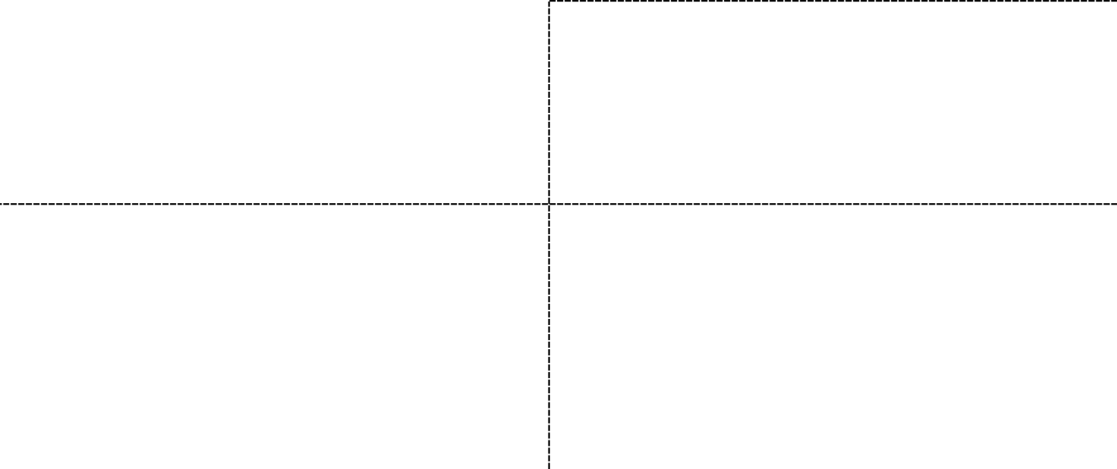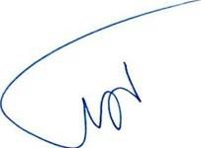Attachments PURCHASE ORDER
Page 1 of 5

SELLER’S ACCEPTANCE:  Technical srl | BUYER: DELTA GMBH
Via Toscana, 9 20052 Vignate – Mi – Italy | Lübecker Straße 1, 22087 Hamburg, Deutschland
Name(s) / Title(s): | Name / Title: Managing Director
Seal & Sign: Date: | Seal & Sign: Date:

Reference Correspondence

  - SELLER’s Commercial Quotation:
    - Quotation 24-2385 R1 dated 09.09.2024 for Pressure Safety Valves with
Comments Made and clarification emails

  - SELLER’s Clarifications Letter(s):
    - No.: Latest Communications by Email.

Attachments

  - SELLER’s Quotation 24-2385 R1 dated 09.09.2024 for Pressure Safety Valves.
  - Pressure Safety Valve calculation and selection sheet 24-2385 RI dated 09.09.24.
  - Safety Valve Sizing Sheet 24-2385 RI dated 09.09.24.
  - Buyers Data sheet.
  - Buyer’s Painting Procedure.
  - Technical and Commercial correspondences via email.

Price

  - Total FCA/TECHNICAL/ITALY (according to Incoterms 2020) price of Equipment subject to this PURCHASE ORDER, including Documentation, Painting according to BUYER’s Procedure, Seaworthy packing, marking, loading and all other related costs based on FCA/TECHNICAL /ITALY delivery term amounts to be 4,690.00 Euro based on relevant unit price(s) mentioned under SELLER COMMERCIAL QUOTATION of this PURCHASE ORDER.
.
  - The unit price(s) shall be fixed and firm for the duration of CONTRACT and shall not be subject to escalation.

Payment

  - 30% of PURCHASE ORDER price shall be paid upon PO countersign
  - 70% of PURCHASE ORDER price after goods readiness and final inspection before delivery according to Clause 3.1 and against presentation of the following documents.

    - One Original Total Signed Payment Invoice.
    - Inspection Release Note of successful Tests (approved by BUYER representative).
    - SELLER’s signed Packing List in Three (3) original copy approved by BUYER’s representative.

    - The original Inspection Certificates identified with the PURCHASE ORDER signed and certified by BUYER, certifying that the quality and quantity of the Materials are strictly complying with the specifications of the Equipment indicated in the PURCHASE ORDER documents. It is essential that the Equipment conform to the detailed specification(s). Failure to follow this procedure will result in Equipment not being called forward to shipment.

    - Submission of final book include: Material Certificates 3.1, Datasheets, As built drawings according to Technical offer 24-2385 R1.

Test and Inspection

  - Minimum required Tests are including:
- Visual Inspection
- Hydrostatic test to ASME B16.34:2017
- Seat Leakage test
- Construction declaration;
- Manual of use and maintenance
- CE/PED certificate
- Material certificate for body, nozzle & disc in accordance with EN 10204 3.1
- ASME Certificate
- G.A. Drawing
- Painting report
- Set point Certificate
- Calculations
- Test Reports
Which will be reviewed during final inspection along with material certificates. Final inspection before shipment for dimensional check and test certificates and report review will be performed by BUYER representative.

  - The procedure and schedule for test and inspection shall comply with vendor’s technical documents specified in SELLER’s procedure approved by BUYER.

  - SELLER should send Inspection notification 10 Calendar days prior to inspection date.

  - SELLER Confirmed Goods are Italian origin and Castings are sourced from India. Chinese/ Russian materials will not be used in this project.

Packing and Marking

  - Packing and Marking shall be made for Sea Shipment in accordance with Sea Worthy Packing requirement.

  - Final Packing List written in English in Three original copy to be submitted to BUYER officially not later than 10 calendar days prior to dispatch of cargo.

Delivery
  - All Equipment shall be delivered within 10-11 weeks (FCA TECHNICAL/ITALY)
from Effective Date of PURCHASE ORDER.
  - Partial delivery is NOT allowed.

Documentation and Drawing

  - Valves datasheets, calculation, G.A. Drawings, ITP and test reports to be submitted by SELLER after purchase order countersign and effective date of the PO.

  - Final vendor prints and technical data books to be submitted along with delivery of Equipment.

  - Test and inspection reports and certificates written in English shall be submitted within five (5) days from the date of final inspection.

Guarantee Period

The Guarantee Period for the subject Equipment shall be 12 months from installation or 24 months from date of shipment, whichever occurs first.

Liquidated Damage

SELLER undertakes to deliver the subject Equipment within the period stipulated under Clause
  - of this PURCHASE ORDER. In the event of any delay beyond the delivery period for reasons attributed to the SELLER, SELLER shall pay the following amounts to BUYER as liquidated damage:

  - The liquidated damage for every full week delay is 0.5% of the PURCHASE ORDER PRICE.

  - Maximum liquidated damage is 5% of the PURCHASE ORDER price. In Case of delay by parts Manufacturer, this delay will be considered as and acceptable, delay and not subject to this article.

  - BUYER has the right to deduct the applicable liquidated damages from any SELLER’s entitlements.

Effective Date of the PURCHASE ORDER

Upon countersigning of this PURCHASE ORDER and fulfillment of the following conditions, this PURCHASE ORDER shall become effective:

  - Upon Countersign of the Purchase Order and advance payment receipt by the SELLER, whichever is latest.

- Arbitration:
Any dispute arising out of or in connection with the Contract, which cannot be settled amicably by the parties in accordance with the provisions of the Contract, shall be finally settled under the Rules of Arbitration of the International Chamber of Commerce (ICC). The arbitration shall be conducted in English at a location agreed upon between the parties, and the arbitral award shall be final and binding on both parties without any right of appeal for any party.
The arbitral award shall also determine the expenses of the arbitration and the party, which shall bear them or the proportion of such expenses to be borne by each party.
Arbitration shall not prevent Seller from continuation of the works.

- Governing Law:

This Contract shall be governed by and interpreted in accordance with the Laws of SWITZERLAND

