NDT Procedure
For
Steel Structure

Rev.  PAGE No. | 00 | 01 | 02 | 03 | 04 | 05 | 06 | 07 | 08 | Rev.  PAGE No. | 01 | 02 | 03 | 04 | 05 | 06 | 07 | 08 | 09
1 | x |  |  |  |  |  |  |  |  | 36
2 | x |  |  |  |  |  |  |  |  | 37
3 | x |  |  |  |  |  |  |  |  | 38
4 | x |  |  |  |  |  |  |  |  | 39
5 | x |  |  |  |  |  |  |  |  | 40
6 | x |  |  |  |  |  |  |  |  | 41
7 | x |  |  |  |  |  |  |  |  | 42
8 | x |  |  |  |  |  |  |  |  | 43
9 | x |  |  |  |  |  |  |  |  | 44
10 | x |  |  |  |  |  |  |  |  | 45
11 | x |  |  |  |  |  |  |  |  | 46
12 | x |  |  |  |  |  |  |  |  | 47
13 | x |  |  |  |  |  |  |  |  | 48
14 | x |  |  |  |  |  |  |  |  | 49
15 | x |  |  |  |  |  |  |  |  | 50
16 | x |  |  |  |  |  |  |  |  | 51
17 | x
18 | x
19 | x
20 | x
21 | x
22 | x
23 | x
24 | x
25 | x
26 | x
27 | x
28 | x
29 | x
30 | x
31
32
33
34
35

- VISUAL TEST PROCEDURE

1.1. Scope
This procedure provides guidance on detection of visual defects and conducts the welding process to highest quality.
The major purpose of this document is to control the quality of welds produced in this company.
It provided the basic reference and inspection steps and describes the tools and method for two major category of Groove and fillet welding in related joints.

1.2. Reference
1.2.1. ASME Code Section V- Article 9 : 2017 Edition
1.2.2. ASNT SNT – TC – 1A- (2016).
1.2.3. AWS D1.1 : 2015 Edition.
1.2.4. JOB SPECIFICATION FOR STRUCTURAL STEEL FABRICATION (1071-00-ED-ST SP-2001-A2)

1.3. Definitions
Project | Structure Fabrication of Chiller Skid
Owner | Polymer Pad Jam Co.
Vendor | Arkan Sanat Paydar Company(ASP)
Contractor | HSE
MC | Toase-ehe Park Sanati Gohar Ofogh

  - Equipment
• Lux meter
• Meter/ ruler
• Temp stick/ pyrometer
• Mirror
• Welding Gauges
• Caliper
• Metal Marker

1.5. Physical requirements of inspector
Must also pass annual eye exams for:
1) Near vision acuity (sharpness of vision) – Jaeger chart
2) Far vision acuity – Snellen chart
3) Colour vision – Ishihara

1.6. Requirements of visual/ direct inspection
Direct visual examination may usually be made when access is sufficient to place the eye within 24 in. (600 mm) of the surface to be examined and at an angle not less than 30 deg to the surface to be examined. Mirrors may be used to improve the angle of vision, and aids such as a magnifying lens may be used to assist examinations.
Illumination (natural or supplemental white light) for the specific part, component, vessel, or section thereof being examined is required. The minimum light intensity at the examination surface/site shall be 100 foot candles (1000 lux). The light source, technique used, and light level verification is required to be demonstrated one time, documented, and maintained on file.

1.7. Qualification of NDT personnel:
The personnel carrying out VT, interpreting and evaluating results shall be qualified at least level II for VT examination as per SNT-TC-1A.

1.8. Groove weld Inspection Steps
1.8.1 Checking the Joint detail:
• Checking of bevel type with last revision of approved WPS and DWG.
• Checking of bevel angle according to last revision of approved WPS. It performed by welding gauge.
• Checking of roughness of bevel surfaces of joint. It performed by visual inspection and the deep or extra roughness of bevel surface not accepted so it shall be grinding until reach the satisfy surfaces.
• Checking the root opening according to WPS. It performed by measurements tools such as meter or calliper and it shall be the range of 1~3mm.
• Checking of cleanliness of surface joint. The surface shall without of any grease, organic materials, paint, rust layers and oxidation (e.g. during cutting by flame cutting tools)
• Checking the usage of start and end extraneous plate for starting and finishing welding on those.

1.8.2 Checking of Welder Qualification
Purchaser shall review related certificates

1.8.3 checking the Preheat Temperature:
• Checking the preheating temperature according to WPS. It performed by portable thermo meter or thermal markers. The minimum range is -10% of mentioned temperature in WPS and the maximum is the mentioned inter pass temperature in WPS.

1.8.4 Inspection of Electrodes:
• Checking the storage condition, temperature and moisture.
• Checking the type and kind of electrode according to WPS.
• Checking of backing of low hydrogen electrode if required. It's included of checking the time and temperature baking.
• Checking the electrode size according to WPS and thickness of joint and welding pass.
• Checking the soundness of electrode covers.

1.8.5 Checking of Ampere of Rectifiers and welding machines:
• According to WPS and specification of electrode manufacturer.

1.8.6 Checking of Cleaning and Back Chipping:
• It shall provide the clean surface without any slag. For reach the best average of cleanliness surface, it performed by machines.

1.8.7 Visual Inspection of welding layer production:
• After welding the defined layer the visual inspection shall performed to detection the visual defect such as "Porosity", "Undercut", "Crack", "LOF", "Slag" ,"Spatter as well"
• This inspection shall perform for each welding layers.

1.8.8 Checking the Inter pass Temperature.
• After welding each layer the inter pass temperature shall check by thermo meter or thermal markers according to approved WPS.

1.8.9-Final Visual Inspection:
• After complete welding the joint and complete cleaning and chipping the final visual inspection shall performed for detect the visual defects such as: Crack, LOF, Non Conformances Weld Profile, Crater Cross,
Undercut, Porosity, Slag, under fill, Excess Reinforcement and Convexity, Overlap, Spatter and Insufficient weld size.

1.9. Fillet Weld Inspection Steps
1.9.1-Cheking the Joint detail:
• Checking of bevel type with last revision of approved WPS. (If required)
• Checking of bevel angle according to last revision of approved WPS. It performed by welding gauge. (If required)
• Checking of roughness of bevel surfaces of joint. It performed by visual inspection and the deep or high roughness of bevel surface not accepted so it shall be grinding until reach the satisfy surfaces. . (If required)
• Checking of cleanliness of surface joint. The surface shall without of any grease, organic materials, paint, rust layers and oxidation (e.g. during cutting by flame cutting tools)

1.9.2 Cheking the Preheat Temperature:
• Checking the preheating temperature according to WPS. It performed by portable thermo meter or thermal markers. The minimum range is minus 10% of mentioned temperature in WPS and the maximum is the mentioned inter pass temperature in WPS.

1.9.3 Inspection of Electrodes:
• Checking the storage condition, temperature and moisture.
• Checking the type and kind of electrode according to WPS.
• Checking of backing of low hydrogen electrode if required. It's included of checking the time and temperature baking.
• Checking the electrode size according to WPS and thickness of joint and welding pass.
• Checking the soundness of electrode covers.

1.9.4 Checking of Ampere of rectifiers and welding machines:
• According to WPS and specification of electrode manufacturer.

1.9.5 Checking Cleaning and Chipping:
• It shall provide the clean surface without any slag. For reaching to high degree of clean surface, It performed by machines.

1.9.6 Final Visual Inspection:
• After complete welding the joint and complete cleaning and chipping the final visual inspection shall performed for detect the visual defects such as: Crack, LOF, Non Conformances Weld Profile, Crater Cross,
Undercut, Porosity, Slag, under fill, Excess Convexity and Concavity of weld reinforcement, Overlap, Spatter, Insufficient Throat and leg size.

1.10 Visual Inspection Acceptance Criteria:
AWS D1.1 Table 6.1: (2015)

1.11. Documentation
1.11.1. Non-reject able indications shall be recorded as specified by the referencing Code Section/project Spec.
1.11.2. Results of the examination shall be recorded in Final Visual and Dimensional Report
Final Visual and Dimensional Report .

2. PENETRANT TEST PROCEDURE
2.1. Scope
The liquid penetrate examination method is an effective means for detecting discontinuities, which are open to the surface of ferrous metals and other materials. Typical discontinuities detectable by this method are cracks, seams, laps, cold, shuts, lamination, and porosity.
In principle, a liquid penetrate is applied to the surface to be examined and allowed to enter discontinuities. All excess penetrate is then removed, the part is dried, and a developer is applied. The developer functions both as a blotter to absorb penetrate that has been trapped in discontinuities and as a contrasting background to enhance the visibility of penetrate.

2.2. Code. Reference
- ASME Section V, Art.6: latest Edition.
- ASTM E165: latest Edition.
- AWS D1.1: Edition 2015
- ASNT SNT TC 1A: latest Edition.
-JOB SPECIFICATION FOR STRUCTURAL STEEL FABRICATION (1071-00-ED-ST SP-2001-A2)

2.3. Definitions

Project | Structure Fabrication of Chiller Skid
Owner | Polymer Pad Jam Co.
Vendor | Arkan Sanat Paydar Company(ASP)
Contractor | HSE
MC | Toase-ehe Park Sanati Gohar Ofogh

2.4. Qualification of NDT personnel:
The personnel carrying out PT, interpreting and evaluating results shall be qualified at least level II for PT examination as per SNT-TC-1A. (They have been qualified by written practice that is based on SNT-TC-1A: 2016)

2.5. Test Procedure

2.5.1 Material:

S235 JR (st37)

2.5.2 Shape of weld:
Groove and fillet welds

2.5.3 Surface condition:
The surface examined shall be suitable for proper interpretation of the liquid penetrate examination.
Prior to liquid examination, the surface to be examined and all adjacent areas within at least 25mm shell be dry and free of any dirt, grease, lint, scale, welding flux, weld spatter, oil and other extraneous matter that would obscure surface openings of otherwise interfere with the examination.
After cleaning, the surfaces to be examined must be thoroughly dry so that no water or solvents remain in or over the discontinuities, as this will hinder the entrance to penetrate.
Drying may be accomplished by normal evaporation or with oil free forced hot air as appropriate to ensure that the cleaning solution has evaporated prior to application of the penetrate.
Surface mechanical cleaning shall be carried out by wire brushing.
Surface preparation by grinding, machining or any other suitable methods may be necessary where surface irregularities could mask indications.
Performing of blasting or any method that can block the opening of discontinuities is not recommended.

2.5.4 Penetrant Application:
Trade name of dye penetrates materials may be: MAGANAFLUX; SKL –SP1 or CREAMAGNA CHEMICALS; CR50 or any other qualified materials.
The penetrate may be applied by any suitable means such as dipping, brushing or spraying to the surface to be inspected so that the entire part of area under inspection is completely covered with penetrate.
The temperature of the surface of the part to be processed shall not be blow 16˚ C not above 50° C throughout the examination period. The penetration (Dwell) time shall be 5 to 30 minutes.

2.5.5 Excess Penetrant Removal:
Excess penetrant shall be removed by wiping with a cloth or absorbent paper, repeating the operation until most traces of penetrates has been removed. The remaining traces shall be removed by lightly wiping the surface with cloth or absorbent patter moistened with solvent. To minimize removal of penetrate from discontinuities; care shall be taken to avoid the use of excess solvent.

2.6 Developing:
The developer shall be applied as soon as possible after penetrant removal; the time interval shall not exceed that established in the procedure. Insufficient coating thickness may not draw the penetrant out of discontinuities; conversely, excessive coating thickness may mask indications.
With colour contrast penetrants, only a wet developer shall be used. With fluorescent penetrants, a wet or dry developer may be used.

2.6.1 Wet Developer Application:
Prior to applying non-aqueous wet (suspension type) developer to the surface, the developer must be thoroughly agitated to ensure adequate dispersion of suspended particles.

2.6.2 Developing Time:
Developing time for final interpretation begins immediately after the application of a dry developer or as soon as a wet developer coating is dry.

2.7 Interpretation:
Final interpretation shall be made after following penetrate to bleed out for a minimum of 7 minutes to a maximum of 30 minutes.
Light intensity on the examination surface shall be 1000 lux (min) for indication evaluation.

2.8. Evaluation of Indications
A) Only indications with major dimensions greater than 1.6 mm shall be considered relevant.
B) Linear indications are those indications in which the length is more than three times the width.
C) Rounded indications or indications which are circular or elliptical with the length equal to or less than three times the width.
D) Any questionable or doubtful indications shall be retest to verify whether actual defects are present.
E) Localized surface imperfections, such as machining marks, surface conditions, or an incomplete bond between base metal and cladding, and may produce similar indications that are not relevant to the detection of unacceptable discontinuities.

2.9. Acceptance standard
All surfaces to be examined shall be free of:
- Any cracks.
- Relevant linear indications
- Relevant rounded indications greater than 3/16 inch (4.8mm)
- Four or more rounded indications in a line separated by 1/16 inch (1.6mm) or less (edge to edge)

2.10. Post examinations cleaning:
Following the examination, the material shall be thoroughly cleaned to remove any penetrant, developer or other material which was employed in the examination.
Cleaning shall be accomplished by using clean, dry cloths, absorbent paper, detergents, organic solvents or wire brushing.

Attention: expiry date of penetrant, developer and cleaner shall be check and reported. Also used PT brand shall be reported.

2.11. Extent of PENETRANT TEST
The extent of examination shall be in accordance with approved weld map and NDT table.

2.12. Inspection Report
Test results shall be reported on the test report.

2.13. Repair Requirements
Unacceptable imperfections shall be removed by grinding and re-examination by Liquid Penetrate Test made to assure the complete removal.
Whenever a defect is removed the area shall be cleaned and welding performed in accordance with the welding procedure completed repairs shall be re-examined by liquid penetrate test.
- Treatment of Indications Believed No relevant:
Any indication that is believed to be non-relevant shall be regarded as an imperfection unless it is shown by re-examination by the same method or by the use of other non-destructive methods and/or by surface conditioning that no unacceptable imperfection is present.
- Examination of Areas From Which Defects Have Been Removed:
After a defect is thought to have been removed and prior to making weld repairs, the area shall be examined by suitable methods to ensure it has been removed or reduced to an acceptably sized imperfection
- Re-examination of Repair Areas:
After repairs have been made, the repaired area shall be blended into the surrounding surface so as to avoid sharp notches, crevices, or corners and re-examined by the liquid penetrate method and by all other methods of examination that were originally required for the affected area
.
2.14. Documentation
2.14.1. Non-reject able indications shall be recorded as specified by the referencing Code Section/project Spec.
2.14.2. Results of the examination shall be recorded in Liquid Penetrant Inspection Report (PT)

3. ULTRASONIC TEST PROCEDURE

3.1 SCOPE

3.1.1 This procedure covers ultrasonic test angle beam and straight beam test.

3.1.2 For the requirements not specified in this procedure, Codes and Standards in para.3.0 or/and COMPANY's specifications shall be applied.

3.2 REFERENCES

3.2.1 ASME Section V - Article 4 latest Ed.
Article 5 Ultrasonic Examination Methods for Materials and Fabrication
3.2.2 ASNT SNT-TC-1A latest Ed.
Recommended Practice for NDT Personnel Qualification and Certification
3.2.3 AWS D 1.1 latest Ed.
3.2.4 ASTM A435 latest Ed.
Ultrasonic Examination Methods for lamination test
3.2.5 JOB SPECIFICATION FOR STRUCTURAL STEEL FABRICATION (1071-00-ED-ST SP-2001-A2)

3.3 PERSONNEL QUALIFICATION
3.3.1 The personnel who are performing the Ultrasonic testing to this procedure shall be qualified and certified as a level II examiner in accordance with the requirements of ISO 9712 or ASNT Recommended Particle No. SNT-TC-1A (2016).
3.3.2 Interpretation must be carried out by inspectors holding at least a valid Certificate level II in accordance with SNT-TC-1A (2016).

3.4. GENERAL REQUIREMENTS

3.4.1 Surface Preparation

3.4.1.1 The search unit contact surfaces on each side of the weld shall be free of weld spatter, roughness, or any irregularities that would interfere with the free movement of the search unit or with the transmission of ultrasound into the test part. The fabricator shall provide for the search unit contact surfaces to be sufficiently finished so as to prevent non-relevant or false indications from masking or interfering with the evaluation of discontinuities.
3.4.1.2 Where the weld surface interferes with the examination, the weld shall be prepared as needed to permit examination.

3.4.2 Examination Coverage
The volume shall be examined by moving the search unit over the examination surface so as to scan the entire examination volume. Each pass of the search unit shall overlap a minimum of 10% of the transducer dimension perpendicular to the direction of the scan.The examination will not find defects with plan parallel to sound beam.

3.4.3 Rate of Search Unit Movement
The rate of search unit movement for examination shall not exceed 6in. /sec (152mm/sec) unless calibration is verified at scanning speed.

3.4.4 Recording Sensitivity Level
Recording of indications shall be made with respect to the reference level.

3.4.5 Application
Information furnished to the NDT contractor shall clearly identify the materials, thickness, location and lengths of welds to be examined in the drawings or NDT map.
A copy of the weld procedure applicable to each specific joint being examined shall be made available for the operators review, prior to commencement of the examination.

3.5. EQUIPMENT AND MATERIAL

3.5.1 Test Instrument
The examination shall be conducted with a pulse-echo ultrasonic instrument, capable of generating, receiving and presenting the relevant pulses on a screen in the frequency range from 1 to 6 MHz Instruments operating at other frequencies may be used if equal or better sensitivity can be demonstrated and documented.

The operator shall carry out the following calibration checks:

Table 1: UT Equipment Qualification and Calibration Requirements

3.5.1.2 Any of the above checks found to be out of tolerance shall be cause for system repair followed by full re-calibration of affected points.

Note 1: The result of such calibration should be signed by contractor and certifying authority and should be maintained for reference in the NDT department and available for Company inspection as required.
3.5.2 Transducers
The following transducer or equivalent may be used:

3.5.2.1 Longitudinal wave search units
Type | Angle | Frequency | Crystal Size | Make of Probe
Single Crystal | 0° | 4 MHz | 20 mm. dia. | HUATEC

3.5.2.2 Shear wave search units
 |  | Type |  | Angle |  | Frequency |  |  | Crystal Size |  |  | Mark of Probe
 |  | Single Crystal |  | 70° |  | 2.25 MHz |  |  | 16 x 20 mm. |  |  | TRU-SONIC
 |  | Single Crystal |  | 45° |  | 2.25 MHz |  |  | 16 x 20 mm. |  |  | TRU-SONIC
 |  | Single Crystal |  | 60° |  | 2.25 MHz |  |  | 16 x 20 mm. |  |  | TRU-SONIC
 |  | Single Crystal |  | 70° |  | 2.25 MHz |  |  | 16 x 20 mm. |  |  | SURESCAN
Single Crystal |  |  | 60° |  |  |  |  | 2.25 MHz |  |  | 16 x 20 mm. |  |  | SURESCAN
 | Single Crystal |  |  |  | 45° |  | 2.25 MHz |  |  | 16 x 20 mm. |  |  | SURESCAN

3.5.3 Materials

3.5.3.1 Couplant
A suitable couplant such as glycerine, oil, or water based paste of cellulose gum, wallpaper adhesive or coupling paste having good wetting characteristics shall be used between the transducer and examination surface. The same couplant shall be used for calibration and examination

3.5.3.2 CALIBRATION BLOCKS
(1) STB-A1 (IIW Type 2) (Fig. 1) or IIW Type 1 block (Fig. 2)
(2) IIW miniature block (Fig. 3) or STB-A3 (Fig. 4)

3.6 CALIBRATION

3.6.1 Material

3.6.1.1 Material from which respective calibration blocks and reference specimens are
Fabricated will be of the same product form and material specification or
Equivalent. The calibration block material will be completely examined with a
Straight beam search unit to ensure free from indications which exceeding remaining
Back reflection.

3.6.1.2 For the examination of welds, which have been post weld heat treated, the calibration block will receive a similar PWHT .

3.6.1.3 When calibration block have not received heat treatment, transfer method shall be used to correlate the responses from the basic calibration block and component. Transfer is accomplished by noting the difference between responses received from the same reference reflector in the basic calibration block and in the component and correcting for the difference.

3.6.2 Surface Finish:
The surface finish of the calibration blocks will be as representative of the surface finish of the components as far as possible with suitable surface preparation or treatment, as practical, to simulate testing conditions.

3.6.3 Calibration Blocks

3.6.3.1 IIW type blocks
For examination in materials where examination surface diameter is greater than 20 inches, a flat basic calibration block, complying with the requirements indicated on figure 1 will be used. Reflectors will have side drilled holes and surface notches oriented parallel to the longitudinal axis of annuals reference specimen.
For examination in material where the examination surface is 20 inches or less, curved annuals basic reference specimen will be used. The size and location of the surface notches and diameter range covered by each block will be as shown in figures 2 and 3.
A single reference specimen may be used to calibrate for examination on component surfaces in the ranges of curvature from 0.9 to 1.5 times the basic reference specimen diameter. Basic reference specimen thickness ranges will be as stipulated in figure 1. These specimens could be

a section of pipe of the same nominal size as one of the components being tested i.e. as off cut pipe being used in fabrication.
3.6.4 The ultrasonic instrument calibration shall be performed at the beginning of each period of extended use (or every 3 months, whichever is less).

3.6.5 The ultrasonic system calibration shall be performed prior to each examination and at least every 4 hours during continuous operation.

3.6.6 Angle Beam Calibration
3.6.6.1 Sound Entry Point (Index Point)
Set the search unit in position on IIW (STB-A1) block, B on STB-A3, or C on IIW miniature block, as applicable, and verify index point (Fig. 5).
3.6.6.2 Sound Path Angle
(1) For angle 45deg. set the search unit in position D on IIW (STB-A1), or J on STB-A3 block (Fig. 5).
(2) For angle 60deg. set the search unit in position D or F on IIW (STB-A1), or E on STB-A3 block (Fig. 5).
(3) For angle 70deg. set the search unit in position F on IIW (STB-A1), or G on STB-A3 block (Fig. 5).
Read angles on the calibration block.

3.6.6.3 Sweep Range
Set the search unit in position An on IIW (STB-A1), B on STB-A3, or C on IIW miniature block, as applicable, and adjust appropriate sweep range for the examination. (Fig. 5)

3.7 Distance Calibration
The CRT will be calibrated for range using the International Institute of Welding STB-A1,
Type 1, 2 and STB-A3 calibration blocks, in the relationship of time versus distance (beam
Path length).

3.8 Sensitivity
The sensitivity shall be adjusted at a location free of indications so that the first back reflection from the far side of the plate will be 50% to 75% of full screen height.

3.9 EXAMINATION PROCEDURE

3.9.1 Straight Beam Examination

3.9.1.1 The scanning of the adjacent base metal shall be performed to detect reflectors that might affect interpretation of angle beam results, and is not to be used as an acceptance-rejection

examination. Locations and areas of such reflectors shall be recorded.
3.9.1.2 The weld and base metal shall be scanned, where required by the referencing code section to the extent possible with the straight beam search unit. The scanning shall be performed at a gain setting of at least two times the primary reference level. Evaluation shall be performed with respect to the primary reference level.

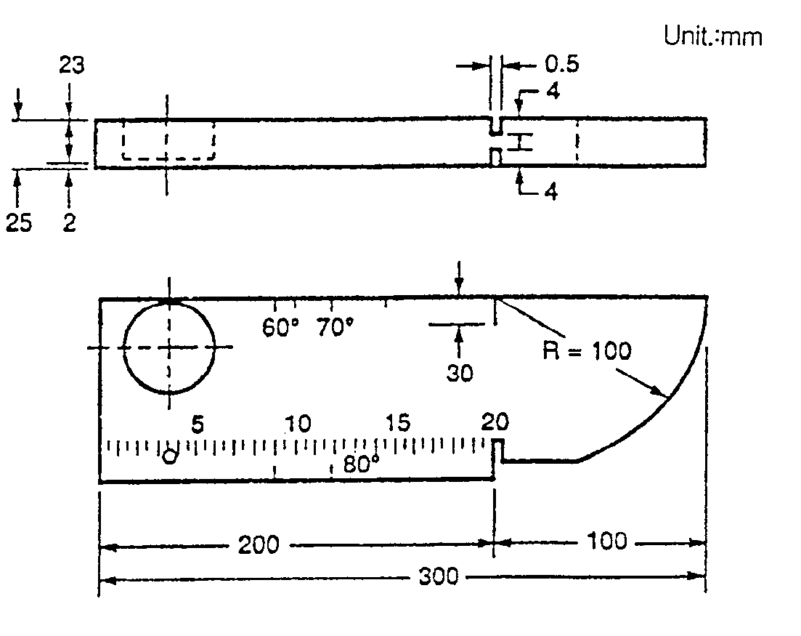

Fig. 1 STB-A1 (IIW TYPE 2) BLOCKS

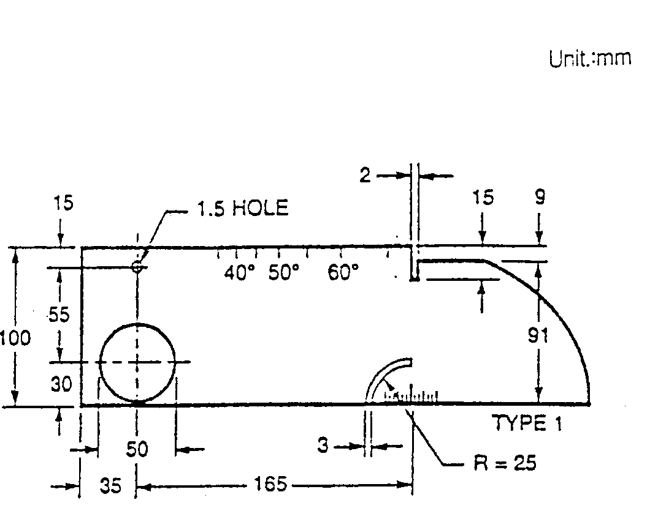

Fig. 2 IIW TYPE 1 BLOCKS

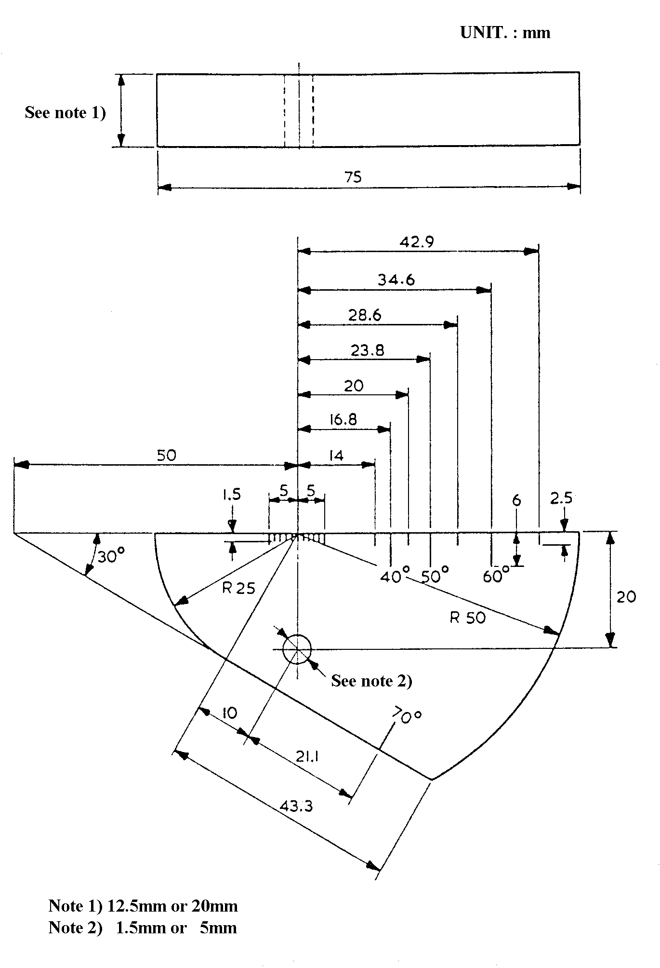

Fig. 3 IIW MINIATURE BLOCK

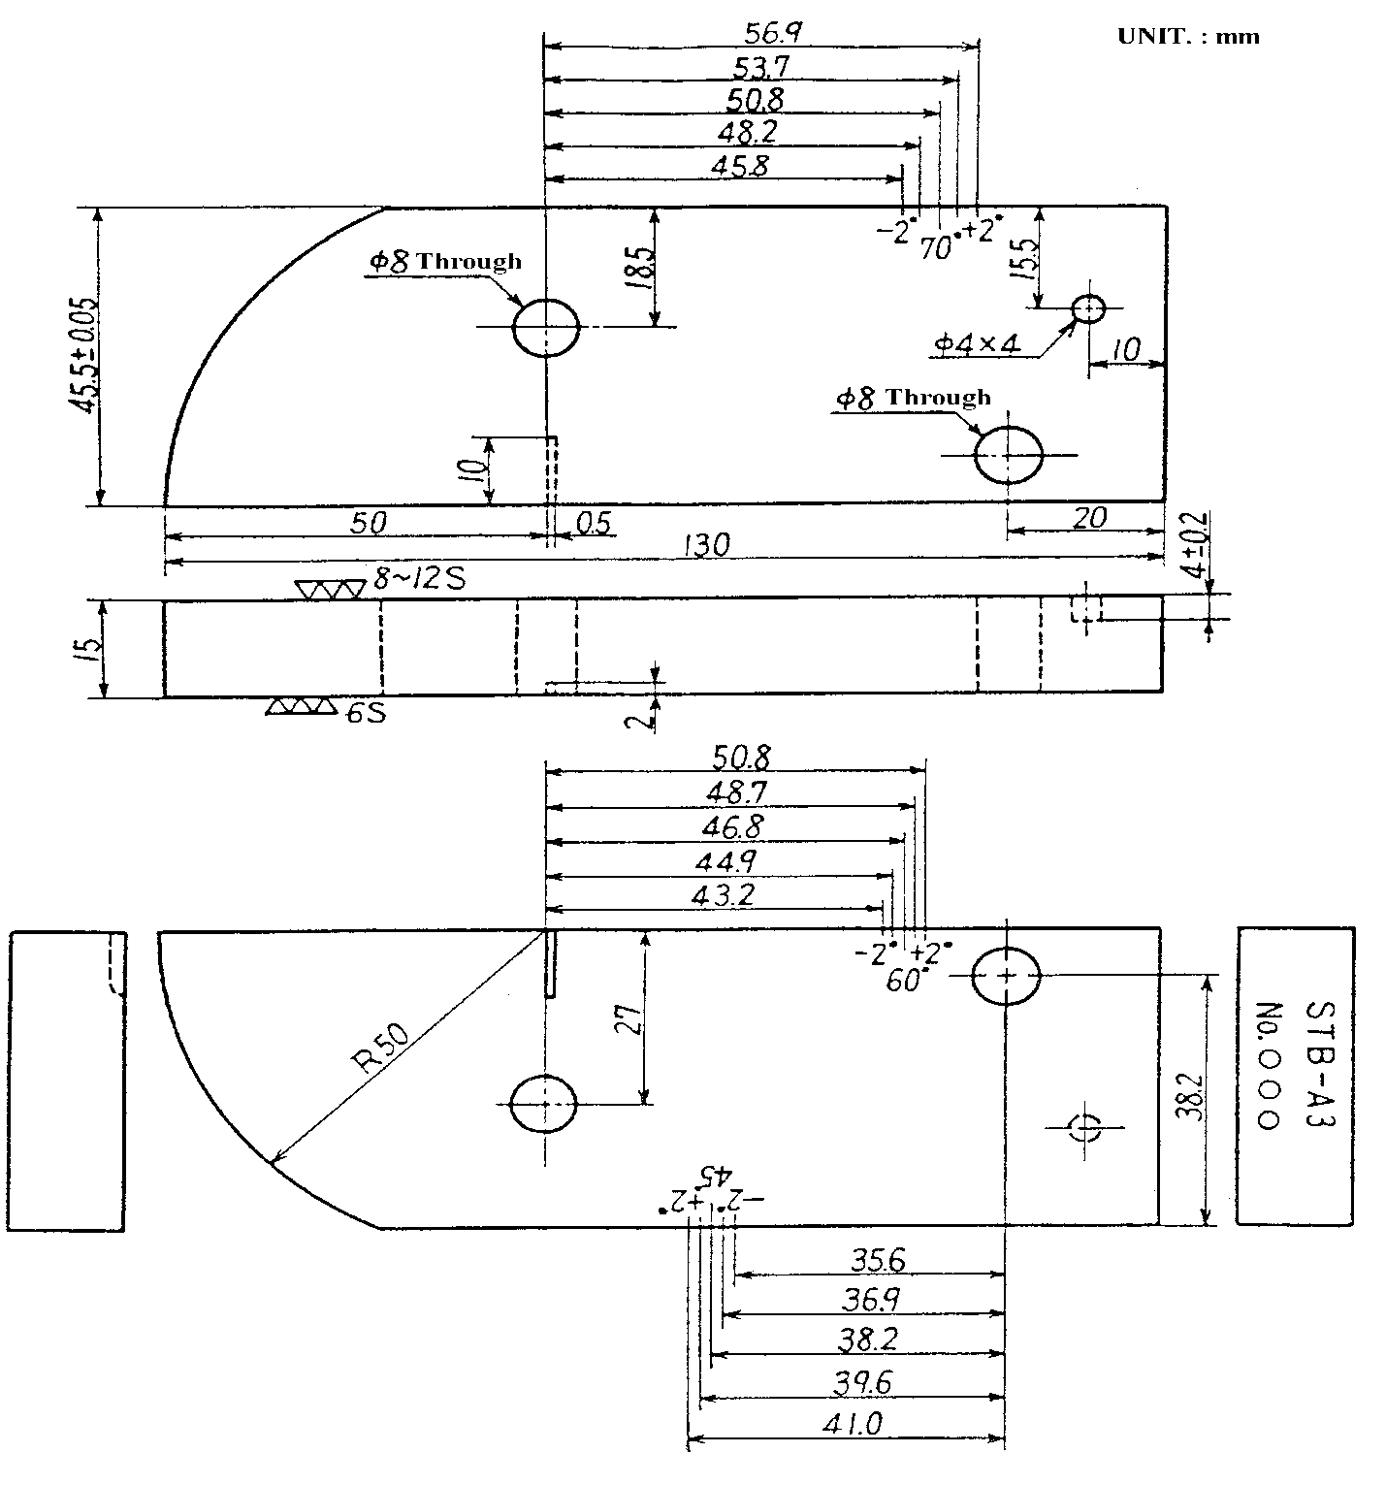

Fig. 4 STB-A3 BLOCK

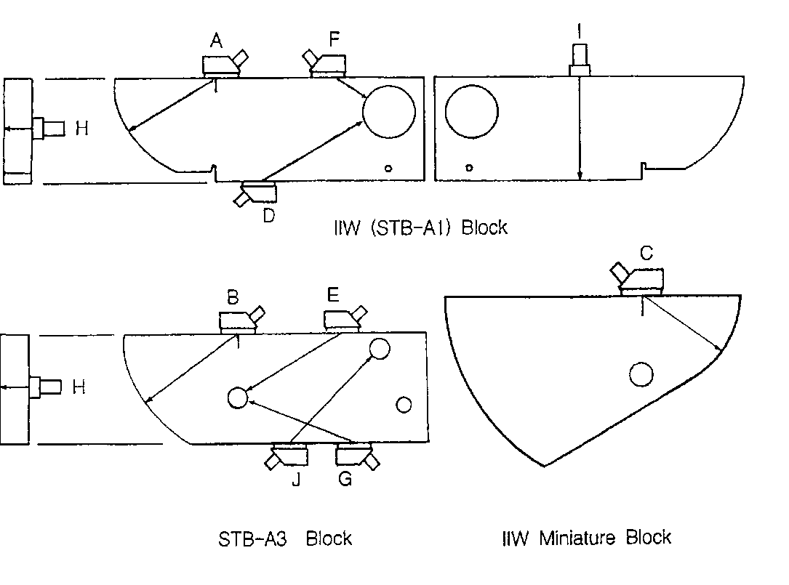

Fig. 5 SEARCH UNIT POSITIONS FOR CALIBRATION

3.9.2 Angle Beam Examination

3.9.2.1 Beam Angle
An angle shall be selected as appropriate for the configuration (bevel or groove angle) of the weld joint being examined and more than one angle shall be used.

3.9.2.2 For butt joint welds, the examination shall be made from both sides of the weld axis from the accessible surface, wherever possible.

3.9.2.3 Angle Beam Scanning for Reflectors Oriented Parallel to the Weld:
The angle beam shall be directed at approximate right angles to the weld axis from two directions where possible. The search unit shall be manipulated so that the ultrasonic energy passes through the required volumes of weld and adjacent base metal. The scanning shall be performed at a gain setting at least 14dB more sensitive than primary reference level. Evaluation shall be performed with respect to the primary reference level.
3.9.2.4 Angle Beam Scanning for Reflectors Oriented Transverse to the Weld:
The angle beam shall be directed essentially parallel to the weld axis. The search unit shall be manipulated so that the angle beam passes through the required volumes of weld and adjacent base metal specified by the referencing Code Section. The scanning shall be performed at a gain setting 14dB more sensitive than the primary reference level. Evaluation shall be performed with respect to the primary reference level. The search unit shall be rotated 180deg.for each side of weld and the examination repeated.

3.10 Inspection of Welds
General
A minimum of two different probe angles should always be applied (see table 2). This is in addition to the straight beam probe required as per Para 13.
For butt joint welds, the examination shall be made from both sides of the weld axis from the accessible surface, wherever possible.
Upon discovering suspect indications both orbital and rotational scan will be carried out to evaluate the characteristics of the reflector.
Time base ranges as specified may be suitably readjusted by the operator in localized areas to highlight suspect deflections and subsequently assist in echo evaluation.
The normal scanning is carried out with at least 6 dB increased gain level, and that all defects sizes will be evaluated at Ref. level.
Longitudinal Scanning:
Scanning for longitudinal discontinuities in the weld body will be carried out with the angle beam at approximately right angles to the weld axis, from two directions whenever possible. Nominal angles of reflection to achieve this are stated in table 2.
Transverse Scanning:
Scanning for discontinuities oriented transverse to the weld will be carried out with the angle beam directed essentially parallel to the weld. For scanning of transverse defects, it should be considered to scan on the weld cap itself, which if necessary, must be ground flat. The search unit will be manipulated so that the angle beam energy passes through the required volumes of weld and adjacent base metal.
A transverse scan will be carried out on all welds scheduled for ultrasonic examination. Nominal angles of reflection to achieve this are stated in table 2. The exception of the above will be when the search unit is scanning essentially as tangent over curved surfaces of 20” diameter or less.

Table 2
 |  | 8 – 25.4 mm. | 25.4 – 50.8 mm. | 50.8 – 65 mm.
45 | HSD  FSD | N.A  N.A | - (36-72)  A. (72-144) | - (72-92)  A. (144-184)
60 | HSD  FSD | N.A.  A. (32-102) | - (51-102)  A. (102-203) | - (102-130)  N.A.
70 | HSD  FSD | N.A.  A. (47-148) | - (74-148)  N.A. | - (148-190)  N.A.
0 | HSD  FSD | N.A.  A. | N.A.  A. | A.  A.

HSD: Half Skip Distance A: Applicable
FSD: Full Skip Distance NA: Not Applicable

3.11 Indication Rating.
The “Indication Rating, d,” in the UT Report, Annex L, Form L-11, represents the algebraic difference in decibels between the indication level and the reference level with correction for attenuation as indicated in the following expressions:
Instruments with gain in dB:
a – b – c = d
Instruments with attenuation in dB:
b – a – c = d

3.12 Post Cleaning
Upon the completion of the examination, the surfaces shall be thoroughly cleaned by wiping with a suitable one as required to remove all traces of couplants.

3.13 ACCEPTANCE STANDARD
The acceptance standards of Ultrasonic Test results shall apply as followings:
Steel Structure: AWS D1.1- clause 6 – table 6.2 or 6.3

3.14 EXAMINATION RECORDS
For each ultrasonic examination, the following information should be identified and recorded.
(1) Procedure No. / Rev.
(2) Ultrasonic examination equipment

(3) Examination personnel identity and level
(4) Calibration sheet identity
(5) Identification and location of weld or volume scanned
(6) Surface from which examination is conducted
(7) Map or record of indications detected or areas clear
(8) Date examination was performed
(9) Couplant type/ name
(10) Basic calibration block identification
(11) Surface condition
(12)Probe’s ID, Frequency and size
(13) Interpretation results
(14)Operators name, signature
(15)Limitations (if any)
(16) Acceptance Standard
(17) Project Name

All UT reports are to be submitted within 24 hours upon the completion of examination. The records shall be signed by the Contractor and Certifying Authority.

3.15. Extent of Ultrasonic TEST
3.15.1 Ultrasonic test shall be performed in accordance with approved weld map and NDT table.

3.16 Acceptance Criteria

3.17 Documentation
ULTRASONIC INSPECTION REPORT

4. Magnetic Particle Inspection Procedure

4.1. Scope:

4.1.1. This procedure defines the criteria and general requirements to carry out magnetic particle examination on welded joints and weld bevels of ferromagnetic materials in order to detect discontinuities open or near to the surface.

4.1.2. This procedure employing yoke technique, with none fluorescent dry or wet systems.

4.2. Purpose

4.2.1. To ensure magnetic particle testing is carried out in a controlled defined manner, in accordance with the requirements of Codes and standard referenced below in Reference.

4.3. Reference

4.3.1. ASME Sec. V, Article 7: latest Ed.

4.3.1. ASNT SNT – TC – 1A (2016)

4.3.3. ASTM-E709-Standard guide for Magnetic Particle Testing.

4.3.4. JOB SPECIFICATION FOR STRUCTURAL STEEL FABRICATION (1071-00-ED-ST SP-2001-A2)

4.4. Definitions

4.4.1. MPI: Magnetic Particle Inspection.

4.4.2. AC: Alternating Current

4.4.3. DC: Direct Current

4.5. Responsibilities:

4.5.1. The NDT Inspector shall be responsible for conducting and reporting the results of inspection in accordance with project contract.

4.6. Personnel Qualification:

4.6.1. Each magnetic particle examiner shall be certified to level II by written practice in accordance with ASNT SNT-TC-1A (2016)

4.7. Procedures:

4.7.1. Equipment:

4.7.1.1 Electromagnetic yokes shall be the adjustable leg type giving an AC magnetic field and shall have a lifting power capable of lifting a test weight of 10 lbs. (4.5 kg) at the max. Pole spacing applicable.

4.7.1.2 Permanent magnets either fixed or adjustable pole shall have a lifting power capable of lifting a test weight of 40 lbs. (18 kg) at the max. Pole spacing applicable.

4.7.1.3 AC Yokes shall be tested for adequate magnetization strength prior to use each day by being able to pick up a 4.5 kg steel weight. Similarly, DC Yokes shall be tested using an 18 kg test weight.

4.7.2. Material:

4.7.2.1 Dry and wet particles and suspension vehicles shall be in accordance with SE-709.

4.7.2.2 Particles shall be used within the temperature range limitation set by the manufacturer of the particles.

4.7.3. Surface Preparation:

4.7.3.1 Generally, satisfactory results may be obtained when the surface of the part is in the as-welded, as-rolled condition. Surface preparation by grinding, machining, or other methods may be necessary where surface irregularities could mask the indication.

4.7.3.2 Prior to all Magnetic Particles examinations, the weld to be examined and all adjacent areas within at least 25mm (1") shall be dry and free of all dirt, grease, lint, scale, welding flux and spatter, oil, or other extraneous matter that could interfere with the examination.

4.7.3.3 Cleaning may be accomplished using detergents, organic solvents, descaling solutions, paint removers, sand or grit blasting methods.

4.7.3.4 If nonmagnetic coatings are left on the part in the area being examined, it shall be demonstrated that indications can be detected through the existing maximum coating thickness applied. When AC yoke technique is used, the demonstration shall be in accordance with Mandatory part of reference standard.

4.7.3.5 The uncoated area or weld under examination shall be temporarily coated with a white matt lacquer, sufficiently opaque to assist in contrast of any indications and to offer a suitable surface to allow particles to remain mobile and form indication.

4.7.4. Examination:

4.7.4.1 All examinations shall be conducted with sufficient field overlap to ensure 100% coverage at the required sensitivity.

4.7.4.2 The temperature shall not exceed the temperature limits as determined by magnetic particle (medium) manufacturer.

4.7.4.3 The method of magnetization shall be done using either electromagnetic yoke or permanent magnet, with pole spacing to be between a minimum of 3 inches (75 mm) and a maximum of 8 inches (200 mm).
Shorter spacing may be used to compensate for the geometry of area being examined or increase
sensitivity, but leg spacing less than 3 inches (75 mm) is not recommended due to the strength of the longitudinal magnetic field at the poles.

4.7.4.4 The Yoke shall be placed in contact with the surface to be examined and energized.

4.7.4.5 While maintaining the magnetic field, apply the magnetic particles so that a light, uniform coating settles on the examination surface.

4.7.4.5.1 Dry Particles:
a) For electromagnetic yoke, the yoke is energized, and the dry particles are applied to the area between the poles. The application of the dry particles shall be stopped and the excess of the examination medium shall be removed before the yoke is de-energized.
b) For permanent magnets, the magnet shall be placed across the area, and the dry particles are applied to the area between the poles. The application of the dry particles shall be stopped and the excess of the examination medium shall be removed before the magnet is removed.
c) For the application of dry particles in either technique, the dry particles shall be introduced to the area very lightly and sparingly so as not to disturb any lightly held particle patterns.
d) Accumulations of excess dry particles in examinations shall be removed with a light air stream from a bulb or syringe or other source of low Pressure dry air. The examination magnetization field shall be maintained while removing the excess particles.

4.7.4.5.2 Wet Particles:
a) For electromagnetic yoke, the yoke is energized after the particles have been applied. The flow of the particles shall stop with the application of current. Wet particle applied from aerosol spray cans may be applied before and/or after magnetizing current is applied.
b) For permanent magnets, the magnet shall be placed across the area, and the wet particles are applied to the area between the poles. The application of the wet particles shall be stopped before the magnet is removed.
c) With the wet particles method, care shall be exercised to avoid “flooding” of the area.

4.7.4.6 The inspection shall be repeated with the magnet/yoke being relocated at approximately perpendicular (90°) to the first magnetization direction forming an "X" pattern, to ensure full coverage of the area under examination.

4.7.4.7 The adequacy or direction of the magnetizing field, when necessary, shall be demonstrated by using the magnetic particle field indicator. The magnetic particle field indicator described in ASME Section V, Article 7, Fig. T-764.1.1 shall be used.

4.7.4.8 Good lighting shall be available to ensure shadows do not obstruct the test areas. A minimum light intensity of 100 foot candles (1000 Lux) is required on the surface to be examined to ensure adequate sensitivity during the examination and evaluation of indications.

4.7.4.9 The light source, technique used, and light level verification is required to be demonstrated one time, documented, and maintained on file.
4.7.4.10 Demagnetization shall be required after the completion of the examination when the residual magnetic field could interfere with subsequent processing or usage.

4.7.4.11 When post-examination cleaning is required, it shall be conducted as soon as practical using a process that does not adversely affect the part.

4.7.5. Interpretation & Evaluation:

4.7.5.1 All relevant indications shall be interpreted and evaluated in accordance with the appropriate criteria after each individual examination and the results recorded on the MT examination Report.

4.7.5.2 All non-relevant indications may be re-examined by different NDT method to verify that no defect is present.

4.7.5.3 All relevant indications shall be evaluated in terms of the acceptance standards of the referencing Code Section.

4.7.6. ACCEPTANCE STANDARDS:

4.7.6.1 Acceptance criteria for specific codes are listed as below.
These acceptance criteria shall apply unless other more restrictive standards are specified by Client.

Code | Rejection Criteria
AWS D1.1 | An acceptance / rejection criteria is dependent on service condition. Refer  to the relevant Project Engineer or the Inspection Department. (Table 6.1  for visual inspection acceptance criteria can be applying in case of no more  requirement by the Clint specification).

4.8. Extent of Magnetic Particle TEST
in accordance with project weld map and NDT table..

4.9. Documentation:

4.9.1. Non-reject able indications shall be recorded as specified by the referencing Code Section/project Spec.

4.9.2. Reject able indications shall be recorded. As a minimum, the type of indications (linear or rounded) or the type of defect, location and extent (length or diameter or aligned) shall be recorded.

4.9.3. Results of the examination shall be recorded in Magnetic Particle examination report

