Packing and Marking Procedure
For
Steel Structure

Rev.  PAGE No. | 00 | 01 | 02 | 03 | 04 | 05 | 06 | 07 | 08 | Rev.  PAGE No. | 01 | 02 | 03 | 04 | 05 | 06 | 07 | 08 | 09
1 | x |  |  |  |  |  |  |  |  | 36
2 | x |  |  |  |  |  |  |  |  | 37
3 | x |  |  |  |  |  |  |  |  | 38
4 | x |  |  |  |  |  |  |  |  | 39
5 | x |  |  |  |  |  |  |  |  | 40
6 | x |  |  |  |  |  |  |  |  | 41
7 | x |  |  |  |  |  |  |  |  | 42
8 | x |  |  |  |  |  |  |  |  | 43
9 | x |  |  |  |  |  |  |  |  | 44
10 | x |  |  |  |  |  |  |  |  | 45
11 | x |  |  |  |  |  |  |  |  | 46
12 | x |  |  |  |  |  |  |  |  | 47
13 | x |  |  |  |  |  |  |  |  | 48
14 |  |  |  |  |  |  |  |  |  | 49
15 |  |  |  |  |  |  |  |  |  | 50
16 |  |  |  |  |  |  |  |  |  | 51
17
18
19
20
21
22
23
24
25
26
27
28
29
30
31
32
33
34
35

Scope
This procedure details the minimum requirements for the preservation, packing, marking and documentation of Steel Structure for The Persian Gulf Bid Boland Gas Treating Project Such Products against the hazards associated with the handling, transportation and climate conditions encountered whilst the items are being handled, in transit or in storage at shop or site.

Purpose
The purpose of this procedure is to provide the methods of packing and marking for protection of the items against corrosion, physical damage, or any effect, which would lower the quality or cause the items to deteriorate during the time they are handled and stored. In case, any conflict between this procedure and relevant Spec, Vendor shall follow Specification.

General Requirements for Packaging
3.1. Corrosion Protection
The Supplier shall ensure the products are suitably protected and packaged to prevent corrosion during handling, transport and storage. Items such as bearings, drive components, machined surfaces and electrical components etc. shall be protected against the possibility of coming in contact with corrosive or harmful substances.
3.2. Safety
The Supplier shall ensure all products are packed to avoid personal injury and damage to equipment and property.
3.3. Optimization
The Supplier shall optimize the size, weight and complexity of the packaging and packaging materials to minimize the cost of transport, handling, storage and site removal disposal of packaging materials.
- The design of packages shall take into consideration the method of lifting and where slings are to be utilized, particularly those weighing in excess of 300 kg; the top edge shall be sufficiently reinforced to withstand the loads that will be applied during lifting.
- The supplier when designing protection packaging for equipment shall provide for the inclusion of lifting lugs and sling points ensuring they are always accessible and available for lifting and transport purposes. All lifting lug eyebolt holes shall be blanked off to stop entry of water and dust.
- Lifting points will be clearly marked and slinging will be performed on specific location. (Example: lifting lugs)
- For the purpose of lifting by forklift truck, packages, where applicable, shall be fitted with skids having a skid height of no less than 100 mm high and 150 mm wide.

3.4. Paint Inspection
Before packaging of the items, the inspection of paint will have been performed.
3.5. The items will be adequately blocked and strapped to prevent damage during transit, handling and storage.
3.6. Small items, loose items or spare parts will be packed separately.
3.7. Package Ties
Tying of packages shall be accomplished by tension-tying with bands or wire; or by hand tying and twisting heavy gage wire or rods. Either bands or wire may be used for package ties, regardless of which type of tie.
3.8. Protectors
Protectors are used with certain products to protect them from damage and prevent shearing of the ties. Various materials, such as lumber, metal, plastic, fiber, or other suitable materials, are used under the package ties as required.

Figure 1. A kind of band protector

3.9. Wooden cases
Wooden cases are generally used for packing any kind of product to ensure maximum safety from transportation and handling damages. These are more commonly used to pack small and multiple items together in a single case and thereby reduce the risk of pilferage. Wooden cases do not have any limitations in use with respect to the size, weight and shape of the item to be packed. Individual package exceeding a gross weight of 3,000 kg should be avoided, if possible.
Cases and crates must be made from new, sound and seasoned lumber. Sheeting must be of min 24mm thickness. Wooden cases can be built to suit various lifting methods like a forklift, crane etc. and accordingly the base and overall construction of the wooden case is designed. Case" packing shall internally be lined with water proof materials. Cases and Crates with a gross weight up to 1,000 kg must be provided with bottom cleats of min. 40 mm thickness to ensure clearance for handling by forklift truck.

Figure 2. Wooden cases in different size, weight and shapes

3.10. Pallets
In most cases packaging should have wooden pallets beneath them. These wooden pallets are basically only a base made in the form of either solid or a crate type to facilitate fork lifting. They should have space of 120mm (min.) from ground to handle easily using crane or forklift.
Figure 3. Plywood and wooden pallets

3.11. Skid
Supporting members placed either lengthwise or crosswise beneath and secured to the material to facilitate handling. There are two different kinds of skids, wooden skid and metal skid. Figure 5 shows these skids. The skids can be slipper or saddle.
3.12. Bundle
Two or more pieces secured together are defined as a bundle. With the usage of pallets, skids(metal or wooden), steel bands, wire, band protector and plastic cover there can be different type of bundles.

Packaging for Steel Structure, Pipe Rack & …
4.1. Type
Items will be packed in type of box, bundle, skid which are defined as follows.
All small items packed in boxes packaged separately.
4.1.1. Box type
Items subject to be stolen or small items such as bolt, nuts, plates, small beams, channels, angles etc.
4.1.2. Skid type
Items such as large beams shall be packed skid type.
4.1.3. Bundle type
Items such as long beams, pipes, handrails, ladders, stairways etc.
4.2. In case of skid or bundle items will be packed using timbers and belts. (Fig. 4) Unless otherwise specified, all export cases, boxes, bundles and containers are to be securely metal strapped with a minimum of two unannealed steel straps in each of two right angled and opposite directions, or where applicable wood reinforced.

Figure 4. Using timber and belts in case of bundle type packing

4.3. Packaging in the type of bundle, thin timber will be put between items to prevent damage.(Fig. 5)
Figure 5. Using thin timber between items
4.4. Some piece of cloth, rubber, etc should be used between the timber and items to prevent painting damage. (Fig. 6)
Figure 6. Preventing painting damage

4.5. As far as possible, items packed should not exceed the following size and weight.
- The length should not exceed 12 meter.
- The width should not exceed 3 meter.
- The Height should not exceed 3 meter.
- The weight should not exceed 10 ton.
* If size and weight exceed the above, the information should be reported to P.M (project management department).

4.6. The space of 120mm (min.) from ground to item should be put to handle easily using crane or forklift. (Fig. 7)
Figure 7. Minimum of 120mm space from ground

4.7. Each packing unit must have a packing list placed inside with a copy of the same packing list in waterproof envelope on the outside.
4.8. Fastening and wrapping during transportation
4.8.1. Appropriate belts or flat metal straps with sufficient strength should be used for fastening and wrapping the equipment to the vehicle during transportation.
4.8.2. If chains or steel ropes are used to fasten the package to the vehicle, steel wrapper plates, some piece of rubbers, timbers, etc should be used between the chain and package to distribute the load and protect the equipment's body and painting from damage.
4.9. Fabricated structures and structural steelwork, etc., should be bundled and packed
using wooden beams and long bolting to secure, marking to in accordance.

Handling
5.1. Before using handling tool and equipment, they will be inspected about their capability.
5.2. Lifting
Experienced or trained personnel will be assigned to the operation of special handling and lifting equipment.
5.3. Handling operation will be performed on specific location.
5.4. The handling methods including devices & equipment will be determined by characteristics of the items to be handled such as size, weight, center of gravity.
Type of handling such as lifting, turning, or positioning.
5.5. Handling operation will be done with care to prevent damage to the machined surface, deletion of identification and distortion of shape or dimension.
5.6. Wire
The sling length will be chosen according to piece dimension. The angle formed by both sling
strands must not exceed 60° in general.

Marking Specifications
6.1 Each shipping package must show the following marks on the appropriate location in accordance with "Marking Point" shown in Form-1.
1 Top mark Refer to Form-3
2 End mark Refer to Form-4
3 Care mark Refer to Form-5
4 Packing List form (Form-6)
6.2 If shipping mark is made directly on equipment, as in the case of Bare packing, the marks shall be written on a white-painted space of 150 mm (length) X 200 mm (width) securely fastened on two opposite ends.
6.3 In case of the skid or bundle packing, the mark shall be made with black paint on paint-baked metal tags and shellacked over.
6.4 In case of skid, bundle, drum and bare packages which are impossible to apply End Mark, Special Mark (shipping mark with symbol mark) shall be attached on two parts of each package.
6.5 The marks shall be stenciled with black oil paint except care mark (not erasable with water) or the equivalent, in clear capital letter. Handwriting of the letters shall not be accepted.
6.6 Care mark shall be stenciled with red paint. Packages containing fragile articles must bear the words "FRAGILE-HANDLE WITH CARE" stenciled on two opposite sides of packages with red paint. If care marks other than those specified in Form-5 are necessary, VENDOR shall notify PURCHASER and get the approval.
6.7 The stenciled characters, though variable in size with size of a Package, shall generally be 80 mm square, and only Package No. and Gross Weight shall be at least 120 mm square, if applicable.
6.8 Units or parts belonging to main equipment but separately packed must be clearly marked for easy identification with the main equipment to which they related.
6.9 Package-numbering shall be made in accordance with Purchaser's system.

6.10 Packages which may be stored in the open, but under a tarpaulin, shall be market with a 6.11 Packages which are to be stored in closed and dry places shall be marked with a red "double roof" symbol.

Documents to Be Included With Shipment
7.1 Two copies of the packing list in a water-proof plastic envelope must securely on the outer surface of the package.
The package shall indicate that the packing list is attached.

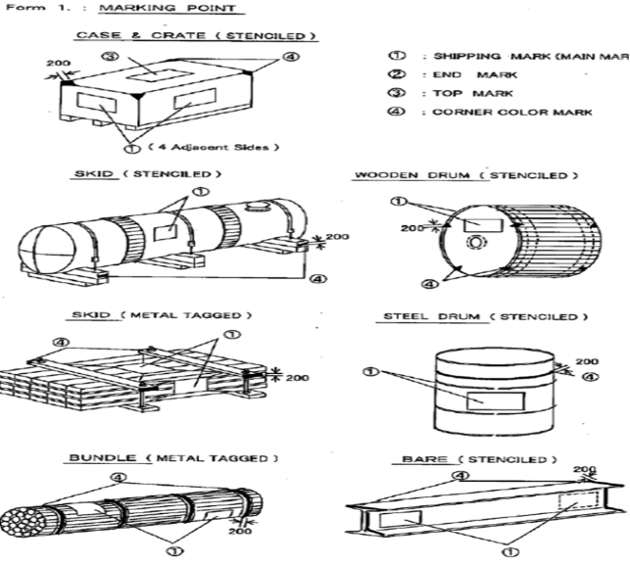

FORM 3: TOP MARK
Vendor shall apply following Top Mark on the top of the package.
FORM 4: END MARK
Vendor shall apply following End Mark.
