Weld Map
For
Steel Structure

Rev.  PAGE No. | 00 | 01 | 02 | 03 | 04 | 05 | 06 | 07 | 08 | Rev.  PAGE No. | 00 | 01 | 02 | 03 | 04 | 05 | 06 | 07 | 08
1 | x |  |  |  |  |  |  |  |  | 36
2 | x |  |  |  |  |  |  |  |  | 37
3 | x |  |  |  |  |  |  |  |  | 38
4 | x |  |  |  |  |  |  |  |  | 39
5 | x |  |  |  |  |  |  |  |  | 40
6 | x |  |  |  |  |  |  |  |  | 41
7 |  |  |  |  |  |  |  |  |  | 42
8 |  |  |  |  |  |  |  |  |  | 43
9 |  |  |  |  |  |  |  |  |  | 44
10 |  |  |  |  |  |  |  |  |  | 45
11 |  |  |  |  |  |  |  |  |  | 46
12 |  |  |  |  |  |  |  |  |  | 47
13 |  |  |  |  |  |  |  |  |  | 48
14 |  |  |  |  |  |  |  |  |  | 49
15 |  |  |  |  |  |  |  |  |  | 50
16 |  |  |  |  |  |  |  |  |  | 51
17
18
19
20
21
22
23
24
25
26
27
28
29
30
31
32
33
34
35

2 | 1 | WELD DETAIL NO.
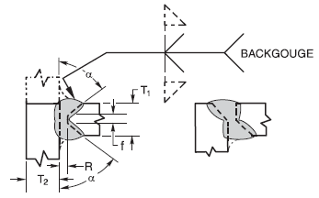 | 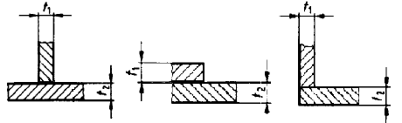 | PREPARATION
ST 37-2 | ST 37-2 | MATERIAL GRADE
THK. > 16 mm | ALL | THICKNESS
GMAW | GMAW | WELD PROCESS
ROOT AND FILL | ROOT AND FILL | WELDING LAYER
AWS A5.18  ER 70S-6(1.2mm) | AWS A5.18  ER 70S-6(1.2mm) | WELDING CONSUMABLE
220-268 | 190-220 | AMPERES | WELDING TECHNIQUE
18-32 | 18-32 | VOLTS | WELDING TECHNIQUE
25-60 | 25-60 | TRAVEL SPEED(cm/min) | WELDING TECHNIQUE
780 | 750 | HEAT INPUT  (j/mm) | WELDING TECHNIQUE
DCEP | DCEP | POLARITY | WELDING TECHNIQUE
1G,2G,3G | 1F & 2F | POSITION | WELDING TECHNIQUE
WP002 | WP001 | WPS
SSS-PQR002A | SSS-PQR001A | SUPPORTING PQR
Min 15°C For T≤38 &  65°C For 38<T≤65 | Min 10°C For T≤38 &  65°C For 38<T≤65 | MINIMUM  PREHEAT TEMP. | HEAT TREATMENT
65° C | 250° C | MAXIMUM  PREHEAT TEMP. | HEAT TREATMENT
300° C | 300° C | MAXIMUM  Inter Pass Temp.  . | HEAT TREATMENT
N.A | N.A | POST WELD HEAT  TREATMENT | HEAT TREATMENT
According to AWS D1.1 (2015) | According to AWS D1.1 (2015) | REMARK

4 | 3 | WELD DETAIL NO.
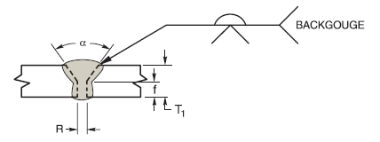 | 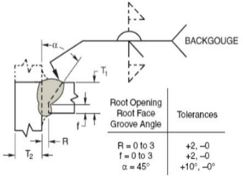 | PREPARATION
ST 37-2 | ST 37-2 | MATERIAL GRADE
6mm ˂ THK. ≤ 16 mm | 6mm ˂ THK. ≤ 16 mm | THICKNESS
GMAW | GMAW | WELD PROCESS
ROOT AND FILL | ROOT AND FILL | WELDING LAYER
AWS A5.18  ER 70S-6(1.2mm) | AWS A5.18  ER 70S-6(1.2mm) | WELDING CONSUMABLE
215-264 | 210-255 | AMPERES | WELDING TECHNIQUE
18-32 | 18-32 | VOLTS | WELDING TECHNIQUE
25-60 | 25-60 | TRAVEL SPEED (cm/min) | WELDING TECHNIQUE
840 | 820 | HEAT INPUT  (j/mm) | WELDING TECHNIQUE
DCEP | DCEP | POLARITY | WELDING TECHNIQUE
1G , 2G , 3G | 1G , 2G , 3G | POSITION | WELDING TECHNIQUE
WP004 | WP003 | WPS NO
SSS-PQR004A | SSS-PQR002A | SUPPORTING PQR
10°C For T≤38 &  65°C For 38<T≤65 | 10°C For T≤38 &  65°C For 38<T≤65 | MINIMUM  PREHEAT TEMP. | HEAT TREATMENT
250° C | 250° C | MAXIMUM  PREHEAT TEMP. | HEAT TREATMENT
300° C | 300° C | MAXIMUM  Inter Pass Temp. | HEAT TREATMENT
N.A | N.A | POST WELD HEAT  TREATMENT | HEAT TREATMENT
According to AWS D1.1 (2015) | According to AWS D1.1 (2015) | REMARK

6 | 5 | WELD DETAIL NO.
 | 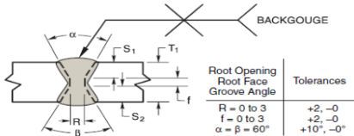 | PREPARATION
ST 37-2 | ST 37-2 | MATERIAL GRADE
THK. ≤ 6 mm | THK. > 16 mm | THICKNESS
GMAW | GMAW | WELD PROCESS
ROOT AND FILL | ROOT AND FILL | WELDING LAYER
AWS A5.18  ER 70S-6(1.2mm) | AWS A5.18  ER 70S-6(1.2mm) | WELDING CONSUMABLE
210-280 | 220-268 | AMPERES | WELDING TECHNIQUE
18-32 | 18-32 | VOLTS | WELDING TECHNIQUE
25-60 | 25-60 | TRAVEL SPEED  (cm/min) | WELDING TECHNIQUE
780 | 780 | HEAT INPUT  (j/mm) | WELDING TECHNIQUE
DCEP | DCEP | POLARITY | WELDING TECHNIQUE
1G , 2G | 1G , 2G, 3G | POSITION | WELDING TECHNIQUE
WP06 | WP05 | WPS
SSS-PQR003A | SSS-PQR004A | PQR
Min 10°C For T≤38 &  65°C For 38<T≤65 | Min 15°C For T≤38 &  65°C For 38<T≤65 | MINIMUM  PREHEAT TEMP. | HEAT TREATMENT
250° C | 250° C | MAXIMUM PREHEAT TEMP. | HEAT TREATMENT
300° C | 300° C | MAXIMUM  Inter Pass Temp | HEAT TREATMENT
N.A | N.A | POST WELD HEAT  TREATMENT | HEAT TREATMENT
According to AWS D1.1 (2015) | According to AWS D1.1 (2015) | REMARK

- | 7 | WELD DETAIL NO.
 | 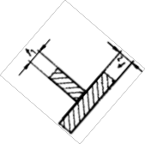 | PREPARATION
 | ST 37-2 | MATERIAL GRADE
 | 10 < Thk. ≤ 40 | THICKNESS
 | SAW | WELD PROCESS
 | 1~n | WELDING LAYER
 | A-5.17  F7AZ-EM 12 | WELDING CONSUMABLE
 | 360-570 | AMPERES | WELDING TECHNIQUE
 | 28-35 | VOLTS | WELDING TECHNIQUE
 | 20-40 | TRAVEL SPEED  (cm/min) | WELDING TECHNIQUE
 | 2852 | HEAT INPUT  (j/mm) | WELDING TECHNIQUE
 | DCEP | POLARITY | WELDING TECHNIQUE
 | 1F | POSITION | WELDING TECHNIQUE
 | WP007 | WPS
 | SSS- P.Q.R No.: 5329-2 | PQR
 | Min 10°C For T≤38 & 65°C | MINIMUM PREHEAT TEMP. | HEAT TREATMENT
 | 250° C | MAXIMUM PREHEAT TEMP. | HEAT TREATMENT
 | 300° C | MAXIMUM  Inter Pass Temp | HEAT TREATMENT
 | N.A | POST WELD HEAT  TREATMENT | HEAT TREATMENT
 | According to AWS D1.1 (2015) | REMARK

