Shipper/Exporter  Delta GmbH |  |  | Purchase Order No.: OFFSITE-61-1
 |  |  | Remarks:
For account & risk of Messes

Consignee
Petroelectric Energy Development
Notify party
Petroelectric Energy Development
Port of loading  Jebel Ali Port | Final destination  Assaluyeh |  | Term of Delivery : CFR Assaluyeh
Carrier  ……N.A………… | Sailing on or about  ……N.A…… |  | Manufacturer  Delta GmbH |  |  | Origin  Japan-Europe
Numbers of PKGS  4 PKGS | Description of Goods  Compressor Skid |  | Total Quantity  2 | Net weight(kg)  7500 | Gross weight(kg)  7900 |  | Serial/Heat No.  N.A
Vendor: Delta GmbH
Buyer: Petro Electric Energy Development Co.
End User/Client: Padjam Polymer Development Company
Vendor Signed & Stamp  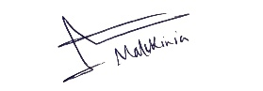   |  | VENDOR Name: Delta GmbH  CEO Name: Mr. Amin Malekinia
buyer Signed & Stamp |  | Buyer Name: Petro Electric Energy Development Co.  CEO Name: Mr.Morteza Salari
Packing List

(Detailed Item List) Page No. 2 of 2
PKG. No. | Description of Goods | ORD. QTY. | Net-  weight  (KGS) | Gross-  weight  (KGS) | Size  (CM x CM x CM) | Serial No./Heat No.
1 | MYCOM oil flooded Explosion proof Screw Compressor Unit P160VSD-M | 2 | 3750 | 3950 | 350X210X280

Vendor Signed & Stamp  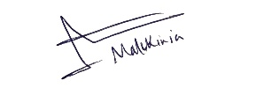 | VENDOR Name:  CEO Name: Mr. Amin Malekinia
buyer Signed & Stamp | Buyer Name: Petro Electric Energy Development Co.  CEO Name: Mr.Morteza Salari

