STYRENE PARK OFFSITE

Document Title
Test Procedures
FOR
Active Carbon Filter & Basket Filter

R0 | 06/09/2024 | Issued For Approval | F.Akhundi | E.Malek | H.Keshmiri
Rev. | Issued Date | DESCRIPTION | PREPARED | CHECKED | APPROVED

REVISION RECORD SHEET
Page | Revisions |  |  |  |  |  |  |  | Page | Revisions
Page | R0 | R1 | R2 | R3 | R4 | R5 | R6 |  | Page | R0 | R1 | R2 | R3 | R4 | R5 | R6
1 | × |  |  |  |  |  |  |  | 41
2 | × |  |  |  |  |  |  |  | 42
3 | × |  |  |  |  |  |  |  | 43
4 | × |  |  |  |  |  |  |  | 44
5 | × |  |  |  |  |  |  |  | 45
6 | × |  |  |  |  |  |  |  | 46
7 | × |  |  |  |  |  |  |  | 47
8 | × |  |  |  |  |  |  |  | 48
9 | × |  |  |  |  |  |  |  | 49
10 | × |  |  |  |  |  |  |  | 50
11 | × |  |  |  |  |  |  |  | 51
12 | × |  |  |  |  |  |  |  | 52
13 | × |  |  |  |  |  |  |  | 53
14 | × |  |  |  |  |  |  |  | 54
15 | × |  |  |  |  |  |  |  | 55
16 | × |  |  |  |  |  |  |  | 56
17 | × |  |  |  |  |  |  |  | 57
18 | × |  |  |  |  |  |  |  | 58
19 | × |  |  |  |  |  |  |  | 59
20 | × |  |  |  |  |  |  |  | 60
21 | × |  |  |  |  |  |  |  | 61
22 | × |  |  |  |  |  |  |  | 62
23 | × |  |  |  |  |  |  |  | 63
24 | × |  |  |  |  |  |  |  | 64
25 | × |  |  |  |  |  |  |  | 65
26 | × |  |  |  |  |  |  |  | 66
27 | × |  |  |  |  |  |  |  | 67
28 | × |  |  |  |  |  |  |  | 68
29 | × |  |  |  |  |  |  |  | 69
30 | × |  |  |  |  |  |  |  | 70
31 | × |  |  |  |  |  |  |  | 71
32 | × |  |  |  |  |  |  |  | 72
33 | × |  |  |  |  |  |  |  | 73
34 | × |  |  |  |  |  |  |  | 74
35 |  |  |  |  |  |  |  |  | 75
36 |  |  |  |  |  |  |  |  | 76
37 |  |  |  |  |  |  |  |  | 77
38 |  |  |  |  |  |  |  |  | 78
39 |  |  |  |  |  |  |  |  | 79
40 |  |  |  |  |  |  |  |  | 80

Contents
1. NDT Procedures 4
1.1. PT PROCEDURE 4
1.2. VT PROCEDURE 8
1.3. RT PROCEDURE 10
1.4. Weld/NDT Map 14
2. Hydrotest Procedure 17
2.1. PRESSURE VESSEL HYDROSTATIC TEST PROCEDURE 17
2.2. PIPING HYDROSTATIC TEST PROCEDURE 20
3. Paint Procedure 25

NDT Procedures

PT PROCEDURE
Purpose
This procedure covers the requirements necessary to the visible solvent removable liquid penetrant examination for detecting discontinuities which are open to the surface of materials.
References
ASME Section V: Nondestructive Examination
ASME Section VIII: Pressure Vessels
ASNT SNT-TC-1A: Recommended Practice for NDE Personnel Qualification and Certification
Responsibility
Contractor QA/QC department shall be responsible for the implementation and control of this procedure.
PT level II inspectors shall be responsible for performing and interpretation of the test with respect to this procedure and preparing the test reports.
Application
This procedure shall be applied for the detection of surface defects and discontinuities in welds, base metal, weld repairs.
This procedure shall be applied for the detection of surface defects in nonporous metallic materials.
Precaution for personnel safety
The liquid penetrant materials should be used in ventilated areas because they are highly volatile and flammable. The liquids should not be heated above 125 (52°C) or exposed to open flames or hot surfaces. Empty aerosol cans shall not be thrown into an open fire because of the explosive hazard.
Care shall be taken to avoid overheating of the pressurized cans.
If they must be heated to reach the required operating temperature heating shall be accomplished by using a hot water bath having an immersed thermometer.
Surface preparation
Surface preparation by normally wire brushing, or grinding may be necessary where surface irregularities could mask indications of unacceptable discontinuities. Blasting with shot or dull sand may peen discontinuities at the surface and shall not be used.
Prior to examination, the surface to be examined and all adjacent areas within at least 1 in.(25.4mm) shall be dry and free of all dirt, grease, lint, scale, welding flux, weld spatter, oil and other extraneous matter that could obscure surface openings or otherwise interfere with the examination.
Typical cleaning agents which may be used are detergents, organic solvents, descaling solutions, and paint removers. At site, penetrant remover shall usually be used.
After cleaning, drying of surfaces to be examined shall be accomplished by normal evaporation or with forced hot air, as appropriate. At least 5 minutes shall be required to ensure that the cleaning solution has evaporated prior to application of penetrant.
Penetrant materials
The term “Penetrant Materials”, as used in this procedure, is intended to include all penetrant, solvents or penetrant remover, developer, etc., used in the examination process.
Intermixing of materials from various manufacturers is not permitted.
Intermixing of materials from different type or/and different family group is not permitted.
Examination procedure
As a standard technique, the temperature of the penetrant and the surface of the part to be processed shall not be below 50F (10C) nor above 125F (52C) throughout the examination period. Local heating or cooling is permitted provided the part temperature remains in the range of 50F (10C) to 125F (52C) during the examination.
Penetrant Application
The penetrant shall be thoroughly agitated prior to its application.
The penetrant shall be applied by spraying so that the entire surface to be examined is completely covered with penetrant.
If reexamination is required on the same area after examination, the area completely shall be cleaned and reexamined in accordance with all of the
requirements of this procedure.
The penetration time shall be 5 to 30 minutes provided the temperature remains in the range of 50F (10C) to 125F (52C). Excess Penetrant Removal
After the specified penetration time has elapsed, any penetrant remaining on the surface shall be removed, taking care to minimize removal of penetrant from discontinuities.
Excess solvent removable penetrants shall be removed by wiping with a cloth or absorbent paper, repeating the operation until most traces of penetrant have been removed. The remaining traces shall be removed by lightly wiping the surface with cloth or absorbent paper moistened with solvent. To minimize removal of penetrant from discontinuities, care shall be taken to avoid the use of excess solvent. Flushing the surface with solvent, following the application of the penetrant and prior to developing, is prohibited.
Drying
A minimum 2 minutes of drying time by normal evaporation shall be allowed after the excess penetrant removal and prior to developer application.
Developing
The developer shall be thoroughly agitated to assure that the solids are in liquid suspension prior to their application.
The developer shall be applied by spraying only to obtain a thin uniform coating over the surfaces as soon as possible after surface drying. Insufficient coating thickness may not draw the penetrant out of discontinuities; conversely, excessive coating thickness may mask indications.
While applying the developer, the nozzle of the aerosol can shall be held at a distance of 12 to 16 inches (30 to 40cm) from the examination surface.
The developing time shall be 7 to 30 minutes.
Precautions should be taken to prevent any object from touching the dry developer film because it is very brittle, loosely held and easily damaged.
Interpretation
Final Interpretation shall be made not less than 10 min nor more than 60 min.
Indications with major dimensions greater than 1/16in. (1.59mm) shall be considered relevant.
A linear indication is one having a length greater than three times the width.
A rounded indication is one of circular or elliptical shape with the length equal to or less than three times the width.
Any questionable or doubtful indications shall be reexamined to determine whether or not they are relevant.
Post Cleaning
Upon the completion of the examination, the surfaces shall be thoroughly cleaned by wiping with a clean cloth moistened with an approved acetone, solvent or cleaner as required to remove all traces of test material.
Defect removal and repair
Unacceptable imperfections shall be repaired and reexamination made to assure removal or reduction to an acceptable size. Whenever an imperfection shall be repaired by chipping or grinding and subsequent repair by welding is not required, the excavated area shall be blended into the surrounding surface so as to avoid sharp notches, crevices, or corners. Where welding is required after repair of an imperfection, the area shall be cleaned and welding performed in accordance with an approved welding procedure.
Examination Records
Reporting In preparing the test record, the following information shall be included;
Examined date
Test material
Penetrant materials
Dwell time
Examiner
Weld identification
Interpretation
Other necessary information
Acceptance standards
All surfaces to be examined shall be free of:
1) Relevant linear indications;
2) Relevant rounded indications greater than 5mm.
3) Four or more relevant rounded indications in a line separated by 1/16 in (1.5mm). Or less, edge to edge;
4) An indication of an imperfection may be larger than the imperfection that causes it; however, the size of the indication is the basis for acceptance evaluation.

VT PROCEDURE
Purpose
This procedure will be followed when visual weld examination is performed in accordance with ASME for the detection of root (when accessible), face, and adjacent base metal anomalies caused by the welding process.
Reference
ASME Section V, Article 9, “Visual Examination”
Acceptance criteria, ASME SEC IX
Personnel Qualifications
Personnel performing visual examination (VT) of welds in accordance with this procedure shall be certified to at least Level II (VT) in accordance with relevant procedure.
Interpretation and evaluation of visual testing results shall be certified by VT Level II.
Responsible Manager/Group Lead:
Ensure visual weld inspectors are qualified and certified.
Ensure only inspectors certified as Level I or Level II in the visual weld inspection discipline performs inspections for the purpose of acceptance.
Select the Method of Inspection
Visual weld inspection is divided into two method categories (direct and remote)
Direct Method – The direct visual inspection method is used when access is sufficient to place the eye within 24 inches of the surface to be examined, and at an angle not less than 30 degrees to the surface to be examined. Mirrors may be used to improve the angle of vision, and aids such as magnifying lenses may be used to assist in the inspection of welds.
Remote Method – The remote visual inspection method may be substituted when direct visual inspection cannot be achieved. Visual aids such as mirrors, telescopes, borescopes, fiber optics, cameras, or other suitable instruments may be used.
Examination Procedure
-Direct visual examination shall be used and may usually be made when access is sufficient to place the eye within 24" of the surface to be examined
and at an angle no less than 30 degrees to the surface.
-Visual examination may begin immediately after completed welds have cooled except visual examination of welds in ASTM A514 and A517 steels shall be performed no less than 48 hours after completion.
-Weld surfaces shall be free of spatter, slag, scale, oil, and grease. Minor slag may be removed during the examination.
Acceptance Criteria
The accessible surfaces of the welds shall be examined visually. The welds shall show complete fusion, and shall be free from cracking or porosity.
(a) All indications characterized as cracks, lack of fusion, or incomplete penetration are unacceptable regardless of length.
(b) Indications exceeding 1 /8 in. (3 mm) in length are considered relevant, and are unacceptable when their lengths exceed:
(1) 1/8 in. (3 mm) for t up to 3/8 in. (10 mm).
(2) 1/3 t for t from 3 / 8 in. to 2 ¼ in. (10 mm to 57 mm).
(3) 3/4 in. (19 mm) for t over 2 ¼ in. (57 mm),
Where t is the thickness of the weld excluding any allowable reinforcement.
For a butt weld joining two members having different thicknesses at the weld, t is the thinner of these two thicknesses.
If a full penetration weld includes a fillet weld, the thickness of the throat of the fillet shall be included in t.
Other
Unless otherwise directed, mark all noted conditions clearly on the weld and adjacent base metal.
Visual examinations shall be done in accordance with the requirements of the applicable project specification, work order instruction or other special requirements, including but not limited to:
-Joint preparation and cleanliness
-Welder and operator qualifications to the applicable joining procedure (prior to application of the joining procedure).
-Fit-up, joint clearance, and internal alignment prior to joining
-Variables specified by the joining procedure, including filler material;
- Position and electrode.
- Condition of the root passes after cleaning - external and, where accessible, internal
- Slag removal and weld condition between passes; and appearance of the finished weld.

RT PROCEDURE
Scope
This procedure describes the operative method and acceptance levels to be followed when carrying out the radiographic examination.
Purpose
The procedure of RT is to determine and evaluate the severity of internal discontinuities in welds.
Qualification of personnel
Personnel performing examination to this procedure shall be qualified and certified in accordance with SNT-TC-1A “Recommended practice for personnel qualification and nondestructive testing”
- Contractor QA/QC department shall be responsible for the implementation and control this procedure.
- NDT level II inspectors shall be responsible for performing and interpretation of the test with respect to this procedure and preparing the test repots.
Referenced documents
Unless otherwise specified by job specifications, following codes and standards shall be applied.
    - ASME Section V : Nondestructive Examination
    - ASME Section IX : Welding and Brazing Qualifications
    - ASNT SNT-TC-1A : Recommended Practice for NDE Personnel Qualification and Certification

Radiographic equipment & accessories
- Source
X-Ray Source
- Manufacturer | Model | Max. KV Rating | Focal Spot | Recommended Thk.
Philips | Macrotank | 200 | 1.6x1.6 | 25 mm
Seifert | Isovolt | 400 | 4x4 | 90 mm
Andrex | CMA – 30 | 300 | 3.5x3.5 | 55 mm

Gamma Ray Source.
Radiation Source | Focal spot | Thk. Range
Ir-192 | 3 x 2 mm | > 3 mm

- Film
Radiographs shall be made using MX-125 or D4 films (film density = 2.5)
- Screen
When using a source greater than 150 KV, intensifying screens of the lead foil type are recommended. Fluorescent, fluorometallic or other metallic screens may be used provided the specified radiographic quality level, density and contrast are obtained.
-Film and screens are handled during set up and exposure in flexible plastic cassettes
- Densitometer
Radiographic densities should be measured with a calibrated densitometer. A visual comparison technique using calibrated step wedge film may be used for estimated radiographic film density. Verification of visually estimated densities shall be confirmed with a calibrated photoelectric densitometer and step wedge film traceable to the National Bureau of standard.

IQI Selection
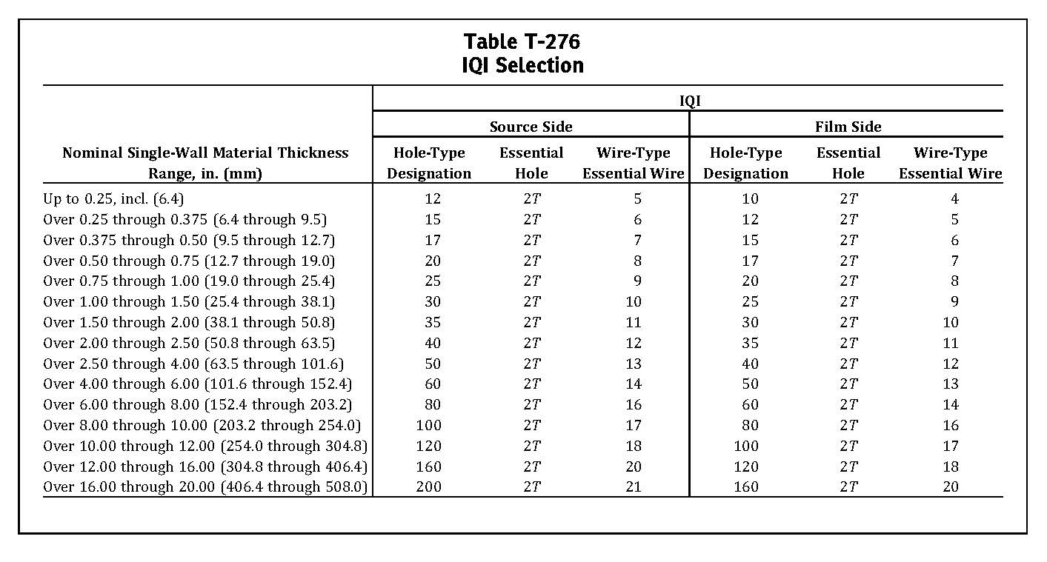The pentameter selection and sensitivity achieved be in accordance with ASME sec. V Article 2 Table 276. For any material thickness range, a penetrometer thinner than listed for that range may be used.
Surface preparation
Prior to radiographic examination, the weld ripples (if necessary) or welded surface irregularities on both, the in and outside (where accessible) shall be removed by nay suitable process to such degree that the resulting radiographic image due to any irregularities cannot mask or be confused with the image of any discontinuity.
Set up for exposure
Penetrometer Wire type penetrometer shall be used according to EN46 the image of the wire indicated in the following table shall be visible on the radiographs.
Placement of penetrometer
The penetrometer(s) shall be placed as specified in fig.1 on the source side on the part being examined. where inaccessibility prevents hand placing the penetrometer(s) on the source side. It shall be placed on the film side in contact with the part being examined. A letter “F” at least as high as the penetrometer identification number(s) shall be placed adjacent to or on the penetrometer(s) but shall not mask the wires.
PENETROMETER
FILM
SOURCE SIDE
PENETROMETER
FILM
FILM SIDE
Source
Source
SOURCE
PENETROMETER
FILM SIDE
SOURCE SIDE
(Fig.1) Placement of penetrometer Placement and number of penetrometers

Weld/NDT Map
Row | Description | Material | NDT
1 | Butt Joint of shell to shell  And shell to head | A516-GR70 | Spot RT
2 | Butt Joint of head | A516-GR70 | Spot RT
3 | Manhole/ Nozzle to shell or head | A106-B / A516-GR70 | 10% UT
4 | Manhole longitudinal welds  (M1 & M2) | A516-GR70 | 10% RT
5 | Fillet weld | A516-GR70  A105  A106-B | 10% PT
6 | Pipe to Pipe, Pipe to Flange and Fitting (for piping) | A106-B  A-105  A234-WPB | 5% RT  (NPS≥2”)

Active Carbon Filter:

Row | Description | Material | NDT
1 | Butt Joint of shell | A53 | Full RT
2 | Cap to shell | A234 WPB / A53 | Spot RT
3 | Nozzle to shell or head | A234 WPB / A106-B / A53 | 10% UT
4 | Fillet weld | A106-B / A105 / A53 | 10% PT
Basket Filter:

Note 1: For all attachment welds 100% VT and 10% PT shall be considered.
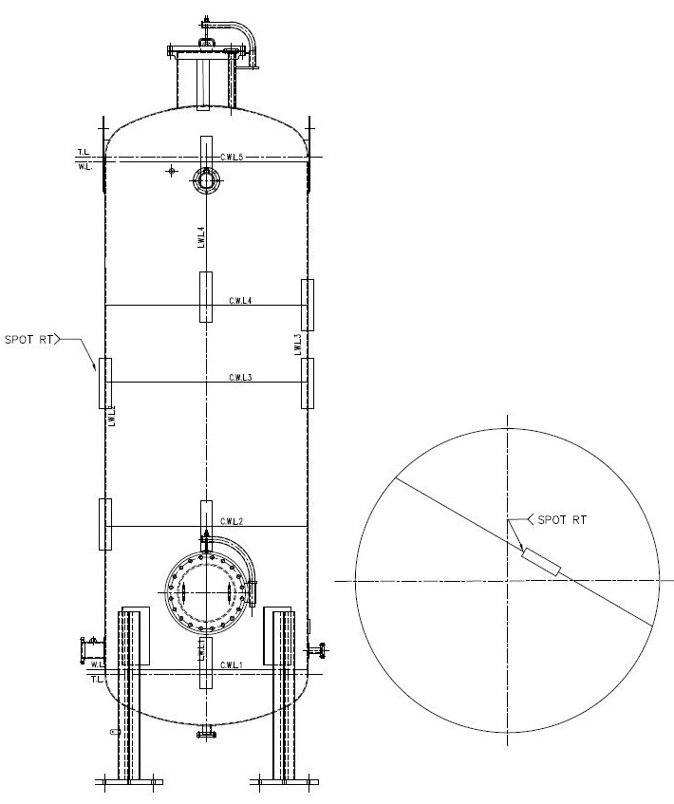
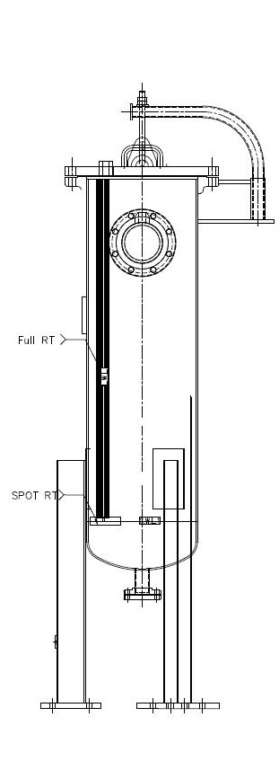

Hydrotest Procedure

PRESSURE VESSEL HYDROSTATIC TEST PROCEDURE
Scope
This procedure describes the control methods of hydrostatic test of the pressure vessel which will be fabricated in accordance with applicable edition and addenda of ASME code section VIII, Division 1. UG-99(b).
Acceptance Criteria
No leakage should occur during test and no pressure drop should be encountered.
Required equipment for testing
- Vent pipe
- Joint for feed water
- Joint for applying the test pressure
- Pressure gauge
It is required two pressure gauges to be installed on vessel. The first one is set up on the highest part of vessel and shows the pressure directly. An indicating gauge shall be connected directly to the vessel. If the indicating gauge is not readily visible to the operator controlling the pressure applied, an additional indicating gage shall be provided where it will be visible to the operator throughout the duration of the test. Its capacity should be between 1.5 to 4 times the test pressures. All pressure gauges should be calibrated against a standard Dead Weight Tester or a calibrated Master Gauge at least every 1 year and also be assured of its calibration during the test and results printed in the calibration certificate for pressure gauge sheet. All pressure gauges used in this procedure shall be having high sensitivity with pressure variation.
- Blind flanges, bolt, nut and gasket
- Pressurizing pump for hydrostatic test and water filling.
Water Requirements
Hydrostatic testing shall be carried out using cleaned water free from suspended soils and other foreign matters.

Test Pressures
The hydrostatic test pressure shall not be less than 1.3 times the times the maximum allowable
working pressure.
Note: The maximum allowable working pressure may be assumed to be the same as the design pressure when calculations are not made to determine the maximum allowable working pressure.
Fill up & Draining Procedure
- Vents shall be provided at all high points of the vessel in the position in which it is to be tested to purge possible air pockets while the vessel is being filled.
- Before applying pressure, the operator shall check the test equipment to assure that it is tight and that all low-pressure filling lines and other appurtenances that Should not be subjected to the test pressure have been disconnected or isolated by Valves or other suitable means.
- After the vessel is completely filled, the vent shall be shut-off.
- The maximum rate of pressure shall be 1 bar/ min.
- After completion of fabrication and testing, the vessels shall be thoroughly drained of water and dried.
- All vessels shall be dried up completely and immediately by draining and air blowing, thoroughly cleaned inside and outside and free of all dirt and loose foreign materials.
- After tightening all of nozzle joints, water is led to vessel through the feed water nozzle. The temperature of the testing water and metal surface of shell body should be 17°C above the minimum design metal temperature (MDMT) during the test and test pressure should not be applied until the vessel and water are about the same temperature. When the vessel was prepared for applying pressure the pressure shall be increased slowly and continuously till reaching 25% test pressure. Then the pressure shall be increasing step by step approximately 25% anticipated test pressure. The pressure shall be held station at the end of increment for sufficient time (5 minutes) to allow the observations (visual inspection) required by the test procedure to be made (according to the test diagram). The test pressure should be held Min.60 minutes. This time specify in the test diagram.
Then we Test pressure during vertical hydrostatic testing shall be checked with top pressure gauge release the pressure down till reaching inspection pressure.
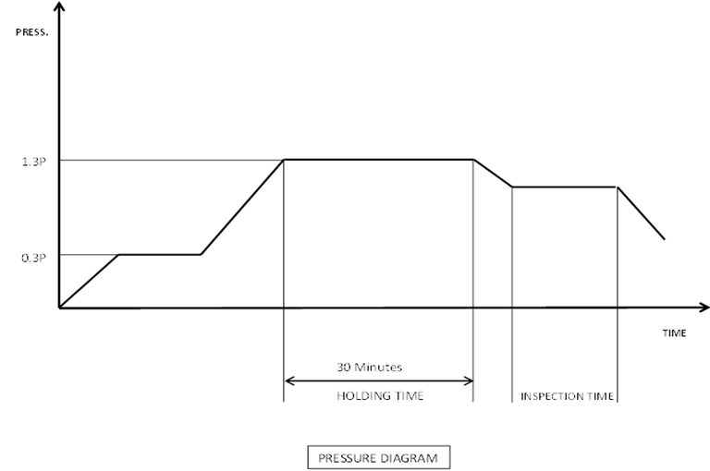
Visual Inspection
- At the pressure described in diagram above inspection for leakage shall be made on the whole body of the vessel. Especially on weld seams and all areas of high stress concentration.
- The test shall be conducted by the manufacturing Dept. and monitored by the Q.A. Inspector & inspected (as Hold point) by the Owner /TPA.
- After completion of the pressure test, the Q.A Inspector shall record the result on the pressure test Report and the Q.A. Dept. manager shall approve and verity it.
Document Control
-All documents prepared for or generated from activities prescribed by this procedure are available to the customer for his review.
-TPA shall sign and stamp all reports and results.

PIPING HYDROSTATIC TEST PROCEDURE
General Requirement
- Care shall be taken to ensure that the following equipment is not subjected to field test pressures:
- Pumps and compressors.
- Rupture discs, safety valves, flame arrestors, filter elements.
- Instruments, including gauge glasses and pressure gauges.
- Equipment where the internal lining may be damaged by the medium.
- Equipment such as filters and driers where the contents could be damaged or contaminated.
- Vessels and exchangers which have hydrostatic test pressures less than the line test pressure.
- Vents shall be provided at all high points in the piping system and drains shall be provided at all low points.
- Fabrication and welding shall be completed prior to system testing.
- Welding cleanup, non-destructive examination, stress-relieving, and other heat treatments shall be completed before pressure testing is performed.
- Insulation and paint shall not be applied over welded, screwed and mechanical joints before pressure testing.
- Testing shall be performed by qualified personnel of executor who are thoroughly familiar with all equipment and test procedures.
Hydrostatic Pressure Testing
-Where the test pressure of piping attached to a vessel is the same as or less than the test pressure for the vessel, the piping will be tested with the vessel at the piping test pressure.
-Where the test pressure of the piping exceeds the vessel test pressure, and it is not considered practicable to isolate the piping from the vessel, the piping and the vessel may be tested together at the vessel test pressure.
-If a portion of a piping system cannot be hydrostatically tested because the presence of water is objectionable, a notation shall be made on the pressure test flow sheets indicating that hydrostatic testing by water is prohibited.
-Cast iron piping with spigot and socket joints shall be intermittently covered, leaving the joints clear and all the bends securely anchored before testing.
Testing Area
- If possible, test equipment including pumps, gauges, and other items shall be located in the same area.
- The area shall be continuously monitored by test personnel while testing is being performed so that any change in test procedures or conditions will be noted immediately and corrective action taken as required.
Test Equipment
Pressure gauge range selected shall be such that the pressure reading occurs between 25 and 75 percent of the full range of pressure gauge.
Test Medium
- The test fluid normally shall be fresh water and shall not contain suspended solids which may plug small lines.
- If the water temperature is likely to fall to zero degrees centigrade (°C) or below, glycol or antifreeze approved by the CLIENT shall be added.
- Carbon and low-alloy steel Piping manufactured from carbon steel or low-alloy steel may be hydrostatically tested with potable water.
Test Pressures
The hydrostatic test pressure, at any point in a metallic piping system shall not less than 1.5 times the design pressure.
Test Duration
The test pressure shall be maintained for at least 30 minutes to allow a full visual inspection of all joints and connections. QC inspector and other inspectors representing CLIENT will carry out a detailed inspection of weld joints and connections for any leak. They shall also monitor for dislocation / movement on supports. Any joint found leaking during a hydrostatic test shall be retested to the specified test pressure after repairs had been made with system depressurized. The test pressure shall be maintained for a minimum of 10 minutes before any system is put to official test. The test duration however, shall be extended whenever needed, to complete the full visual inspection.

Test Preparation
- All piping intended for other than liquid service shall be adequately supported by temporary supports, if necessary, particularly on lines using spring or counterweight supports. Large adjacent lines shall not be tested simultaneously where the weight of the combined test water load may overload the structure of supports.
- The executor of test shall consider temporary gaskets when making connections that will be broken for testing or reassembly after testing.
- The executor shall take care to avoid contaminating valve seats with foreign particles.
Lines containing check valves shall have the pressure source located on the upstream side. If impossible, the check valves shall be removed from the line or blocked open.
- Lines which have spring hangers or are counterweight supported shall be temporarily blocked up during testing in order to sustain the weight of the test fluid. Sometimes spring hangers are provided with stops for carrying the test load and need not be blocked up.
- Equipment that is not to be included in the test shall be isolated by blinds or shall be disconnected from the piping.
- Pressure control valves with internal passages between the process fluid and the diaphragm shall be isolated from the test. External connections shall be disconnected or blocked during the test. The diaphragm pressure shall be bled off.
- Expansion joints of the sliding sleeve or bellows type should be provided with temporary means to limit lateral movement.
- Expansion joints, instruments, filters and similar equipment for which the maximum permissible cold test pressure is considerably lower than the maximum hydrostatic test pressure permissible for the other components of the system shall be removed or blanked off from the line before testing. Such equipment should be inspected during the commissioning with due regard to the pressure limitation.
- Plugs shall be removed from tell-tale holes in compensating rings and reinforcement pads around branches (nozzles) and the holes left open during hydrostatic testing and observed for any leakage.
- Prior to commencement of the test a thorough check shall be made to ensure all fittings, flanges, plugs, etc., are in place. All flanges and flanged fittings shall be bolted and bolts properly torqued.
- Testing of more than one individual section simultaneously may be carried out by connecting the sections with suitable jumper lines. The materials used in the fabrication of these jumpers shall be of the same quality as the system under test, as a minimum. Threaded piping shall be minimized on jumper lines.
- Instrument piping at orifice flanges shall be removed or a drain or vent shall be opened to ensure that the instrument does not become pressurized because of a leaking valve.
- Mounted instrumentation shall be isolated from the system during testing.
- The supply connection size shall ensure filling of the system within a reasonable time, and it shall have a flanged valve.
- A valve shall be used for depressurizing, for which a globe valve is preferred.
- The same bolt and Gasket type which is used in process should be used for Hydro test.
- All reinforcing pads or each segment thereof shall be air tested to 1 bar prior to hydrostatic testing. - All welds shall be inspected inside and outside during the test. Test holes shall be open during the hydrostatic test and plugged with a no hardening sealant or heavy grease after the hydrostatic test.
Procedure for Hydrostatic Pressure Test
- The Q.C. Inspector shall be notified of the date and time of hydrostatic test by the Project Leader/Piping Engineer and shall coordinate with the CLIENT representatives as soon as the lines are accepted for hydrostatic test.
- Pressure test sections shall be chosen by the executor, based on testing as much piping as possible at one time without exceeding the allowable test pressure of the weakest element in the system.
- Vents and other connections that can serve as vents shall be open during filling so that all air is vented prior to the application of test pressure to the system.
- Test pressures shall be taken at the lowest point of a line or test system.
- During hydrostatic testing, care must be exercised to limit the applied pressure to the particular portion of the system designated on the field pressure test flow diagram.
- Care must also be taken to avoid overloading any parts of supporting structures.
- Where conditions require a test pressure to be maintained for a period of time, during which the test medium in the system might be subject to thermal expansion, provision shall be made for the relief of excess pressure due thereto. (by either installation of a proper relief valve or discharging excess pressure.)
- Test pressure shall not be applied against any closed valve unless the maximum allowable working pressure of the valve exceeds the test pressure.
- If the test pressure is the same upstream and downstream of a control valve, the block and by-pass valves shall be left open, with the control valve open or closed (whichever is most convenient).
Measures to be taken after Hydrostatic Testing
- After hydrostatic testing is completed and approved by the CLIENT, the system shall be depressurized.
- After depressurizing, lines and equipment shall be completely drained.
- Special attention shall be given to points where water may be trapped such as valve bodies or low points.
- All temporary blanks and blinds shall be removed. Valves, orifice plates, expansion joints and short pieces of piping which have been removed shall be reinstalled with proper and undamaged gaskets in place. Valves which were closed solely for hydrostatic testing shall be opened. Temporary piping supports shall be removed so that insulation and painting may be completed.

Paint Procedure
Scope
This Specification covers the requirements for the protection of ferrous metal from corrosion by use of paint coatings and includes requirements and maintenance painting.
Terms And Definitions
DFT: | Dry Film Thickness
WFT: | Wet Film Thickness
Codes And Standard
The requirements contained in the latest editions of the following standards shall form an integral part of this specification in the manner and to the extent specified herein.
IPS
IPS-E-TP-100: Engineering Standard for Paints
IPS-C-TP-101: Construction Standard for Surface Preparation
IPS-C-TP-102: Construction Standard for Painting
SSPC
SSPC Volume 1: Good Painting Practice
SSPC Volume 2: System & Specifications
DIN Standard
DIN 55928: Corrosion Practice for Protection of steel structures by the application of organic or metallic coating
DIN 2403: Identification of pipelines according to the fluid conveyed
German Standards RAL-color codes 840HR
ASTM
ASTM D 3359: Standard Test Methods For Measuring Adhesion By Tape Test
ASTM D 4541: Standard Test Method For Pull-Off Strength Of Coatings Using Portable Adhesion Testers
ASTM A385: Standard Practice for Providing High-Quality Zinc Coatings (Hot-Dip)
ASTM D4283: Standard Test Method For Viscosity Of Silicone Fluids
ASTM D4285: Standard Test Method for Indicating Oil or Water in Compressed Air
NORSOK
M 501: Surface Preparation And Protective Coating
General Notes
Non-Painted Surfaces:
All surfaces shall receive an appropriate paint system as specified in this specification with the following exceptions:
- Any equipment furnished completely painted by the Supplier unless it is specially required to match a color scheme or to repair damage to the paint film
- Hot-dip galvanized steel, stainless steel and non-ferrous metals, Monel, brass, copper, aluminum jacketing, unless it is specially required;
- Non-metallic surface;
- Nameplates, code stampings and push-buttons;
- Surfaces to be fireproofed;
- Machined surfaces
- Concrete, brickwork, tile, glass and plastics, unless specially required;
- Rubber, hoses, belts, flexible braided connectors, stainless steel tubing, fittings , gages, valve stems and motor shafts.
- And any surface particularly indicated as not to be painted.
Paint shall not be applied under the following conditions:
- When the temperature of the surface is less than 3°C above the dew point of the surrounding air, and/or the relative humidity is higher than 80%;
- When the temperature is below 5°C;
- When the surface temperature is higher than 35°C; as recommended by Supplier.
- When there is the likelihood of an unfavorable change in weather conditions within two hours after coating;
- When there is a deposition of moisture in the form of rain, condensation, frost, etc., on the surface.
- Outside daylight hours on exterior location,
- Painting In exterior locations may be suspended due to wind speed at the discretion of the Company.

Surface Preparation
Preparation before Blast Cleaning
- All rough-edged cuts and welds, weld spatters, indentations, all surfaces and protrusions must be ground to smooth out the contour before the surface is prepared for painting. Any grinding performed after blast cleaning, must be re-blasted to required roughness.
- Prior to surface preparation, the surface shall be inspected for spotting oil and grease deposits or pollution on the surface. If any, the deposits of oil or grease shall be removed from the surface by solvent cleaning (SSPC-SP1) prior to further surface preparation.
- Prior to blast cleaning the substrate shall be dry and at least 3°C above the dew point temperature.
- Visual inspection shall be carried out to detect any sharp edges, weld spatter or visible laminations. Where these are discovered, they shall be ground smooth prior to water washing.
- The steel to be blast-cleaned by dry methods shall be dry and the operating conditions shall be such that condensation does not occur on it during the work. When compressed air is used, this shall be dry and free from oil.
- Weld defects such as pin holes and discontinuities shall be rectified.
- Weld undercutting shall be filled or dressed.
- Excessive weld spatter shall be dressed off (Only light spatter will be adequately removed by blast cleaning).
- Welding slag shall be cleaned off.
- Laminations, laps and shelling shall be dressed off completely.
Required Cleanliness
The standard of cleanliness for blasted surface could be described as per follow:
- Sa2 ½ (Very through blast cleaning): when viewed without magnification, the surface shall be free from visible oil and grease and dirt and mill scale, rust and paint.
Required Roughness
The surface roughness of steel work shall be in the range of 50 to 75 micron for painting and coating.
Blasting
Only dry blast cleaning procedures shall be allowed. The compressed air used for blast cleaning shall be free of detrimental amount of water and oil. Blast cleaning shall be scheduled to allow priming on the same day.
Selection of abrasives for blast cleaning shall be in accordance with the recommendations give in SSPC-SP COM and the recommendations agreed with the individual paint manufacturer for each type of paint used. Generally, this shall give a surface profile or anchor pattern within the range 50-75 microns with rogue peaks of maximum amplitude 100 microns.
Blast abrasive media shall be free of corrosion producing contaminants and oil.
Precautions
Surface preparation by dry blasting techniques shall not be performed if:
- At temperatures below 5°C (41°F)
- When the surface temperature is less than 3°C above the ambient dew point,
- When the air's relative humidity is greater than 85 %.
Surface not Blast Cleaned
Surfaces to be painted which cannot be blast cleaned due to inaccessibility or impracticality (e.g. oil or instrument air tubing) may be cleaned either mechanically or chemically upon the approval of the Company's representative.
After Blast Cleaning
- All prepared surfaces shall be primed within four hours or before visible re-rusting occurs, whichever is soonest.
- Care shall be taken not to contaminate blast cleaned surfaces prior to painting.
- The prepared blast cleaned surface shall be completely primed the same day as blasted, and before any visible rusting or deterioration of the surface occurs. No blasted surface shall stand overnight before coating.
- Residual shot, grit and dust shall be completely removed after blasting.

Storage, Mixing and Thinning of Products
Storage Conditions
- All paint and thinner containers shall be kept closed before use and stored under shelter.
- Any paint which has gelled or settled during storage shall not be used.
- Any paint for which the shelf life is expired shall not be used.
- Thinners, solvents, etc. shall be stored in a suitably ventilated fireproofed building, separate from other painting consumable.
Mixing
- All the ingredients in each container shall be thoroughly mixed and homogenized. Mechanical mixing shall be such that all pigments or other agents are held in solution during application. Manual mixers are not authorized.
- Paint mixed in the original container shall not be transferred until all settled particles have been remixed with the medium. This does not imply temporary removal of part of the medium to facilitate mixing. Paint shall be mixed with mechanical mixers to keep the pigment in suspension.
- Paint shall not be mixed or held in solution with air bubbles.
- If a skin has formed in the container, it shall be cut and removed. If the skin is thicker than 1 mm, the paint shall not be used.
- All pigmented products shall be strained after mixing unless Contractor equipment is provided with adequate strainers.
- Strainers must allow all pigments to pass through, but not any skin.
- Products with unlimited pot life or which do not alter on standing may be mixed at any time; however, if they have set, they must be mixed immediately before use. Paint shall not be kept in the spray equipment pots overnight, but shall be put back into a closed container and remixed before re-use. Containers must be marked with the involved paint's pot-life.
- Hand mixing of paints shall be permitted only for containers up to 5 liters. All larger containers shall be mixed by mechanical agitators and brought to a uniform consistency. Where pigment separation readily occurs, such as heavy or metallic pigments, prevention shall be made for continuous mixing during application.
Thinning
- No thinners are to be added unless necessary for proper application. Thinning must never exceed Supplier recommendations.
- Thinners used must be those suggested by the Supplier.
- When use of thinner is authorized by the Supplier, it shall be added during mixing. Contractors shall not add thinner after the paint has been thinned to the proper consistency. Thinners must be added under the guidance of a specialist who is thoroughly familiar with the quantity and type of the added thinner.

Application of Paint
Paint Systems
- Type, number of coats, thickness & top coat RAL must be in accordance Appendix A
- The primer to finishing coat paint shall be from the same Supplier for each system to ensure compatibility.
Application
- As far as possible, each coat of paint shall be applied in a continuous, even coat free of holiday. Any area which has not been properly coated or missed shall be repainted.
- Each coat must cure or dry properly before application of the next coat. The applicator shall follow Manufacturer’s instructions.
- When several coats of the same type of paint have been specified, alternate coats of paint shall be tinted as much as possible to make sure that the surface is completely covered. If a colorant is added, it shall be compatible with the paint and not alter its service life.
- Brush application of paint shall be in accordance with the following:
a) Brush type and quality shall enable proper application of paint. Round or oval brushes are best suited for rivets, bolts, irregular or rough surfaces or pitted steel. Flat and wide brushes are suitable for large flat surfaces, but must not exceed 125mm. Long handle brushes shall not be authorized. Brush applied coats shall be as smooth and uniform as possible.
b) Paint shall penetrate angles.
c) Protruding parts shall be pre coated.
d) All paint drips shall be removed with the brush.
e) A minimum of brush strokes shall be visible.
f) Surfaces that are not accessible to brush shall be sprayed or painted with a sheep skin.
Application by airless
Airless spray is a preferred method for paint application, and shall satisfy the following condition:
a) The equipment manufacturer’s recommendation shall be followed for choosing the nozzle and pressure ratio.
b) Equipment used for air-less spray shall be fitted with pressure indicators and regulators adopted to service.
c) Traps or separators shall be installed to trap oil or water condensed in the air.
d) Continuous mechanical agitation shall keep paint mixture in spray pots or containers.
e) Spray equipment shall be kept clean so that dust, dry paint or other foreign matter is not deposited in the coat to paint.
f) Any solvent left in the spray equipment shall be completely removed before applying the paint to the surface.
g) Paint flow and spray pattern should be adjusted by changing the spray cap on the spray gun. Care should be taken to select the correct cap for the particular application. For good results the gun is held at right angles to the work and about 300 to 400 mm away. The speed of the operating stoke should be much faster than for normal spraying.
h) For large area, start at the top corner and spray to the end of the top area, (except for the edge). Then return, over lapping the first area just enough to form a uniform coating. Care should be taken that this must be slight.
i) When spraying horizontal surfaces, start at one side of the near edge and spray to the other side of the near edge, and then reverse direction working away from the near edge.
Drying Painted Surfaces
- An additional coat of paint shall not be applied until the previous coat is dry and may be painted. Read Supplier's instructions for drying times with respect to ambient temperature and humidity.
- Paint shall not be dried under conditions that may cause wrinkling, blistering, pore formation or other injurious defects.
- No drier shall be added to paint.
Repair of Damaged Paint Areas
When factory painted or painted surfaces have been marked in handling, the damaged paint and non-adherent paint shall be removed and the surface thoroughly cleaned. The edges of the damaged area shall be smoothed. Surface preparation shall extend approximately 5 cm into the sound coat.

Inspection
Painting works achieved in accordance with this specification, shall be inspected by a Company’s representative.
Each paint coat shall be free from defects and damage. Finished paint shall have the correct shade, degree of gloss and even and be free from tackiness after drying / curing and from cracks, holidays, runs, sags, wrinkles, patchiness, brush or roller marks, or defects that may be deleterious to the quality of the coating.
Free Access to Products and Work Site
The Inspector or the Company's representative shall be allowed free access to the products and the work site.
Humidity Check
The air's relative humidity shall be measured with a psychrometer. Surface preparation and/or paint application operations shall not commence until relative humidity is less than the limits set in this specification. Relative humidity shall be measured and recorded a minimum of six (6) times a day whence two (2) times before commencement of work. Moisture on the surface being prepared or painted shall be measured every day with a surface moisture indicator before beginning surface preparation operations or applying a coat of paint.
Thickness Check
- Dry paint thickness shall be measured with a magnetic probe, such as Micro test or elcometer or equivalent. It is imperative that the magnetic probe be calibrated for each thickness of coating steel support with a non-magnetic block whose thickness is as close as possible to the coating being checked.
- Each coat's thickness and total thickness shall be checked. Make five (5) separate spot measurements spaced evenly over each section of the structure 10 square meters in area (divide the entire surface in 10 square meter areas).
- On each spot, make 3 readings by moving the probe a short distance for each new gage reading. Discard any unusually high or low gage reading that cannot be repeated consistently. Take the average of the three (3) gage readings as the spot measurement.
- For each successive coat, the minimal allowable thickness shall be at least 80 % of the specified thickness; the maximum thickness shall not exceed 150 % of the specified thickness.
- For the total system, the minimal allowable thickness shall be at least 80 % of the specified thickness. The maximum thickness shall not exceed 150 % of the specified thickness unless the paint remains soft or shows mud crack or orange skin or wrinkling which cause rejection of the paint.
Surfaces with coat thicknesses out of tolerance shall:
- be sand blasted if too thick and repainted,
- Receive an additional paint coat to obtain specified thickness.
In order to achieve the specified dry film thickness, frequent checks of wet film thickness shall be carried out during the paint application with film thickness gauges such as the elcometer wheel or comb type. In the vent of the film thickness not meeting the specified requirements, additional coat(s) of the paint concerned shall be applied in compliance with the specified requirements.
Adherence Check
Paint adherence shall be checked as per ASTM method D 3359. Method A (X cut) shall be used for paint film thicker than 125 microns; Method B (lattice pattern) shall be used for paint films up to 125 microns.
Test Method A:
An X-cut is made in the film to the substrate, pressure-sensitive tape is applied over the cut and then removed. Acceptable rating is 5A (No peeling or removal) or 4A (Trace peeling or removal along incisions or at their intersections).

Test Method B:
A lattice pattern with either six or eleven cuts in each direction (cross cut) is made in the film to the substrate, pressure-sensitive tape is applied over the lattice and then removed, and adhesion is evaluated by comparison with descriptions and illustrations. Spacing between the cut lines shall be 1 mm for film thicknesses up to 50 microns and 2 mm for film thicknesses from 50 to 125 microns. Acceptable results are rate 5B (The edges of the cuts are completely smooth; none of the squares of the lattice is detached) or 4B (Small flakes of the coating are detached at intersections; less than 5% of the area is affected
If the test is unsatisfactory, the entire surface shall be blast cleaned and repainted. Recoating after this destructive test is at the Contractor's expense

Appendix A
ITEM | PAINT SYSTEM |  |  |  | DFT (DRY FILM THICKNESS)  IN MICRONS |  |  |  | RAL
ITEM | Surface  Preparation | Layer No.1 | Layer No.2 | Layer No.3 | Layer No.1 | Layer No.2 | Layer No.3 | TOTAL | RAL
Active carbon Filter, Basket Filter, Piping  External surface- | Sa 2,5 | Zinc-rich epoxy | Epoxy mid coat | Polyurethane finish coat | 70 | 60 | 70 | 200 | 9006
ladder and platform | Sa 2,5 | Zinc-rich epoxy | Epoxy mid coat | Polyurethane finish coat | 70 | 50 | 50 | 170 | 2000
Instrument and electrical items | TO MANUFACTURER’S STANDARD

