NDE Procedure

PURCHASER'S COMMENT/APPROVAL STATUS |  |  |  |  |  |  | Purchaser: NARGAN
1 | AP: Approved (Released for Manufacturing) |  |  |  |  |  | Purchaser: NARGAN
2 | AN: Approved With Minor Comments (Fabrication may Proceed) |  |  |  |  |  | Requisition No.: DPIC98-12-001-000-ME-MR-4150-0001-D1
3 | NF: Approved With Comments (Fabrication not Proceed) |  |  |  |  |  | Requisition No.: DPIC98-12-001-000-ME-MR-4150-0001-D1
4 | RJ: Rejected |  |  |  |  |  | Item No. (Tag No.): PK-6101
5 | NR: Not be Returned |  |  |  |  |  | Item No. (Tag No.): PK-6101
Date: XX.XX.XX Signature: |  |  |  |  |  |  | Vendor Doc. No.: DPIC9812-000-VD-1002-ME-PRC-0070
 |  |  |  |  |  |  | 
D0 |  | 22-Nov-21 | IFA | E.Nasrollahi | M.Razmgir | S.Kabiriyan
REV. |  | DATE  ISSUE | Purpose of Issue | PREPARED | CHECKED | APPROVED

REVISION INDEX
SHEET NO. | REVISION |  |  |  |  |  |  | SHEET NO. | REVISION
SHEET NO. | 00 |  |  |  |  |  |  | SHEET NO. | 00
1 | X |  |  |  |  |  |  | 37 | X
2 | X |  |  |  |  |  |  | 38 | X
3 | X |  |  |  |  |  |  | 39 | X
4 | X |  |  |  |  |  |  | 40 | X
5 | X |  |  |  |  |  |  | 41 | X
6 | X |  |  |  |  |  |  | 42 | X
7 | X |  |  |  |  |  |  | 43 | X
8 | X |  |  |  |  |  |  | 44 | X
9 | X |  |  |  |  |  |  | 45 | X
10 | X |  |  |  |  |  |  | 46 | X
11 | X |  |  |  |  |  |  | 47 | X
12 | X |  |  |  |  |  |  | 48 | X
13 | X |  |  |  |  |  |  | 49 | X
14 | X |  |  |  |  |  |  | 50 | X
15 | X |  |  |  |  |  |  | 51 | X
16 | X |  |  |  |  |  |  | 52 | X
17 | X |  |  |  |  |  |  | 53 | X
18 | X |  |  |  |  |  |  | 54 | X
19 | X |  |  |  |  |  |  | 55 | X
20 | X |  |  |  |  |  |  | 56 | X
21 | X |  |  |  |  |  |  | 57 | X
22 | X
23 | X
24 | X
25 | X
26 | X
27 | X
28 | X
29 | X
30 | X
31 | X
32 | X
33 | X
34 | X
35 | X
36 | X

TABLE OF CONTENTS

1 Definition 4
2 Part 1 : Ultrasonic Examination Procedure 5
3 Part 2 : Liquid Penetrant Examination Procedure 21
4 Part 3 : Radioghraphic Examination Procedure (Gamma-Ray Examination) 28
5 Part4: Magnetic Particle Examination Procedure 37
5 Part5: Appendix 44

DEFINITIONS

Owner: DEHDASHT PETROCHEMICAL INDUSTRY COMPANY

Contractor: NARGAN & PETROPART

Vendor: KASRAVAND Co.

Project: DEHDASHT HIGH DENSITY POLYETHYLENE PROJECT

Part 1

Ultrasonic Examination Procedure

Table of Content

1 Scope 7
2 Reference Documents 7
3 General Requirements 7
4 Equipment 8
5 Calibration Blocks 9
6 Surface Condition 10
7 Instrument Calibration 10
8 Transfer Variation Correction 12
9 Scanning Sensitivity 12
10 Information Prior To Inspection 12
11 Inspection Sequence 12
12 Evaluation Of Indications 13
13 Acceptance Criteria 14
14 Post Examination Cleaning 15
15 Reporting 15
16 Calibration Blocks Figure 17

- Scope
1.1 This procedure describes the minimum requirements for carrying out ultrasonic examination of welds and adjacent base material by manual contact method of carbon steel & Stainless Steel plates, pipes, forgings and cast materials of thickness 5 mm to 150mm for Refrigeration Package
.
1.2 Where required by the referencing Code Section, this procedure shall be demonstrated to the satisfaction of the Authorized Inspector prior to implementation and demonstration records shall be maintained.
1.3 When Procedure qualification is specified, a change of requirement stated in Table T-422 of ASME Section V identified as essential variable from the specified Value, or range of values, shall require re qualification of this procedure. A similar change in the non-essential variables, however, does not require re-qualification of this procedure.
1.4 The extent of examination shall depend on the contract and/or applicable code requirements and approved tank and vessel welding book.

- Reference Documents

2.1 The latest edition of the following documents shall be referred to in conjunction with this procedure:
a) ASME Sec. V Boiler and Pressure Vessel Code- NDE.
b) ASME B31.3 Chemical Plant and Petroleum Refinery Piping.
c) NDT Personnel Qualification and certification
e) REQUIREMENTS FOR PRESSURE VESSELS
2.2 In case of conflict between this procedure and any project specifications, datasheets, referenced standards and codes, it shall be drawn immediately to attention of Employer (COMPANY) in writing for approval before commencement of work.

- General Requirements

3.1 Personnel Qualification:
3.1.1 Only certified NDE ASNT Level II or NDE ASNT Level III personnel shall interpret and evaluate examination results.

  - Written Procedure Requirement

Procedure Qualification
When procedure qualification is specified, a change of requirement in the below Table identified as an essential variable from the specified value, or range of values, shall require re-qualification of the written procedure. A change of a requirement identified as a nonessential variable from the specified value, or range of values, does not require re-qualification of the written procedure. All changes of essential or
Non essential variables from the value, or range of values, specified by the written procedure shall require revision of, or an addendum to, the written procedure.

- Equipment

4.1 Ultrasonic flaw detector shall be of pulse-echo type with an A-scan display. The instrument shall be capable of operating at frequencies over the range of at least 1 to 5 MHz and shall be equipped with a stepped gain control in units of 2.0 dB or less, e.g. Krautkramer USM 35 DAC etc.
4.2 Transducers can be either single or dual crystal elements. The nominal frequency shall be between 1 to 5 MHz.
4.3 For straight beam examination, longitudinal wave transducers shall have crosssection size of diameter 10 to 25mm.
4.4 For angle beam examination, shear wave transducers having cross-section size of 8 mm x 9 mm to dia.10 mm x15 mm shall be used. The crystal dimensions shall beselected appropriate to contact examination surface. Nominal transducer angle shall be 45°, 60° and 70° and the angle of the transducer shall be selected according to the material thickness, its acoustic property, included angle and type of the weld bevel.
4.5 Co-axial cables of a length of 6 ft. to 15 ft. with suitable connectors, mimic gauge (wire type for final weld profile) and soldering wire (for heel/throat profiles of TKY joints) shall be available to the UT operator.
4.6 Search units with contoured contact wedges may be used to aid ultrasonic coupling. Calibration shall be done with the contact wedges to be used during the examination.
4.7 The couplant, including additives, shall not detrimental to the material being examined. Cellulose paste, glycerin, oil, grease or other proprietary brand couplant may be used. Same couplant shall be used on calibration blocks as on the item to be tested.
4.8 When used on or when it may come in contact with nickel base alloys, the couplant shall not contain more than 250 ppm of sulfur. Similarly, for austenitic stainless steel or titanium, the couplant shall not contain more than 250ppm of halides (chlorides plus fluorides)
4.9 The amplitude linearity of the ultrasonic instrument shall be accurate over its useful range to + 20% of the nominal amplitude ratio, to allow measurement of indications beyond the linear range of the vertical display on the screen. Refer Appendix I of this procedure for the method to check amplitude linearity. 4.10 Screen height linearity shall be within +5% of the full screen height for 20% to 80% of the calibrated screen points. Refer Appendix I for the procedure, which shall be performed at the beginning of each period of extended use or 3 months, whichever is less.

- Calibration Blocks

5.1 Calibration and reference blocks shall be provided so as to enable system calibration in accordance with the referencing code. These blocks may include but are not limited to the following:
IIW Calibration block V1.
IIW Calibration block V2.
IOW blocks.
ASME basic calibration blocks – (see fig-5 and table 1 for details)
5.2 The reference block material shall be of the same product form and material specification or equivalent P-Number grouping as one of the materials being examined. For calibration block of dissimilar metal welds, the material selection shall be based on the side of the weld from which the examination will be conducted. When two or more base material thicknesses are involved, the calibration block
Thickness shall be determined by the average thickness of the weld.
5.3 For examination of Pipe materials with diameter 20 in. (508 mm) and less, the basic calibration block shall be curved. A single curved basic calibration block may be used to calibrate for the examination of surfaces in the range from 0.9 to 1.5 times the basic calibration block. The calibration reflectors shall be longitudinal and circumferential notches on both the inner and outer surfaces. The sizes, locations of
The calibration reflectors and ratio limits for curved surfaces are shown in figure 1 and 2 respectively.
5.4 The temperature differential between the calibration block and examination
Surfaces shall be with in 25 °F (14°C).
5.5 Horizontal & vertical linearity shall be qualified as per ASME Sec.V.
6. Surface Condition

6.1 The base material surface shall be free from any weld spatter, surface. Irregularities or substances that could interfere with the examination.
6.2 The weld surface may be in the as welded condition provided this does not interfere with the examination. Where any weld surface preparation is required, this is to be agreed with the client on a case-by-case basis.

7. Instrument Calibration

7.1 ANGLE BEAM CALIBRATION
7.1.1 The beam index point shall be determined using the IIW V1 or V2 calibration blocks.
7.1.2 The search unit shall be placed on the block and the echo signal received from the quadrant shall be brought to the maximum amplitude.
7.1.3 The beam index point shall then be marked on the search unit, which lies directly above the center of the quadrant (see Figure 3).
7.1.4 To determine the angle of the beam axis, either V1 or V2 block may be used. Position the search unit as shown in Figure 4 and maximize the signal.
7.1.5 The angle is indicated by the engraved numbers on the side of the block, directly below the marked beam index point.
7.1.6 Basic calibration block, (see fig 5) shall be used for calibration. This calibration shall provide the following measurements.
7.1.6.1 Distance range calibration
7.1.6.2 Distance amplitude correction
7.1.6.3 Echo amplitude measurement from the surface notch in the basic calibration block.
7.1.7 Calibration of range scale shall be in accordance with the material thickness and test requirements
7.1.8 DAC curves shall be prepared in accordance with Appendix II, of this procedure.
7.2 Straight Beam Calibration:
7.2.1 The calibration shall provide the following measurements:
7.2.1.1 Distance range calibration
7.2.1.2 Distance amplitude correction.
7.2.2 The horizontal sweep shall be adjusted for distance calibration to present the equivalent of at least two plate wall thicknesses on the display.
7.2.3 DAC curves shall be prepared in accordance with Appendix II, where required by the applicable code.
7.3 Re-Calibration.
7.3.1 When any part of the examination system is changed, a calibration check shall be made on the basic calibration block to verify that 1/4T, 1/2T and 3/4T points on the sweep and distance amplitude correction values recorded satisfy the requirements of 7.1& 7.2 above.
7.3.2 A calibration check on at least one of the basic reflectors in the basic calibration block or a check using a simulator shall be made at the end of each examination or series of similar examinations, every 4 hour during examination, and when examination personnel (except for automated equipment) are changed. The sweep and distance amplitude correction values recorded shall satisfy the values noted prior to the examination.
7.3.3 Any simulator checks that are used shall be made on the entire examination system. The entire system does not have to be checked in one operation, however, for its check the search unit shall be connected to the ultrasonic instrument and checked against a calibration reflector. Accuracy of the simulator checks shall be confirmed, using the basic calibration block, at the conclusion of each period of extended use, or every 3 months, whichever is less.
7.3.4 If any of the following are noted, then the area inspected since the last calibration shall be re-examined.
- A point on the DAC line has moved on the sweep line by more than 10% of the sweep division reading.
- A point on the DAC curve has decreased by more than 20% or 2 dB of its amplitude.
7.3.5 If a point on the DAC curve has increased by more than 20% or 2dB of its amplitude, all indications recorded since the last valid calibration shall be reevaluated and their values amended on the reports.

8. Transfer Variation Correction
8.1 Difference in attenuation between the reference block and material under test due to material differences or surface condition shall be determined and adjustment in scanning sensitivity shall be made accordingly. See Appendix III for method to determine transfer variation correction.

9. Scanning Sensitivity
9.1 The scanning sensitivity shall be set at a minimum of 6 dB higher than the reference level gain setting plus transfer variation correction.

10. Information Prior to Inspection
10.1 Prior to the Ultrasonic examination of welds, the following information shall be provided to the NDT operator as a minimum:
- type of material
b) Joint configuration
c) Welding process
d) Any repairs if carried out previously
e) Post or pre-weld heat treatment
f) Inspection code and acceptance criteria

11. Inspection Sequence

11.1 The base material, either side of the joint, shall be scanned using straight beam search unit to determine the presence of any defects or other features which could interfere with the subsequent examination of the joint. Location and areas of any reflectors noted shall be recorded.
11.2 The weld metal shall be scanned, where required by the referencing code section or project specification, to the extent possible with the straight beam search unit. The scanning shall be perform at a gain setting of at least two times the primary reference level.
11.3 To detect reflectors oriented parallel to the weld, the angle beam shall be directed at approximate right angles to the weld axis from two directions, where possible. The search unit shall be manipulated so that the ultrasonic energy passes through the required volumes of weld and adjacent base metal.
11.4 For detection of reflectors oriented transverse to the weld, the angle beam shall be directed essentially parallel to the weld axis.
The search unit shall be manipulated so that the angle beam passes through the required volumes of weld and adjacent base metal. The search unit shall be rotated 180º and the examination repeated.
11.5 An overlap of at least 10% shall be maintained throughout the scanning to ensure full coverage of the area being examined with a scanning speed not exceeding six inches per second.
11.6 Welds that cannot be fully examined from two directions using the angle beam technique
(eg. Corner and tee joints) shall also be examined, if possible, with a straight beam technique. These areas of restricted access shall be noted in the examination report.
11.7 Welds that cannot be examined from at least from one side (edge) using the angle beam technique shall be noted in the examination report. For flange welds, the welds may be examined with a straight beam or low angle longitudinal waves from the flange face provided the examination volume can be covered.
11.8 When examination of weld metal overlay cladding is required by the referencing Code Section, the following techniques shall be used.
11.8.1 When examination for lack of bond and clad flaw indications is required, the examination shall be performed from the clad surface with the plane separating the elements of the dual element search unit positioned parallel to the axis of the weld bead.
11.8.2 When examination to check for lack of bond only is required, the examination may be performed from either the clad or unclad surface and the search unit may be moved either perpendicular or parallel to the weld direction.
11.9 Refer to Appendix IV of this procedure – “Technique Sheets”, for examination technique details.

12. Evaluation of Indications
12.1 Certain metallurgical discontinuities and geometric conditions may produce indications that are not relevant. The identity, maximum amplitude, location and extent of reflector causing a geometric indication shall be recorded.
12.2 The following steps shall be taken to classify an indication as geometric:
12.2.1 Interpret the area containing the reflector in accordance with the applicable examination procedure.
12.2.2 Plot and verify the reflector coordinates. Prepare a cross sectional sketch showing the reflector position and surface discontinuities such as root and counter bore.
12.2.3 Review fabrication or weld preparation drawings. Other ultrasonic techniques or nondestructive examination methods, if required, may be used to determine a reflector’s true position, size and orientation.
12.3 Any imperfection that causes an indication in excess of 20% of DAC shall be investigated to the extent that it can be evaluated in terms of the acceptance standards.
12.4 Reflectors evaluate as laminar reflectors in base materials which interfere with scanning of examination volumes shall require the angle beam examination technique to be modified such that the maximum feasible volume is examined and shall be included in the examination report.
12.5 Imperfections shall be evaluated for cross-sectional heights of reflectors utilizing proven sizing methods such as ‘20-dB drop’, ‘Maximum amplitude’ etc. and length of the imperfections shall be determined using proven methods such as ‘6-dB drop’ method, as described below.
12.5.1 Height – The indication obtained from the discontinuity shall be maximized by probe manipulation and adjusted to a known value e.g. 80% of full screen height.
The search unit shall be moved towards the discontinuity until the indication height begins to drop towards the base line. The location of the leading edge of the indication in relation to the display horizontal base line shall be noted once the indication is dropped by 20 dB from the previously noted maximum height. Moving the search unit away from the discontinuity until the indication height has dropped by 20 dB of the original value, note the location of the leading edge of the indication in relation to the display horizontal base-line scale. The mathematical difference between the two readings noted will be the height of the discontinuity.
12.5.2 Length – The indication shall be maximized and set to a known value e.g. 80% of full screen height. The search unit, then, shall be moved towards one end of the discontinuity until the indication drops by 6dB (50% of the maximum indication height noted previously). This location shall be carefully marked using a fine-line method. The steps above shall be repeated for locating the opposite end of the
Discontinuity and location shall be marked carefully. The distance between the two locations marked as above will be considered the length of the discontinuity.
13. Acceptance Criteria

13.1 Acceptance criteria shall depend up on the applicable Code Section. The acceptance criteria for pressure vessel is ASME SEC VIII-Div.1, APPENDIX 12(Page: 59).

14. Post Examination Cleaning
14.1 Post examination cleaning shall be carried out where specifically requested by the client. A suitable method of cleaning as agreed with the client shall be employed.

15. Reporting
15.1 All non-reject able indications shall be recorded as specified by the referencing Code section.
15.2 Reject able indication shall be recorded. As a minimum, the type of indication (i.e. Crack, Non-fusion, and Slag etc.), Location and extent (i.e. length) shall be recorded.
15.3 A report shall be generated detailing results of the examination. The report shall contain following information, as a minimum.
15.3.1 Clients’ name.
15.3.2 Project title/number/Job Number
15.3.3 Work site
15.3.4 Item description
15.3.5 Drawing / Weld map number, as applicable
15.3.6 Material, dimensions, thickness
15.3.7 Procedure Reference.
15.3.8 Surface condition/temperature
15.3.9 Flaw detector make/type/serial number.
15.3.10 Calibration block used.
15.3.11 Couplant details.
15.3.12 Special equipment, if used.
15.3.13 Simulation blocks, if used.
15.3.14 Instrument level gain.
15.3.15 Examination technique.
15.3.16 Weld/ Position /Joint number
15.3.17 Welding Process
15.3.18 Result (accept or reject, details and sketch/map of indications, as and where applicable)
15.3.19 Examination date and time.
15.3.20 Technicians name and qualification.
15.4 A Standard report format is attached in page 17 of this procedure
15.5. Sample Inspection Report
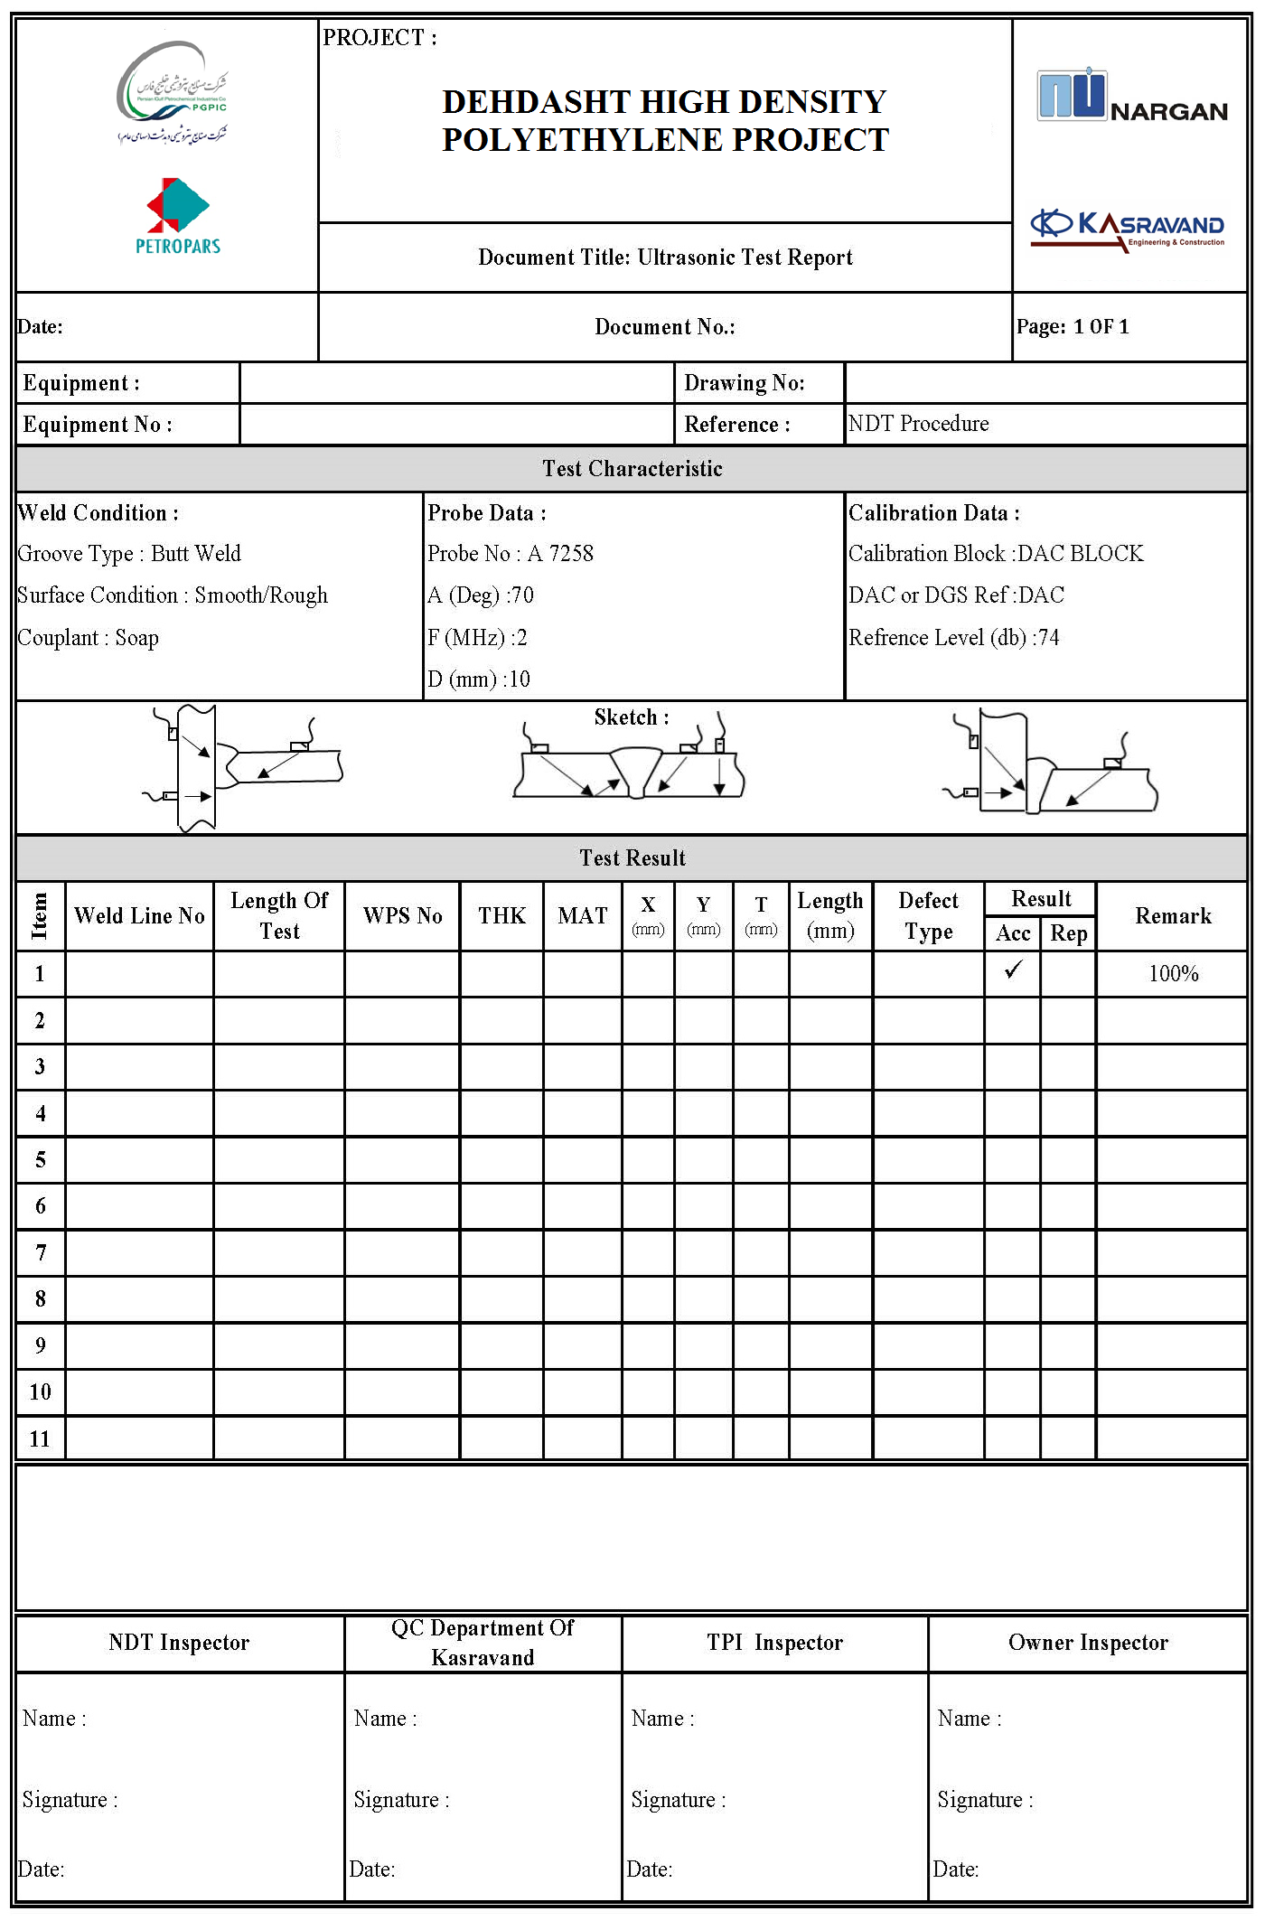
16. Calibration Blocks Figure

Part 2

Liquid Penetrant Examination Procedure

Table of Content

1 Scope 24
2 Reference Documents 24
3 Technique 25
4 Surface Preparation 25
5 Drying After Preparation 25
6 Testing Media 25
7 Examination 26
8 Acceptance Criteria 26
9 Post-Test Cleaning 27
10 Reporting 27

- Scope
The test procedure is written in accordance with ASME Sec V Article 6, Liquid penetration Examination for pressure vessels fabricated under ASME Section VIII Div. (1) Refrigeration Package.

Table T-621 ASME Sec V

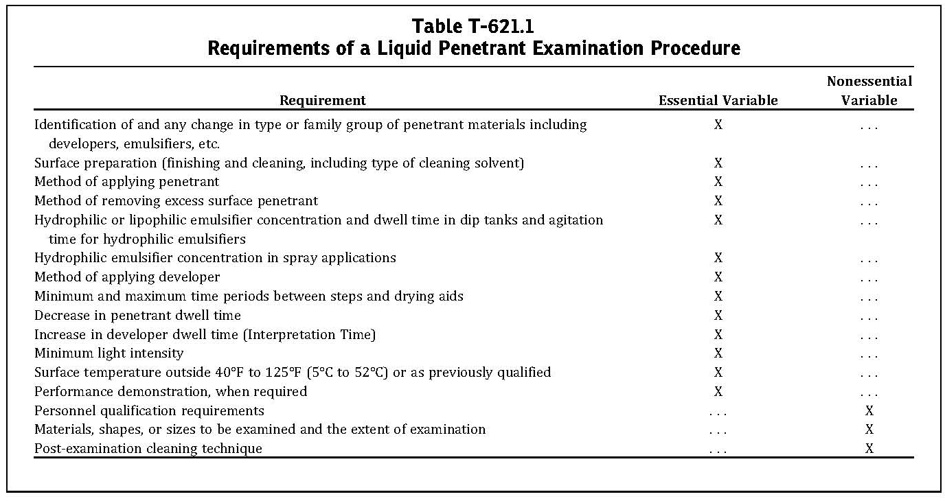

2. Reference Documents
2.1 The latest edition of the following documents shall be referred to in conjunction with this procedure:
a) ASME Sec. V Boiler and Pressure Vessel Code- NDE.
d) ASNT-SNT-TC-1A. Procedure for NDT Personnel Qualification and certification
c) ASME SEC VIII Div. 1 Boiler and Pressure Vessel Code.
d) Requirements for Pressure Vessels
2.2 In case of conflict between this procedure and any project specifications, datasheets, referenced standards and codes, it shall be drawn immediately to attention of Employer (COMPANY) in writing for approval before commencement of work.
- Technique
Either a color contrast penetration or fluorescent penetrant technique may be used. In both the cases the penetrant shall be removable by solvent.

- Surface Preparation
In general, satisfactory results may be expected when the surface of the part is in the as welded, as rolled, as cast, or as forged condition. Surface preparation by grinding, machining, or other method may be necessary where the surface irregularities could mask the indications of unacceptable discontinuities.
Prior to any liquid penetration examination, the surface to be examined and all adjacent areas within at list 1 in. shall be dry and free of all dirt, grease, lint, scale, welding flux, weld spatter, oil, and other extraneous matter that matter that could obscure surface opening or otherwise interface with the examination. Cleaning agents that are to be used shall either be detergents or organic solvents.

- Drying After Preparation
After cleaning, the drying of the surfaces to be examined shall be accomplished by normal evaporation or with force hot air as appropriate. A minimal period of 15-min laps shall be permitted to ensure that the cleaning solution has evaporated prior to application of the penetrant.

- Testing Media
6.1 A solvent-removable system consisting of the following (aerosol spray type) will be used for examination.
Srem Cleaner S-190
Srem Penetrant P-125
Srem Developer A-175
6.2 The contaminant content for all liquid penetrant materials used on Austenitic stainless steels be according to T-640 of ASME. V and MANDATORY APPENDIX II of ARTICLE 6 of ASME sec V.

- Examination

7.1 Technique for Standard Temperature
As a standard practice, neither the temperature of the penetrant nor the surface of the part to be examined shall be below 15.5°C(60°F) or above 51.6°C(125°F) throughout the examination period. Local heating or cooling is permitted, provided the part temperature remain in the range of 15.5°C to 51.6°C during the examination. Where it is not practical to comply with these temperature limitations, the test may be carried out at another temperature, provided the procedure adopted is qualified as specified in T-653 (Technique for non standard temperatures). Minimum black light intensity shall be 1000 μw/cm2and a maximum intensity of 1,100 μW/cm2.

7.2 Penetrant Application
The penetrant is applied by spraying to the entire surface to be examined. The excess penetrant is allowed to drain from the part after application, while allowing for proper dwell time. In general, a dwell time of 5 to 10-min is sufficient for most of the applications.

7.3 Excess Penetrant Removal
After a dwelling time of 5 to 10 min, excess penetrant can be wiped off by a clean lint-free cloth, repeating the operation until most traces of penetrant have been removed. The remaining traces shall be removed by wiping the surface with cloth or absorbent paper moistened with solvent. The direct spraying of the solvent onto the surface following the application of penetrant prior to developing is prohibited.

7.4 Drying After Excess Penetrant Removal
For the solvent removal method, the surface may be dried by normal evaporation.

7.5 Developing
The developer shall be applied as soon as possible after the removal of penetrant. The time interval shall not exceed 5 min under any circumferences. A nonaqueous developer shall be used with either color contrast or fluorescent penetration.

8. Acceptance Criteria
The acceptance criteria of the component shall be evaluated in terms of acceptance standards of ASME Section VIII Div. 1 requirements Appendix 8 (Page:57).

- Post-Test Cleaning

Post cleaning is necessary in cases where residual penetrant or developer could interfere with subsequent processing or with service requirements. A simple water rinse, machine wash, or a solvent soap may be employed for the purpose.

- Reporting

A report format has been attached to this procedure and it shall be prepared by PT level II and approved by level II or level III and sent to the concerned, QC inspector.
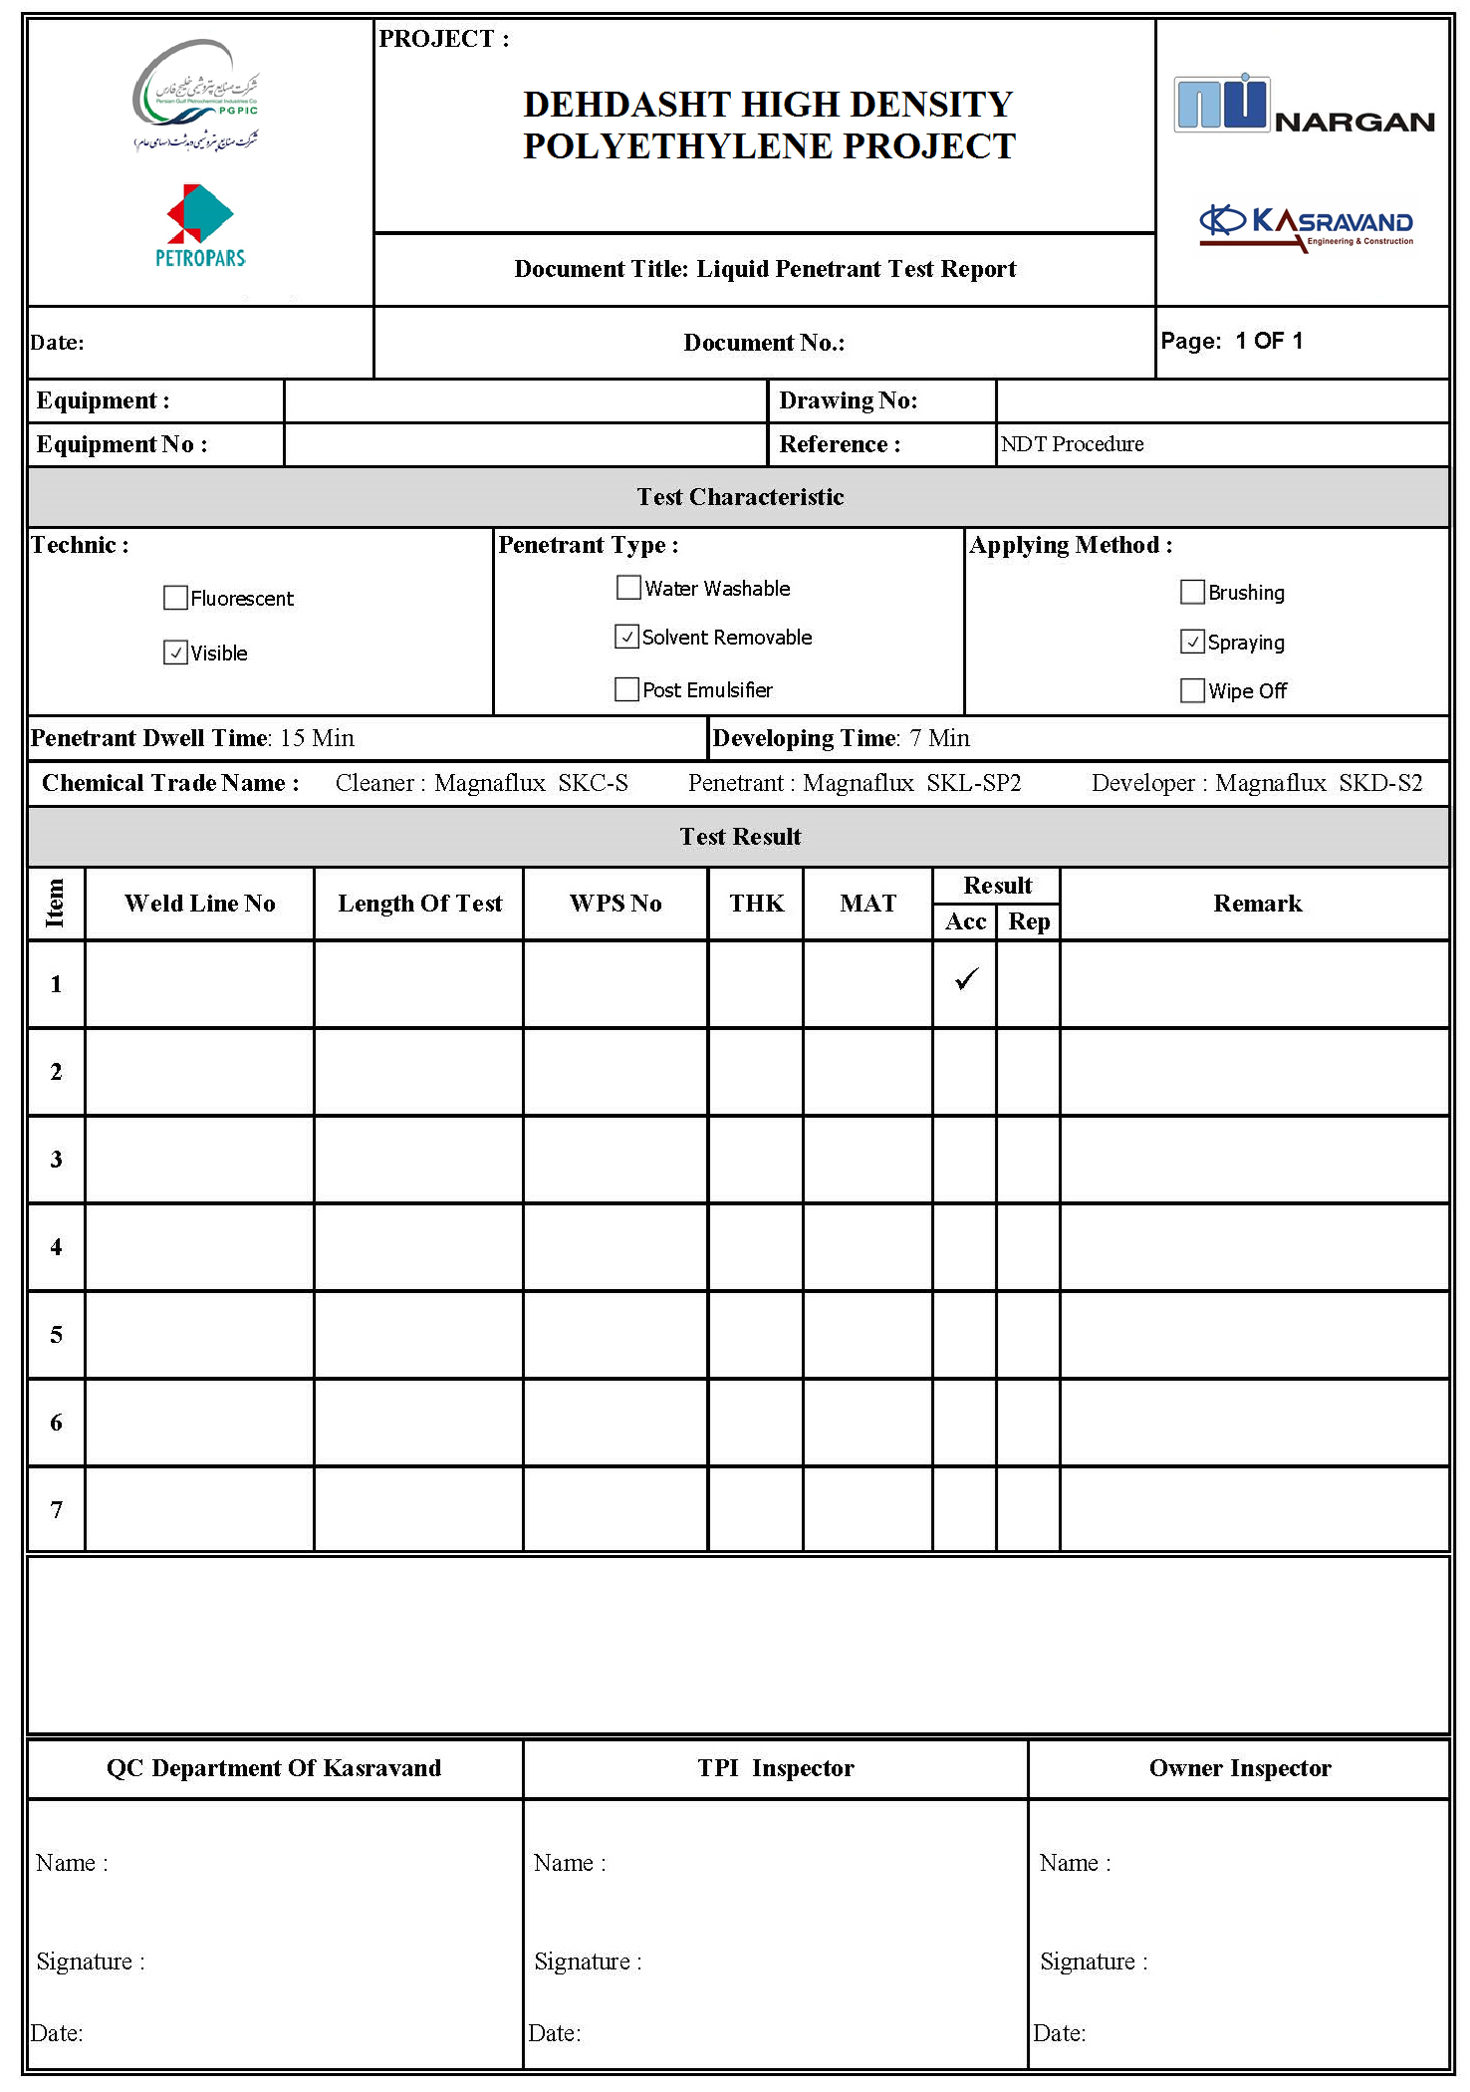

Part 3

Radiographic Examination Procedure
Gamma-Ray Examination

Table of Content

1 Scope 31
2 Reference Code 31
3 Surface Preparation 31
4 Radiography Equipment & Consumable 31
5 Developing 32
6 Stop Bath Or Rinse 32
7 Fixing 32
8 Washing 32
9 Quality Of Radiographs 32
10 Exposure Technique 33
11 Intensifying Screens 33
12 Penetrometer (IQI) 33
13 Placement And Number of IQI 33
14 Selection of IQI 34
15 Unsharpness Geometric 34
16 Density Limitation 35
17 Radiography Identification 35
18 Back Scattering Check 36
19 Storage of Radiograph 36
20 Interpretation and Evaluation 36
21 Acceptance Standard 36
22 Densitometer 36
23 Personnel Qualification 37
24 Sample Inspection Report 38

- Scope

The test procedure is written in accordance with ASME Sec V Article 2, Radiographic test for pressure vessels fabricated under ASME Section VIII Div. (1) for Refrigeration Package.

- Reference Code

ASME Section V Article 2 2018 Edition.
ASME Section VIII Div. 1 2018 Edition.
SNT – TC – 1A 2006 Edition.
REQUIREMENTS FOR PRESSURE VESSELS
Purchase Order
- In case of conflict between this procedure and any project specifications, datasheets, referenced standards and codes, it shall be drawn immediately to attention of Employer (COMPANY) in writing for approval before commencement of work.

- Surface Preparation

All welded joints before radiography examination shall be subjected to 100% visually inspected. spatter and other surface irregularities that cause difficulty in detecting defects shall be remove.

- Radiography Equipment& Consumable
  - Gamma - radiography:
Isotope Type: Ir192Source size 2 x 3 mm
Film type: ASTM E 1815 – 96 Type 1(e.g. Kodak MX 125 or Agfa D4 or Fuji)
- Radiography shall be made using industrial radiography film type class I per ASTM, equivalent to AGFA D4, Kodak, Industrex MX, FUMADUX R4 or FUJI IX50. Width of film should be 10 cm. in special cases; a smaller width film can also be used, provided 15mm of the base metal appear on each side of the weld on the radiograph. Minimum source power should be 20 curie for RT test.

  - Processing: Manual Processing shall be used.

- Developing
Films will be placed in hangers and immersed in developer solution with constant agitation for even development. Developing time shall be in accordance to that recommended by film manufacturer. It shall normally be 5 minutes at 20° C. If developer temperature varies, development time should be adjusted according to manufacturer s recommended time.

- Stop Bath or Rinse
When development is finished, the films shall be immersed in stop bath or rinsed in clean running water to stop the activity of the developer.

- Fixing
Fixing shall be done for at least twice the cleaning time.

- Washing
Washing shall be done with constant flow of clean fresh water. Rate of water flow shall be approximately 5 to 6 times the volume of water tank per hour. Filters should be used if necessary. Minimum time is as per manufacturer’s recommendation.

- Quality of Radiographs
All radiographs shall be free from mechanical, chemical or other blemishes to the extent that they do not mask and are not mask and confused with the image of any discontinuity in the area of interest of the object being radio graphed. Such blemishes include, but are not limited to:
fogging
Processing defects such as streaks, watermarks, or chemical stains.
Scratches, finger marks, crimps, dirt, static marks, or tears.
False indication due to defective screens.

- Exposure Technique (Appendix I)
Applicable exposure will be chosen based on shape, size and material thickness of the object to be the tested. The technique and time shall be reported on the RT report. Other information is:
Up to 2.5 inch diameter -DWDI (Double Wall Double Image)
Diameter 2.5 to 16 inch – DWSI (Double Wall Single Image)
Above 16 inch – DWSI or SWSI (Double Wall Single Image or Single Wall Single Image)

- Intensifying Screens
The lead screen shall be used with 0.175 mm thickness in front and back of film. Fluorescence screens shall not be used. Location markers shall be used as per Fig. T-275 ASME Sec V.
- Penetrometer (IQI)
IQI shall be wire type and identified in accordance with the thickness of the job to achieve the required sensitivity as per ASME Sec. VIII
- Placement and Number of IQI
The IQI shall be placed transversely across the weld seam at the source side. In cases where placement of IQI on the source side is impracticable , the IQI shall be placed on the film side with an Identification letter “F” at least as high as the identification number either adjacent or on the IQI. One IQI shall be used for each radiograph. Orientation of the IQI shall be such that thickest wire faces the center of its film length. For spherical components where the source is placed at the center of the component for a single exposure, at least three IQI’s, spaced approximately 120 deg. apart, are required under the following conditions:
- When a complete circumference is radiographed using one or more holders, or:
- when a section or section of a circumference, where the length between the ends of outermost section span 24 or more deg. , is radiographed using one or more film holder. Additional film location may require obtaining necessary IQI spacing. When the weld metal is of an alloy group or that has a radiation attenuation that differs from the base material, the IQI material selection shall be based on the weld metal. When the density limits cannot be met with one IQI, and the exceptional density area(s) is at the interface of the weld metal and the base metal, the material selection for the additional IQIs shall be based on the base material.

- Selection of IQI
I) IQI’s shall be selected from either the same alloy material group or from an alloy material group or grade with less radiation absorb ion than the material being radio graphed according to specification.
II) For welds with reinforcements, the wire diameter on the IQI is based is the nominal single wall thickness plus the estimated weld reinforcement. Backing rings or strips are not to be considered as part of the thickness in IQI selection. For welds without reinforcement, the thickness on which the IQI is the nominal single wall thickness.

- Unsharpness Geometrics
Geometric unsharpness resulting from the following:
I) Source size
II) Distance from source of radiation to weld or object being radiographed.
III) Distance from source to the film Shall be calculated from:
Ug = F. d / D

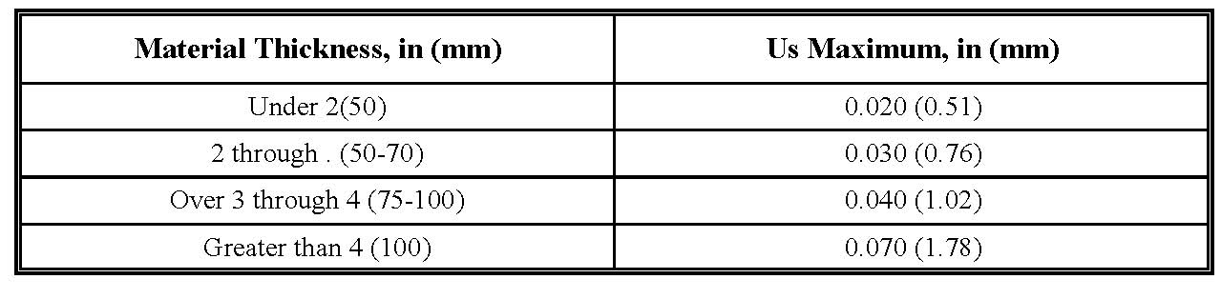Recommended maximum values for geometric unsharpness are as follow

Note: Material thickness is the thickness on which the IQI is based.
The sfd should be as large as possible to reduce the geometric unsharpness. This relation is dependent on the source strength and the specimen thickness as the time of the exposure will increase in proportion to the square of the distance.
The object to film distance should be kept to the minimum.

- Density Limitation
Single-film viewing shall be used, and the film density shall be in the range of 2.5 to 3.5. For those instances where the variable thickness makes single film impracticable, with the Client approval, double film viewing may be used. For the double film technique, the film density shall be in the range of 2 to 3.5 for the double film combination or each individual film. Higher densities (up to 4.0) may be acceptable if adequate viewing and satisfactory interpretation of higher density film are permitted by the viewing equipment.

- Radiography Identification
Lead Markers shall be used in radiograph identification. All radiographs must bear the following markings:
1) Location markers shall be used for reference of the part being radiographed. These markers are not allowed to be in contact with the weld areas.
2) The location or system (for piping) and the joint number shall be clearly marked on the top left hand corner.
3) Minimum overlap shall be 25 mm.
4) The date shall be shown at the lower right hand corner of the film .the manufacturer shall prepare and document the radiographic technique details .as a minimum, the following information shall be provided:
(a) Project Name/Number
(b) Manefacturer Abbreviation
(c) Identification, e.g. job/contract number and heat number (if applicable)
(d) The dimensional map (if used) of marker placement in accordance with T-275 (ASME Sec.V article2).
(e)Number of radiographs (exposures)
(f)Base material type and thickness, weld thickness, weld reinforcement thickness, as applicable
(g) Maximum distance from source side of object to the film
(h) Film manufacturer and manufacturer s type /designation
(i) Number of film in each film holder /cassette
(j) Single or double- wall exposure
(k) Single or double-wall viewing
(l) Welder Stamp
(m) Weld joint No.
(n) Repair marks, R1, R2, R3 for repair RS for Reshoot

- Back Scattering Check
Back scattering shall be checked with a lead marker "B" minimum 12.7 mm height by 4.2mm thick attached to the back of each film cassette. The film shall be considered unacceptable if a light image appears on the dark background. However, a dark image of the "B" on a lighter background should not be in cause for rejection.

- Storage of Radiograph
Film shall be stored strictly as per manufacturer recommendation.

- Interpretation and Evaluation
All radiographs shall be free from mechanical, chemical, or other blemishes to the extent that they do not mask and are not confused of the object being radiographed. Such blemishes include, but are not limited to:
(a) Fogging;
(b) Processing defects such as steaks, watermarks, or chemical stains;
(c) Scratches, finger marks, crimps, dirtiness, static marks. Smudges, or tears;
(d) False indications due to defective screens.

- Acceptance Standard
Acceptance Standard for evaluation discontinuities shall be in Accordance with the requirement of UW-51, UW-52 (Page:60) and ASME Sec VIII Division 1 Appendix4 (Page:49).

- Densitometer
Densitometers shall be calibrated at least every 90 days during use as follows:
A step wedge calibration film, traceable to a national standard step table and having at least 5 step with neutral densities from at least 1.0 through 4.5, shall be used.

- Personnel Qualification
Radiographers shall be qualified to ASNT Level II in accordance with recommended practice in compliance with SNT – TC – 1A (personnel qualification and certification in Nondestructive testing).
24. Sample Inspection Report
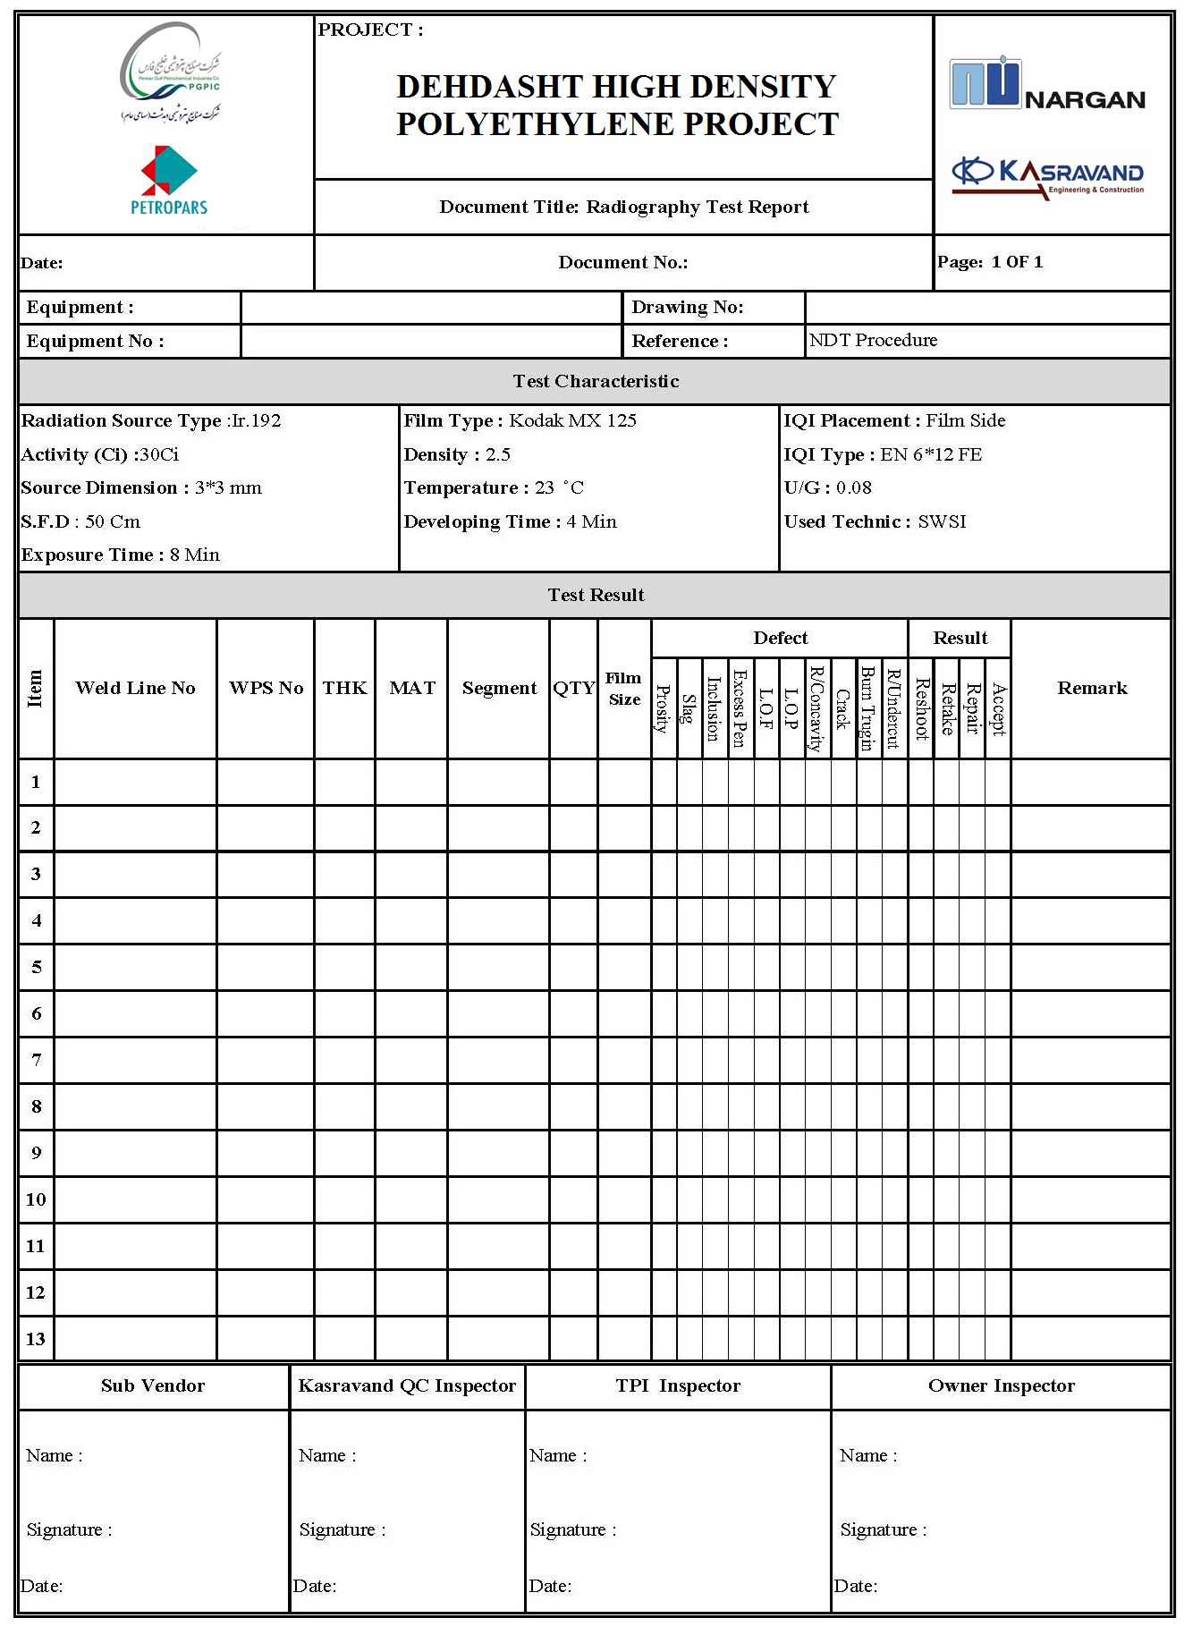

Part 4
Magnetic Particle Examination Procedure

Table of Content

1 Scope 41
2 Application Codes And Standard 41
3 Examination Time 42
4 Surface Preparation 42
5 Examination Medium 42
6 Magnetization Method 43
7 Calibration of Equipment 43
8 Demagnetization 43
9 Method Of Examination 43
10 Interpretation 44
11 Indications Evaluation 44
12 Acceptance Criteria 44
13 Repairs 44
14 Post Cleaning 44
15 Personnel Qualification 45
16 Sample Inspection Report 46

- Scope
The test procedure is written in accordance with ASME Sec V Article 7, Magnetic Particle Examination for pressure vessels fabricated under ASME Section VIII Div. (1) for Refrigeration Package.

Table T-721 ASME Sec V

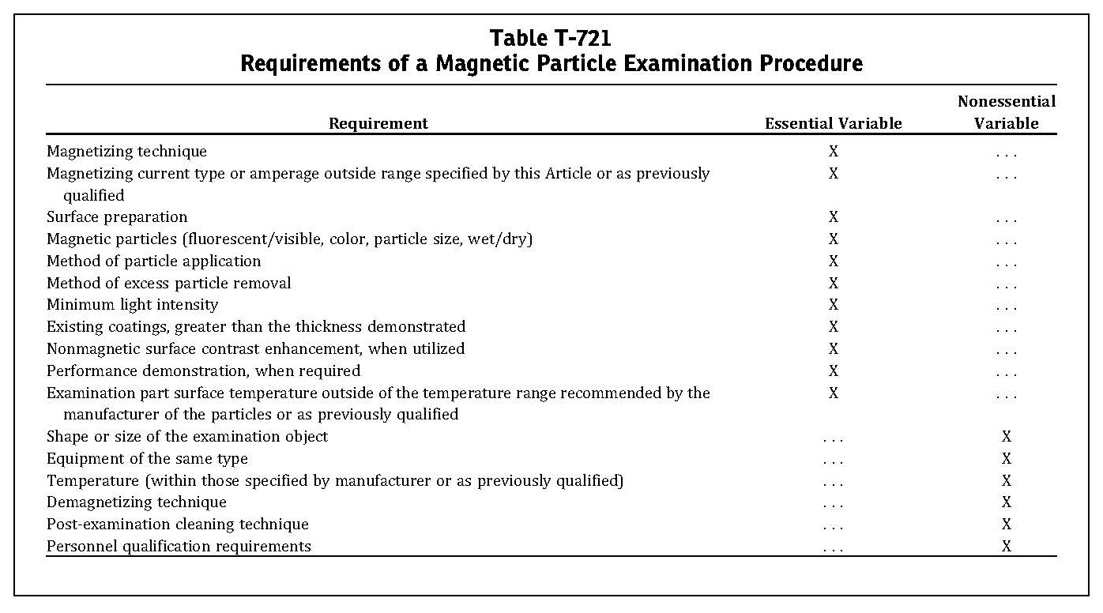

- Application Code and Standards
ASME Sec VIII Appendix 6 2018 Edition
ASME Sec V. Article 7 2018 Edition
SNT-TC-1A 2006 Edition
REQUIREMENTS FOR PRESSURE VESSELS
- In case of conflict between this procedure and any project specifications, datasheets, referenced standards and codes, it shall be drawn immediately to attention of Employer (COMPANY) in writing for approval before commencement of work.

- Examination Time
MPI of welds may begin immediately after the completed welds have cooled to ambient temperature.

- Surface Preparation
4.1. Prior to magnetic particle Inspection the surface of the part to be examined and all adjacent area within at 50mm shall be clean, dry and free of contaminants such as dirt, oil ,grease,looserust, loose mill sand,loose mill scale, lint, thick paint, welding flux/slag, and weld spatter that might restrict particle movement. When testing a local area, such as weld, the area adjacent to the surface to be examined, must also be cleaned to the extent necessary to permite detection of indications.
4.2. If a non-conducting coating is left on the area to be examine that has a thickness greater than 0.05mm, it must be demonstrated that discontinuities can be detected through the maximum thickness applied.
4.3. Cleaning of the test surface may be accomplished by detergents, organic solvent, or mechanical means. Welded surface are generally satisfactory, but if the surface is unusually non uniform, interpretation may be difficult because of mechanical entrapment of the magnetic particles. In case of doubt, any questionable area should be re cleaned and reexamined.

- Examination Medium

5.1. The magnetic particles used for finding discontinuities will be powder for wet test, fluorescents or non-fluorescents.
5.2. The magnetic particles used for magnetic particle inspection should have a very high permeability and a low retentivity. Factors such as the particles density, size, shape and color all affect the sensitivity of the test.
5.3. Wet magnetic particles are designed to be suspended in a vehicle such as water or light petroleum distillated in a given concentration for application to the surface by flowing, spraying, or pouring. they are available in both fluorescent and no fluorescent concentrates.
5.4. The following medium and /or similar can be used:
a) Fluxo 7 (white contrast)
b) Fluxo 3 ( black Ink)

- Magnetization Method
6.1. The method with yoke shall be used.
a) This method shall be used only to detect some surface discontinuities.
b) The AC magnetizing technique will be used provided that it has a 4.5 Kg lifting power at the 50 To 100 mm pole spacing.
c) Two examination at least shall be carried out in every area where the Yoke is placed so that the flux line result approximately perpendicular.
d) Two examination at least shall be carried out with a sufficient overlapping (Min. 15%) so as to ensure the 100% covering of the surface to be tested.
6.2. The following equipment and /or similar can be used:
a) Western Instrument –WE3HDK
- Calibration of Equipment
The magnetic particle equipment employed should be maintained in proper working order at all times. The frequency of verification calibration, usually every six months, or whenever a malfunction is suspected.
- Demagnetization
When residual magnetism in the part could interfere with subsequent or usage, the part shall be demagnetized any time after completion of the examination.
- Method of Examination
Examination shall be done by continuous method. The wet continuous magnetization technique generally applies to those parts processed on a horizontal wet type unit. It involves bathing the part with the examination medium to provide an abundant source of suspended particles on the surface of the part and terminating the bath application immediately prior to cutting off the magnetizing current. The duration of magnetizing current is typically on the order of (1/2 s) with two or more shots given to the part.
Direction of Magnetization:
At least two separate magnetization direction (approximately perpendicular) shall be performed on each area.

- Interpretation
Non fluorescent particles; For this method the examination is performed using visible light
A minimum light intensity of 100 foot candles (1000 lux) is required to ensure adequate sensitivity during the examination and evaluation of indications.

- Indications Evaluation
11.1 All indications shall be evaluated in terms of the acceptance of the referencing code section.
11.2 Discontinuities on or near surface indicated by retention of the examination medium.
11.3 Broad areas of particle accumulation, which might mask indications from discontinuities, are prohibited, and such areas shall be cleaned and re-examined.
11.4 Any questionable or doubtful indication shall be re-examined to determine whether or not they are relevant.
- Acceptance Criteria
As per ASME Sec VIII Div.1, Appendix 6:
All surfaces to be examined shall be free of:
(a) relevant linear indications;
(b) relevant rounded indications greater than 3⁄16 in. (5 mm)
(c) four or more relevant rounded indications in a lineseparated by 1⁄16 in. (1.5 mm) or less, edge to edge.
- Repairs
13.1 Discontinuities exceeding the above mentioned limits shall be removed, and the part will be repaired according to the applicable procedure.
13.2 The area under repairing, plus 50mm per each side, shall be checked as per the starting procedure conditions.
- Post Cleaning
Post-test cleaning is necessary where magnetic particle material(s)could interfere with subsequent processing or with service requirements.
The techniques employed are:
* Drying of wet particles and subsequent removal by brushing or compressed air.
* Removal of wet particles by flushing with solvent.
* Other suitable techniques may be used if they will not interfere with subsequence requirements.
- Personnel Qualification
Personnel performing nondestructive testing shall be qualified and certified in accordance with ASNT Qualification Recommended Practice No. SNT-TC-1A. Only individuals qualified for NDT Level I and working under the NDT Level II or individuals qualified for NDT Level II may perform nondestructive testing.

- Sample Inspection Report

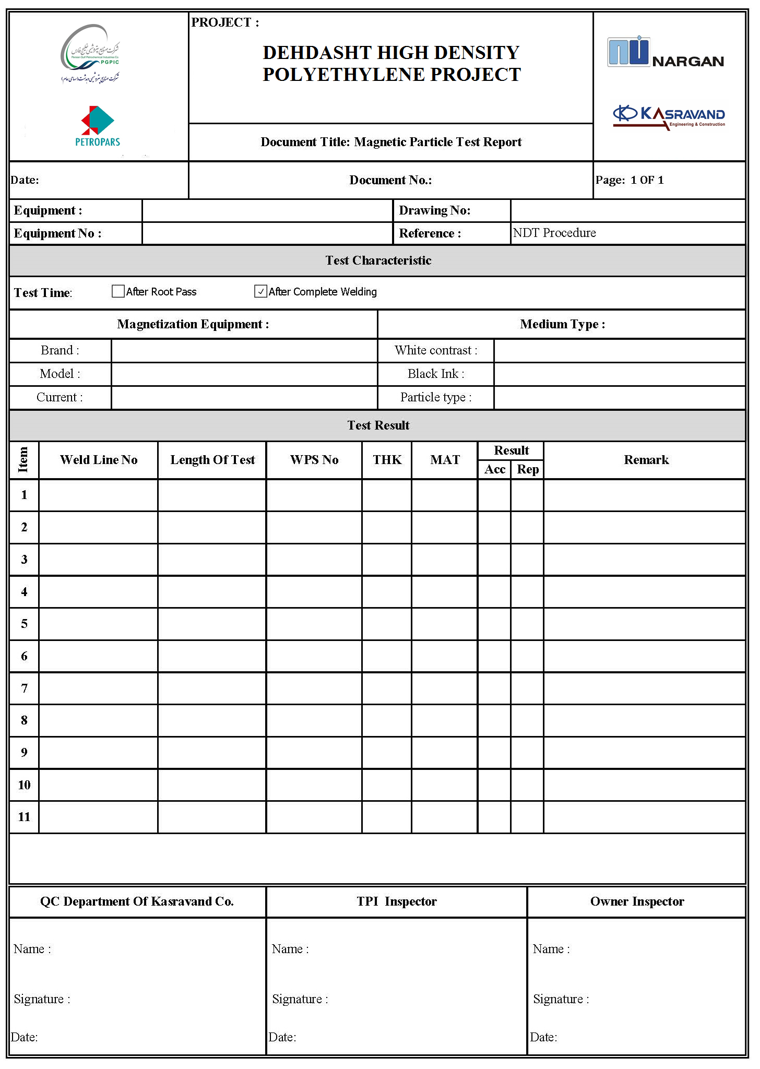

Part 5

Appendix

- ASME SEC VIII-Div.1, APPENDIX 4

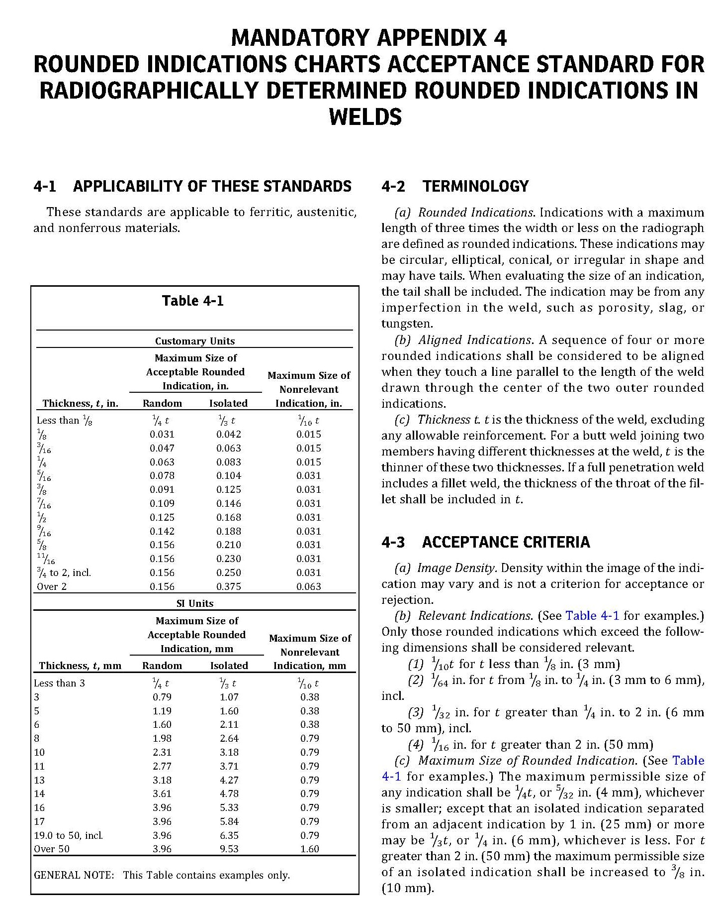

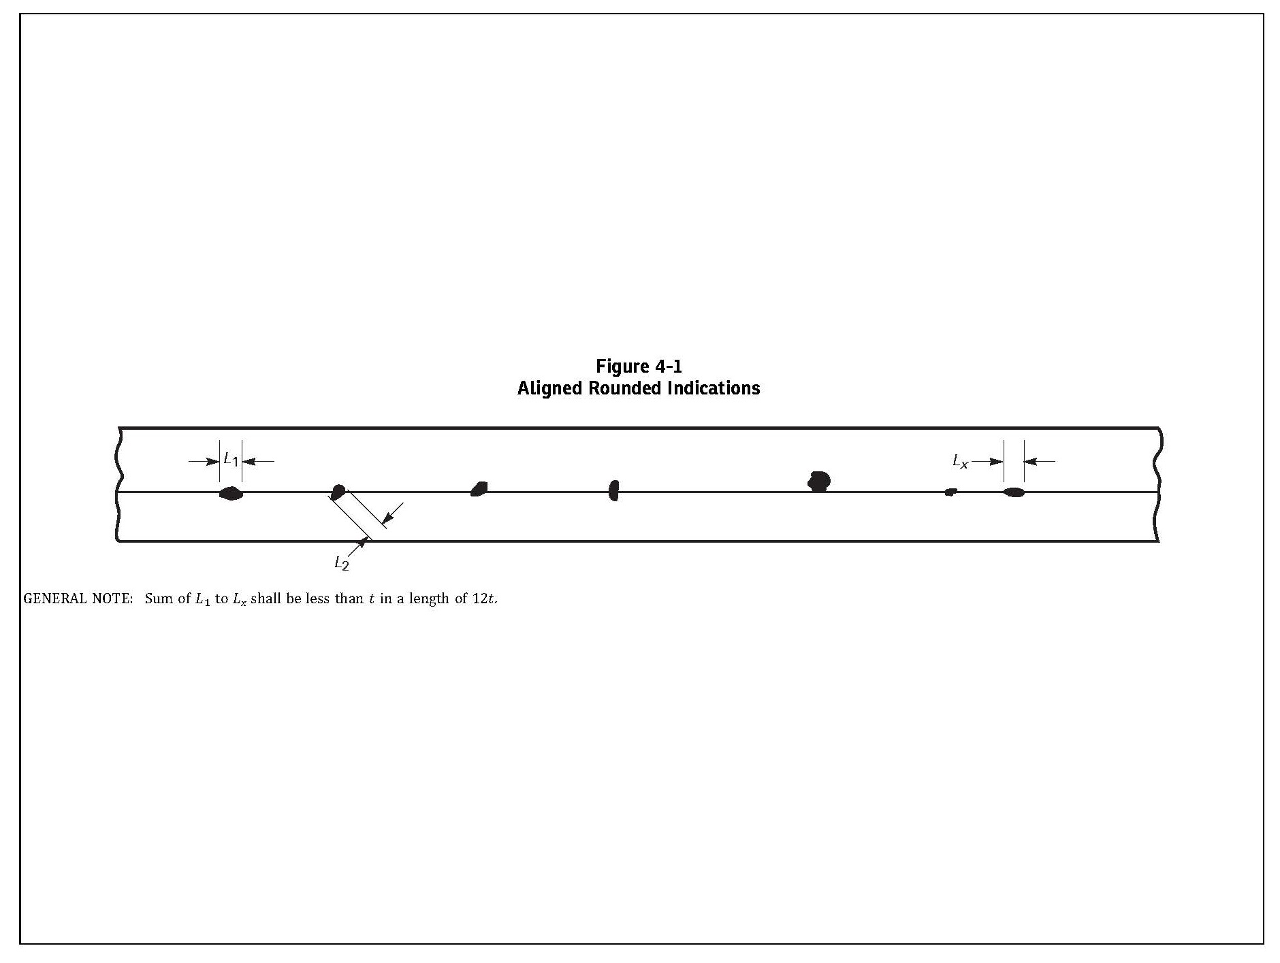

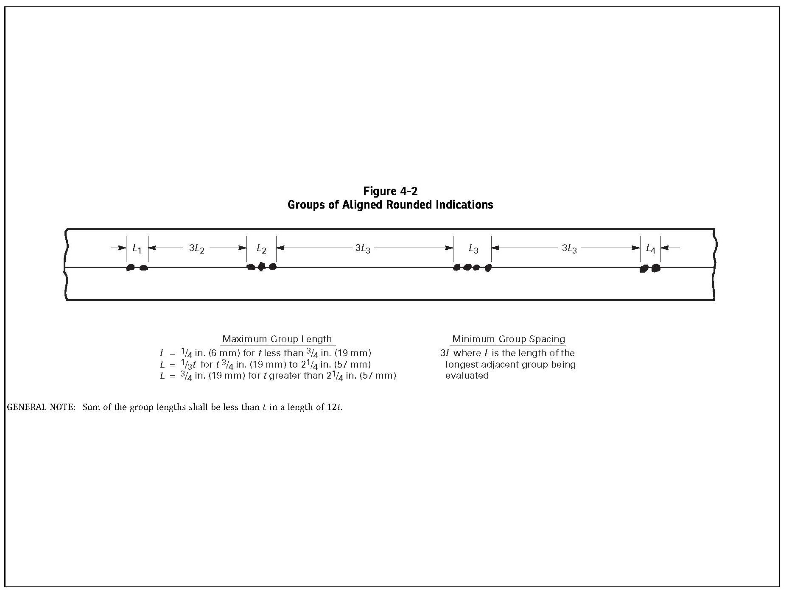

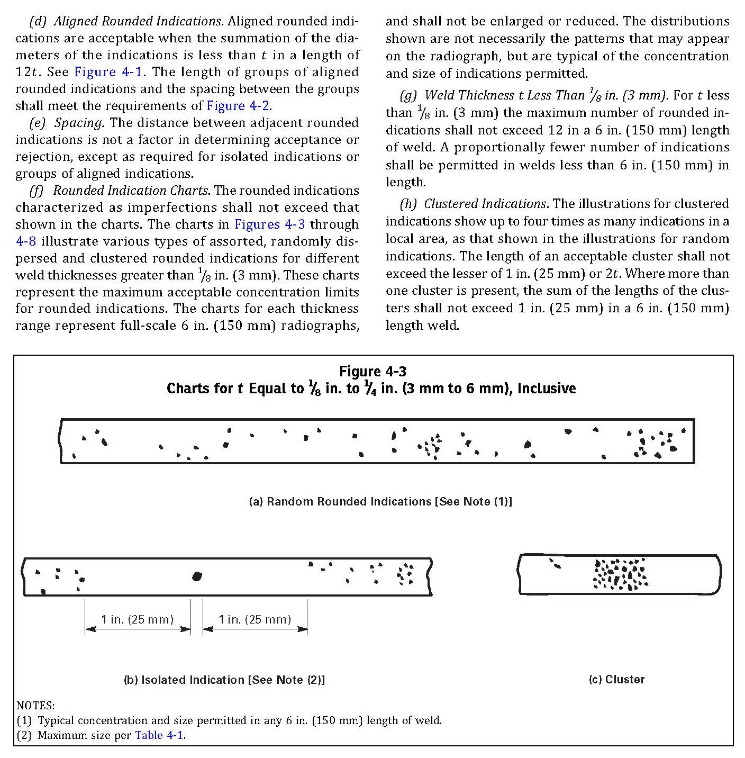

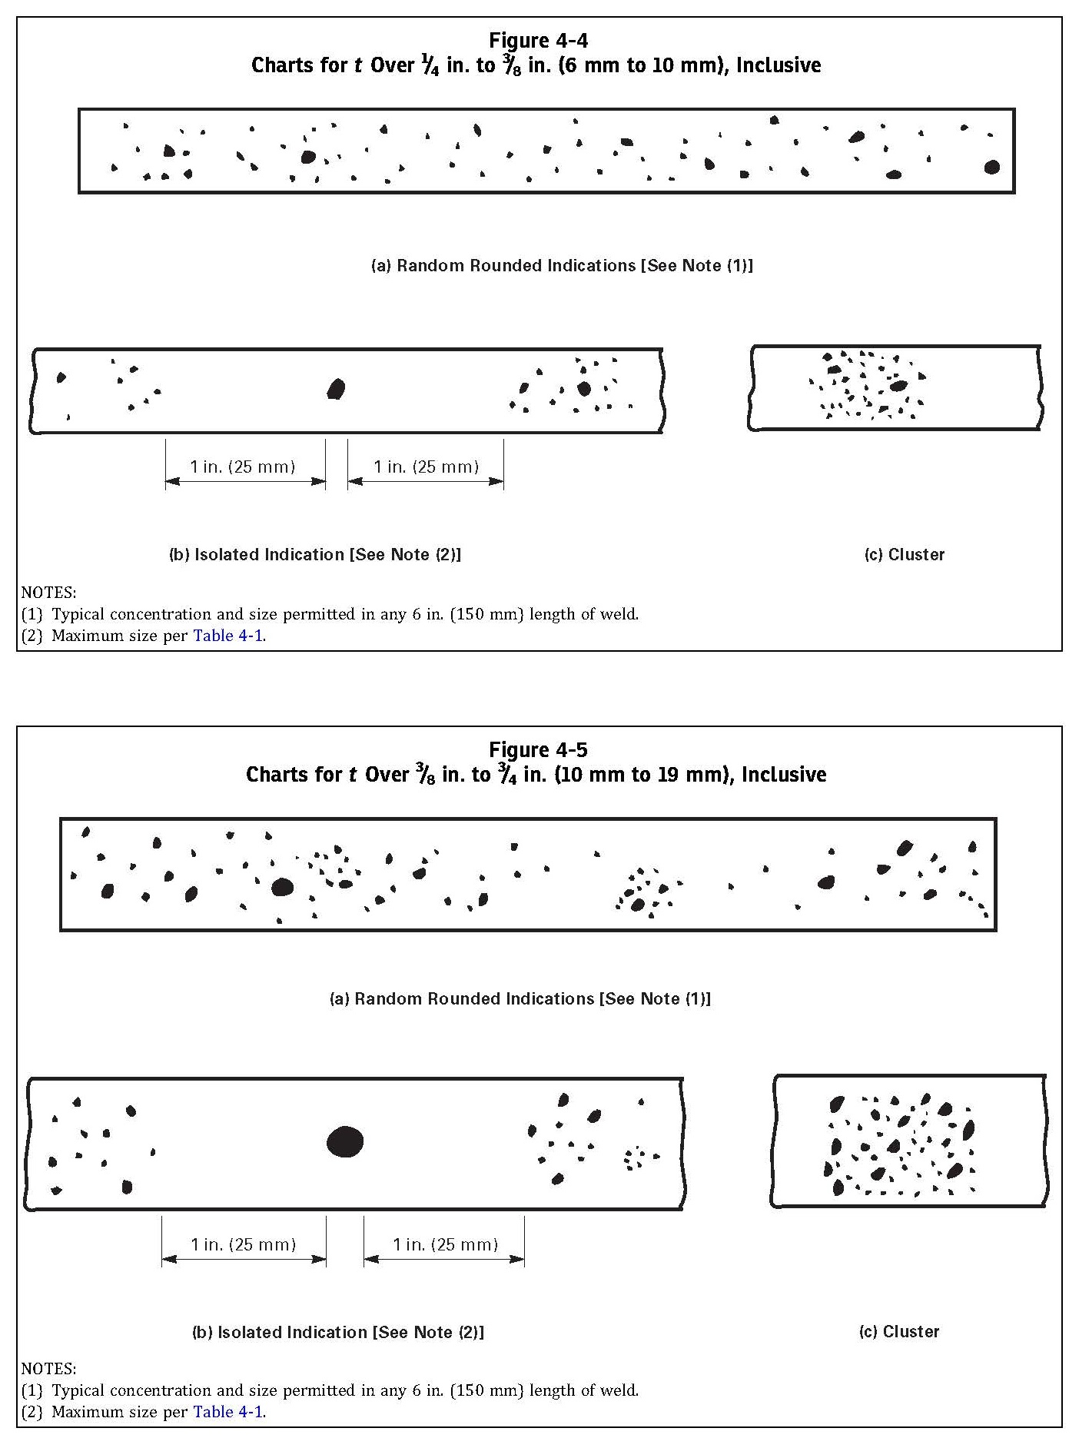

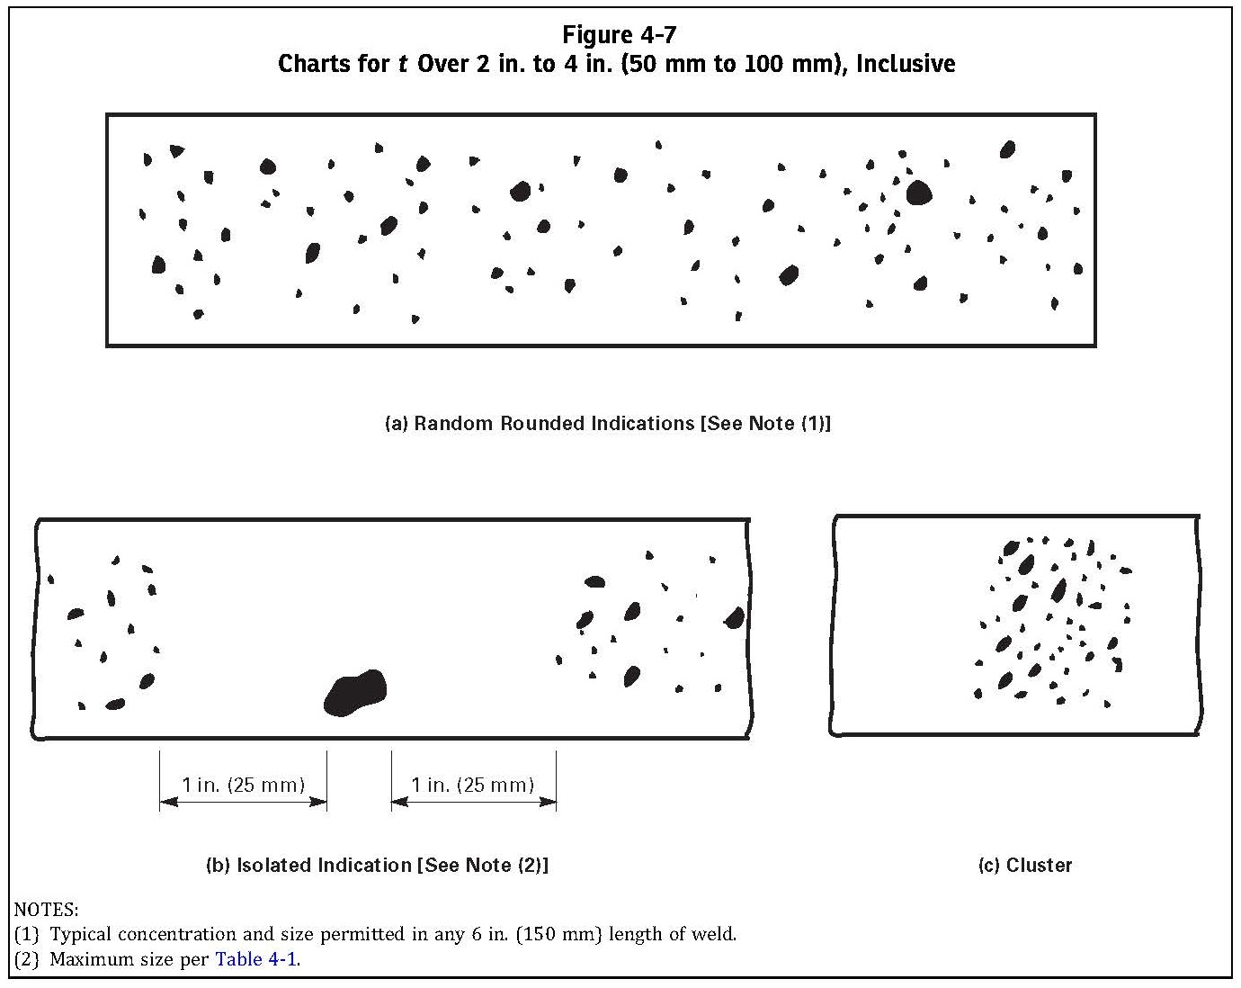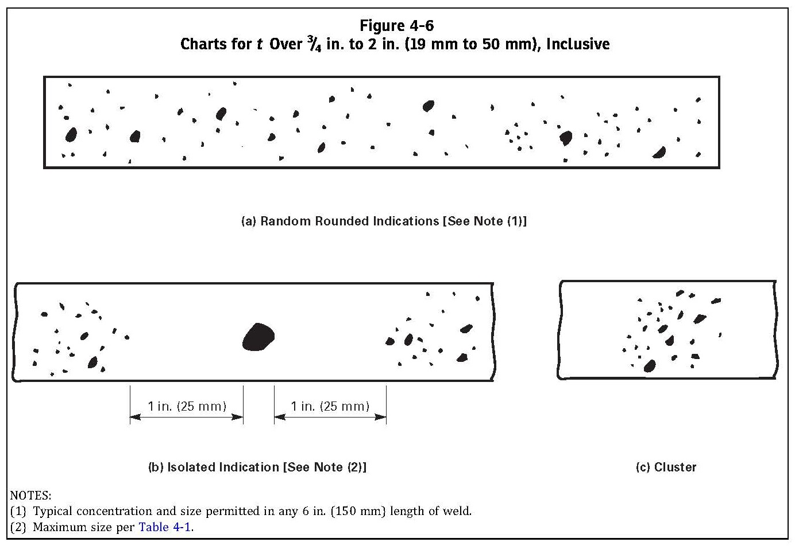

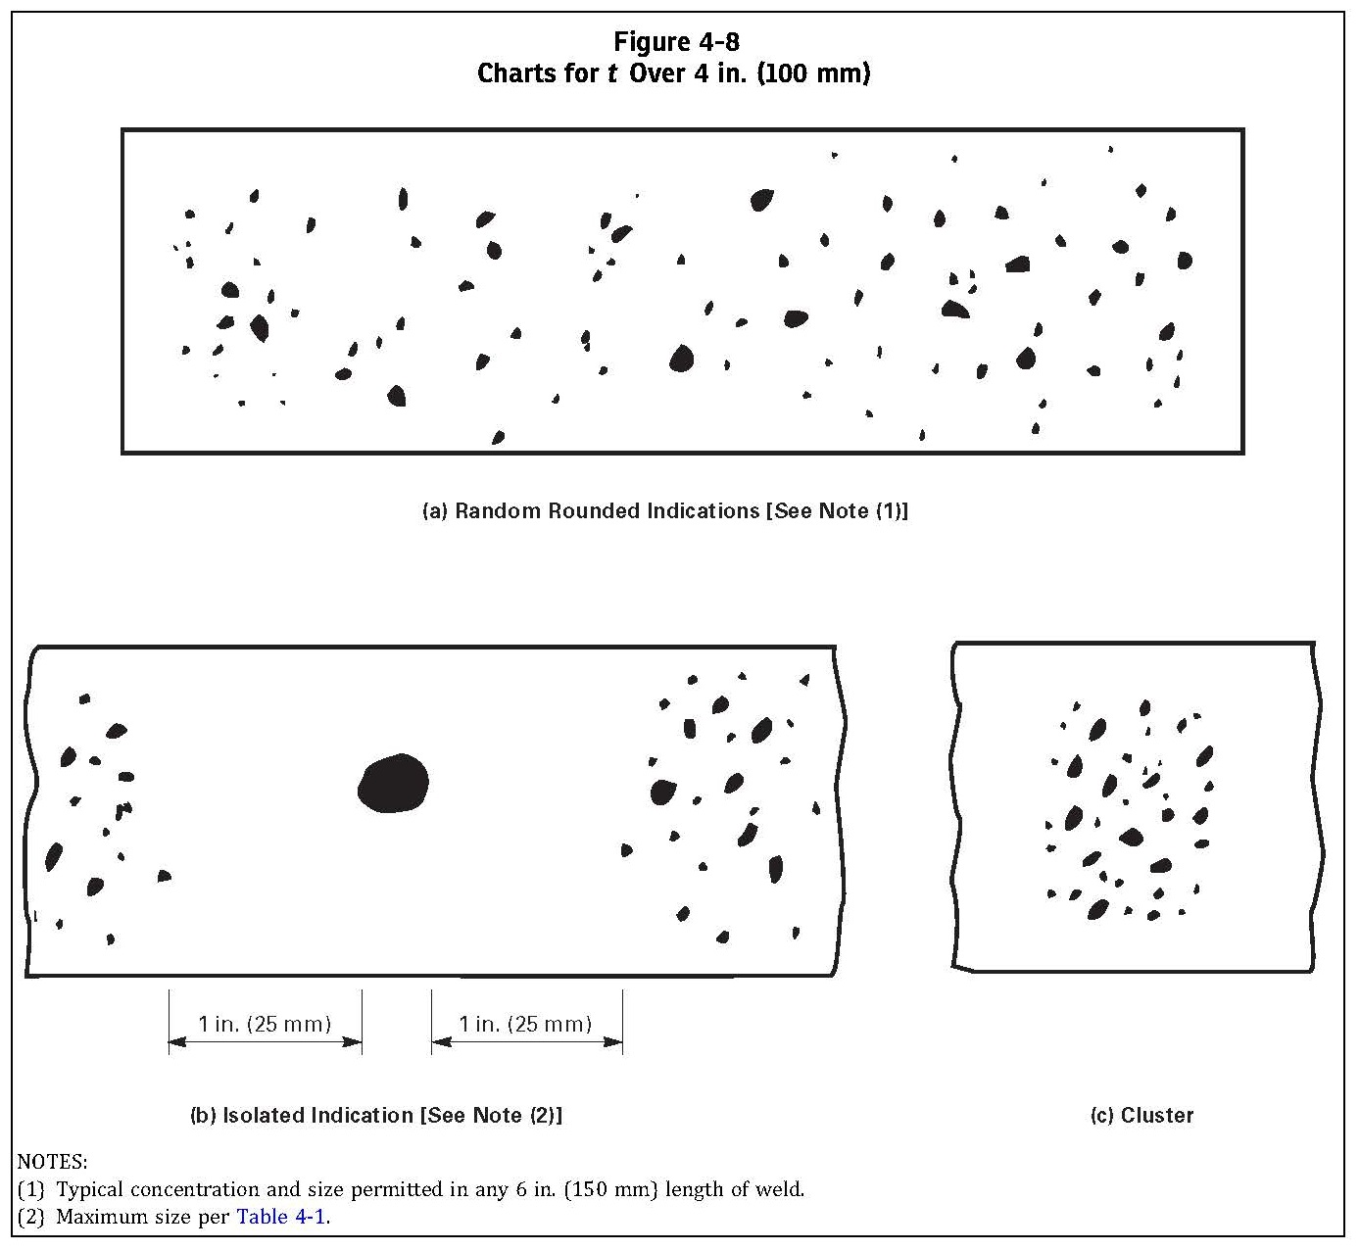

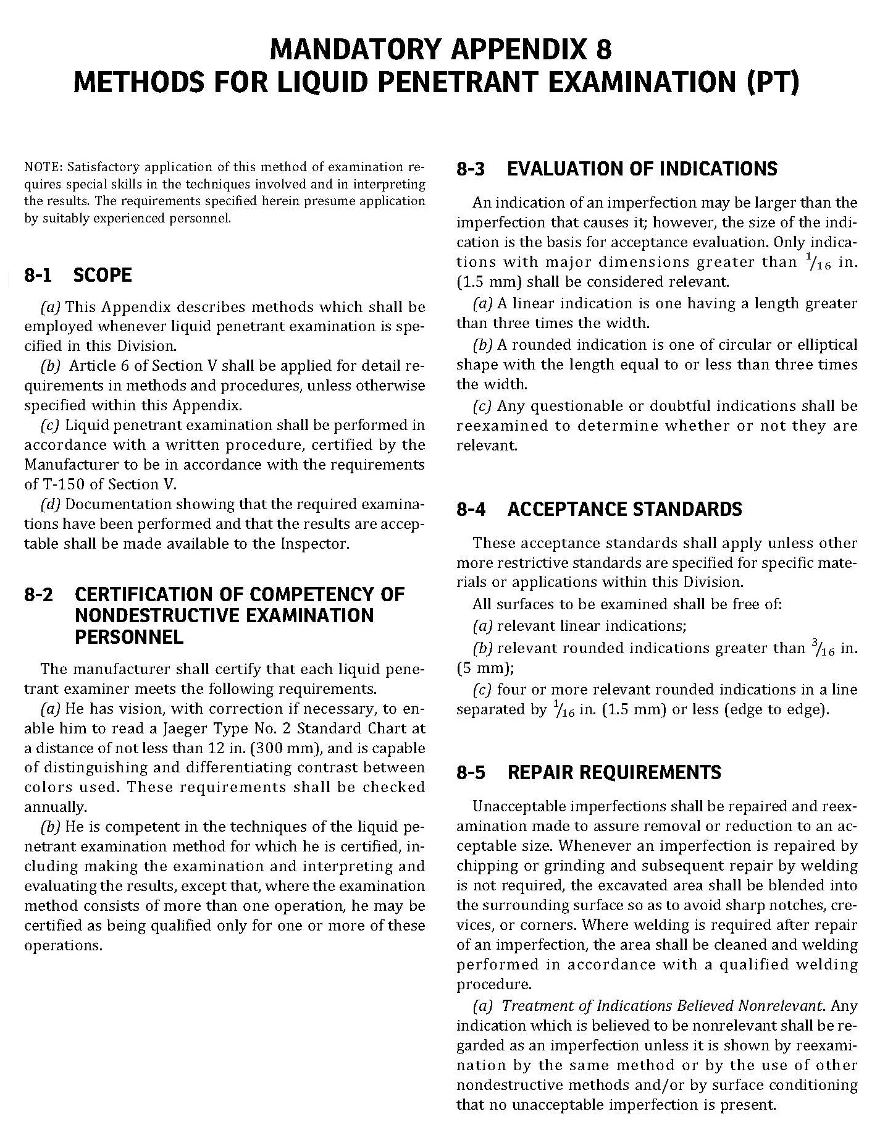

- ASME SEC VIII-Div.1, APPENDIX 8

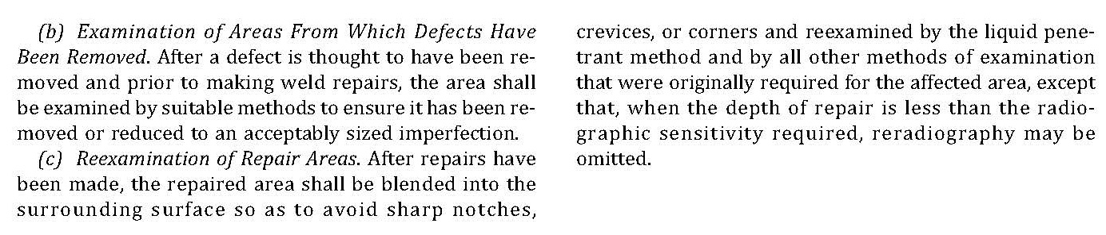

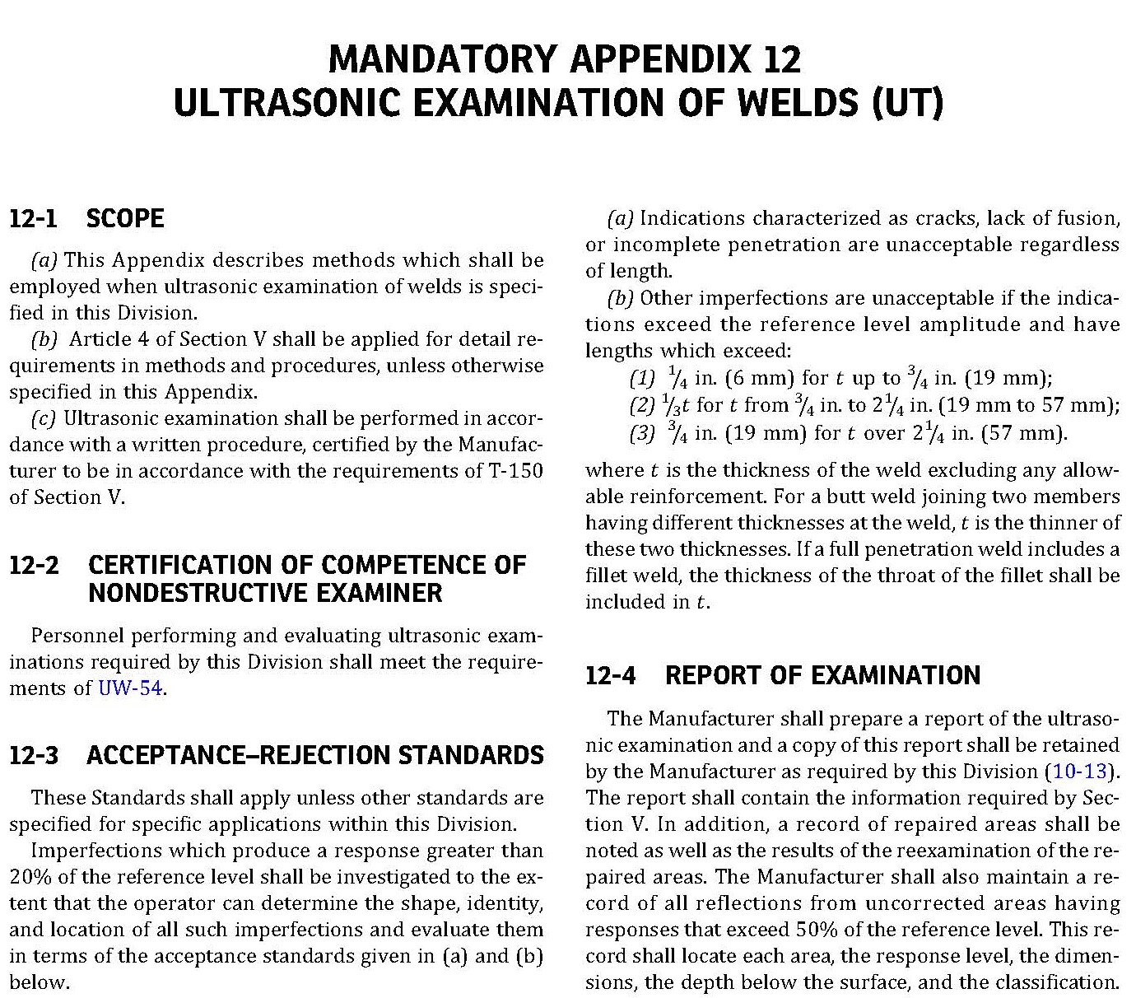

- ASME SEC VIII-Div.1, APPENDIX 12

